Calc4fem Getting Started Guide
Calc4fem ( http://calc4fem.narod.ru/ )— is the open source spreadsheet for plane frames, beams and trusses calculation. Finite Element Method for beam elements is used.
Scheme of use see here

INPUT DATA
All data must be added on the “Data” sheet. The program reads the data by the special keywords (in the green cells - “nodes”, “elements”, etc). You may tab it in arbitrary order in “Data”-sheet.

Nodes Array
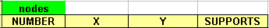
NUMBER – node numbers (positive whole numbers);
X, Y - nodes coordinates (Cartesian CS);
SUPPORTS – node supports.
Next keys are allowed:
x;
y;
xy, hinge;
xrot, xrotz;
yrot, yrotz;
rot, rotz;
xyrot, rigid.
Section Types Array
NUMBER – section type number (see “num SecProp” in Elements Array);
E – Young's Modulus;
A – cross section area;
J – moment of inertia (optional);
h – cross section height of section (optional).

For truss elements J=h=0 (or empty cell).

Elements Array
EL_NUM – number of element;
num i, num j – nuber of nodes (begin, end)
num SecProp – cross-section type number (See NUMBER in the Section Types Array)
CONNECTION TYPE – use the key “h” (“hinged”) for hinged connection in the begin or in the end of element.

Base Loads Array
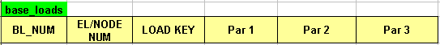
BL_NUM – Base load number for current load;
EL/NODE NUM – element/node number (in dependence on type of applying load);
LOAD KEY – literal key of load type (“fx”, “fy”,... “Pc”);
Par1, Par2, Par3 – parameters of load (values, distance, angels – see the table below)

Table 1 - Load Keys

Load Key | Scheme | Description
fx | 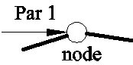 | Nodal load
fy | 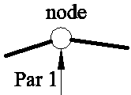 | Nodal load
mz | 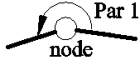 | Nodal moment
ux | 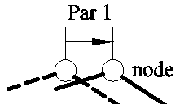 | Nodal displacement as a load  (Is not converted into Wolsink's program)
uy | 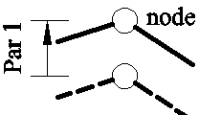 | Nodal displacement as a load  (Is not converted into Wolsink's program)
rotz | 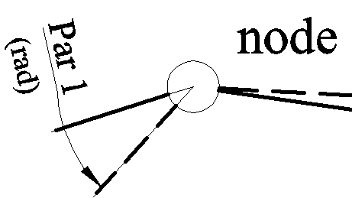 | Nodal rotation as a load  (Is not converted into Wolsink's program)
p1 | 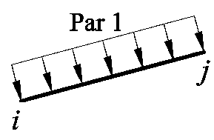 | Distributed load
p2 | 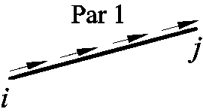 | Distributed load

Load Key | Scheme | Description
qx | 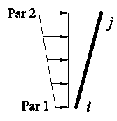 | Distributed load (according a vertical projection)
qy | 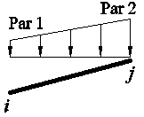 | Distributed load (according a horizontal projection)
Pc | 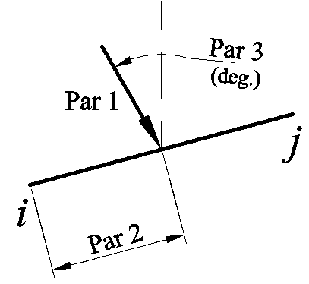 | Point load on the beam
Mc | 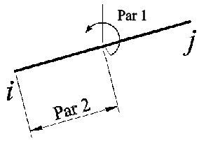 | Moment load on the beam
q |  | Non-uniform distributed load

Load Combination Array
Coefficients for base loads: Number of nonempty rows = number of combinations

For example:

Combination #1: (base_load#1)*0.9+(base_load#2)*0.8
Combination #2: (base_load#1)*1.2+(base_load#2)*1.4
Combination #3: (base_load#1)*1.2+(base_load#2)*(-1.4)

The Results
After calculation the program creates (recreates) several sheets: “Results”, “Graph” and (optional) - “Matrix”.
The “Results” sheet contains:
- Nodal results (reactions and displacements at different base loads and load combinations)
- Element results (extremal moments, axial and shear forces over the all load combinations).
The “Graph” sheet contains geometry of frame or truss, node and element numbers.
The “Matrix” sheet contains the common stiffness matrix and the force vectors for all base loads.
User Functions
1) eRes(element_number, key_of_result, base_load_number, t)

key_of_result:
"nsec"- Section type number for current element
"len"- lenth of element: Lenth=[(x_{j}-x_{i})²+(y_{j}-y_{i})²] ^{1/2}
"EA" – axial stiffness (E*A);
"EJ" – bending stiffness (E*J);
"l" : cosα = (x_{j}-x_{i})/Lenth;
"m" : sinα = (y_{j}-y_{i})/Lenth;
“Mt” - bending moment along beam axis (for x=t*Lenth);
“Qt”- shear force along beam axis (for x=t*Lenth);
“Nt”- axial force along beam axis (for x=t*Lenth);
“yloc” - Displacements along beam axis (for x=t*Lenth);
“phi” - Angle of rotation beam axis (for x=t*Lenth).

base_load_number and t = x/Lenth – optional variables (for result key = “Mt”, “Qt”, “Nt”, “yloc”, “phi”).

2) eRes_epure(element_number, key_of_result, base_load_number, t)

This function is used for quick getting of epures.
“eRes_epure is” is array function.
Use it with CTRL+SHIFT+ENTER to create table (array) of results.
key_of_result:
"yloc", "phi", "Mt", "Qt", "Nt" - displacements, angles of rotation, bending moments, shear forces, axial forces respectively. If key_of_result="all" then result of calculation is the table of all listed values (but "yloc" are multiplied by -1000 and "phi" are in degrees).
t = x/Lenth is column vector for array function.
See http://www.youtube.com/watch?v=UMHpvS_BN7E

3) eRes_comb(element_number, key_of_result)

This function is for getting results for load combinations.

key_of_result:
Extremal values available: "Mmin", "Nmin", "Qmin", "Mmax", "Nmax", "Qmax", "ymax".

You can use arrays (the list with element numbers) “element_number” via columns selection.

Also see the lessons:
http://www.youtube.com/watch?v=xABqaWOywd4
http://www.youtube.com/watch?v=XoiVTdpThC4
http://www.youtube.com/watch?v=OkJFATf1ylk

4) rRes(node_number, key_of_result, base_load_number)

Reads Nodal Base Load Reactions into Array

Input :
node_number -> Nodes for reading nodal reactions
key_of_result - “Rx” = Reaction force in direction X
“Ry” = Reaction force in direction Y
“Rm” = Reaction moment in direction Z
base_load_number -> Corresponding base load number

Useful links

http://www.openoffice.org/ | OpenOffice web site
http://portableapps.com/apps/office/openoffice_portable | Portable version for OpenOffice for Windows (it works without installation)
http://members.ziggo.nl/wolsink/ | Homepage Mechanical programs (freeware). Calc4fem can convert data for 2D part of this program automatically.
http://maxima.sourceforge.net/ | Maxima, a Computer Algebra System
http://pitonyak.org/ | Andrew Pitonyak's OpenOffice Macro Information

The Authors
Alifanov Leonid (aliphanov@yandex.ru);
Majugin Alexander (madzhugin@yandex.ru)
Baldini Robert (Italy) — rRes function

Special Thanks
Putevskoy V. - VB-code for solving linear system equations.
Wolsink G. (Netherlands) http://members.ziggo.nl/wolsink/ - for his wonderful program.
William Schelter – for the Maxima (a Computer Algebra System).

