Background

Neutrino oscillation has been a hot topic in the scientific community as of late. It was the subject of the 2015 Nobel Prize in Physics, and will be a focus of both the US and international physics community in the upcoming Deep Underground Neutrino Experiment (DUNE). Oscillation is the process by which neutrinos produced as one flavor can be detected as a different flavor after traveling some distance. A main goal of DUNE is to determine the presence of charge-parity (CP) symmetry violation in oscillations. CP symmetry governs that matter and antimatter behave identically, and violating this would mean neutrinos and antineutrinos have a different oscillation probability. CP violation in oscillations is an open question in High Energy Physics, and can provide profound insight into the matter-antimatter asymmetry we observe in the universe.

In the oscillation probability, CP violation is represented by the parameter δ_{CP}. The effect of CP violation on the oscillation probability is dependent on the neutrino energy, and any bias in the energy will result in a bias to δ_{CP}. Due to this, neutrino energy reconstruction is one of the largest sources of systematic uncertainty in DUNE. It has been shown that in a experiment similar to DUNE, an underestimation of neutrino energy by 20% can lead to a bias to the measurement of δ_{CP} on the order of one standard deviation¹.

Neutrino energy is estimated from the reconstructed energy of final state particles that are produced in neutrino-nucleus interactions. The neutrino energy can be mis-estimated if particles interact inelastically or are unable to be reconstructed because of scattering in the detector medium. This is referred to as Secondary Interactions (SI) of particles. These processes will be a significant problem for DUNE experiment, and must be studied.

For DUNE, knowledge of pion-Argon SI will particularly require a large improvement. Data from previous pion scattering experiments is used to inform pion SI models, and, until recently, pion-Argon data existed only below 240 MeV pion kinetic energy. This leaves a lack of constraints for pion-Argon SI at energies relevant to DUNE. The recent Liquid Argon in a Testbeam (LArIAT) experiment has provided pion-Argon scattering data up to 1.2 GeV, and my upcoming measurement on DUNE’s prototype detector, ProtoDUNE, will provide data at even higher energies. It is important to use the LArIAT and ProtoDUNE data to constrain SI models in DUNE’s experimental simulations.

Geant4 is used to simulate particles as they travel through a detector, and will be used by DUNE to simulate SI. A technique known as tuning can be used to constrain models based on external data. This ability is absent in Geant4, and it must be implemented in order to utilize LArIAT and ProtoDUNE data. My project will consist of providing this implementation, and then providing a tune of Geant4’s SI model to the LArIAT data. The implementation and subsequent tuning will be informed by work done by the T2K collaboration to use pion-Carbon scattering to constrain models for a similar process². This will set the stage for a tune to ProtoDUNE data once my measurement has been made.

STILL NEED TO PUT IN A PART ABOUT ::: CONNECTIONS OF THE PROPOSED SCGSR RESEARCH TO THE RESEARCH ACTIVITIES OF THE COLLABORATING DOE LAB & SCIENTIST

Research Objectives and Goals

In order to understand the current status of Geant4’s SI model, an important early step will be to determine its current prediction for the pion-Argon interaction cross section. This will be compared to the available LArIAT data, and will be used to highlight discrepancies between the two.

After investigating Geant4’s current predictions, I will move on to implementing the tuning ability into Geant4. For tuning, the SI model will be parameterized by factors that scale the rate of individual pion-nucleus interaction modes, and provide a new prediction for the rates of interaction. These parameters are then varied, and a fit to external data is performed. The tuned prediction and error bands are produced from the fit results

Implementing tuning will require an effort to develop a software package that will interface with Geant4. The aforementioned work done by T2K required a similar package to interface with their own simulations². I will use the T2K work to inform the design of the Geant4 package. At minimum it must have the following functionality:

- Loading in external data sets
- Reading in previously computed nominal prediction
- Performing the fit and finding the best-fit prediction
- Producing error bands from the fit results
(Might get rid of this list)
Once the tuning package is created, the next step will be to perform a fit to previous data sets in order to understand the current uncertainties of Geant4’s SI model. These data sets will be from experiments of pions scattering off of various nuclear targets, including the one data set for pion-Argon scattering below 240 MeV. After this, a final fit will be performed with the LArIAT data set included. The original and updated predictions and error bands will be presented along with the LArIAT data for comparison.

This research will be immensely beneficial to my thesis work. Performing the fit to the LArIAT data will provide an understanding of the uncertainties for a measurement and detector similar to my measurement on ProtoDUNE. Additionally, implementing tuning in Geant4 would result in an extension to my thesis in which I use the ProtoDUNE perform another tune to the ProtoDUNE measurement.

R&D Approach, and Expected Scientific and Technical Results

This work will be well informed by the experience learned from the T2K pion tuning work. An example of their previous and updated tuning is shown in Figure 1. A significant reduction of their uncertainties associated with pion scattering – on the order of 50% - is expected².

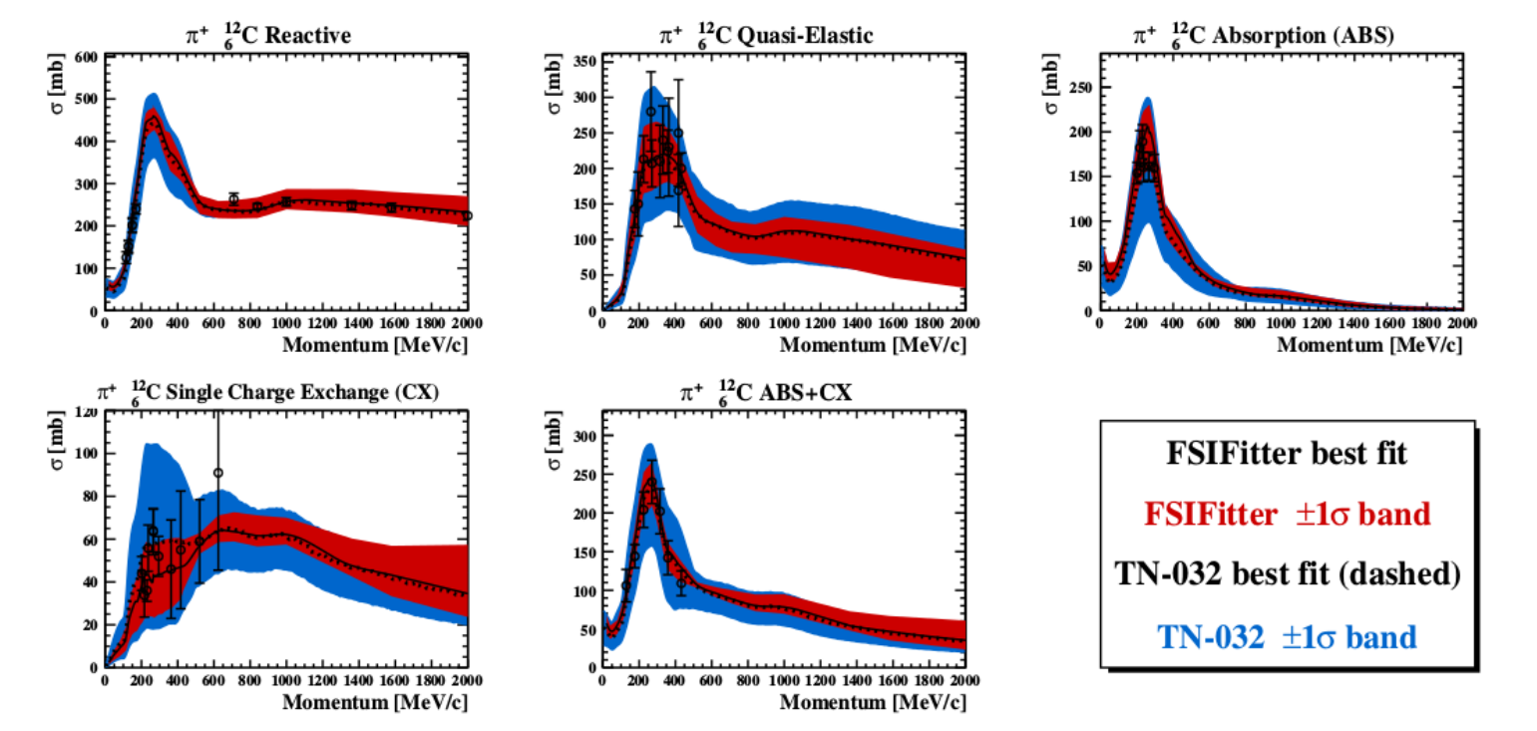
Figure 1: Results of the T2K tuning to external pion data. The different plots correspond to different pion-Carbon interaction modes. The blue error band is from a previous tune. The red is from an updated tune using newly available pion-Carbon scattering data.

Fermilab hosts a High Performance and Parallel Computing (HPC) department that I will use for performing the simulations and fits necessary for the tuning. These processes are computationally intensive, so having a stable and powerful computing resource such as the HPC will be crucial for this work.

Additionally, Fermilab is the site of the LArIAT experiment, as well as many of the scientists associated with the experiment. Performing this work at Fermilab will put me in close proximity with those scientists, and will give me the chance to learn firsthand about the experimental setup and uncertainties associated with LArIAT’s measurements. This will not only benefit my work on the tuning, but will inform my decisions in assigning uncertainties in a measurement at ProtoDUNE.

SAY SOMETHING ABOUT GEANT4 DEVELOPERS AT FERMILAB HERE

References
[1] A Ankowski, et. al. Missing energy and the measurement of the CP-violating phase in neutrino oscillations. Physical Review D, 92:091301, 2015.
[2] T Feusels, et. al. Tuning of the NEUT Cascade Model using π ± -A Scattering External Data to Improve Final State Interaction and Secondary Interaction Systematic Uncertainties. T2K-TN-325, 2017.

