**Instructions for Downloading a Ximera Certificate**

1. After you have completed a Ximera assignment, you will see a “Complete” page with a link to view your certificate, as shown below. Click on the link.  
     
   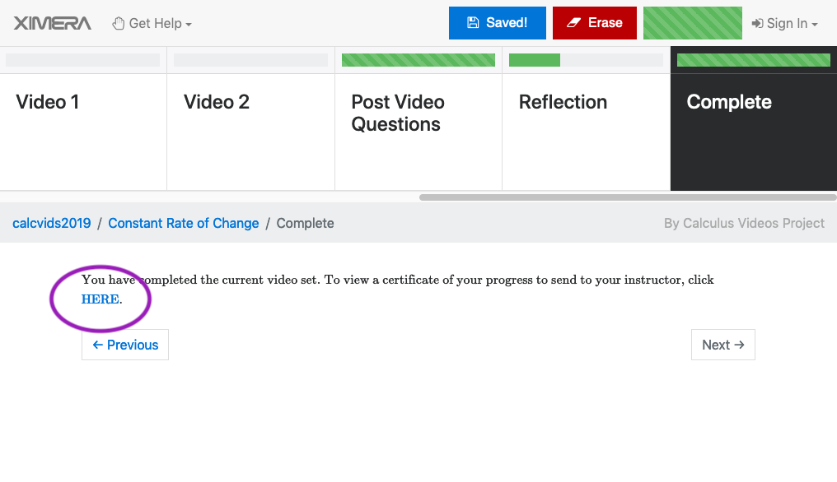
2. You’ll see your certificate displayed in your web browser; it will look something like this:  
     
   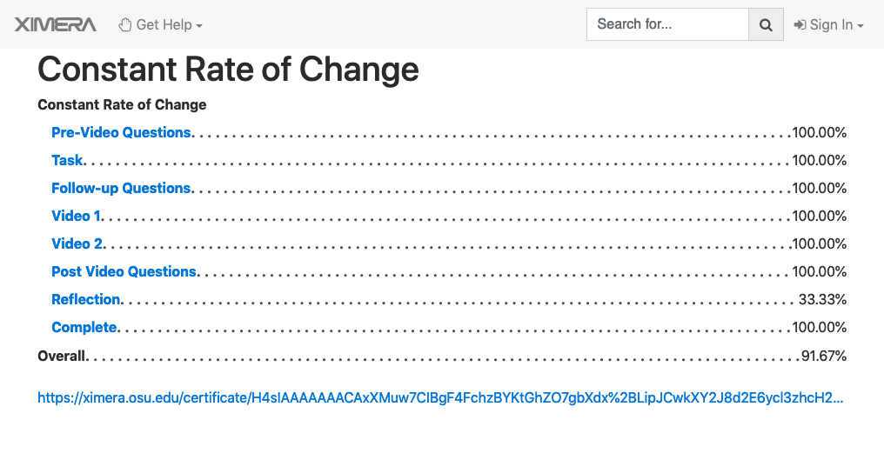
3. To download this certificate as a PDF file:
   1. Instructions for Google Chrome
      1. Click on the “File” menu and select “Print”  
         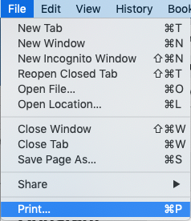
      2. In the window that appears, next to Destination select “Save as PDF”  
         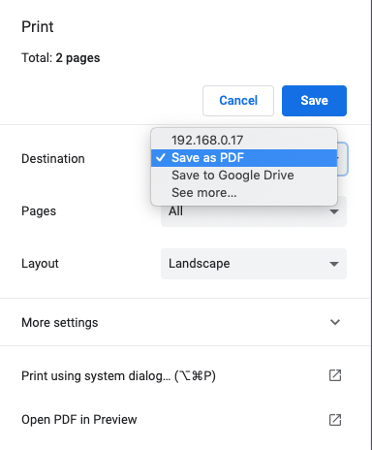
      3. Click “Save”
   2. Instructions for other browsers on a Macintosh computer:
      1. Click on the “File” menu and select “Print.” Alternatively you can hold down the command key and press “P”  
         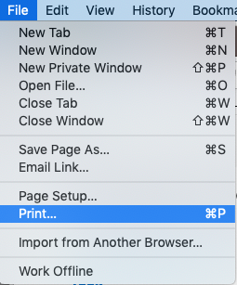
      2. Click on “PDF” and then “Save as PDF” as shown below  
         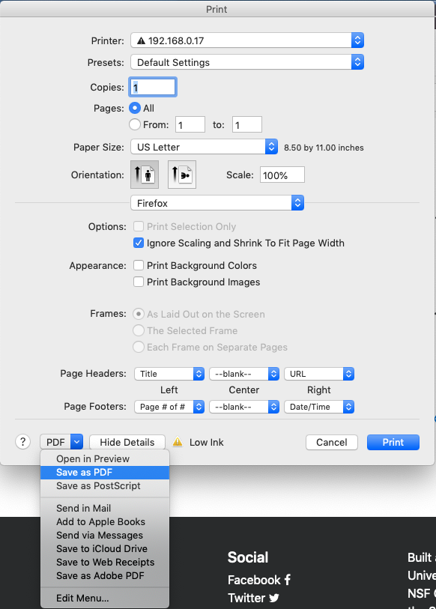
   3. Instructions for other browsers on Windows computers:
      1. Hold down the control key and press “P”
      2. In the dialog box that appears, select “Microsoft Print to PDF” and then click “Print”  
         