**Intellectual Need Task for The Extreme Value Theorem**

For each interval below, does the function (graphed below) attain a maximum and minimum value?

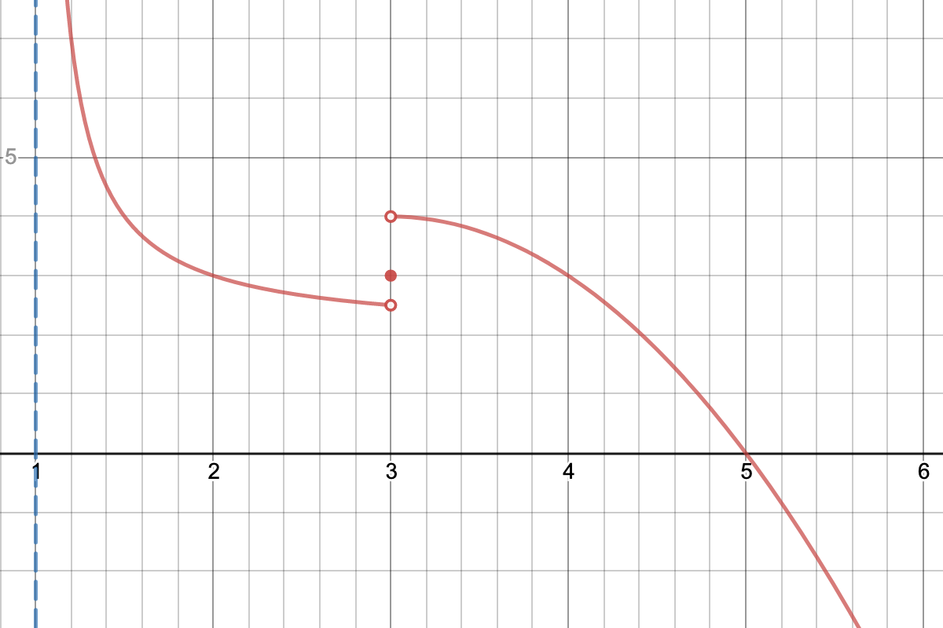

1. (1, 2.5)
2. [1.25, 2]
3. [1.25, 2)
4. [1.5, 3]
5. [2, 3.5]