**Intellectual Need Task for FTOC Part 2**

Below is a graph of the function $f\left(x\right)=e^{-x^{2}}$.

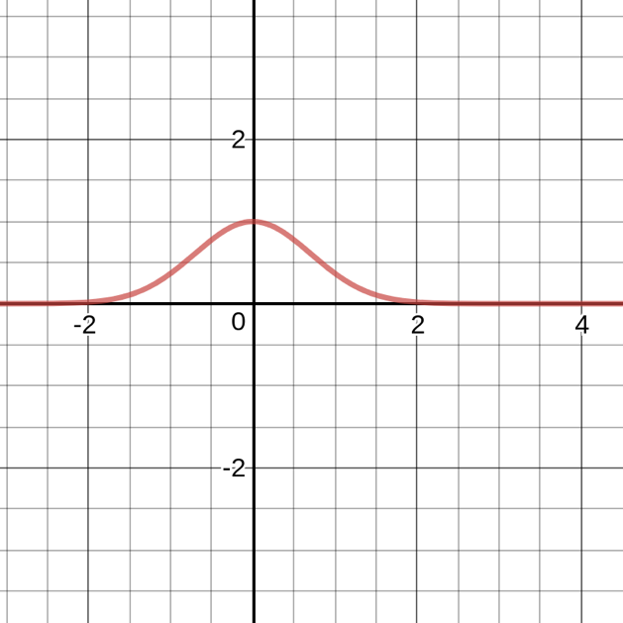

Determine an antiderivative to the function.