**Intellectual Need Task for Graphing Constant Rate of Change**

Below is a video of a cow (with a parachute) being launched from a cannon.

Graph the cow’s height off the ground as a function of total distance traveled.

* + 1. 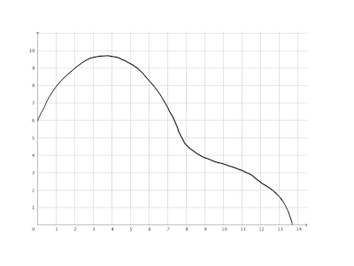
    2. 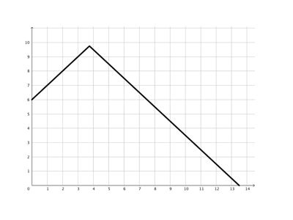
    3. 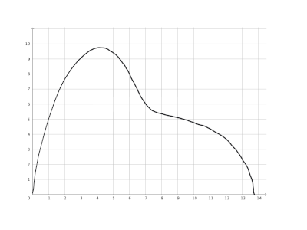
    4. 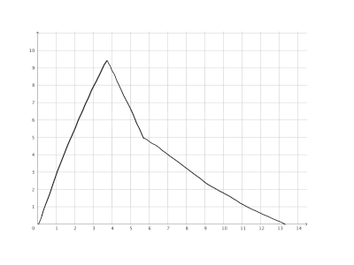
    5. 