**Intellectual Need Task for Implicit Differentiation**

Below is a graph of (x2+y2+1.2x)2=1.2(x2+y2)

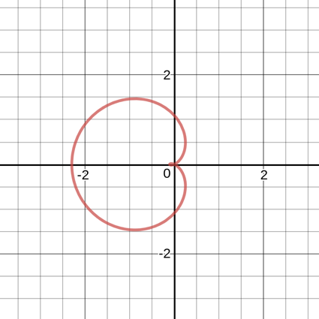

What is the slope of the tangent line to the curve at the point (0,1.2)?

1. -5/6
2. 0
3. -6/7
4. -1
5. -7/8