**Intellectual Need Task for Limit Definition of Derivative**

Vicki took 400 mg of Ibuprofen to relieve knee pain. The amount (mg) as a function of elapsed time (hours) is *f*(*t*)=400(0.71)*t*.

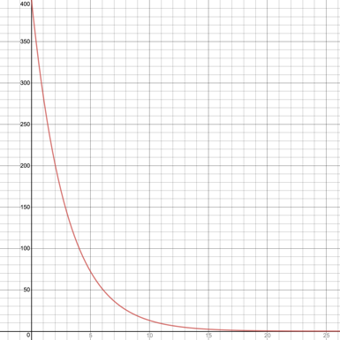

Approximate the rate of change of the amount of Ibuprofen in Vicki’s body with respect to the number of hours elapsed when *t*=4:

* + 1. -35 mg/hour
    2. -35 mg
    3. 100 mg/hour
    4. 100 mg
    5. 25 mg/hour
    6. 25 mg