**Intellectual Need Task for Slopes of Secants and Tangents**

Below is a graph of a function

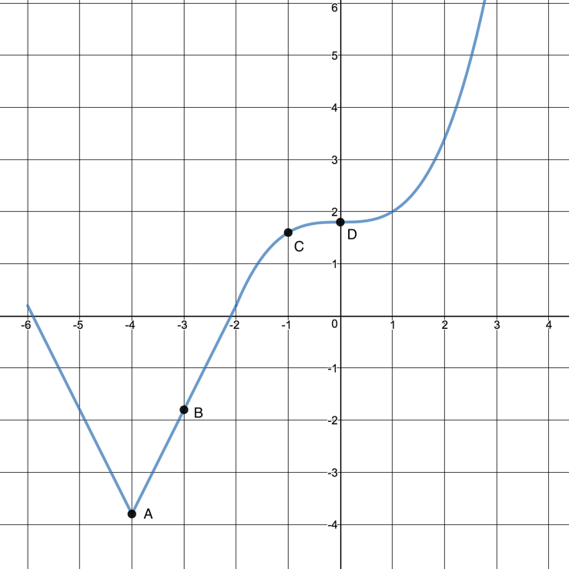

Which of the following shows the tangent line to the graph at point B?

* + 1. 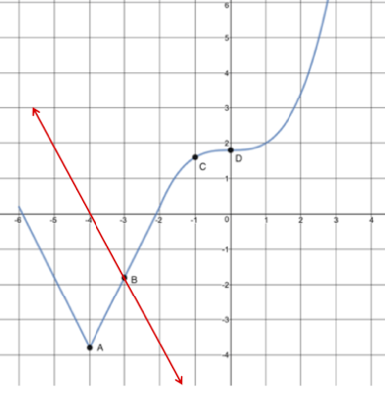
    2. 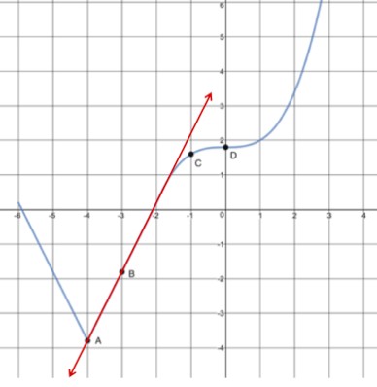
    3. The tangent line exists, but isn’t either of the previous options
    4. There is no tangent line to the graph at point B

What would tangent lines look like at points A, C, and D?