**Carolina Aldana Yabur**

* + Prompts Used: Record exact Copilot queries.
  + Responses Received: Summarize or paste relevant AI suggestions.
  + Implementation Details: Explain how AI-generated solutions were applied or modified.
  + Adjustments: If modifications were made, describe how and why.
* **Prompt Used:** What is the syntax of a HashSet?
* **Response Received:**

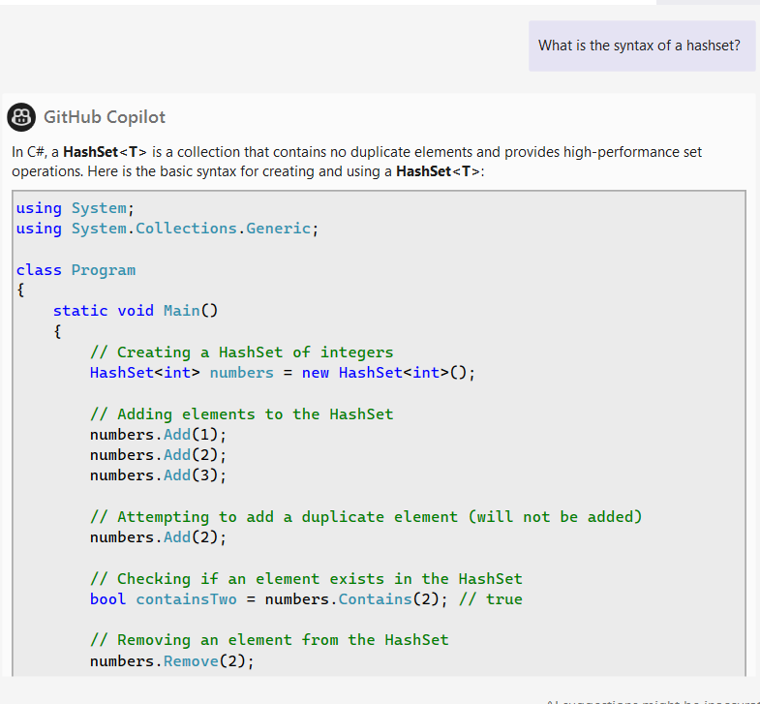

* **Implementation Details:** I used the response to apply the syntax of a HashSet to Question 1 (Missing Numbers) and Question 3 (TwoSum).
* **Adjustments:** I applied the syntax to question 1 and question 3 as:
* HashSet<int> numsHashset = new HashSet<int>(nums);
* HashSet<int> numsHashset = new HashSet<int>(nums);
* **Prompt Used:** How to define an array in C#
* **Response Received:**

* **Implementation Details:** I used the response to apply the syntax to question three (TwoSum), since I needed an array rather than a list.
* **Adjustments:** I applied the syntax to question 3 as:
* int[] twoSum = new int[] {};
* **Prompt Used:** Binary search syntax
* **Response Received:**

* **Implementation Details:** I used the response to apply the syntax to question 6 (Minimum in Rotated Sorted Array)
* **Adjustments:** I applied the syntax to question 6 as:

while (left < right)

{

// Calculate the middle index of the current range.

int mid = (left + right) / 2;