**SUPPLEMENTARY MATERIAL**

**Challenges in estimating species age from phylogenetic trees**

Carlos Calderón del Cid1,2, Torsten Hauffe2, Juan D. Carrillo2, Rachel C. M. Warnock3, Daniele Silvestro2,4

1Laboratório de Ecologia Espacial, Instituto de Biologia, Universidade Federal da Bahia, CEP 40170-110, Salvador, Bahia, Brasil

2Department of Biology, University of Fribourg, Switzerland and Swiss Institute of Bioinformatics, Fribourg, Switzerland

3Erlangen

4Department of Biological and Environmental Sciences and Gothenburg Global Biodiversity Centre, University of Gothenburg, Sweden

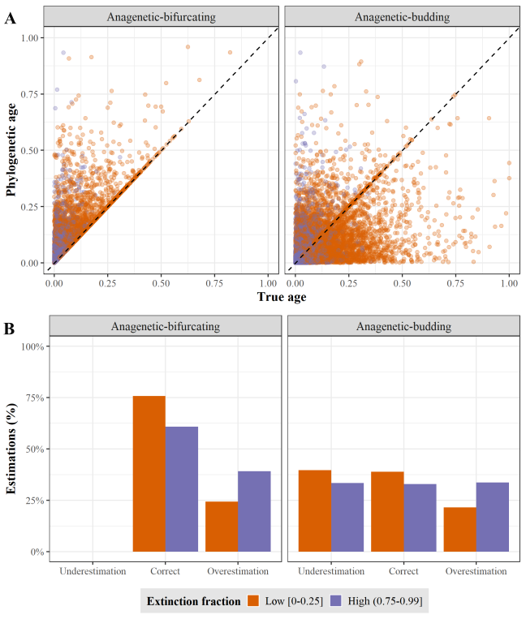

**Figure SM1. A)** True age versus phylogenetic age at low and high extinction fraction for Anagenetic-bifurcating and Anagenetic-budding speciation. Each point represents a species. True and phylogenetic ages are scaled to the root age of the correspondent phylogenetic tree. B) Percentage of underestimations, correct estimations, and overestimations at low and high extinction fraction for Anagenetic-bifurcating and Anagenetic-budding speciation.

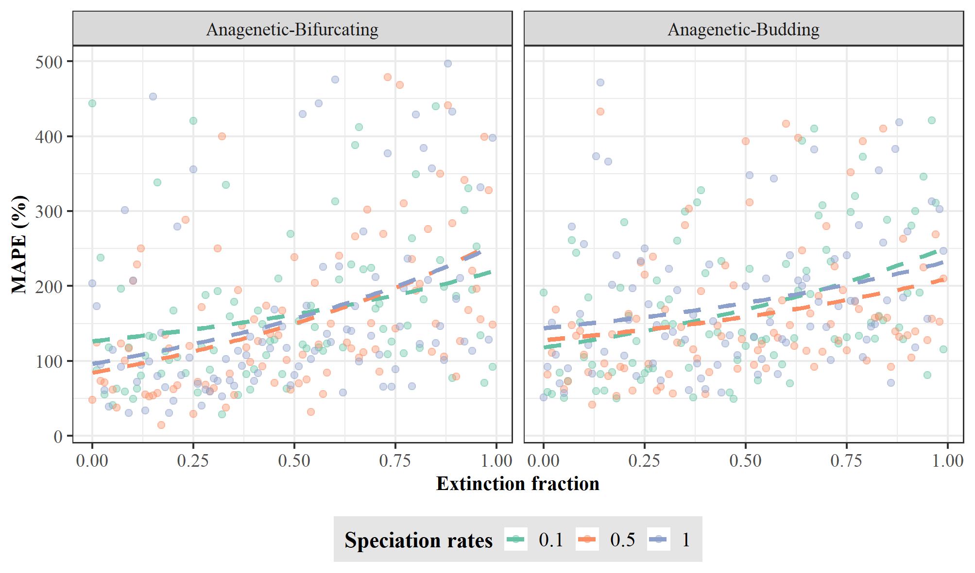

**Figure SM2.** Error in equating phylogenetic age with speciation age. The error was quantified as mean absolute percentage error (MAPE) between the true and phylogenetic ages across all species for each tree simulated under Anagenetic-bifurcating (left) and Anagenetic-budding speciation (right). Each dot represents one replicate of the 300 trees for each speciation mode using different rates of speciation and extinction fraction. The dashed lines represent, for each speciation rate, the MAPE trend along extinction fraction.

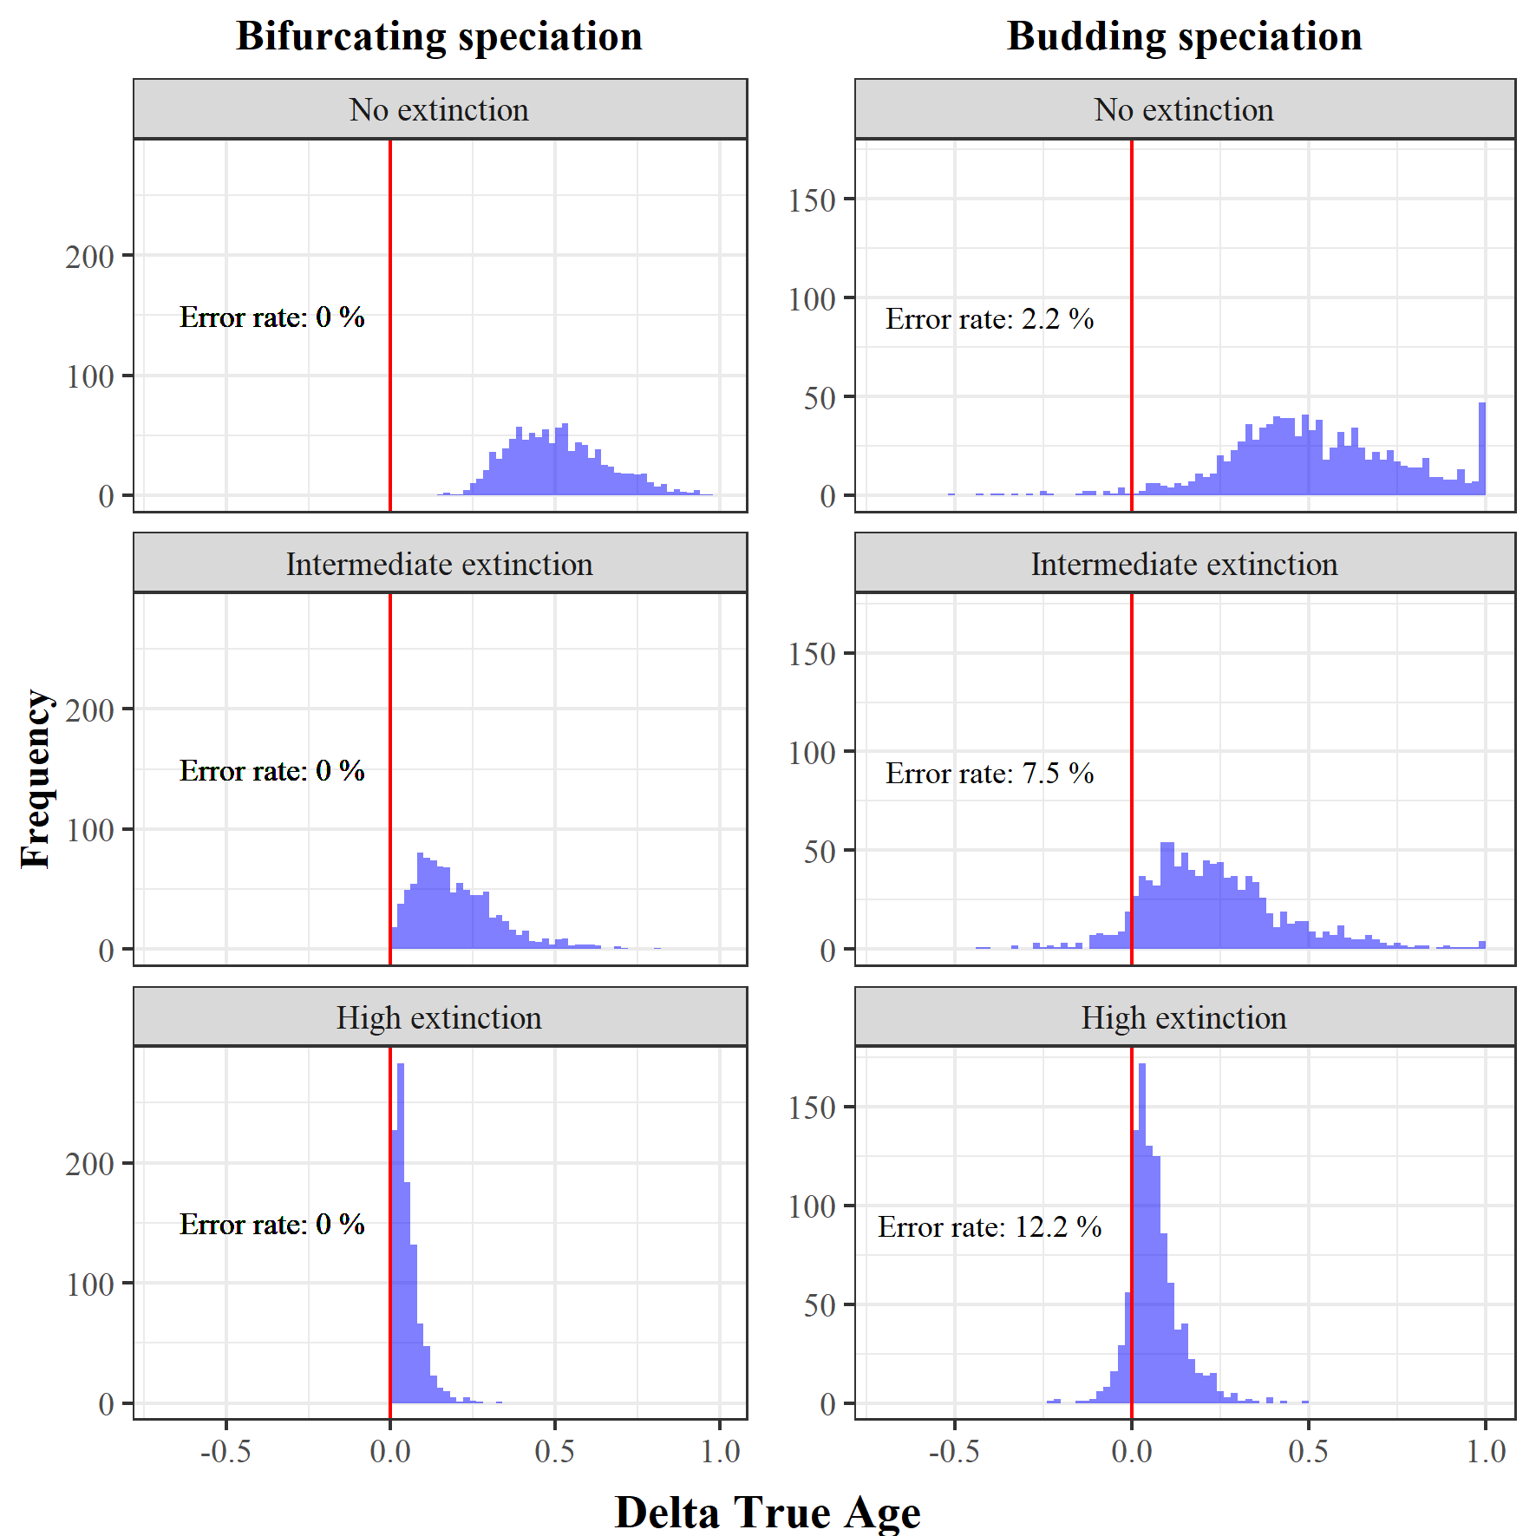

**Figure SM3.** Error in estimating the relative age of species. For each of the 1000 simulations under bifurcating (left) and budding (right) speciation, combined with three different extinction levels, we selected the oldest and youngest species according to the phylogenetic ages, and calculated the difference in their true ages (ΔTrue age). A ΔTrue age smaller than 0 indicates that the phylogenetic oldest species was estimated to be in fact younger than the phylogenetic youngest species, and therefore, the comparison of phylogenetic ages is qualitatively wrong.

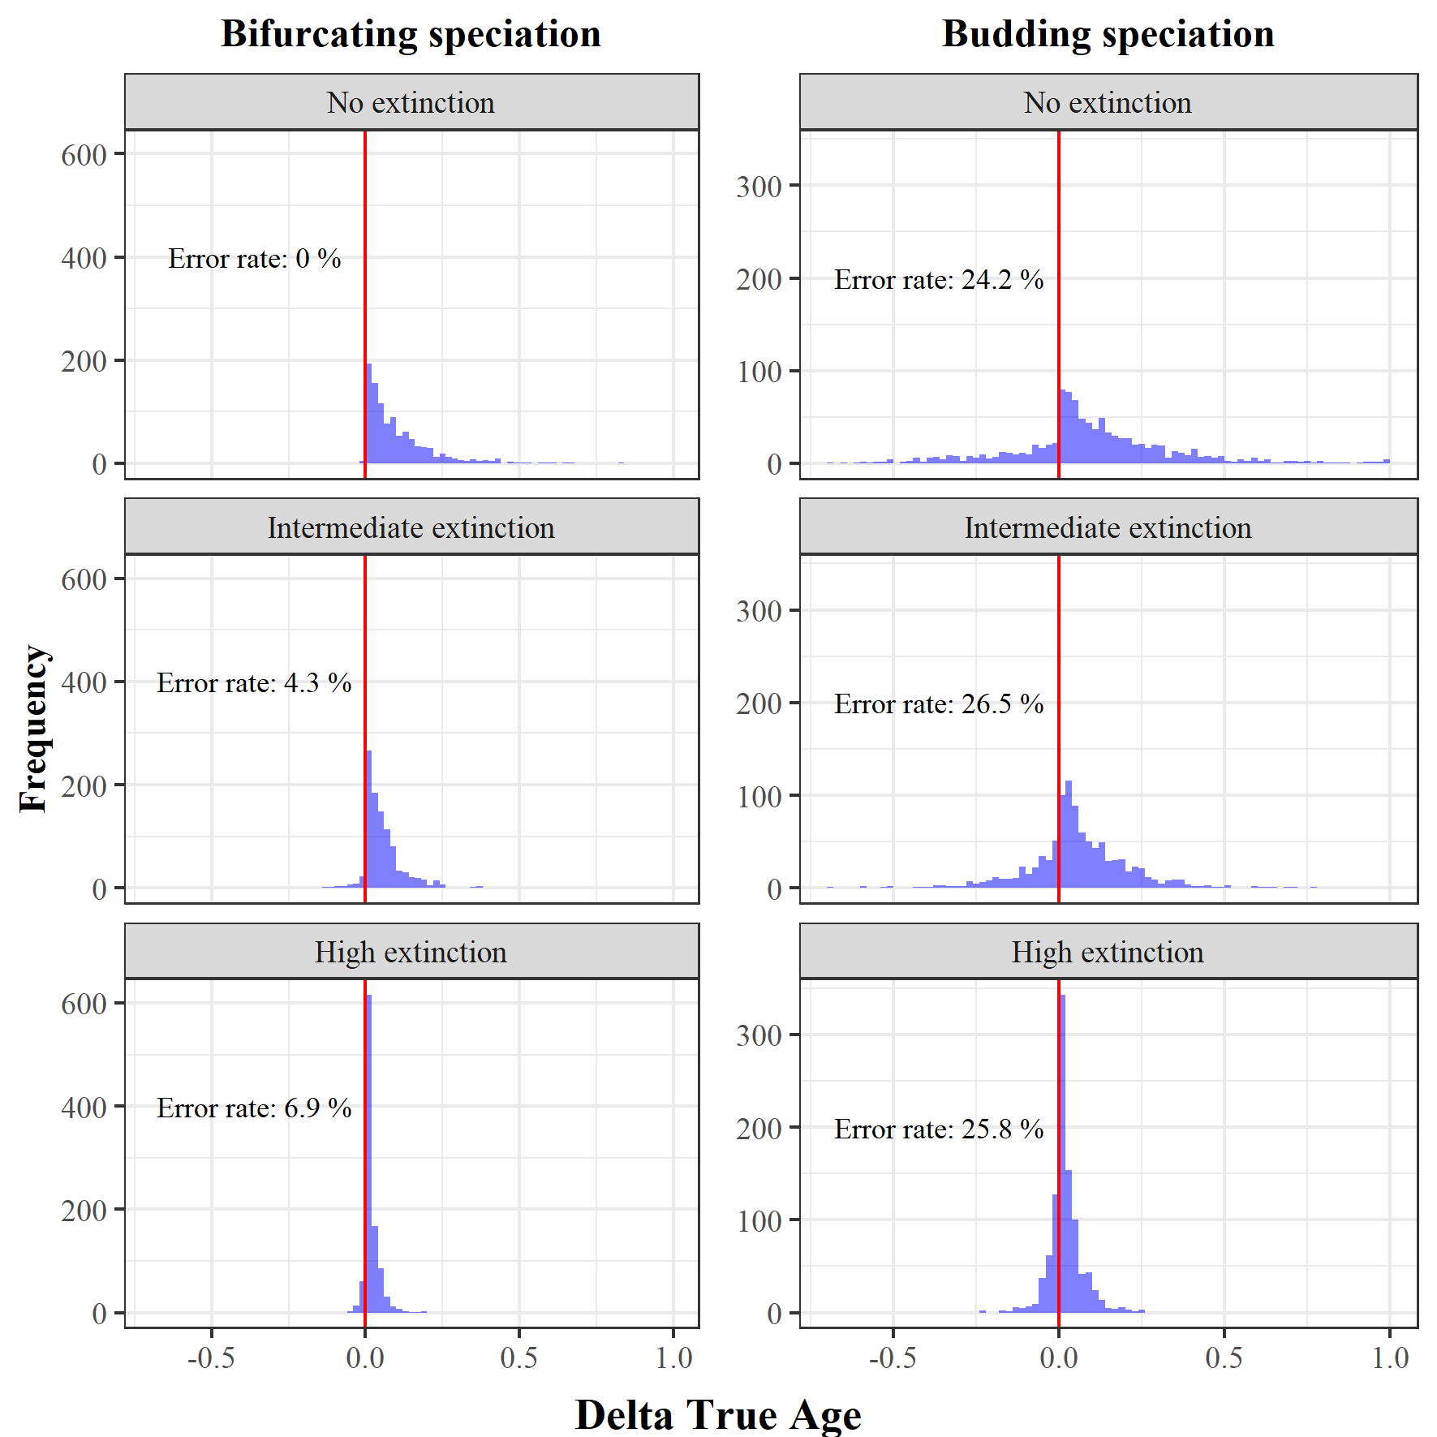

**Figure SM4.** Risk to confuse older with younger random species. For each of the 1000 simulations under bifurcating (left) and budding (right) speciation, combined with three different extinction levels, we selected two random species and defined which was the older and younger according to the phylogenetic ages, and calculated the difference in their true ages (ΔTrue age). A ΔTrue age smaller than 0 indicates that the phylogenetic older species was in fact younger than the phylogenetic younger species, and therefore, the comparison of phylogenetic ages is qualitatively wrong.

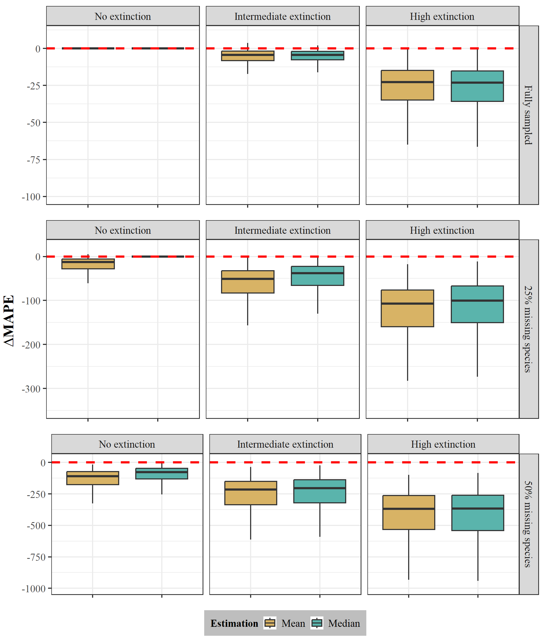

**Figure SM5**. Performance of the probabilistic age estimator. ΔMAPE for the three extinction scenarios (no extinction, intermediate, and high; from left to right) and the three sampling scenarios (full, 25%, and 50% missing species; from up to down) was quantified as the difference of the mean absolute percentage error (MAPE) of the probabilistic estimator point estimates (mean and median) and the MAPE of the phylogenetic age. The MAPE was quantified as the difference between the true and point estimates (mean and median) of phylogenetic ages for 100 species across 1000 trees for each extinction scenario simulated under bifurcating speciation. The red dashed line represents no difference between the compared MAPEs, negative ΔMAPE values indicate an improvement in the accuracy of the probabilistic estimator over the phylogenetic age. We note that for clarity, we used different scales for the Y-axis for each sampling fraction.

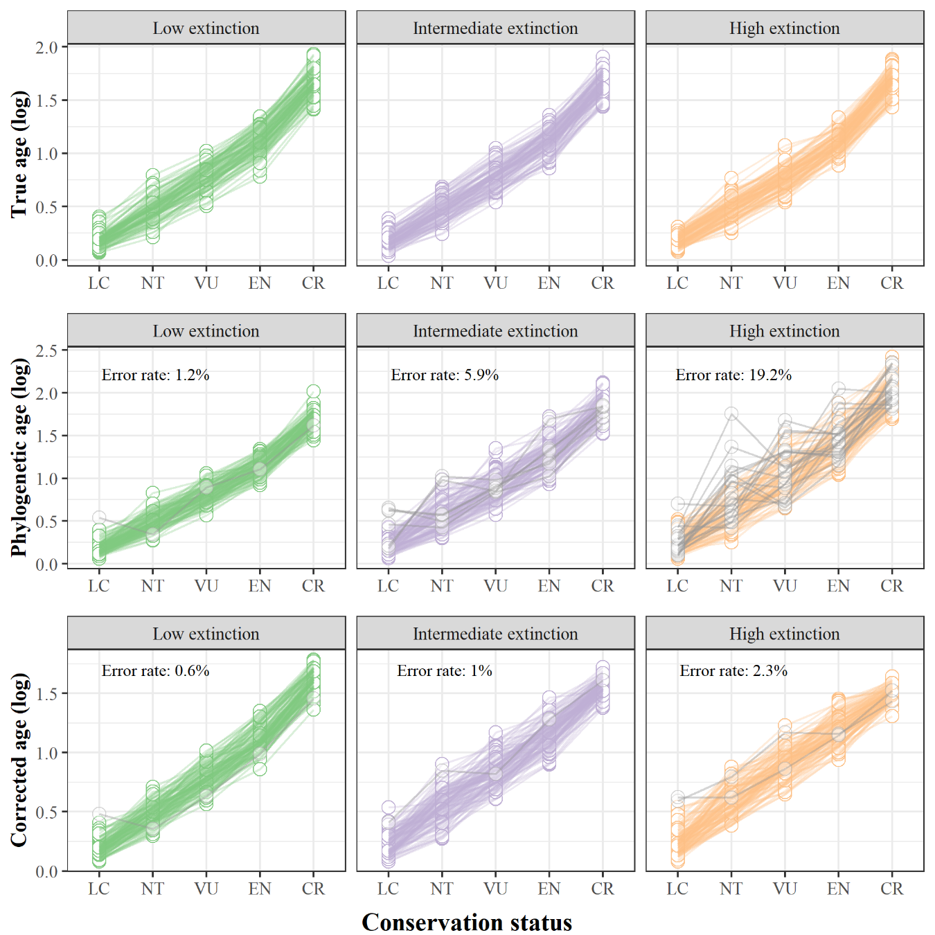

**Figure SM6.** Power to recover an age extinction-risk relationship. Simulated species ages under three extinction scenarios (low, intermediate, and high; from left to right), assuming bifurcating speciation, and fully sampled trees were binned into conservation status categories, which represent an increase in extinction risk by true age (LC = Least Concern; NT = Near Threatened; VU = Vulnerable; EN = Endangered; CR = Critically Endangered). We used the phylogenetic age and the corrected age obtained from our corrective function to calculated the mean age per conservation status category and assess if every mean age increases in comparison with the previous category with lower extinction rate. The error rate is the percentage across all 1000 phylogenies where the relationship between the mean ages and the conservation categories is not always increasing (shown by grey lines).