**DNA Clean-Up Using Solid Phase Reversible Immobilization (SPRI)**

**Introduction**

DNA would precipitate and bind to the surface of carboxyl coated magnetic particles when there is high concentration of polyethylene glycol (PEG) and salt. This process can be use to purify DNA (Hawkins et al., 1994). Agencourt’s AMPure XP purification system provides paramagnetic beads in optimized buffer to selectively bind DNA. The size of DNA retained is determined by the ratio of the AMPure XP beads solution to the sample. For example, when a 1.8-volume of beads added to 1-volume of sample, DNA larger than 100bp would be kept.

Instead of adding more or less beads, 20% PEG solution (see attached recipe) can be added to “dried” (using magnetic plate) beads and the sample to optimize size selection for retained DNA. The following experiments show the effect of adding different amount of PEG to the sample on the size of DNA retained (Fig. 1). For different batch of PEG and beads, the optimal conditions should be tested out empirically.

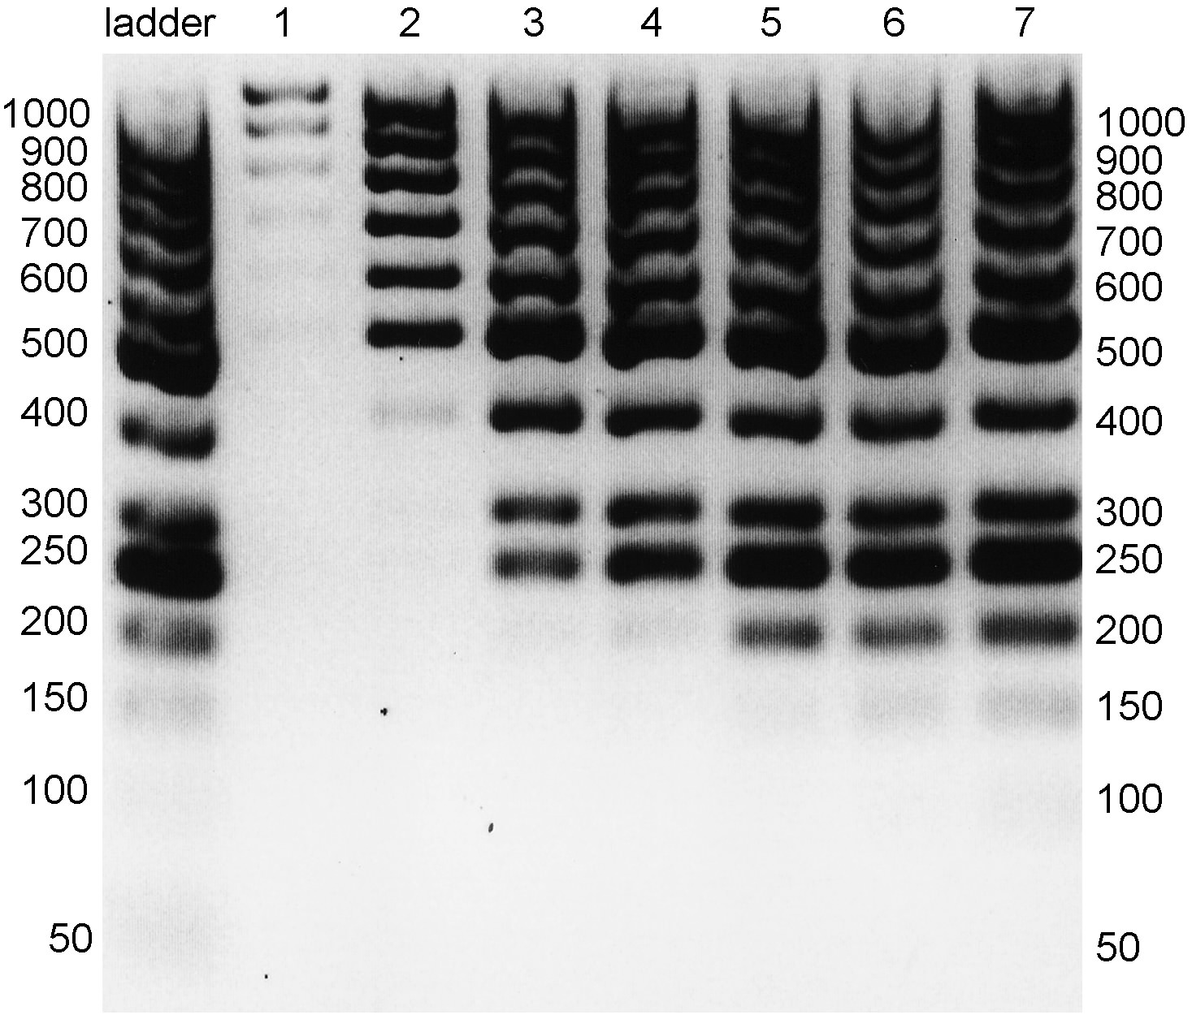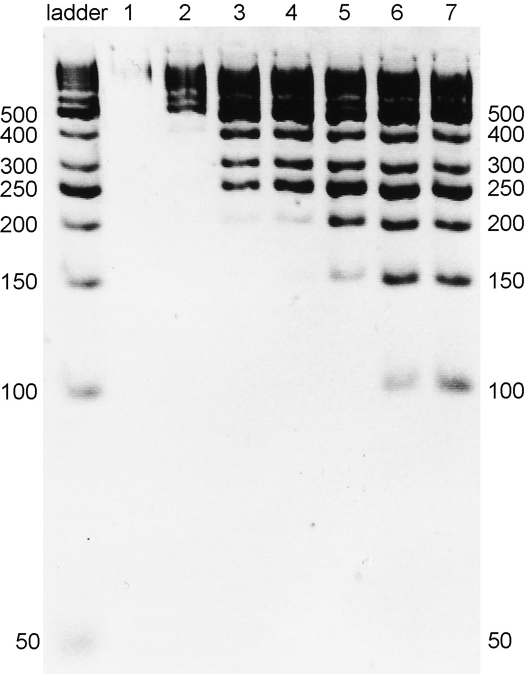

Fig.1. Agarose gels showing DNA ladder (GeneRuler 50 bp #SM0373) cleaned up with different amount of PEG added (lane descriptions are listed in table 1). Left – 2% agarose gel; right – 4% agarose gel.

Table 1. Description for each lane(道) with different amount of PEG added.

|  |  |  |  |  |  |  |  |
| --- | --- | --- | --- | --- | --- | --- | --- |
| Lane | 1 | 2 | 3 | 4 | 5 | 6 | 7 |
| Sample (μL) | 40 | 40 | 40 | 40 | 40 | 40 | 40 |
| 20% PEG (μL) | 15 | 20 | 25 | 30 | 40 | 80 | 120 |
| Conc. of PEG (%) | 5.45 | 6.6 | 7.69 | 8.6 | 10 | 13.3 | 15 |

**DNA clean-up procedure**

1. Resuspend the stock solution of SPRI bead (AMPure kit; product #: A63881). Always make an aliquot from the stock to avoid contaminating the whole stock. To make subsequent pipetting easier, add Tween 20 to the aliquot to a final concentration of 0.05% (i.e., add 1 μL of Tween 20 to 2 mL of bead suspension).

2. First add 50 μL beads in an empty tube, dry the beads using magnetic plate, then add the sample and PEG buffer to the dried beads. The amount of PEG added could be adjusted for preferred DNA size according to Fig. 1.

3. Seal the tubes with caps and vortex for several seconds. Repeat vortexing several times to ensure the beads are properly suspended.

4. Let the tube stand for 5-10 min at room temperature (more time needed when high concentration of PEG is used). Collect the liquid at the bottom of the tube by briefly centrifuging.

5. Place the tube on a 96-well ring magnetic plate, and let it stand for 5-10 min to separate the beads from the solution (more time needed when high concentration of PEG is used). Pipette off and discard the supernatant without removing the beads.

6. Leave the tube on the magnetic rack, and wash the beads by adding 186 μL of freshly prepared 70% ethanol. Let stand for 1 min and remove the supernatant. *Keep the tube on the magnetic rack, do not disturb the beads!!!

7. Repeat Step 6 one more time.

8. Remove residual traces of ethanol. Let the beads air-dry for 5 min at room temperature without caps.

9. Add 20 μL of nuclease free water or EBT to the wells and seal the tube with caps.Remove the tube from the magnetic rack, and resuspend the beads by repeated vortexing.Let it stand for 1 min, and then collect the liquid in the bottom of the wells by briefly centrifuging. Occasionally the beads may appear clumpy after vortexing; this does not have a negative effect on DNA recovery.

10. Place the tube back on the magnetic rack, let stand for 1 min, and transfer the supernatant to a new tube. Carry over of small amounts of beads will not inhibit subsequent reactions.

**Recipe for 100 ml PEG solution (20% PEG8000, 2.5 M NaCl)**

|  |  |
| --- | --- |
| Reagent | Amount |
| PEG8000 (cat #: Fisher BP233-1) | 20 g |
| NaCl | 14.6 g |
| H2O to 100 ml |  |

Note: After autoclaved or heated, two layers of liquid may form, but it would become homogeneous after cooled down.