Economics and Society Individual Coursework: the introduction of VAT and private school fees:
The introduction of VAT on private school fees represents a significant policy shift in the UK education system. From January 2025, private school tuition fees which were previously exempt from VAT, became subject to the standard VAT rate, increasing the cost of private education for families. The stated aim of the policy is to raise revenue to fund public schools and promote greater fairness within the education system, but it has generated substantial debate about its distribution, efficient and welfare effects.
PART 1:

- Prompt: Write a concise 300-word summary explaining the UK policy of applying VAT to private school fees. Describe the main changes introduced by the policy, the mechanisms through which it affects schools and households, and its costs and benefits. Use concepts from public economics such as tax incidence, elasticity, efficiency costs, and equity considerations. The summary should be accessible, analytical, and neutral in tone.
Output generated: The policy to apply Value Added Tax (VAT) to private school fees represents a significant shift in the taxation of education services in the UK. Previously, private school fees were exempt from VAT, meaning that schools did not charge VAT on tuition and were also unable to reclaim VAT on many of their input costs. Under the new policy, standard-rate VAT will be charged on fees, increasing the headline cost of private education and allowing schools to reclaim VAT on a range of goods and services used in teaching.

The main effect of the policy is an increase in the price of private schooling. The extent to which this cost is passed on to parents depends on demand elasticity: if parents are relatively insensitive to price changes, most of the VAT burden will fall on them; if they are more responsive, schools may absorb part of the cost through reduced margins or spending cuts. The policy also generates a substitution effect, as some families may switch from private to state schools, increasing enrolment pressure in the public sector.

In terms of costs, the policy may impose efficiency losses by distorting schooling choices and potentially lowering educational quality if schools reduce investment. There may also be fiscal costs for the government if the state system must accommodate additional pupils. However, the policy is expected to raise substantial revenue, contributing to public finances.

From an equity perspective, the VAT charge is broadly progressive, as private schooling is primarily consumed by higher-income households. The policy therefore shifts part of the tax burden toward wealthier families, enhancing vertical equity. Overall, the VAT reform involves trade-offs between revenue generation, potential efficiency costs, and distributional objectives.

- The AI generated output performs well in providing a clear and accessible explanation of the VAT reform on private school fees. It accurately outlines the core policy change: private school tuition fees becoming subject to VAT, alongside the ability of schools to reclaim VAT on inputs. This reflects strong factual grounding and helps clarify an often-misunderstood aspect of the reform. In particular, the distinction between the statutory VAT rate and the effective rate faced by schools is important for understanding the true price impact of the policy.

The output further demonstrates a good grasp of public economics concepts introduced in the course. It effectively incorporates ideas such as tax incidence and demand elasticity to explain how the burden of VAT is likely to be distributed between schools and families. In addition, it presents a balanced discussion of potential benefits such as revenue generation and improved equity and potential costs such as pressure on the state school system and efficiency losses. This balanced approach reflects analytical neutrality and avoids overt normative bias.

However, the output has several limitations. The most notable being its lack of empirical detail. It does not provide quantitative estimates of revenue raised, expected changes in pupil numbers, or explicit references to empirical sources such as the Institute for Fiscal Studies (IFS). While this may partly reflect constraints imposed by the prompt, the absence of evidence weakens the credibility of the analysis. In addition, the discussion of school responses is underdeveloped. Although it notes that schools may absorb some of the VAT burden, it fails to explore specific mechanisms such as cost- cutting, restructuring or reductions in bursary provision, which are central to a full application of tax incidence theory.

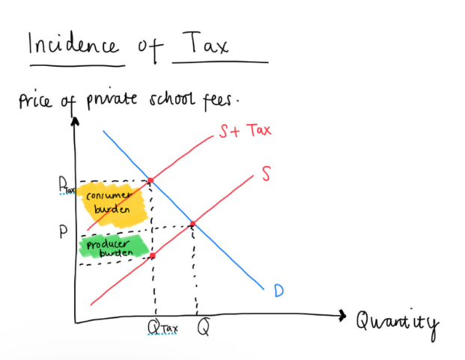
Finally, the output does not address policy implementation challenges, such as administrative costs, transitional arrangements, or timing, all of which are relevant when assessing real-world effectiveness.

Turning to the accuracy of specific claims, the output correctly states that VAT raises the headline price of private schooling while allowing schools to reclaim VAT on inputs. This is explicitly supported by the IFS, which notes that the reform results in an effective VAT rate of around 15% rather than the full 20% (IFS, p.3), with approximately £340 million reclaimable through input deductions (IFS, p.16).

The claim that demand for private schooling is inelastic in the short run and only moderately elastic over time is also well supported. The IFS finds that the short run effects are ‘extremely small’ and that the relationship between fees and demand is ‘quite weak’ (IFS, pp.3, 11), while estimating a 3-7% reduction in attendance over the longer term (IFS, p.26). This aligns closely with Lecture 9, which emphasises that private school attendance is shaped by deeper social and income-related factors rather than price alone (Lecture 9, slide 13 and 25).

Finally, the suggestion that schools may respond through cost reductions or lower investment is partially supported. The IFS notes that schools could absorb some of the VAT increase by reducing expenditure (IFS, p.18). While the output goes further by mentioning bursaries and investment, this is a reasonable extension of the argument, particularly given lecture 9’s discussion of private school advantages such as smaller class sizes and better facilities (slide 23), which could be affected by expenditure cuts.

Overall, while the output is conceptually sound and largely accurate, it would be significantly strengthened by greater empirical grounding, deeper analysis or supply side responses, and more explicit consideration of implementation issues.

- The introduction of VAT on private school fees represents a significant shift in how the UK tax system treats education services. Under the reform, private schools lose their long-standing VAT exemption and are required to charge VAT at the standard rate on tuition fees. While this clearly raises the headline price of private education, the Institute for Fiscal Studies (IFS) emphasises that schools will be able to reclaim VAT on their inputs, such as maintenance and supplies. As a result, the effective VAT rate is estimated to be closer to 15% rather than the full 20% (IFS, pp.3 and 16). This distinction is crucial for accurately assessing the true price impact faced by families.

The extent to which this VAT increase is passed on to parents depends on the economic incidence of the tax, which in turn determined by the elasticity of demand for private schooling. Consistent with standard tax incidence theory, the IFS finds that demand for private schooling is relatively inelastic in the short run, implying that most of the tax burden is likely to be borne by parents rather than absorbed by schools (IFS, pp.3 and 11). However, overtime behavioural responses are more likely. The IFS estimates a 3-7% reduction in private school attendance in the longer run (IFS, p.26), suggesting that some families may move their children into the state sector. Lecture 9 highlights that private schooling reduces pressure on state school resources (slide 14), implying that any migration back into the public system could increase fiscal and capacity pressures, particularly in already stretched areas.

In terms of equity, the policy is broadly progressive. Private school attendance is heavily concentrated among high-income households (IFS, p.3; Lecture 9 slide 25), so applying VAT effectively shifts part of the tax burden towards families with a greater ability to pay. However, this does not mean the policy is distributionally neutral. Families attending lower-fee independent schools, including some middle-income households, may be disproportionately affected, raising concerns about horizontal equity.

Overall, the VAT reform reflects a trade-off between revenue generation (estimated at £1.3 -1.5 billion per year (IFS, p.26)). This leads to potential costs arising from behavioural responses, increased pressure on state schools, and distribution, consequences. While the policy is well motivated on equity grounds, its effectiveness depends on how both families and schools adjust in practice.

Part 2 (40 marks)
1.

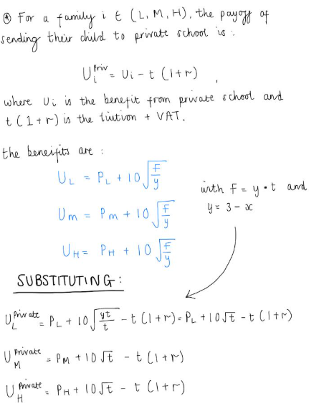
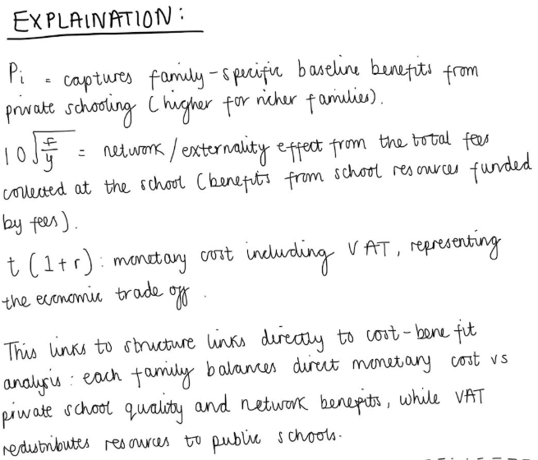

How these terms show to the policy trade-offs:
- Incidence / who pays: (1 + r) t directly reduces private payoff. Families with higher Pi tolerate higher net cost, therefore they may remain in private school while lower-P families switch. This models vertical distributional effects (VAT falls on consumers of private schooling, who tend to be richer).
- Behavioural responses / elasticity: change in r affect U^priv i and so the margin of switching between public and private. Since U^pub also depends on y (through T), there are feedback. A switch of public raises x changes public payoff per pupil, and changes VAT base.
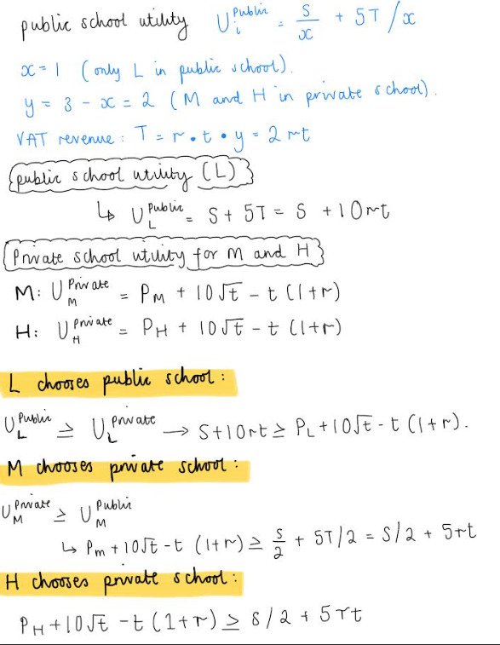
2.

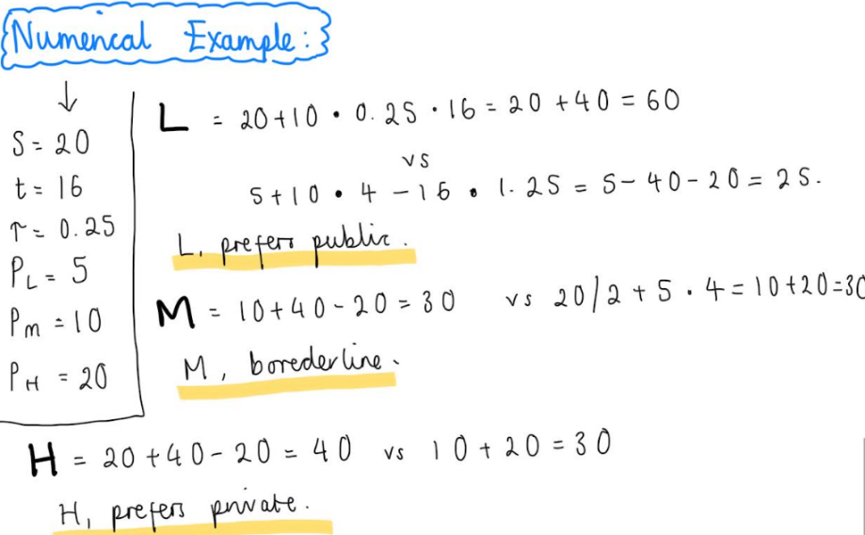

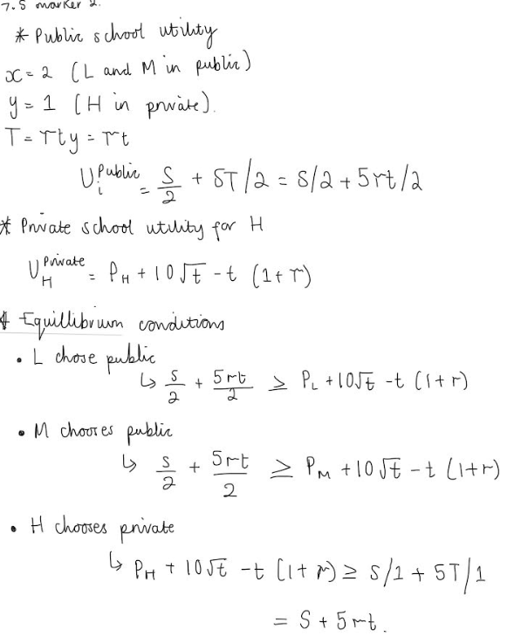

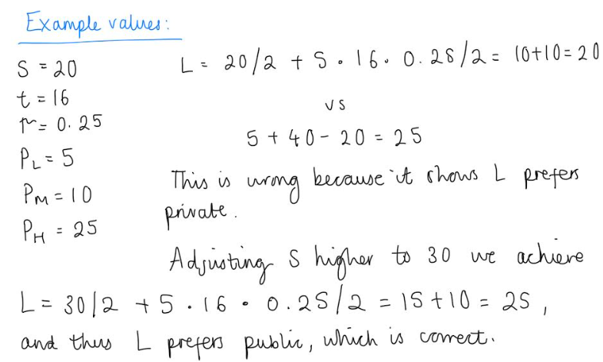

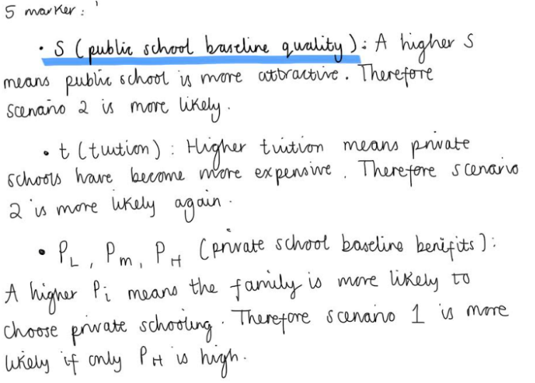

Therefore scenario 1 occurs when private benefits outweigh public utility. Scenario 2 occurs when public school utility is strong due to S or VAT.
5.

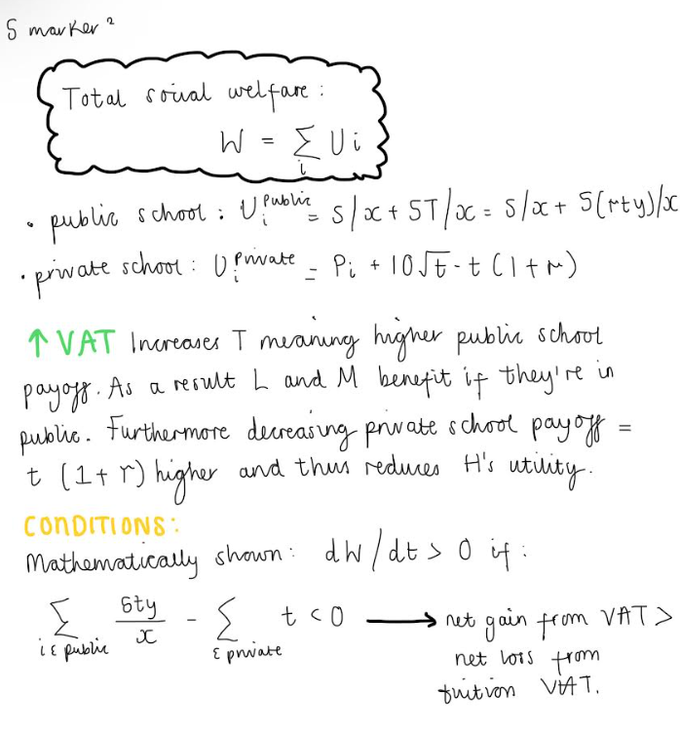
Increase in welfare: if families moving to public school gain more from extra T than loss for private school families → sum of utilities rises. When S small and y large, so redistribution improves equity.

Decrease in welfare: if VAT is too high → private school families lose more than public school families gain.

- The introduction of VAT on private school fees can be justified on efficiency, equity and redistribution grounds, bit its desirability depends on parameter valises such as the strength of public school benefits and families’ heterogenous valuation of private education.

The theoretical model highlights that VAT raises the cost of private schooling directly reducing the net utility of families who choose private schools. This effect is strongest for high income families, who are the most likely to remain in private education due to their higher baseline preference (P_H)). However, VAT revenue is transferred into public schools, improving public school quality through increased funding. This generate a positive fiscal externality for familied attending public school, especially when the number of public school students is small, since VAT funding is distributed amongst fewer children.

From a redistribution perspective, VAT on private schools is progressive. Higher- income families bear most of the tax burden, while low- and middle-income families benefit indirectly through improved public-school quality. This aligns with the lecture’s concepts od benefit-based taxation and vertical equity, as those with greater willingness to pay for private schooling contribute more to public provision. In scenario 2 of the model, VAT makes public schooling significantly attractive that both low- and middle-income families choose it, improving their welfare revenue to a no-VAT benchmark.

However, the model also shows that VAT is ambiguously welfare-improving. If private schooling generates large net benefits (higher Pi) or if VAT discourages private attendance excessively, total social welfare may fall due to efficiency losses. This reflects the classic equity-efficiency trade off studied in public economics. High VAT may distort educational choices away from privately optimal outcomes, especially if public schools are congested or poorly managed (low S).

Overall, VAT on private schools can be a good policy if public schools effectively translate additional funding into quality improvements. In such cases, Vat improves equity with limited efficiency costs. However, if public school quality is weak or private education delivers substantial social value, the policy risks reducing welfare despite achieving redistribution.

Part 3 (30 marks)

Theoretical predictions from the model:
VAT and private school attendance | When the VAT rate rise (r) private school attendance(y) decreases because the total cost of private schooling t(1+r) rises. This effect is stronger for low- and middle-income families (lower Pi) than for high income families.
VAT and public-school attendance | When the VAT rate (r) increases, public school attendance (x) increases, as higher VAT revenue (T) improves the payoff from public schooling. This effect is stronger when baseline public school quality (S) is sufficiently high.
Tuition fees and school choice | When private school tuition fees (t) increase, private school attendance (y) decreases and public school attendance (x) increases, because both tuition and VAT payments rise.
Public school quality and enrolment | When baseline public school quality (S) increases, public school attendance (x) increase sand private school attendance (y) decreases, holding other parameters constant)
Income related heterogeneity | When families baseline preference for private school Pi increases, the probability that they choose private school increases. Therefore, higher income families are less responsive to changes in VAT or tuition fees.
Conditional welfare effects of VAT | When VAT (r) increases, total social welfare increase only if the gains to public school students from higher funding exceed the utility losses of private school students from higher costs.

- Private School attendance (y)
How to measure:
- Number or proportion of pupils enrolled in private, including fee-paying / independent, schools in given regions or country. This would be best on a yearly basis to observe changes over time.
Data Sources:
- Department of Education (DfE): ‘Schools, pupils, and their characteristics’- this includes pupils counts by school type (state vs independent0 and characteristics (DfE Pupil Census Data England).
- Independent Schools Council (ISC) Census: detailed counts of independent school pupils and annual changes in enrolment.
Tuition Fees (t)
How to measure:
- Average annual private school tuition fees (before and after VAT), broken down, if possible, by region or school type (day vs boarding).
Data sources:
- ISC Census / Annual Report fees tables: This publishes the average fee for moment independent schools.
- BBC/ISC reporting on fee increases after VAT: news summaries of fees rising following Vat implementation (e.g., average termly fees).
Public School attendance (x):
How to measure:
- Number or share of pupils enrolled in state (publicly funded) schools; ideally sub-divide by local authority or region to capture geographical variation.
Data Sources:
- DfE national pupil census (state schools); cover all state-funded schools in England.
- England School Census dataset; contains attendance information for state school pupils.
Family income or socio-economic status (for heterogeneity):
How to measure:
- Indicators such as household income brackets or eligibility for free school meals (FSM) as a proxy for low vs middle bs high income.
Data source:
- DfE pupil characteristics data includes free school meal eligibility at the pupil level.
- For more detailed family income data, surveys like the Household Longitudinal Study
(Understanding Society) can be linked to education choices and are widely used in research.
Public school Quality (S)
How to measure:
- School performance metrics such as exam results, Osted ratings, progression results, or value-added scores.
Data Source:
- Ofsted inspection outcomes and performance tables: These figures are publicly reported for state schools on Ofsted of DfE. The data can function as a proxy for quality differences.
Social Welfare Outcomes (aggregate utility proxy)
How to measure:
- Changes in measurable welfare outcomes such as state school performance post VAT, changes in private school enrolment or distribution of school funding per pupil.
Data Source:
- DfE school funding data: ‘Finance and funding’ datasets that show per pupil allocations, which could proxy public school utility improvements.
- Combines with attendance data above, this can be used to infer net welfare changes.

- Prediction: When the VAT rate on private school fees increases, private school attendance decreases, with a stronger effect for lower-income families.
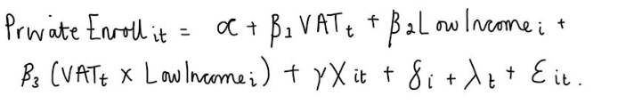

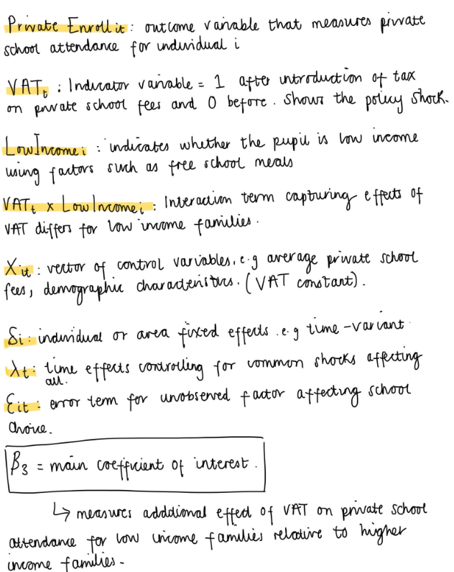

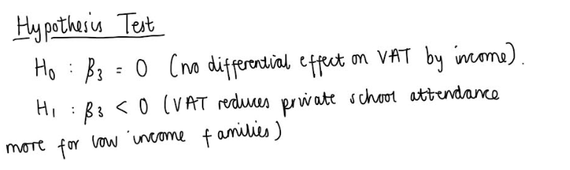
Rejecting the null hypothesis in favour of H1 would provide empirical support for the theoretical prediction that VAT disproportionately discourages private school attendance among lower-income households, consistent with the model’s mechanism.

- Endogeneity concerns and solutions: The proposed regression may have several endogeneity problems, which could lead to bias the estimated effect of VAT on private school attendance. These issues arise both from omitted variables from the behavioural mechanisms highlighted in the theoretical model.

Firstly, omitted variable bias is a key concern. In the models, the school choices depend not only on VAT but also on public school quality, baseline presences for private schooling and local education conditions. If these factors are correlated with VAT exposure and not fully controlled, the estimated VAT coefficient will be biased. For example, areas with higher0qualiry public schools may also be more politically supportive of redistributive policies such as VAT, leading to a negative relationship between VAT and private school attendance. A solution is to include individual or area fixed effects and time fixed effects, which control for time invariant observed preferences and common shocks. This solution is practical and widely used.

In addition, simultaneity and policy endogeneity may arise. The theoretical model shows that VAT revenue affects public school quality, which in turn affects school choice. If public school quality responds to changes in private school attendance, the direction of causality becomes unclear. In this case VAT is not strictly exogenous it may be introduced in response to perceived inequality or declining public school quality. A solution for this is to use a difference-in-difference design (DiD). This would mean treating the VAT introduction as an exogenous policy shock. This approach relies on the parallel trend assumption, which can be evaluated using pre-reform data. In practice, this is feasible if the reform is implemented nationally at a clearly defined point in time.

Furthermore, selection bias may arise because families with stronger preferences for private education (high Pi) are less responsive to VAT. If these preferences are unobserved, estimated effects may conflate true price sensitivity with selection on unobservable. An instrumental variables (IV) approach, using exogenous variation such as pre reform private school fee levels interacted with VAT, which could address this. Although finding a valid instrument in practice may be challenging.

Overall, while endogeneity concerns are significant, the combination of fixed effects, difference-in-difference, and robustness checks make it possible to credibility evaluate the models’ predictions, provided high quality data is available.

Part 4 (15 marks)
- The theoretical model from part 2 clarifies the economic incentives behind imposing VAT on private school fees and provides the fundamental framework for evaluating the core arguments surfaced in the YouTube videos. One video illustrates critics calling the VAT a ‘jealousy tax’ (a levy aimed at reducing privilege by making private education more costly and redistribution revenue to public schooling. The other video highlights warnings that VAT could be ‘leading to more closures and more hardship’ for families and smaller schools. In effect, these positions reflect distributional and efficiency concerns that only partly captured in the model.

In the model, increasing VAT raises the cost of private schooling and thus reduces private school attendance, while increasing public school funding. This leads to a potential rise in public school attendance when baseline public school quality is sufficiently high. This captures the basic redistribution arguments; Vat can transfer resources for high-income private families to improve public education, aligning with the ‘fairness’ narrative in the videos. The emphasis on preferences for public vs private schooling, modelled through different baseline benefits, also helps explain why some families (middle, lower income) might benefit more from VAT-funded strengthening of public schools.

However, the videos raise additional points not included in the model. First, critics argue that VAT could disproportionately harm families of children with special educational need (SEN) whose needs are inadequately met in the state sector, potentially forcing them out to suitable private provision. This is not modelled, as all children currently dace the same public school payoff regardless of education need. Second, there is concern about school closures and long-term impacts on school choice, especially for smaller private schools with tighter budgets. Finally, the ‘jealousy tax’ framing suggest social and political motivations beyond pyre utility trade-offs, highlighting notions of fairness and resentment that are outside the model’s purely economic payoffs.

To incorporate these arguments, the model would need extensions. First being heterogenous education needs. Introducing additional dimensions of utility that reflects differential access to state schooling for SEN children. This could be modelled by assigning higher disutility for SEN families if public school quality is not sufficient, or by adding a specialised service utility. In addition, school viability and market structure can extend the model. By including private schools’ financial constraints, where VAT affects not only family choices but also schools’ costs and survival probabilities. This could introduce a dynamic element where school closures feed back into available choices ad long run welfare. And finally, behavioural preferences and fairness. By incorporating a social utility component representing beliefs about fairness or social status. This would allow analysis of political support for VAT not just as an economic decision, but as a social preference reflecting inequality aversion.

By linking the theoretical model with empirical evidence and nuanced public arguments, we gain a richer understanding of both the mechanic and the political economy underlying he VAT policy debate.

References:
https://www.gov.uk/government/statistics/schools-pupils-and-their-characteristics-january-2025
https://www.isc.co.uk/media/0u0llqvv/_isc_census_2025_29may25.pdf
https://www.nboa.org/net-assets/news/view/u.k.-private-school-fees-up-22
https://financial-benchmarking-and-insights-tool.education.gov.uk/data-sources
https://www.tax.org.uk/tax-treatment-of-private-schools-an-explainer
https://news.sky.com/story/vat-on-private-school-fees-has-had-damaging-effect-on-children-court-hears-13339764

