FORM - 2
THE PATENTS ACT, 1970
(39 OF1970)
&
THE PATENTS RULES, 2003
COMPLETE SPECIFICATION
(See Section 10 & rule 13)
1. TITLE OF THE INVENTION:
AI BASED CODING SUPPORT SYSTEM FOR DIFFERENTLY-ABLED PEOPLE
2. APPLICANTS:

NAME: NAME: Dr. Mahalingam College of Engineering and
Technology

NATIONALITY: Indian Educational Institute

ADDRESS: Makkinaickenpatti Post, Udumalai Road,
Pollachi,Coimbatore, Tamil Nadu – 642 003
3. PREAMBLE TO THE DESCRIPTION:

The following specification particularly describes the invention and the manner in which it is to be performed.

AI BASED CODING SUPPORT SYSTEM FOR DIFFERENTLY-ABLED PEOPLE
FIELD OF INVENTION
This invention is associated with artificial intelligence and software engineering, particularly in the development of assistive technologies that improve accessibility in human–computer interaction.
BACKGROUND OF THE INVENTION
The existing development tools and development environments are mainly dependent on keyboard and mouse interaction for writing, editing, and browsing source code. These tools, though efficient and effective for able-bodied people, act as major barriers for differently-abled people, especially those with physical, motor, or vision-impaired abilities, and those with or temporarily afflicted with RSI injuries or other disabilities.
There are several assistive technologies, ranging from screen readers to simple speech-to-text tools, which have been developed to serve this purpose. However, such tools have been designed to perform general text dictation and do not have any knowledge of programming syntax, program logic, or relationships of code. For this reason, they are not very efficient tools to carry out complicated programming tasks such as program debugging.
Highly advanced coding assistants based on AI have also been developed with functions such as code suggestion and completion. However, such systems mainly benefit from text-based interfaces and involve more precise manual human intervention. Finally, uncontrolled generative AI systems can also generate unintended and possibly unsafe coding changes, thus raising issues regarding reliability, security, and maintainability.
Consequently, there is a requirement of an intelligent speech-enabled coding assistant system, which requires the integration of artificial intelligence and controlled code manipulation to deliver safe and efficient coding assistance to the differently abled community.
SUMMARY OF INVENTION
The instant invention aims to solve the problems of accessibility and usability in software development tools by employing an AI-driven voice assistance coding system in an integrated software development environment. This invention allows programmers to write software applications without the need to manually type, as they can speak in natural language, which will be translated into text and processed by AI for coding.
In contrast to existing speech-to-text systems or unconstrained generative coding assistants, the proposed system makes use of controlled code transformation patterns to provide predictable and safe code generation/modification. The code generation/modification tool makes use of the code editor context information, which includes the active language, cursor position, and code selection status.
The importance of this invention is in its functionality of reducing unreliability and lack of confidence in code development deployment as it inhibits unintended code modification development, in addition to increasing accessibility for differently abled persons. The system can work in academia and professional DevOps for software development.

BRIEF DESCRIPTION OF THE ACCOMPANYING DRAWINGS
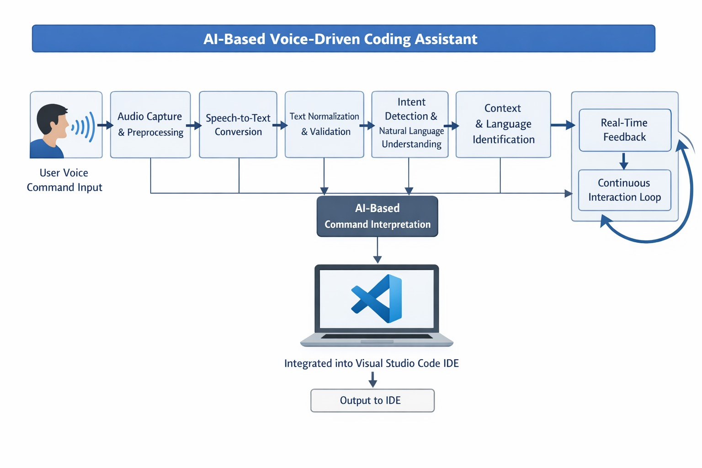
Figure 1 diagram showing the design of the voice-controlled coding assistant that uses AI, and it is coupled with the Visual Studio Code development environment. This includes the audio input interface, speech-to-text processing module, intent processing and natural language understanding module, command processing by AI, integration by understanding, and controlled execution of coding actions.
DETAILED DESCRIPTION OF THE INVENTION:
The current invention consists of an AI-powered voice-assisted coding assistant designed to function as an extension within the integrated development environment, for example, Visual Studio Code. The invention is developed with the purpose of ensuring safe, controlled, and predictable manipulation of the code while facilitating hands-free and accessible software development. The invention, as shown in Figure 1, consists of the voice input module, the speech-to-text processing module, the artificial intelligence-powered intent analysis module, the context analysis module, and the controlled code engine.
In a representative embodiment, a user engages in interaction by giving a voice command through a microphone interface. The voice input module receives the audio signal and conducts necessary preprocessing steps like removing noise and handling silence in the received audio signal and sends it to a speech-to-text processing unit. The speech-to-text processing unit translates the audio input received into a text format accurately conveying the user’s voice command.
The converted textual command is then supplied to the intent interpretation module. This module uses artificial intelligence as well as natural language processing concepts in determining the semantics associated with the command. The command is accordingly classified into a set of predetermined categories meant for code generation, code change, intended navigation, as well as code execution. The module is distinct in the manner that it does not only focus on generative coding models. The module is deterministic in nature. It generates concrete commands within a predetermined format. This is aimed at ensuring predictability in the functioning of the system.
The system also comprises a context analysis part that acquires real-time information from the integrated development environment. Information includes but is not limited to the current programming language being executed, the cursor location, file scope, and code selection status. The acquired context information is fused with the analyzed intent to get the correct programming action. Awareness of the context avoids the insertion of wrong code in programming, decreases logical errors, and ensures a correct operation irrespective of the development context.
Owing to the inferred intention and contextual inputs, the controlled code generation engine carries out the insertion or modification of code according to templates and transformation algorithms. For instance, if there is an inferred intention of function creation, it generates a semantically valid function structure according to the current programming language. If an inferred intention of modification is traced, it involves deterministic transformation of valid code segments present in the existing code. The controlled process does not allow any dangerous or unintended modification while supporting intelligent assistance at par with high-end tools.
Finally, the generated code or response will then be sent back to the integrated development environment and implemented in the due location. This system will offer real-time feedback to the user in terms of visual or audio signals for successful execution or in case of errors and constraints to the user. Other safety measures such as error validation checks, timeout features, and techniques of graceful degradation are implemented in this system in order to ensure stability and reliability in this system. This embodiment will enhance functionalities to differently abled users.

Claims
We claim the following:
1. An artificial intelligence-driven, voice-activated coding assistant system, comprising: a voice input module designed to receive and process spoken commands from a user; a speech-to-text processing unit that translates the spoken commands into textual formats; an intent interpretation module to analyze the textual representations for determining predefined programming intents; a context-analysis component configured to fetch contextual data from an integrated development environment; and a controlled code generation engine executing deterministic code generation or modification actions inside the integrated development environment, based on the identified intent and contextual information.
2. The system of claim 1, wherein the speech-to-text processing unit transforms spoken commands to normalized textual data for further semanticanalysis.
3. The system, according to claim 1, wherein the intent interpretation module classifies text commands into predefined intent categories of code creation, code modification, navigation, and code execution;
4. The system of claim 1, wherein code is inserted or modified only upon receipt and verification of the user's intent and context.
5. The system of claim 1, further including the system being in a position to give real-time feedback to the user on whether the issued commands were executed successfully, resulted in an error, or had limitations.
6. The system specified in claim 1, restricting it to a limited output of unrestricted generative code to assure predictable, safe, and controlled code manipulation.
7. The system as described in claim 1, whereby the user intention and editor context checks are performed prior to executing any code changes.
8. The system as described in claim 1, wherein the system provides real-time feedback information on the execution of the instructions successfully, incorrectly, and with limitations.
9. The system as described in claim 1, which is established to facilitate software development and specifically designed for easy accessibility by physically and motor impaired users.
ABSTRACT
AI BASED CODING SUPPORT SYSTEM FOR DIFFERENTLY-ABLED PEOPLE
The subject of the present invention is an artificial intelligence-powered and voice-controlled coding assistant system, intended to be interfaced inside an integrated development environment (IDE) to provide accessible and controlled software development. Conventional programming assistance tools, requiring keyboard and mouse operations, have been found to be a major problem to the differently-abled population. The voice-controlled system assists in programming tasks by understanding voice instructions and interpreting them in a textual form through a voice or speech-to-text processing module. An intention module then identifies the textual instructions and determines predefined actions in programming. In addition, context details, including details about the programming language and cursor position, obtained from the integrated development environment, are used to provide accurate and predictable handling of programs. A controlled code generating module finally uses predefined templates and rules to eliminate any chances of risky manipulations in programs.

