UNIVERSITI MALAYSIA SARAWAK
Faculty of Computer Science and Information Technology
TMA3084 Software Engineering Laboratory | Semester 1, 2026/2027
PROJECT PROPOSAL
(Product Requirements Document)
THE MINUM’S MANAGEMENT SYSTEM (TMS)
Group Number / Name | Group 04 – MegaMind
Lab Group / Demonstrator | Group 1 – Mr. MD. Aminul Islam Rakib
Client / Organisation | Petrus Anak Jinai, CEO, THE MINUM’S
Lecturer | Ts. Nurfauza Jali
GitHub Repository | https://github.com/caleb-144/Software-Engineering-Lab.git
Version / Date | v1.0 (original)
Team Members
No. | Name | Matric No. | TSPi Role | Signature
 | Caleb Budi anak Christopher | 102483 | Software Project Manager (PM) | 
 | Reynoldson Ganing anak Alfred Jabu | 102936 | Backend & AI Integration Specialist | 
 | Muhammad Fahdil bin Suliadi | 102733 | Lead Mobile Architect (UI/UX) | 
 | Joeshua Rangga anak Joseph | 102632 | Lead Systems Analyst & Requirements Engineer | 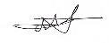
 | Matthias Lemada Anak Peter | 102673 | Quality Assurance & CI/CD Engineer
Declaration
By signing above, we certify that this proposal is our own work, that all external sources, libraries, APIs and AI-assisted content are acknowledged, and that we have not engaged in plagiarism or unauthorised collusion (Peraturan Akademik UNIMAS, Etika Akademik). AI tool usage is recorded in LOGAI.

Table of Contents
Abstract 1
1. Introduction 1
1.1 Client Background 2
1.2 Team Background 3
2. Problem Statement 3
3. Project Objectives & Success Metrics 4
4. Project Perspective 5
4.1 Target Users 5
4.2 System Context and Architecture 6
5. Project Scope 7
5.1 In Scope / Out of Scope 7
5.2 Features and User Stories 7
5.3 A.I Feature 8
5.4 Non-Functional Requirements and Constraints 8
5.5 System Environment 9
6. Task Allocation & Team Contribution 9
7. Team Goals 10
8. Expected Results 11
8.1 Working System 11
8.2 Documentation and Artefacts 11
9. Project Planning 12
9.1 Methodology 12
9.2 Submission Schedule 12
9.3 Development Milestones (GitHub) 13
9.4 Risks and Assumptions 14
10. References 15
Appendix A: Client Meeting Evidence 15
Appendix B: Revision History 16

Abstract
THE MINUM’S seeks to improve its ordering process and daily operations through the adoption of a digital ordering and inventory management system. The current reliance on traditional face-to-face ordering may lead to communication errors, inefficient order coordination, and additional manual workload for workers. Furthermore, the absence of a centralised digital system may make it challenging to maintain accurate inventory records and monitor product availability. To address these challenges, this project proposes the development of a Flutter-based mobile application that integrates customer ordering and inventory management into a single platform. The proposed application will enable customers to browse food and beverage menus, view prices and product availability, access promotional information, check upcoming events, and place orders through their mobile devices. It will also allow staff to digitally record their check-in and check-out attendance. The system will also provide inventory management functionalities. Additionally, a Google Gemini-powered AI chatbot will be integrated to assist customers by answering frequently asked questions about menu items, prices, availability, and the shop’s services. If the chatbot cannot provide the required information, customers will be directed to contact the manager for further assistance. The expected outcome of this project is a functional mobile application that streamlines the ordering process, facilitates communication between customers and workers, reduces manual workload, and improves inventory management. Overall, the proposed system aims to enhance operational efficiency while providing customers with a more convenient and accessible ordering experience.

1. Introduction
Our team proposes a comprehensive digital ordering and operational hub for THE MINUM’S ENT. We aim to transition customer interactions from traditional face-to-face service to a seamless mobile platform. The application is designed to streamline the entire ordering process, serving as a central bridge between customers and staff. It will feature an AI-powered chatbot that assists customers by answering questions about menu items, prices, and product availability, providing a more convenient and efficient ordering experience. If the chatbot cannot answer a question, it will direct customers to contact the manager for further assistance. Additionally, a real-time inventory management system will help staff monitor product status and track material availability, supporting smoother daily
operations and more effective inventory control.
A mobile application is the ideal fit for this project because it aligns perfectly with the fast-paced nature of the food and beverage industry. It empowers customers with the convenience of browsing menus, viewing live promotions, and placing orders directly from their personal devices. Mobile food-ordering applications can provide customers with convenient access to food ordering and can influence customer satisfaction and continued intention to reuse the application (Alalwan, 2020).

1.1 Client Background
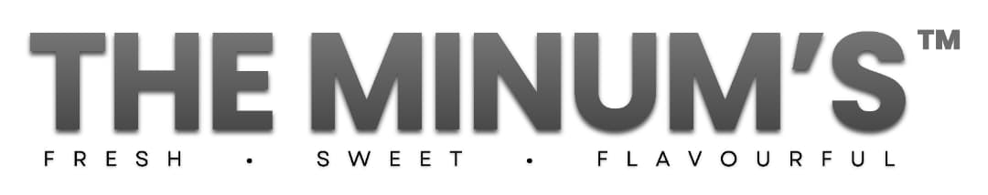
Figure 1.1 The Minum’s ENT. Logo

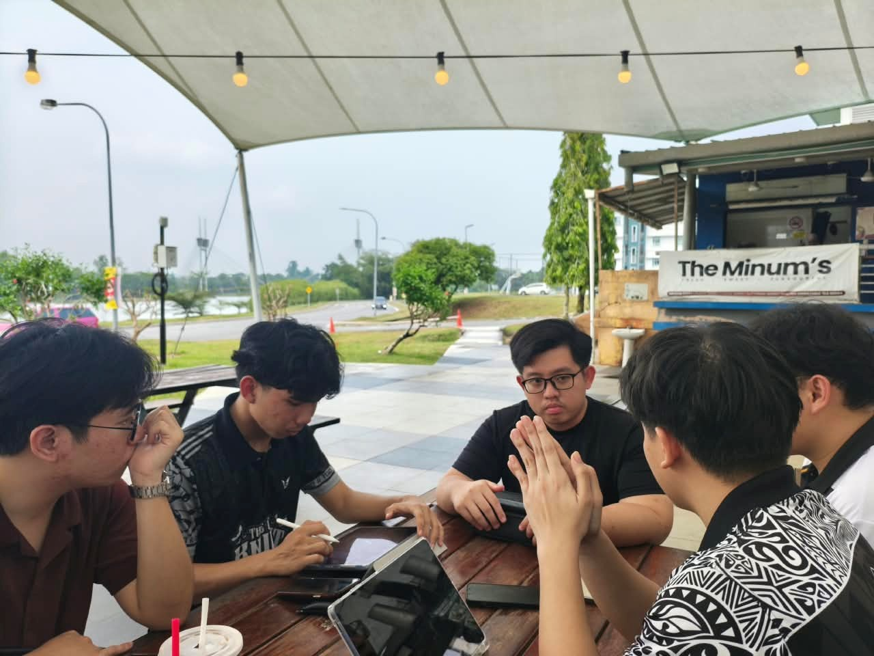
Figure 1.2 Interview with client
Established in 2024, THE MINUM'S ENT. is a food and beverage enterprise focused on delivering quality refreshments and customer experiences. The project's primary client contact is the founder, Petrus Anak Jinai. The proposed digital ordering application and operational hub are designed to support an estimated 100 intended users, encompassing both the business's operational staff and its daily customer base.

1.2 Team Background

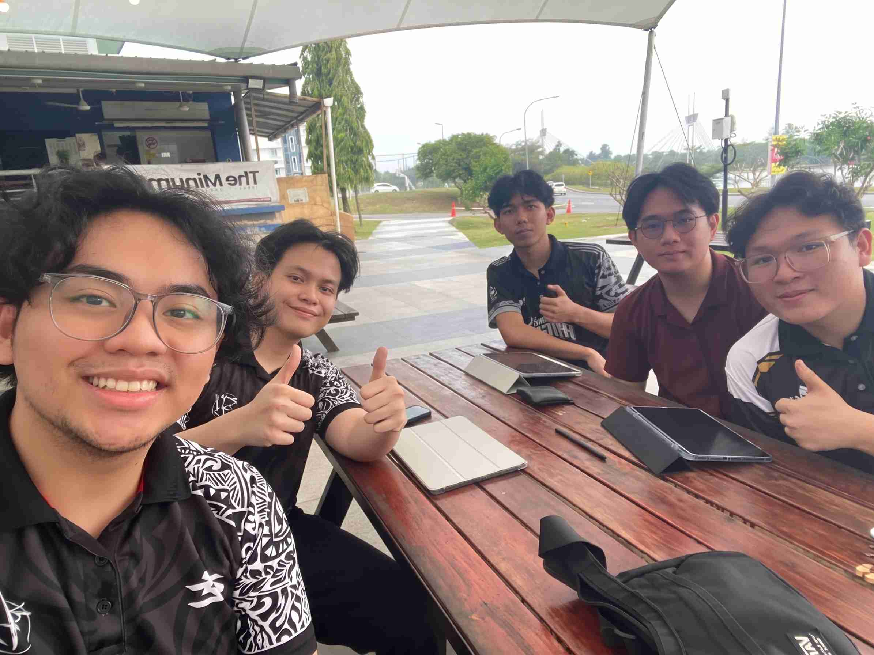
Figure 1.3 Team Members
Operating under the motto "Smart Solutions, Seamless Experiences," MegaMind is a well-rounded team of software engineering students offering specialized expertise across the development lifecycle, including project management, client requirements, UI/UX design, AI integration, and quality assurance.

2. Problem Statement
ID | Current process / problem | Impact on client | Evidence (source)
P1 | Staff attendance and working hours are managed manually, including staff check-in and check-out. | Difficult to monitor staff attendance, working hours, and staff availability efficiently. | Client interview
P2 | Inventory is tracked and managed manually. | Difficult to monitor stock and may lead to stock shortages or overstocking. | Client interview
P3 | Customer orders are handled manually. | Orders may be missed or recorded incorrectly, causing delays in serving customers. | Client interview
Table 1: Summary of client problems

Proposed solution: Similar problems have been observed in manual restaurant ordering processes, where staff handling multiple orders can result in late, incorrect, unclear, or forgotten orders (Wong & Kamaludin, 2024). A Flutter mobile app that manages staff attendance, inventory, and customer orders in one centralized system, using AI to provide useful insights.

3. Project Objectives & Success Metrics
No. | Objective | Solves | Success metric (how we measure) | Priority
O1 | To study and analyze THE MINUM'S ENT's operational workflows, focusing primarily on staff attendance tracking and inventory management, followed by customer order handling. | P1, P2, P3 | SRS and PRD signed off by client by Milestone 1 (Week 5). | High
O2 | To design and develop the core Flutter mobile app featuring digital staff check-in/check-out tracking and real-time inventory stock management. | P1, P2 | 100% of Must-Have FRs for attendance and inventory pass acceptance tests by Milestone 2 (Week 9). | High
O3 | To integrate a Cloud Generative AI module (Google Gemini) to assist with menu queries, availability, and inventory stock insights. | P2, P3 | AI API response latency < 3 seconds with ≥ 90% accuracy on test menu and inventory evaluation datasets. | High
O4 | To implement digital customer ordering functionality and evaluate the complete system with the client through User Acceptance Testing (UAT). | P3, All | ≥ 50 test cases executed, ≥ 60% code coverage, 0 critical defects in LOGD, and signed Client Acceptance Form (FORM-CLIENT-ACCEPT) by Milestone 4 (Week 15). | Medium
Table 2: Project objectives and success metrics

4. Project Perspective

4.1 Target Users
User type | Description | Main needs / goals | Device / tech level
Customer | Daily visitors that purchasing food and beverage from THE MINUM. | - Browse menus, check live pricing and availability of the product.  - Interact with AI chatbot for quick input and services.  - Place order directly. | Android device (smartphone or tablet) at least Android 10 and above, moderate technical skill
Staff | Operational workers that handling service, order fulfillment, and inventory stock tracking. | - Perform digital check-in or check-out attendance tracking  - Directly record stock-in or stock-out transaction  - Update product availability in real time | Android device (smartphone or tablet) at least Android 10 and above, moderate technical skill
Manager/CEO | The business founder and administrator that manage overall operations, staff hours, and inventory | - Monitor staff attendance records and working hours  - Manage menus items, prices, and inventory levels.  - Review customers questions and feedback escalated by AI chatbot | Android device (smartphone or tablet) at least Android 10 and above or Laptop that have at least Windows 11 and above, high technical skill
Table 3: Target users

4.2 System Context and Architecture
The proposed mobile application acts as a modern, centralized digital platform transitioning THE MINUM'S ENT. from traditional face-to-face ordering and manual record-keeping to an automated, cloud-connected operational hub. It interfaces directly with customers for ordering and AI-assisted inquiries, while simultaneously supporting staff and managerial workflows for attendance and inventory control.
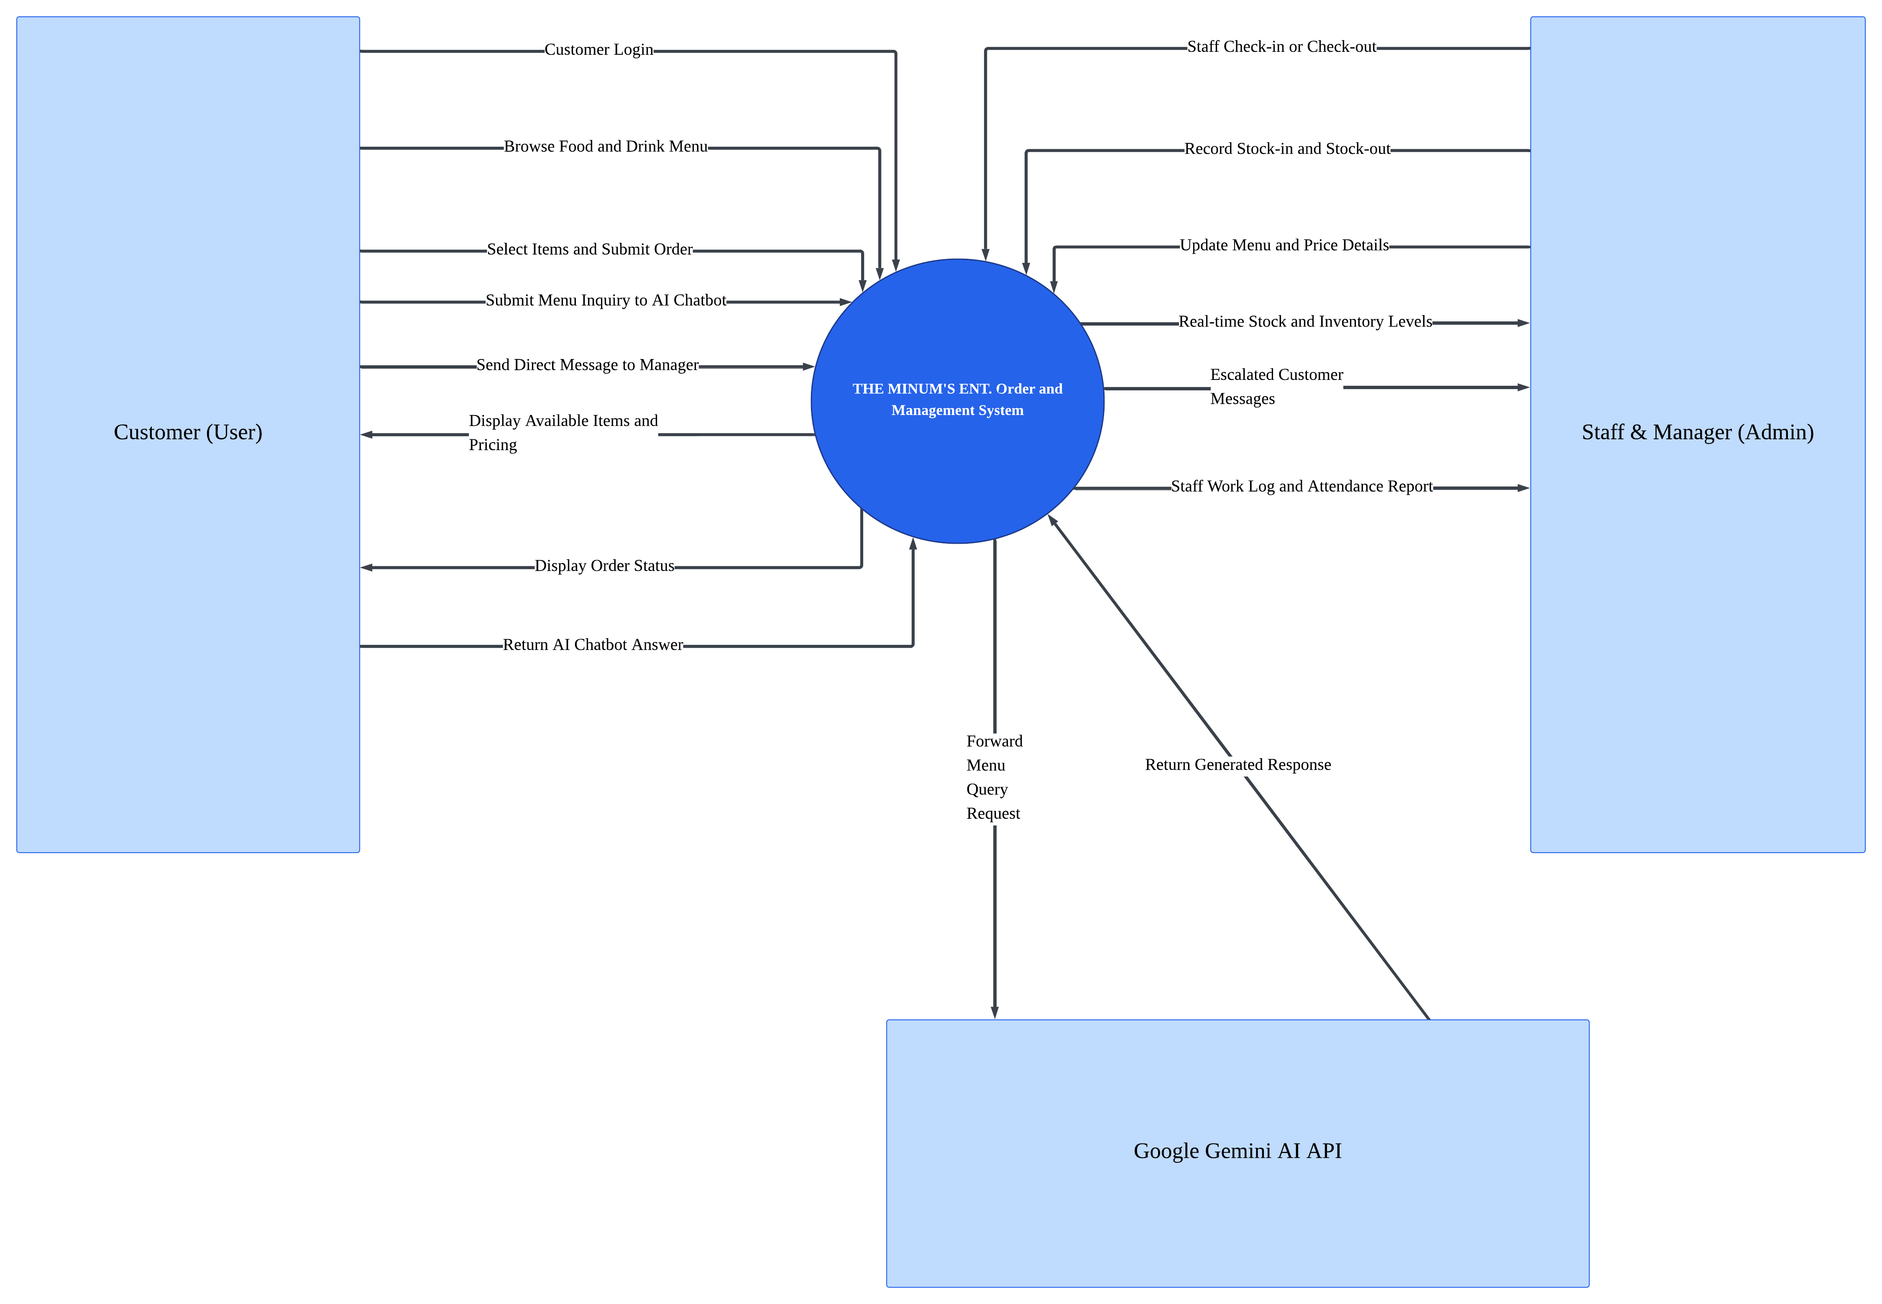
Figure 4.1 Context Diagram of THE MINUM ENT. System
The system context diagram for THE MINUM'S ENT. Management System is illustrated in Figure 4.1, showing how the system interacts with Customer, Staff & Manager, and Google Gemini AI API at the higher level. The Customers are able to log into the mobile app to view the menu, place an order, track their order online, and also send inquiries through the AI Chatbot or directly to managers. Staff & Manager will be interacting with the system to take care of their attendance, register stock-in and stock-out, edit menu information, and view reports related to inventory and work log.

5. Project Scope

5.1 In Scope / Out of Scope
In Scope (will deliver this semester) | Out of scope (will not deliver)
Staff and customer login, with role-based manager access | Unable to use debit card to pay
Customer menu displaying food, drinks, prices, and availability | Food delivery and real-time delivery tracking
AI chatbot for menu items, prices, availability, and kiosk services | AI answering questions unrelated to the kiosk's menu and services
Direct communication with the manager when the AI cannot answer | Integration with external restaurant platforms or third-party systems
Table 4: Scope boundary

5.2 Features and User Stories
FR-ID | Module | User story (As a … I want … so that …) | Priority
FR-01 | User Management | As a customer, I want to register and log in so that I can access the customer features. | Must
FR-02 | User Management | As a staff member or manager, I want to log in using authorised credentials so that I can access functions according to my assigned role. | Must
FR-03 | Menu Management | As a customer, I want to view the food and drink menu, prices, and availability so that I can choose what to order. | Must
FR-04 | AI Chatbot | As a customer, I want to ask the AI chatbot about menu items, prices, availability and kiosk services so that I can get accurate information quickly. | Must
FR-05 | Manager Communication | As a customer, I want to send a message to the manager through the application when the AI chatbot cannot answer my question so that I can receive the correct information. | Should
FR-06 | Order Management | As a customer, I want to select food and drinks and submit my order so that I can order items from the kiosk. | Must
FR-07 | Inventory Management | As a staff member, I want to record stock-in and stock-out transactions and update food and drink availability so that inventory quantities remain accurate and customers can see which items are available. | Must
FR-08 | Staff Attendance | As a staff member, I want to check in and check out through the application so that my attendance and working hours can be recorded digitally. | Must
Table 5: Features and user stories

5.3 A.I Feature
The AI chatbot helps customers get quick and accurate information about the kiosk’s food and drinks, including prices and availability. If the chatbot cannot answer a question, it allows the customer to contact the manager for further assistance. This adds real value by reducing repeated questions to staff and helping customers make decisions more easily.

Item | Description
AI capability | AI chatbot for answering customer questions about the menu.
User value | Helps customers quickly check food and drink prices, availability and other menu information. It also allows customers to contact the manager if the AI cannot answer.
Input → Output | Input: Customer's question and menu information. Output: An AI-generated answer based on the available menu information.
AI service / API | Google Gemini API.
Constraints | Protect the API key, control API usage costs, handle slow responses and prevent the AI from providing incorrect menu information. Customers can contact the manager if the AI cannot answer.
Table 6: AI feature summary

5.4 Non-Functional Requirements and Constraints
NFR-ID | Category | Requirement / Constraint | Target
NFR-01 | Performance | The system should load screens and inventory records quickly. | Within 2 seconds under normal network conditions.
NFR-02 | Security | The system must restrict access to authorized users according to their roles. | All protected functions require authentication and role-based authorization.
NFR-03 | Usability | The system should allow kiosk staff to record stock transactions easily. | Stock-in and stock-out can each be recorded in 3 or fewer main steps.
NFR-04 | Reliability | The system must save inventory transactions accurately without duplication. | Every successfully submitted transaction is saved once and updates the stock quantity correctly.
NFR-05 | AI Accuracy | The AI chatbot must provide accurate answers based on the available menu information. | At least 90% of answers are correct in a test set of 30 menu-related questions.
NFR-06 | Compatibility | The mobile application must work on supported Android devices. | Compatible with Android 10 and above.
Table 7: Non-functional requirements and constraints

5.5 System Environment
Layer | Technology / Tool | Justification
Mobile app | Flutter (Dart 3), Material 3 | Meets course requirements and supports cross-platform development.
State management | Provider | Simple to learn and suitable for managing inventory, staff attendance and customer orders.
Backend / database | Firebase Authentication + Cloud Firestore | Provides user authentication and cloud storage for inventory, sales, staff and order records.
AI service | Google Gemini API | Powers the AI chatbot to answer customer questions using available menu information.
Version control & CI | GitHub + GitHub Actions | Supports team collaboration, version control and automated testing.
Target devices | Android 10+ phones | Provides a defined minimum Android version for development and testing.
Table 8: System environment

6. Task Allocation & Team Contribution
Member | TSPi role | Owned features (FR-IDs) | Other responsibilities / contribution
Caleb | Software Project Manager (PM) | FR-02 (Role-Based Authentication) | Overall project scheduling, sprint planning, risk escalation, GitHub Projects board administration, compiling weekly reports (WEEK/SCHEDULE), and team coordination.
Fahdil | Lead Mobile Architect (UI/UX) | FR-07 (Inventory Management) | UI/UX prototyping, Provider state management architecture, Flutter Material 3 design system, database schema design, and modular Dart architecture.
Joeshua | Lead Systems Analyst & Requirements Engineer | FR-08 (Staff Attendance) | Client requirements elicitation, authoring SRS and PRD, requirement traceability matrix, managing client communication/meeting evidence, and UAT coordination.
Reynoldson | Backend & AI Integration Specialist | FR-04 (AI Chatbot)  FR-05 (Manager Comm) | Backend API and Firebase database integration, Google Gemini AI integration, AI error/fallback handling, maintaining AI audit log (LOGAI), and PR code reviews.

Matthias | Quality Assurance & CI/CD Engineer | FR-01 (User Reg/Login)  FR-03 (Menu Display)  FR-06 (Order Management) | GitHub Actions CI/CD workflow, automated unit/widget test planning, defect tracking (LOGD), maintaining test execution log (LOGTEST), ensuring ≥60% code coverage, and APK release packaging.
Table 9: Task allocation and contribution

7. Team Goals
No. | Team goal | Measure
G1 | Deliver a high-quality and reliable mobile application that meets the agreed client requirements. | All Must-have functional requirements pass their acceptance tests; at least 50 test cases are executed, code coverage reaches at least 60%, and no critical defects remain before final release.
G2 | Maintain a productive, well-managed development process throughout the project. | All four project milestones (M1–M4) are reviewed against their planned deadlines, and weekly progress reports and the GitHub project board are updated.
G3 | Ensure fair contribution, accountability, and effective collaboration among all team members. | Every assigned task is linked to a GitHub Issue and FR-ID; each code change is submitted through a pull request, peer-reviewed, and passed through automated CI checks before merging.
G4 | Maintain regular client engagement to validate requirements and ensure the system meets operational needs. | Conduct a client review at least once every two weeks, document feedback and decisions, and obtain client acceptance through UAT before the final release.
Table 10: Team goals

8. Expected Results

8.1 Working System
The final deliverable of this project is THE MINUM'S ENT. Mobile Application (v1.0.0), a fully functional cross-platform Android application that integrates customer ordering, staff attendance management, and inventory tracking into a single platform. Customers can register, log in, browse the food and beverage menu, check item availability, and place orders through the application. The application also includes a Google Gemini-powered AI chatbot to answer customer enquiries about menu prices, item availability, and kiosk services, with an option to contact the manager for further assistance when needed.
Staff and administrators can access role-based features to manage attendance records, monitor inventory levels, and record stock movements. These features aim to improve daily operations, maintain accurate records, and streamline kiosk management.
The project will be considered successfully completed when the release APK (v1.0.0) has been tested, at least 50 test cases have been executed, code coverage reaches a minimum of 60%, and no critical defects remain unresolved in the Defect Log (LOGD). Formal client approval must also be obtained through the UAT Acceptance Form (FORM-CLIENT-ACCEPT) by Milestone 4 (Week 15).

8.2 Documentation and Artefacts
Deliverable | Submitted with
Project Proposal (original) | Proposal Submission (Week 4)
Revised Proposal and Software Requirements Specification (SRS) | Initial Report (Week 9)
Runnable prototype (4–5 screens), tagged release | Demo 1 (Week 9)
Software Design Specification (SDS), test plan and results (LOGTEST), user manual, maintenance plan, client acceptance form | Final Report (Week 13)
Release APK, demo video (5–10 min), presentation slides | Final Demo 2 (Week 14)
GitHub repository and complete project file | e-Archive (Week 15)
TSPi forms (LOGT, LOGD, LOGAI, SCHEDULE, SUMP, SUMQ, SUMS, SUMTASK, WEEK, PEER) and meeting minutes | Ongoing; compiled in Final Report
Table 11: Deliverables

9. Project Planning

9.1 Methodology
The project will adopt Agile methodology using the Scrum framework to support iterative development and regular client feedback (Scrum.org, 2020). This iterative approach is highly suitable for THE MINUM'S ENT., as it allows the founder to provide regular, incremental feedback on the staff attendance and real-time inventory modules. Our team, MegaMind, will distribute Team Software Process (TSPi) roles across all team members to ensure balanced accountability. Development will follow a strict spec-driven GitHub workflow: every feature corresponds to a GitHub Issue tagged with an FR-ID. Code is developed on a separate branch, requires a Pull Request (PR) with peer review, and must pass automated CI checks before being merged into the main branch. Furthermore, during UI development and unit testing, the team will use generic user placeholders rather than hardcoding personal names into the staff or customer profiles to ensure data privacy and generic usability.

9.2 Submission Schedule
Phase | Deliverable | Week | Due
Phase 1: Planning & Development | Proposal Submission | 4 | 16 Oct 2026
 | Proposal Presentation | 5 | 19 – 23 Oct 2026
 | Initial Report | 9 | 16 Nov 2026
 | Demo 1 | 9 | 16 – 20 Nov 2026
Phase 2: Finalisation & Closure | Final Report | 13 | 24 Dec 2026
 | Final Demo 2 | 14 | 28 – 31 Dec 2026
 | e-Archive | 15 | Before 10 Jan 2027
Table 12: Submission schedule

9.3 Development Milestones (GitHub)
Milestone | Week | Key output | Status
M1 – Scope & Requirements | 4 – 5 | GitHub repo, issue board, CI file; proposal and initial SRS in /docs | Planned
M2 – Design & Prototype | 9 | SDS draft, 4–5 screen prototype, green CI, v0.2.0 tag | Planned
M3 – Product & Verification | 13 | ≥50 tests, ≥60% coverage, AI feature working | Planned
M4 – Final Release & Acceptance | 15 | Release APK v1.0.0, client sign-off, e-Archive | Planned
Table 13: Development milestones
Sprint 1: Discovery & Requirements |  | M1
Sprint 2: Attendance & Inventory UI |  |  |  |  |  |  | M2
Sprint 3: Customer Orders & AI Backend
Sprint 4: Testing & Verification (CI) |  |  |  |  |  |  |  |  |  |  | M3
Sprint 5: Final Release & Client UAT |  |  |  |  |  |  |  |  |  |  |  |  | M4
Figure 3: Gantt chart

9.4 Risks and Assumptions
ID | Risk / assumption | Likelihood | Impact | Mitigation
R1 | Client unavailable for continuous review/UAT | Medium | High | Agree on a fixed fortnightly 30-minute review slot and use asynchronous video updates for minor check-ins.
R2 | Cloud AI API free tier usage limits exceeded during testing | High | Medium | Implement local mock responses for the AI service during routine UI testing; protect API keys using .env to prevent accidental external usage.
R3 | Integration issues between Flutter frontend and Cloud backend | Medium | High | Complete the architectural prototype in Week 8 before full implementation; ensure CI pipeline automatically catches breaking contract changes.
R4 | Uneven workload distribution affecting TSPi peer evaluations | Low | Medium | Enforce strict GitHub Issue assignments mapped to FR-IDs; Planning Manager monitors PR contributions weekly to rebalance tasks among the four team members.
Table 14: Risks and assumptions

10. References
- Alalwan, A. A. (2020). Mobile food ordering apps: An empirical study of the factors affecting customer e-satisfaction and continued intention to reuse. International Journal of Information Management, 50, 28–44. https://doi.org/10.1016/j.ijinfomgt.2019.04.008

- Scrum.org. (2020, November 21). The Scrum framework, illustrated. https://www.scrum.org/node/44195

- Wong, P. K., & Kamaludin, H. (2024). Online Food Ordering System in Triple L Café by Scanning Quick Response (QR) Code. Applied Information Technology and Computer Science, 5(1), 799–816.

Appendix A: Client Meeting Evidence

Meeting Minute Summary 1

Date: 2 October 2026
Attendees: Caleb Budi anak Christopher (Project Manager), Reynoldson Ganing anak Alfred Jabu (Backend & AI Integration Specialist), Muhammad Fahdil bin Suliadi (Lead Mobile Architect), Joeshua Rangga anak Joseph (Lead Systems Analyst), Matthias Lemada anak Peter (Quality Assurance & CI/CD Engineer), and Petrus Anak Jinai (Client/CEO of The Minum's Enterprise).
Key Decisions:
- Agreed to develop a Flutter-based mobile application for staff attendance, inventory management, customer ordering, and AI chatbot support.
- Approved the initial functional requirements (FR-01 to FR-08), simplified staff check-in/check-out to three or fewer steps, and added direct manager communication as a fallback.
- Excluded online payment gateways and food delivery tracking from the current development scope.

Meeting Minute Summary 2
Date: 13 October 2026
Attendees: Caleb Budi anak Christopher (Project Manager), Reynoldson Ganing anak Alfred Jabu (Backend & AI Integration Specialist), Muhammad Fahdil bin Suliadi (Lead Mobile Architect/UI/UX), Matthias Lemada anak Peter (Quality Assurance & CI/CD Engineer), and Petrus Anak Jinai (Client/CEO of The Minum's Enterprise). Joeshua Rangga anak Joseph (Lead Systems Analyst & Requirements Engineer) was absent due to attending an official event.
Key Decisions:
- Confirmed the project scope, including staff attendance, inventory management, digital ordering, and the AI chatbot, while excluding online payments and delivery tracking.
- Agreed to develop a creative, vibrant, and user-friendly UI/UX design using Material Design 3 and interactive Flutter widgets.
- Decided to prepare high-fidelity UI/UX prototypes and update the SRS usability requirements based on client feedback.

Appendix B: Revision History
Version | Date | Changes (e.g. after proposal presentation feedback) | By
1.0 | 17th October 2026 | Original submission | 17th October 2026

