Caleb Lee Liang Heng 1002673

Nashita Abd Tipusultan Guntaguli 1003045

50.039 - Deep Learning Homework #4 (Coding)

**Transfer Learning Task**

Choice of pretrained network: Resnet-18

Trained over: 15 epochs (batchsize 32, learning rate 0.002)

Loss: Cross Entropy Loss

Transformations:

MEAN = [0.485, 0.456, 0.406]

STD = [0.229, 0.224, 0.225]

* Training
  + transforms.RandomHorizontalFlip(0.5)
  + transforms.RandomResizedCrop(224)
  + transforms.ToTensor()
  + transforms.Normalize(MEAN,STD)
* Validation/Testing
  + transforms.Resize(224)
  + transforms.CenterCrop(224)
  + transforms.ToTensor()
  + transforms.Normalize(MEAN,STD)

Performance:

|  |  |  |  |
| --- | --- | --- | --- |
| Model | Validation Accuracy (Best Epoch) | Test Accuracy | Remarks |
| A | 0.28022875816993464 (epoch 14) | 0.2676056338028169 | Without pre-trained weights, train all layers |
| B | 0.9019607843137255  (epoch 14) | 0.8873239436619719 | With pre-trained weights, train all layers |
| C | 0.8978758169934641  (epoch 14) | 0.8849765258215962 | With pre-trained weights, train last two layers |

From all 3 models, testing and validation accuracies are consistently similar, with validation accuracies being slightly higher for all three cases.

Curves of training loss, validation loss and validation accuracy:

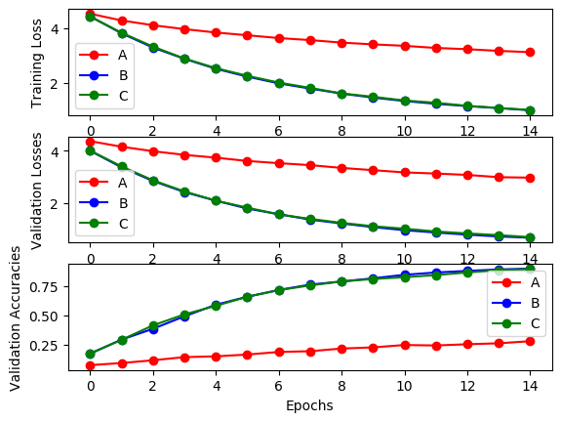

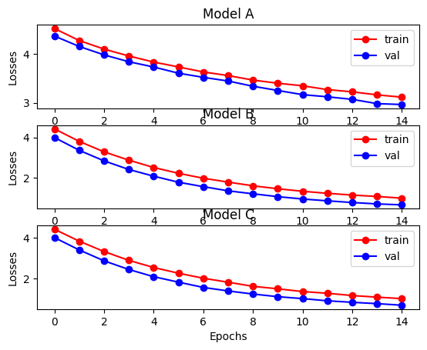

Based on the Loss graphs, we observe that there is still some underfitting for the training of all 3 models. This means that more than 15 epochs is necessary for these models to have a good fit of the data.

Appendix

Print log:

