User Guide: Python 15-minute Demand Visuals Tool

Tool Purpose
To create a variety of visualizations (graphs) using 15-minute demand data that help to understand trends in the plant's demand patterns. The following visualizations will be produced:
- Histogram of demand magnitude
- Line graph of annual demand pattern
- Line graph of average daily demand pattern for each day
- Line graph of average daily demand pattern for weekdays (Mon-Fri)
- Line graph of average daily demand pattern for weekends (Sat-Sun)
- Line graph of average daily demand pattern for hottest days (July, August)
- Line graph of average daily demand pattern for coolest days (December, January)
- Box and whisker plot for monthly demand

Tool Contents
- INPUTS - modify each input variable according to the instructions
- CALCULATIONS/PLOTTING - do not modify this or the tool will break :/

Instructions
File Organization
- Download the Python tool (15MinData_Visualizations_2026.py) and all 15-minute data file(s) for which you want to create visualizations (only one file path is necessary, but multiple can be pasted in case you have multiple electrical meters that you want to perform a combined analysis on) in the same folder. Ensure the data file is in Excel format (.xslx file extension). To get the 15-minute data files, ask the facility to request them from their utility provider.
Excel File Editing
- Open the 15-minute data file(s) and delete all columns except the following:
A B C
Date Time Usage (kWh)
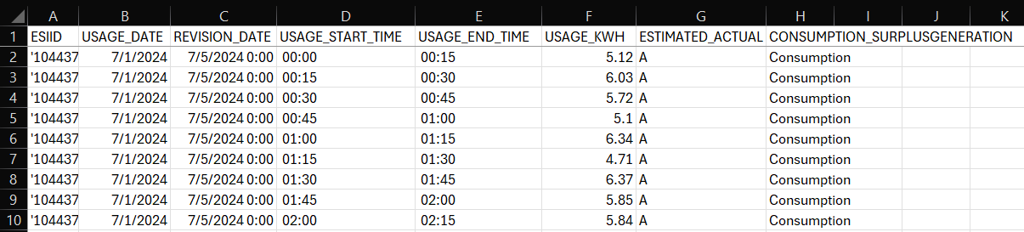

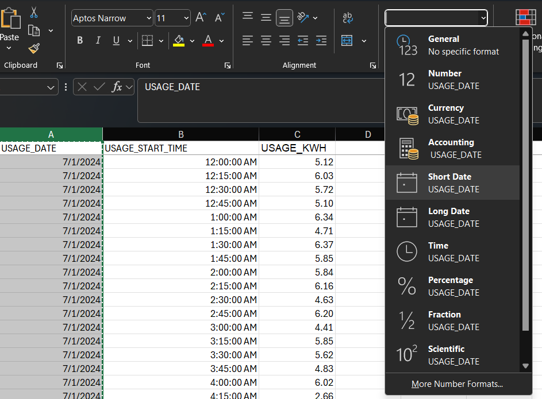
If there are multiple "Energy Consumption" columns in one Excel file, each of these columns likely belongs to a different meter. Split these into multiple files, each with duplicate "Date" and "Time" columns. Ensure the columns are in the order shown above. If you were given multiple 15-minute data files (in the case of multiple meters), and you intend to plot the data of all meters together, ensure each file begins and ends with the same start and stop "Date" and "Time". If they don't, delete rows with extra "Date" and "Time" values that aren’t present in other files.
- Ensure that there are no hours skipped ahead or behind due to daylight savings in March and November. Additionally, some data sets may have jumps in time. Be sure to remove these.
- Take note of the interval between time steps as you will use this value later. Then, select the "Date" column (including the heading), and set all values to the "Short Date" format. Select "Time" and "Energy Consumption" columns and select the "Number" format. Your "Time" column should start at a value of 0 at the beginning of each day and increase (in ascending order) to 0.9895 by the end of the day. It should restart this cycle each day.
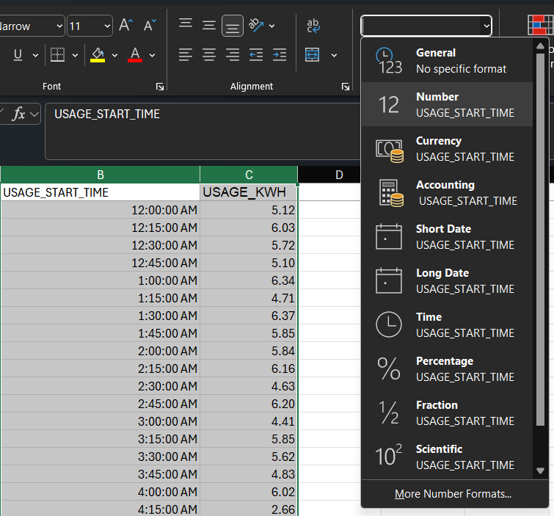

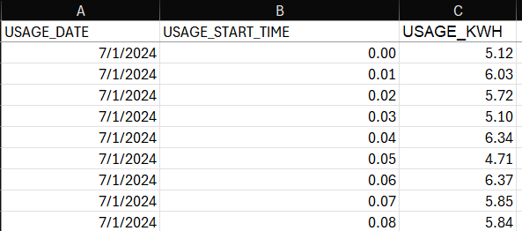
Python File Editing
- Save the updated 15-minute data file(s). Ensure they are in the same folder as the Python tool.
- Open the Python file in your favorite IDE (like Spyder, Jupyter notebook, etc.).
- Open the file manager. For each 15-minute data file you want to create visualizations for, right click the file in the file manager and select "Copy as path". Then, in the Python tool paste each within the list in the INPUTS section with the name "data_file_paths". Separate list items with a comma.
- For each file path you have pasted, change the backslashes to forward slashes.

- Type the time interval between data points for your data in the variable "time_step". Most will have 15 minutes, and so this is the default value.
- Type either "kW" or "kVA" in the variable "demand_type" depending on which demand unit you want your graphs in.
  - If you chose "kVA", type one power factor value (from 0 to 1) in the list "power_factors" for each 15-minute Excel file you want to process. Note that the first power factor value in "power_factors" corresponds to the first Excel file path in "data_file_paths", and the same for the second, etc.
  - If you chose "kW", type "NA" in "power_factor".
- Type the title header you want for your graphs in "title_header". If you have only one 15-minute demand data file, this should probably be blank ("") so no header is added to the title.
If you have uploaded all files for your site's meters, this should probably be "All Meters".
If you have only uploaded a single meter, name it for that meter "Meter #####".
- Run your code!!

Troubleshooting
This section contains a list of any weird or edge-case issues you may encounter when using the tool. If you don’t find your edge case yet in the document, send an email to noah_s_hank@tamu.edu, and for help with troubleshooting the tool and so that this troubleshooting section can be updated.
Excel File Editing
No contents currently
Python File Editing
No contents currently

