CSCI-E15 Final Project Specification
Caleb Davis
HUID 80749171

Overview
This project proposal is for a continuation of the site I developed this past Spring as my final project for the class CSCI-E12 (Fundamentals of Website Development).

Original Site
The starting point for this project is an existing online photo gallery, showcasing the photography and modeling work of my girlfriend Lily (her site is available at http://lilysprite.com). Prior to the start of this semester, the site was essentially geared towards one specific audience – a user browsing her photos (prospective clients, models, or friends). To facilitate browsing, it consisted of a landing page, several gallery pages (Portraits, Creative Photography, Fantasy Edits, and Lily's own modeling), and an 'About' bio page.

Landing Page:
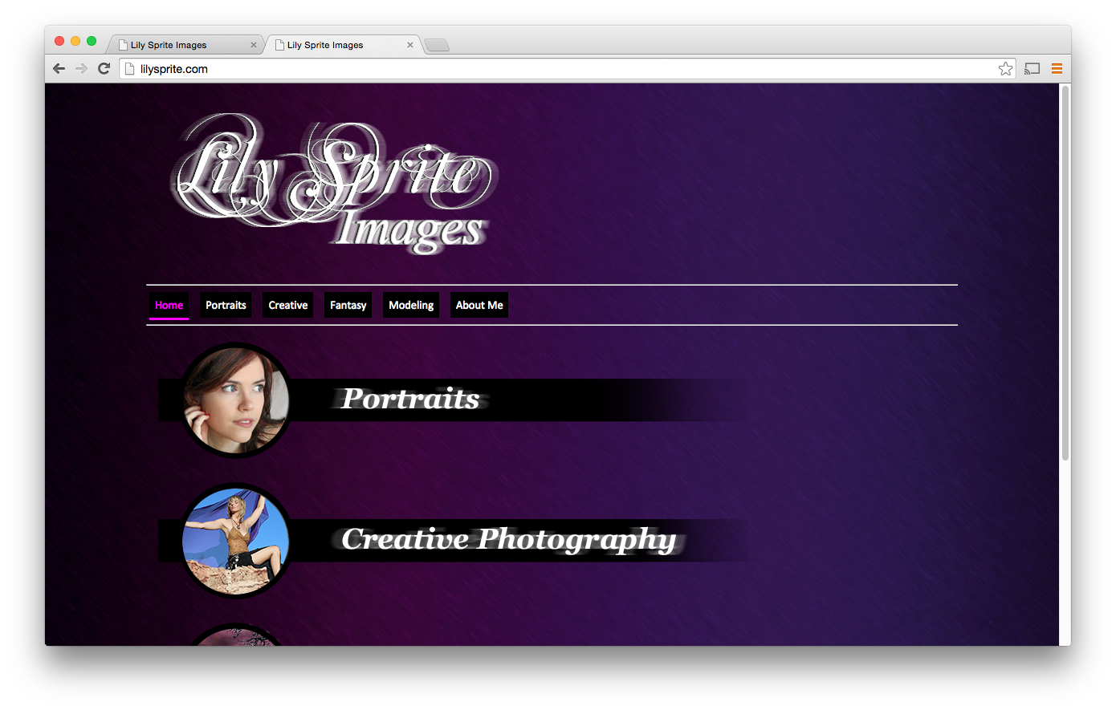
The landing page allows the user to select one of the four photo galleries, or to view Lily's Bio page.

Gallery Page:
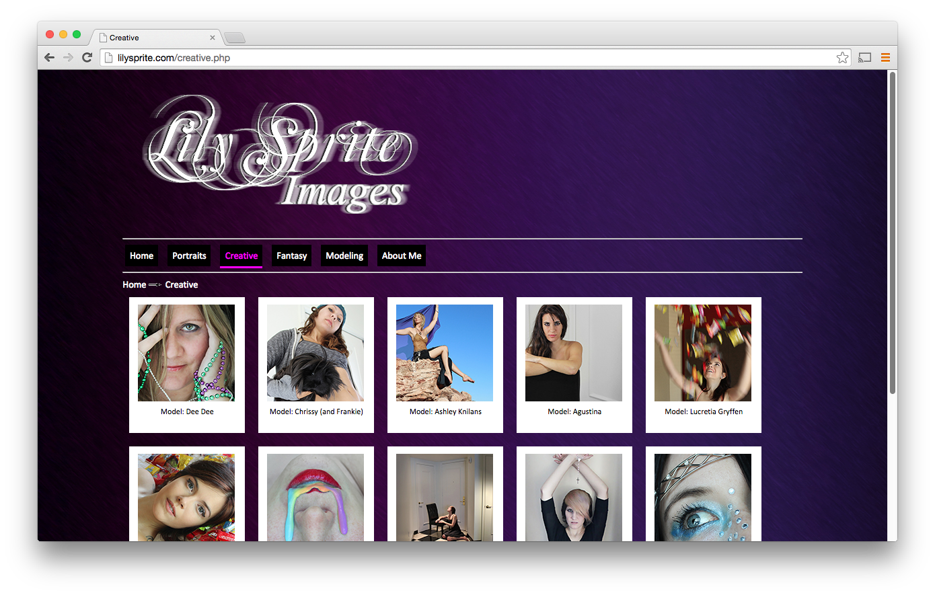
The gallery pages each show a set of thumbnail images. Clicking on one brings up a large modal display of the full image (using the FancyBox 2.0 jquery widget).

About Page:
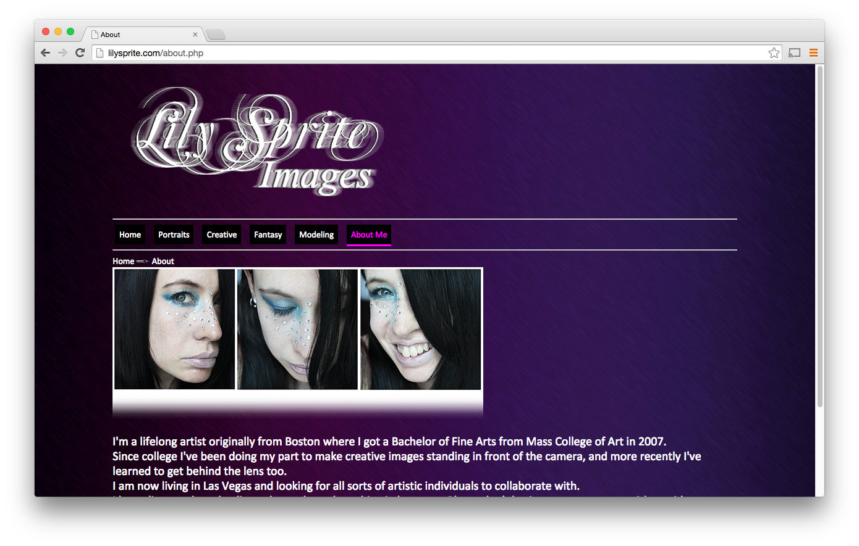
The About page is simply some static text and images, describing Lily and her photography/modeling aspirations.

Proposed Enhancements
The new site will offer several enhancements, both functional for the front-end, and DB/dynamic on the server-side.

Functional Enhancements: Three roles vs. One
The new site will expose user-specific functionality, based on three categories of role: Guest, Registered User, and Administrator.

I. Guest access:
The old site adequately handled the functionality needed for users in the Guest role: Browsing of thumbnail images in four public galleries, and viewing full images by clicking on any thumbnail.

II. Registered Users:
The new site will permit users access to selective content, based on identity. To this end, the new site exposes three new actions, geared towards the concept of a 'Registered' user:
- User signup – a registered user is one whom the site can remember and identify. The registered user has signed up (supplying name, e-mail address, and password), storing his/her information in the site's database.
- User login – After signing up, a registered user can login with the previously supplied credentials (e-mail address and password). From that point on, the site keeps track of the user's browsing session, allowing the site to provide custom content.
- Per-user selective content – a registered user can view restricted content: Photos which the administrator user has designated as accessible to that specific user, but not necessarily accessible to everyone. After user login, a registered user has access to a special gallery (labelled 'Restricted'). The images in that restricted gallery are associated with one or more authorized users. If one of those authorized users is logged in, that photo will be visible to him/her. As far as any other users are concerned, that photo does not exist.

III. Administrator User
In addition to 'registered' users, there will be a final special category of user: The site administrator (specifically, Lily). The administrator can publish new photos to the site. From a data perspective, a photo consists of its image file, its thumbnail, a caption, and optionally the set of permitted users (accessible in the special 'restricted' gallery). This leads to three new administrator-only actions:
- Photo publish – The site exposes to the administrator a UI which permits creating of a new photo. This means the UI must allow the administrator to set five attributes: The main photo image file, the thumbnail file, the caption, the selection of the photo's parent gallery, and the optional set of users to whom the site grants browsing/viewing access (by selecting the photo's parent gallery to be the 'restricted' gallery, the administrator indicates the need to specify which set of users should be granted access).
- Photo modify – The site exposes to the administrator a UI which permits changing some attributes of a photo (specifically, the caption and the optional set of permitted users). The selection involves choosing a gallery, and then choosing (through display of thumbnails) the specific photo to modify. Once the administrator selects the photo, another UI allows the administrator to change caption and the set of authorized users.
- Photo delete – The site exposes to the administrator a UI which permits selection of a photo to remove from the site. The selection involves choosing a gallery, and then choosing (through display of thumbnails) the specific photo to remove.

Server-side Enhancements:

Current Shortcomings:
The current site is a mix of hand-coded html/php files, an 'images' folder, and four special .csv format databases. This approach lends to several shortcomings:

Difficult Photo Administration
Using FTP transfers, and a text editor, Lily is able to publish images to one of the four hard-coded galleries, by listing that photo in the corresponding .csv file. The fields of the file indicate the main image file, the thumbnail, the parent gallery, and the photo caption. Not being a software engineer or IT professional, Lily has a lot of trouble putting new content up. By switching to web UI's and a database, administration becomes less onerous.

Complex, brittle code:
A second category of shortcomings in the current site is related to the back-end: the server uses some rudimentary php to parse the .csv gallery files, and to generate the snippets of html/javascript necessary to compose each gallery page. The absence of any object abstractions make any changes code-intensive, and complicated to maintain.

Lack of User Authentication:
Lily needs to give some of her clients exclusive access to photos (especially when she contracts work on images shot by other photographers, and makes photoshop-style edits). Currently she places those photos in a special sub-folder, and sends e-mail to her clients with the URL. A cleaner, more professional approach would be huge. With its current technology, it would be difficult for me to modify the existing site to incorporate this kind of functionality.

Proposed Implementation:
The proposed enhancements would eliminate most of the above mentioned shortcomings. They would allow for easier site administration, enhanced user-specific browsing, and back-end code maintenance/refactoring.
The current administration tasks move into the site itself – new administrator pages will permit photo management. This will be a huge win for Lily, who won't need to muck around with text editors and FTP clients. The Laravel framework provides a lot of the infrastructure for administration – user and file management, and advanced page routing/filtering.
For development purposes, the new approach eliminates 'spaghetti-coded' php content generation. The HTML will instead be templatized through blade syntax, and driven by a single object database. The Laravel php framework will provide intelligent organization and routing through the site, and an object model exposing the database content as related php class instances (classes such as 'Photo', 'Gallery', and 'User'). The framework deals with most of the object->database interactions, user authentication, and file upload. Implementing the various guest user, registered user, and administrative use-cases will be much simpler with a framework. It should allow quick creation of the various necessary UI's, and well organized code to easily manipulate the system entities (photos, galleries, and users). Finally, a framework makes it much easier for page elements and routes to be conditionally activated, based on state variables such as currently-logged-in user, target/destination pages, and form post data.

Stretch Goals:
In addition to implementing user-specific publishing, and in-site content administration, if time allows, I'd like to implement gallery administration. This would involve administration UI geared towards creation, modification, and deletion of galleries themselves (not just the contained photos). At a minimum, I should store all the gallery meta-data in the database, and drive gallery page construction from that data (instead of hard-coded as it is right now). This way, even if I don't get around to the gallery administration UI by the project due-date, I won't have to re-factor the gallery construction code to support this feature.
It also would be nice to have secure user signup/login (over HTTPs), and e-mail facilities for password reminders/resets.

