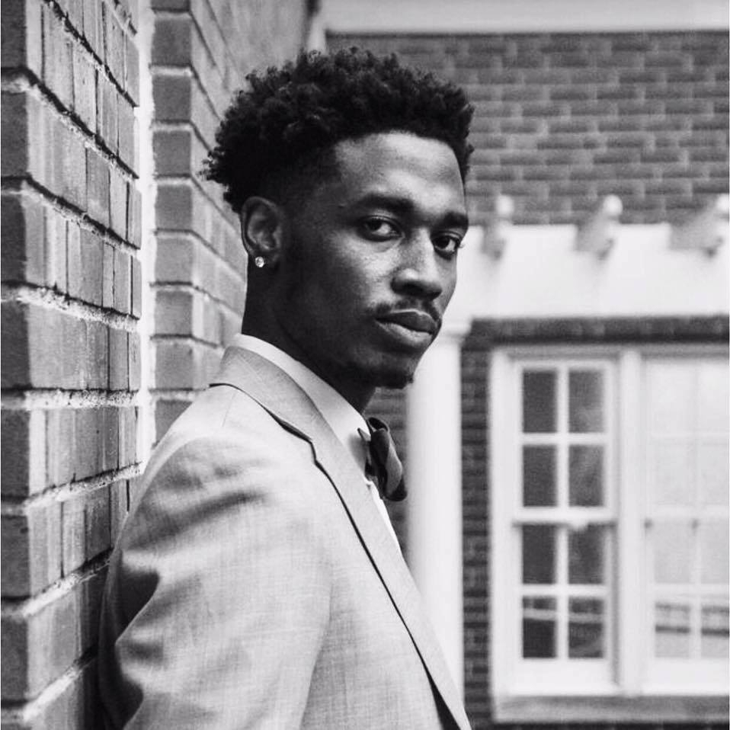
Caleb A. Wright
Bass-Baritone

3150 Whitethorn Rd Email: CAW5699@gmail.com
Cleveland Heights OH 44118 Telephone: (216) 502-7122

Roles
Balthazar Amahl & The Night Visitors Forest Hill Church Fall, 2016
George Godspell Tri-C West Spring, 2014
John Henry (Young) The Life of John Henry The Rainey Institute Spring, 2016
Gospeleer Finian’s Rainbow Mercury Summer Stock Summer, 2016
Harpo (understudy) The Color Purple The Karamu House Fall, 2012

Scenes
“Au Fond Du Temple Saint” Les Pecheurs De Perles Nadir
“Prima Che D’Altri” Il Trovatore Count di Luna
“O Isis und Osiris” Die Zauberflote Sarastro
“Bess, You Is My Woman Now” Porgy & Bess Porgy
“It Ain’t Necessarily So” Porgy & Bess Crown

Teachers Vocal Coaches Stage Directors
Sara Haus (2017-2018, Current) Andre Solomon-Glover Pierre Jaques-Brault
Richard Anderson (2014-2016) Lowell Lieberman Terrence Spivey
Caroline Selia (2011-2013) Anne Wilson Mason Stewart
Carolyn Smith (2007-2010)) Robert Porco

Conductors YAPs/Studio Programs Masterclasses
Maestro Franz Welzer-Most Songfest – Apprentice Artist Lowell Lieberman
Maestro Robert Porco Lara Troyer
Maestro Giancarlo Guirerri Andre Solomon-Glover

Solo Opportunities
The Cleveland Orchestra Martin Luther King Chorus 2015
The Cleveland Orchestra Martin Luther King Chorus 2016
The Voices of Koinonia Sons of Zion Album Recording 2018
The Cleveland Orchestra Chorus Concert Series 2015
The Cleveland Orchestra Chorus Concert Series 2016

