Caleb Bahne - ME 140 Exam 2 1
Problem 21 1
Problem 22 3
Problem 23 - Golden Section Search 5
Problem 24 - Linear System 6
Problem 25 - Gauss Seidel 7

Caleb Bahne - ME 140 Exam 2
10.28.25
clc; clear;

Problem 21
Bisection Method
f = @(x) -8-12*x+8*x.^2-3.25*x.^3;
fplot(f, [-1 0]) % looks to be between -1 and 0
xl = -1; xu = 0; es = 0.01;
[root,relErr,iter] = bisect(f,xl,xu,es)
% False Position Method
% help falsepos
[root_fp,froot_fp,ea,iter_fp]=falsepos(f,xl,xu,es)
% Bisect Approx Error
f05 = f(-0.5)
fn1 = f(-1)
f1 = f(0)
% False pos approx err
ea = 100;
xr = xl;
xrold = xr;
fl = f(xl);
fu = f(xu);
xr = xu - fu*(xl - xu)/(fl - fu) % false-position formula
ea = abs((xr - xrold)/xr) * 100
f_xr = f(xr)
xu = xr;
fu = f(xu);
xrold = xr;
xr = xu - fu*(xl - xu)/(fl - fu)
ea = abs((xr - xrold)/xr) * 100
root =
-0.4817
relErr =
0.0063
iter =
15
root_fp =
-0.4817
froot_fp =
-2.1248e-04
ea =
0.0059
iter_fp =
8
f05 =
0.4062
fn1 =
15.2500
f1 =
-8
xr =
-0.3441
ea =
190.6250
f_xr =
-2.7914
xr =
-0.4456
ea =
22.7763
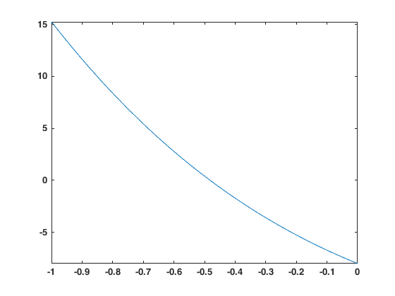

Problem 22
newtraph
func = @(x) x.^3+4*x.^2-10*x-5.2;
dfunc = @(x) 3*x.^2+8*x-10;
fplot(func, [-7 3])
es = 0.1; xr = 3.5;
% help newtraph
[root_nr,ea,iter_nr]=newtraph(func,dfunc,xr,es)
% mod secant
help modSecant
delta = 0.001;
root_ms = modSecant(func,xr,delta,es)
% find all roots
coeff = [1 4 -10 -5.2];
roots(coeff)
root_nr =
2.0644
ea =
4.0139e-04
iter_nr =
5
xr=modSecant(f,x,delta,tol,maxIt)
Implements the modified secant method
f = function to find the root of
x0 = initial value
delta = value of delta
tol = stopping criteria tolerance
maxIt = maximum number of iterations
xr = found root
ABH
Spring 2023
root_ms =
2.0685
ans =
-5.6158
2.0644
-0.4485
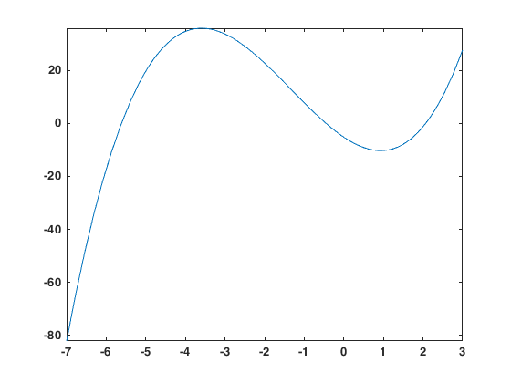

Problem 23 - Golden Section Search
help goldmin
f = @(x) 2*x.^4+x.^3+10*x.^2+4*x;
g = @(x) -2*x.^4-x.^3-10*x.^2-4*x;
[x_min,fx,ea,iter]=goldmin(f,xl,xu,es)
[x_max,fx,ea,iter]=goldmin(g,xl,xu,es)
% help fminbnd
X = fminbnd(f, xl, xu) % min
X_max = fminbnd(g, xl, xu)
x_min =
-0.3444
fx =
-0.2042
ea =
0.0863
iter =
15
x_max =
-0.9992
fx =
-6.9837
ea =
0.0779
iter =
13
X =
-0.3441
X_max =
-1.0000

Problem 24 - Linear System
A = [2 -8 3; -4 1 7; 5 3 -2];
b = [40; -30; 50];
C = A\b
C =
11.6933
-1.1182
2.5559

Problem 25 - Gauss Seidel
A = [2 -8 3; -4 1 7; 5 3 -2];
b = [20; -15; 25];
C = A\b
help GaussSeidel
[x_gs,ea,iter_gs] = GaussSeidel(A,b) % diverges
% diagonally dominant
A_dd = [5 3 -2; 2 -8 3; -4 1 7];
b_dd = [25; 20; -15];
[x_gsdd,ea,iter_gs] = GaussSeidel(A_dd,b_dd)
% with relaxation
% help GaussSeidelRelax
lambda = 0.01;
[x,ea,iter] = GaussSeidelRelax(A,b,lambda)
C =
5.8466
-0.5591
1.2780
GaussSeidel: Gauss Seidel method for solving a system of linear equations [A]{x}={b}
[x,ea,iter] = GaussSeidel(A,b,es,maxit): Gauss Seidel without relaxation
input:
A = coefficient matrix
b = right hand side vector
es = stop criterion (default = 0.00001%)
maxit = max iterations (default = 50)
output:
x = solution vector
ea = maximum relative error (%)
iter = number of iterations
x_gs =
1.0e+46 *
-0.9614
2.6633
1.5913
ea =
158.4333
iter_gs =
50
x_gsdd =
5.8466
-0.5591
1.2780
ea =
6.4896e-06
iter_gs =
18
x =
6.0762
3.8069
-1.8140
ea =
5.6880
iter =
50
Published with MATLAB® R2024a

