ME 140 Exam 3 - Caleb Bahne
Problem 21 1
Problem 22 1
Problem 23 4
Problem 24 6

Problem 21
A = [-3 5; 110 -302];
% help eig
[V,D] = eig(A)
% polynomial method
p = poly(A) % char polynomial coeffs
% help poly
d = roots(p) % eigenvals
V =
0.9392 -0.0166
0.3434 0.9999
D =
-1.1717 0
0 -303.8283
p =
1.0000 305.0000 356.0000
d =
-303.8283
-1.1717

Problem 22
W = [65 72 76 80 83 85];
A = [2.06 2.12 2.14 2.18 2.20 2.25];
[a r2] = linregr(W,A)
% help linregr
% log10(A) = log10(alph) + beta*log10(W)
[a_pl, r2_pl] = linregr(log10(W), log10(A))
alpha = 10^(a_pl(2))
beta = a_pl(1)
% check results
hold on;
fplot(@(x) alpha*x^beta, [65 85]); hold off;
% nonlinear method doublecheck
nlm = fitnlm(W,A, @(b,W) b(1)*W.^b(2), [1 1])
% seems consistent with transform and the Excel plot below
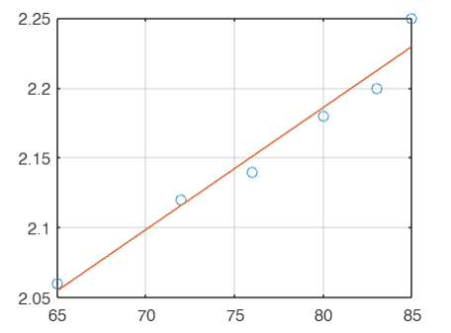
a =
0.0087 1.4864
r2 =
0.9656
a_pl =
0.3025 -0.2359
r2_pl =
0.9608
alpha =
0.5809
beta =
0.3025
Warning: Function behaves unexpectedly on array inputs. To improve performance,
properly vectorize your function to return an output with the same size and
shape as the input arguments.
nlm =
Nonlinear regression model:
y ~ b1*W^b2
Estimated Coefficients:
Estimate SE tStat pValue
________ ________ ______ __________
b1 0.57562 0.079288 7.26 0.0019116
b2 0.30461 0.031712 9.6053 0.00065668
Number of observations: 6, Error degrees of freedom: 4
Root Mean Squared Error: 0.015
R-Squared: 0.959, Adjusted R-Squared 0.949
F-statistic vs. zero model: 6.18e+04, p-value = 1.05e-09
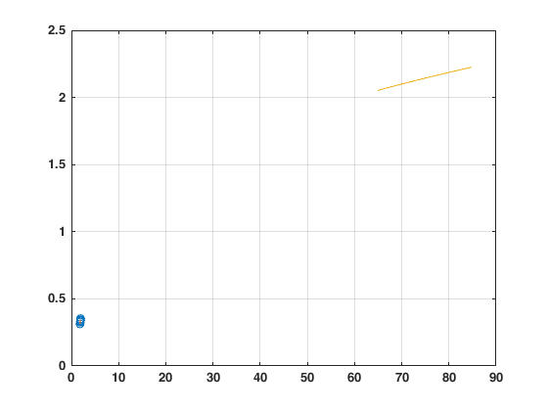
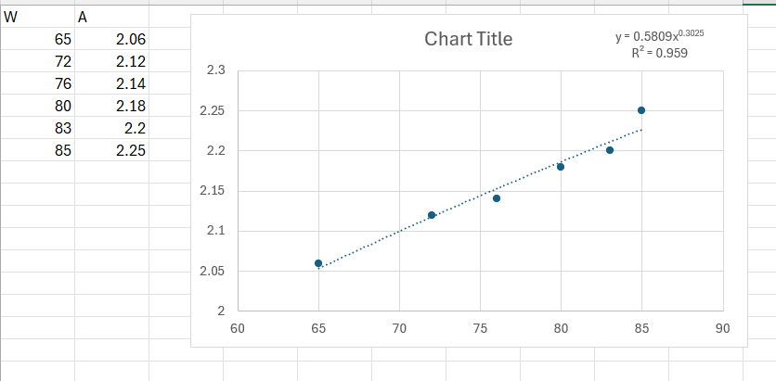

Problem 23
x = [1 2 3 4 5 6 7];
y = [3.5 1.6 1.3 0.85 0.76 1.4 0.54];
% Newton interp poly
% help Newtint
xx = 1.7;
yint = Newtint(x,y,xx)
% Lagrange (no exclusion of the last point)
help Lagrange
xx = 1.5;
yint_L = Lagrange(x,y,xx)
% plot to evaluate the last value
plot(x,y,'*')
% Lagrange (exclude last point)
x1 = [1 2 3 4 5];
y1 = [3.5 1.6 1.3 0.85 0.76];
yint_L1 = Lagrange(x1,y1,xx)
% Relative error
re = abs(yint_L1-yint_L)/yint_L1
% polyint
polyint(x,y,xx) % similar to the Lagrange way
yint =
1.8225
Lagrange: Lagrange interpolating polynomial
yint = Lagrange(x,y,xx): Uses an (n order
Lagrange interpolating polynomial based on n data points
to determine a value of the dependent variable (yint) at
a given value of the independent variable, xx.
input:
x = independent variable
y = dependent variable
xx = value of independent variable at which the
interpolation is calculated
output:
yint = interpolated value of dependent variable
yint_L =
2.0879
yint_L1 =
2.1523
re =
0.0299
ans =
2.0879
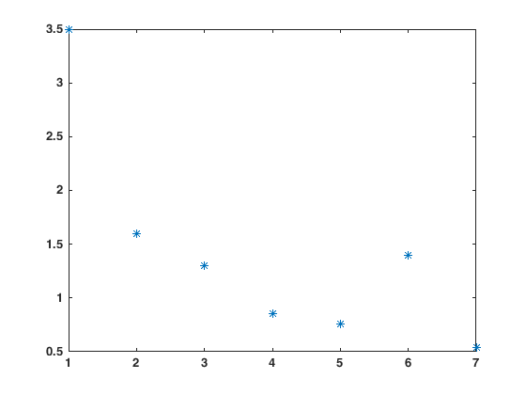

Problem 24
% Romberg integration
f = @(x) x.^2 + 4*x.^(-2) - 4;
a = 1; b = 4; es = 1;
% help romberg
[q,ea,iter] = romberg(f,a,b,es)
% integral
q1 = integral(f,a,b)
q =
12.0448
ea =
0.1869
iter =
2
q1 =
12
Published with MATLAB® R2024a

