ME 140 Final Exam - Caleb Bahne
Problem 41 1
Problem 42 1
Problem 43 3
Problem 44 4
Problem 45 6
Problem 46 8
Extra Credit 9

Problem 41
m = 70; t = 2; g = 9.81; cd = 0.3;
v = sqrt(g*m/cd)*tanh(sqrt(g*cd/m)*t)
v =
18.5894

Problem 42
% find roots between xl and xu
f = @(x) -6-10*x+9*x.^2-7*x.^3;
xl = -1; xu = 0; es = 0.01;
help bisect
[root,relErr,iter] = bisect(f,xl,xu,es)
fplot(f, [-2 2]); grid on;
% Find all roots
coeff = [-7 9 -10 -6];
all_roots = roots(coeff)
bisect: root location zeros
[root,relErr,iter] = bisect(func,xl,xu,es,maxit,p1,p2,...)
input:
func = function handle (@)
xl, xu = lower and upper guesses
es = desired relative error (default = 0.0001%) (input %)
maxit = maximum allowable iterations (default 50)
p1,p2... = additional parameters used by func
output:
root = real root
relErr = approximate relative error (%)
iter = number of iterations
root =
-0.4054
relErr =
0.0075
iter =
15
all_roots =
0.8456 + 1.1829i
0.8456 - 1.1829i
-0.4054 + 0.0000i
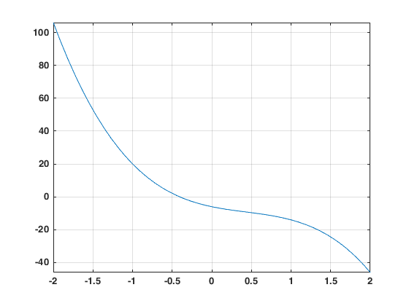

Problem 43
% Solve for x1, x2, x3
A = [3 -8 2; -4 1 9; 5 3 -4];
B = [25; -35; 66];
C = A\B
% Check ans
A(1,1)*C(1)+A(1,2)*C(2)+A(1,3)*C(3) % should be 25
A(2,1)*C(1)+A(2,2)*C(2)+A(2,3)*C(3) % -35
A(3,1)*C(1)+A(3,2)*C(2)+A(3,3)*C(3) % 66
% Use Gauss Seidel
help GaussSeidel
es = 0.5;
[x,ea,iter] = GaussSeidel(A,B,es) % diverges
% Get things diagonally dominant
A2 = [5 3 -4; 3 -8 2; -4 1 9];
B2 = [66; 25; -35];
[x,ea,iter] = GaussSeidel(A2,B2,es)
C =
13.2284
2.2702
1.7382
ans =
25
ans =
-35.0000
ans =
66
GaussSeidel: Gauss Seidel method for solving a system of linear equations [A]{x}={b}
[x,ea,iter] = GaussSeidel(A,b,es,maxit): Gauss Seidel without relaxation
input:
A = coefficient matrix
b = right hand side vector
es = stop criterion (default = 0.00001%)
maxit = max iterations (default = 50)
output:
x = solution vector
ea = maximum relative error (%)
iter = number of iterations
x =
1.0e+37 *
0.7425
0.8668
1.5782
ea =
102.0421
iter =
50
x =
13.2256
2.2673
1.7373
ea =
0.3793
iter =
5

Problem 44
W = [50 62 71 80 83 85];
A = [1.85 1.94 2 2.1 2.13 2.15];
% Linearize for A = aW^b
% log10(A) = log10(alpha) + beta*log10(W)
[a, r2] = linregr(log10(W), log10(A))
alpha = 10^(a(2))
beta = a(1)
% Check by plotting
f = alpha*W.^beta;
plot(W,A,'b',W,f,'g')
% Power law equation
nlm = fitnlm(W,A,@(b,W)b(1)*W.^b(2), [1 1])
a =
0.2852 -0.2209
r2 =
0.9794
alpha =
0.6013
beta =
0.2852
nlm =
Nonlinear regression model:
y ~ b1*W^b2
Estimated Coefficients:
Estimate SE tStat pValue
________ ________ ______ __________
b1 0.59284 0.054053 10.968 0.00039264
b2 0.28857 0.021299 13.549 0.00017178
Number of observations: 6, Error degrees of freedom: 4
Root Mean Squared Error: 0.019
R-Squared: 0.98, Adjusted R-Squared 0.974
F-statistic vs. zero model: 3.42e+04, p-value = 3.42e-09
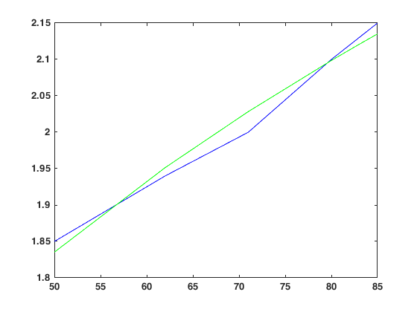

Problem 45
% eigenvalues and vectors
help eig
A = [-4 6; 66 -313];
[V,D] = eig(A)
% Check with characteristic eq
P = poly(A)
lamda = roots(P)
EIG Eigenvalues and eigenvectors.
E = EIG(A) produces a column vector E containing the eigenvalues of
a square matrix A.
[V,D] = EIG(A) produces a diagonal matrix D of eigenvalues and
a full matrix V whose columns are the corresponding eigenvectors
so that A*V = V*D.
[V,D,W] = EIG(A) also produces a full matrix W whose columns are the
corresponding left eigenvectors so that W'*A = D*W'.
[...] = EIG(A,"nobalance") performs the computation with balancing
disabled, which sometimes gives more accurate results for certain
problems with unusual scaling. If A is symmetric, EIG(A,"nobalance")
is ignored since A is already balanced.
[...] = EIG(A,"balance") is the same as EIG(A).
E = EIG(A,B) produces a column vector E containing the generalized
eigenvalues of square matrices A and B.
[V,D] = EIG(A,B) produces a diagonal matrix D of generalized
eigenvalues and a full matrix V whose columns are the corresponding
eigenvectors so that A*V = B*V*D.
[V,D,W] = EIG(A,B) also produces a full matrix W whose columns are the
corresponding left eigenvectors so that W'*A = D*W'*B.
[...] = EIG(A,B,"chol") is the same as EIG(A,B) for symmetric A and
symmetric positive definite B. It computes the generalized eigenvalues
of A and B using the Cholesky factorization of B.
[...] = EIG(A,B,"qz") ignores the symmetry of A and B and uses the QZ
algorithm. In general, the two algorithms return the same result,
however using the QZ algorithm may be more stable for certain problems.
The flag is ignored when A or B are not symmetric.
[...] = EIG(...,OUTPUTFORM) optionally specifies the output format
for the eigenvalues returned in D. OUTPUTFORM can be:
"vector" - Each page of D is a column vector.
"matrix" - Each page of D is a diagonal matrix.
See also EIGS, PAGEEIG, CONDEIG, ORDEIG.
Documentation for eig
doc eig
Other uses of eig
sym/eig symbolic/eig
V =
0.9781 -0.0193
0.2081 0.9998
D =
-2.7237 0
0 -314.2763
P =
1.0000 317.0000 856.0000
lamda =
-314.2763
-2.7237

Problem 46
% Derivative
syms x
f = 3*exp(-0.9*x);
df = diff(f)
dfunc = matlabFunction(df);
dfunc_2 = dfunc(2)
% Integral
f = @(x) (x-5./x).^4;
F = integral(f,1,3)
% check
hold off;
fplot(f,[1 3])
df =
-(27*exp(-(9*x)/10))/10
dfunc_2 =
-0.4463
F =
42.3506
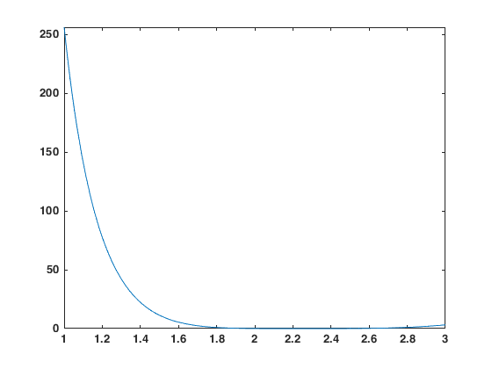

Extra Credit
tspan = [0 2];
y0 = 1; h = 0.001;
[t,y] = rk4(@dydtsys,tspan,y0,h);
plot(t,y)
% integrate
trapuneq(t,y)
% Notes
% - you could also find a nonlinear model for y
% - you could differentiate y at any point on [0 2]
% - you could find the minimum of y on the interval
ans =
1.3653
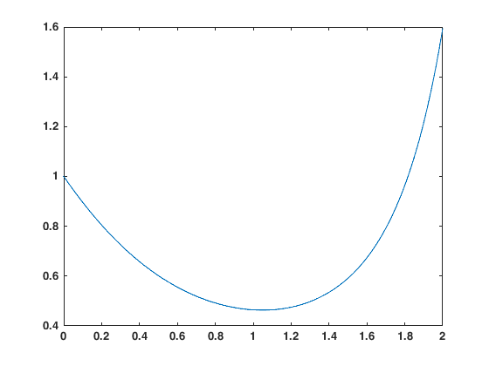
Published with MATLAB® R2024a

