**COS 375 – Assignment #1 Screenshots**

**Login Screen:**

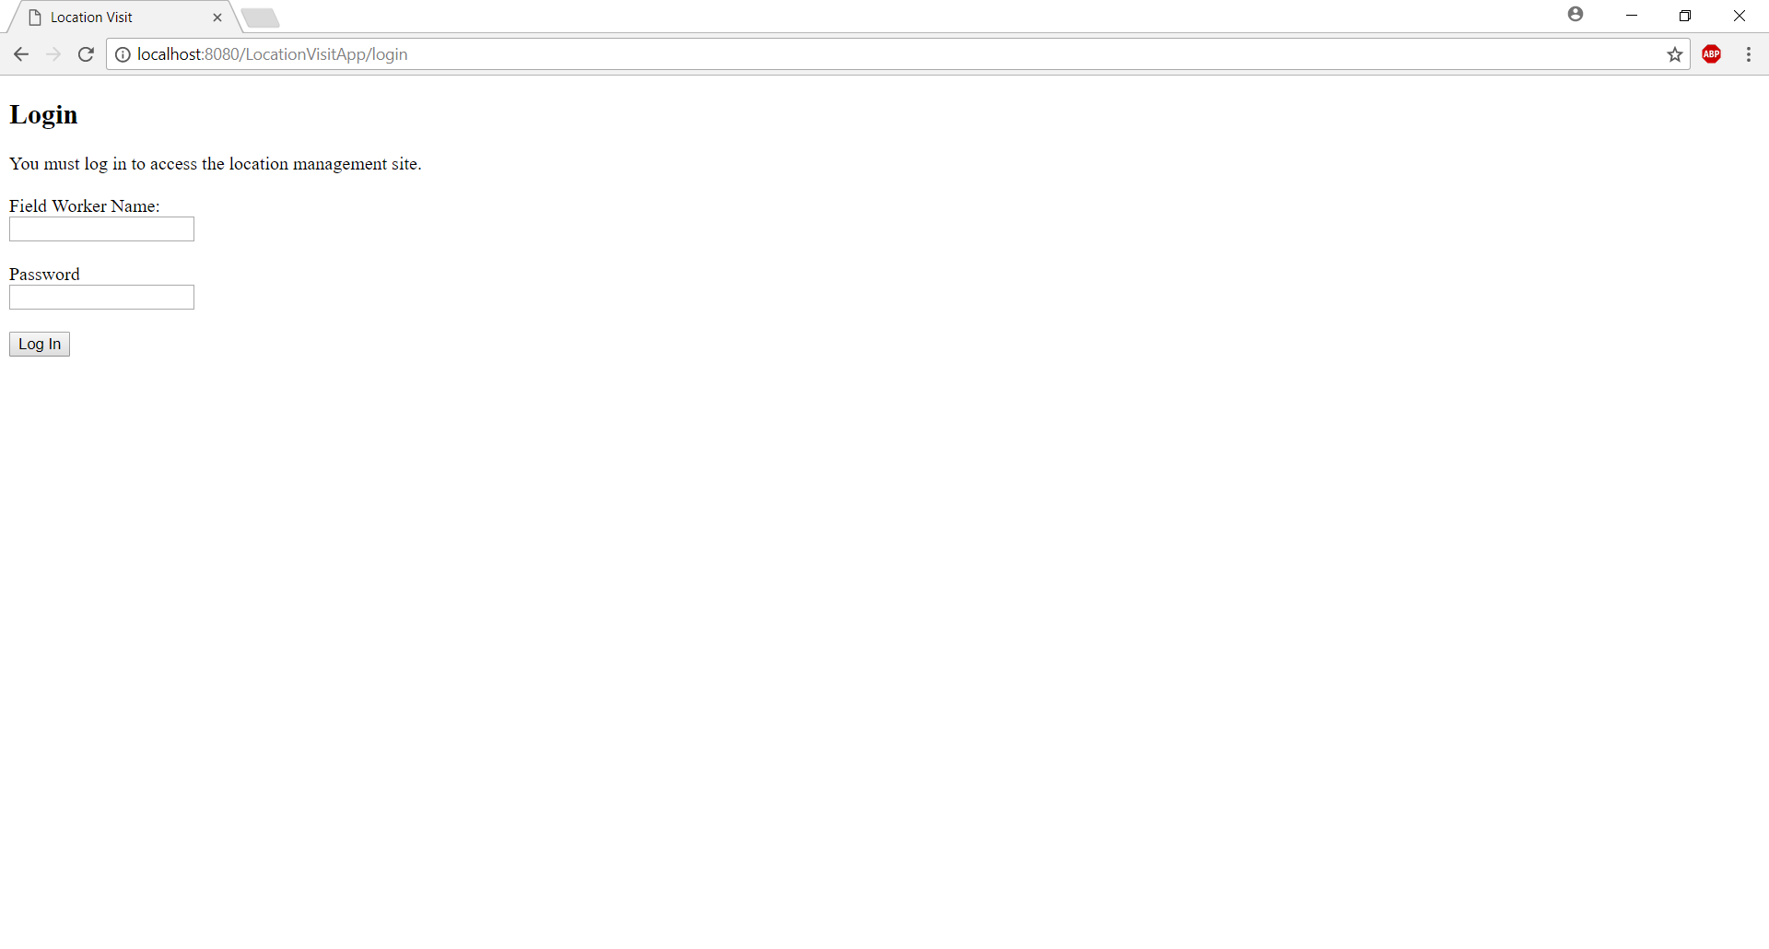

**No Locations Yet:**

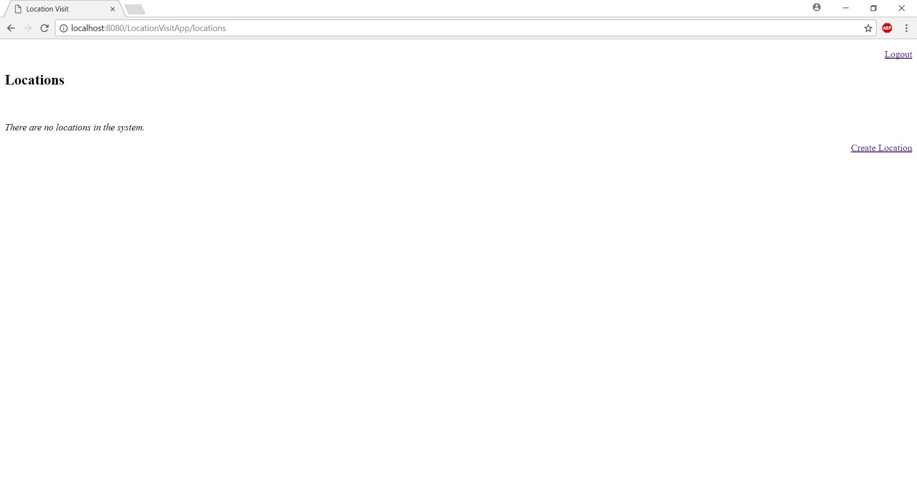

**List of Locations:**

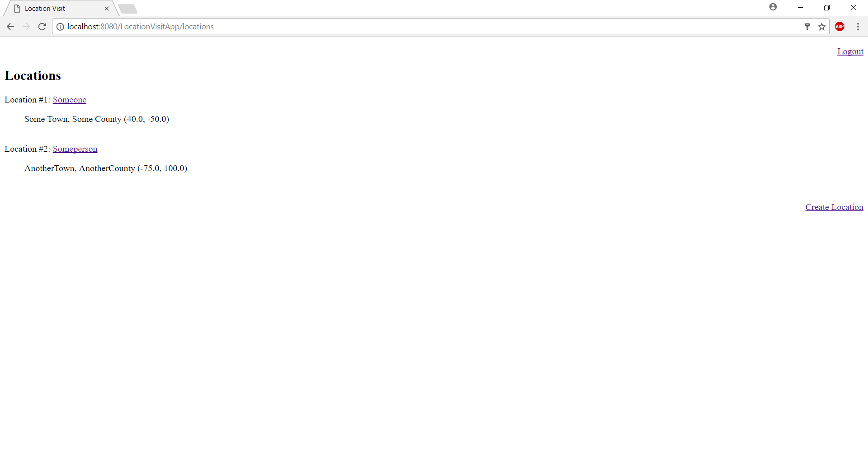

**A Specific Location:**

