**COS 375 – Assignment #3 Screenshots**

**Opening Screen:**

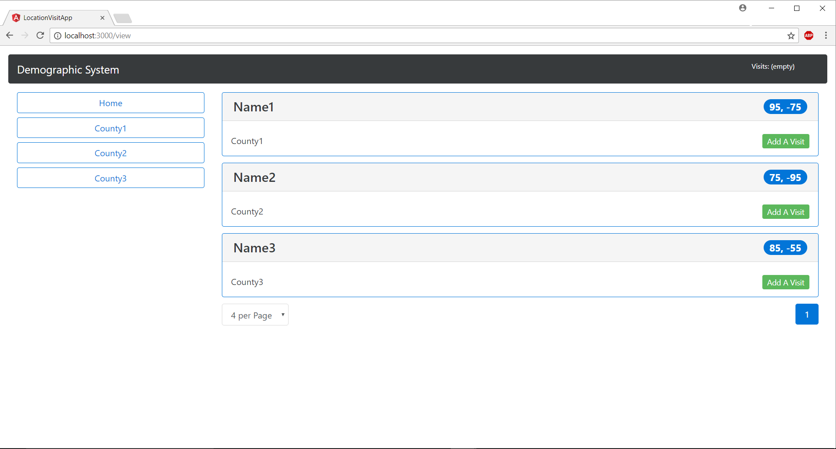

**Visit Detail Screen:**

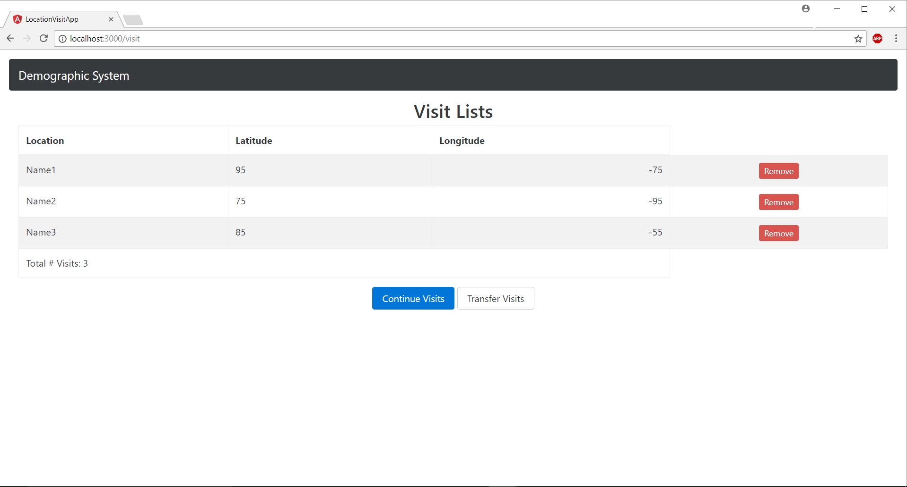

**Visit Transfer Screen:**

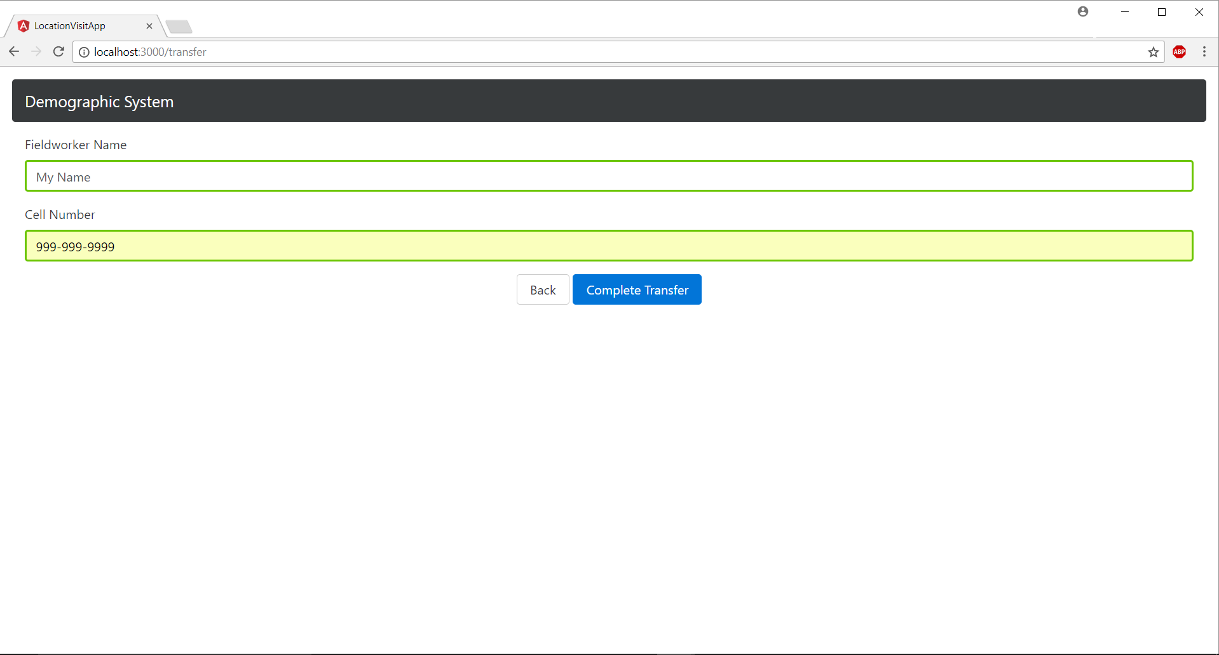

**Transfer Completed Screen:**

