**COMPUTER SCIENCE AQA**

**A-LEVEL NEA**

CONTENTS

ANALYSIS 3

Current Market and Applications 5

REFERENCES 8

# ANALYSIS

In an age of an ever-increasing reliance on technology, with more and more people adopting a sedentary lifestyle, health and fitness has become an aspect that in many cases have become neglected. However, there is now an increasing pressure on governments and on society to change old habits of an unhealthy lifestyle, to a more active one.

Countless studies suggest that exercising not only improves physical health but also has significant impact on improving mental health and relieving stress. One study suggests that those who exercised had 43.2% fewer days of poor mental health in a month than those who did not. [1]. This shows to us the importance of exercise, especially as one of the leading causes of death in the US [2] and as well as for men in the UK [3] is heart disease, which can be preventable through exercise and a healthy diet.

Despite majority of the public knowing the great benefits of exercising, only 63.3% of people aged over 16 consider themselves physically active doing 150 minutes or more of moderate intensive activity in a week, according to a UK government survey. [4] There remains a large portion of the public which do not exercise, for many different and respective reasons. Various reasons may include: not having enough time during the day to exercise, finding a gym that is affordable or simply not having enough motivation to work out.

Whilst a large chunk of the population remains unactive, the proportion of the population, especially within young adults, who have access mobile smart phone continues to increase. One study suggests, that for those aged 16-24 years old, roughly 99% of respondents say they have a smart phone, for those living in the UK [5]. This is a rather a stark contrast to society just 10-20 years ago, where smartphones had barely begun to break into the common consumer market. This really shows to us the commonality of smart phone nowadays and how much of the UK’s population use smart phones on a daily basis, especially younger people.

My objective in this NEA is to investigate two main problems. One is to help young people become more active through the use of a working fitness app, and the other is to simultaneously investigate how exercises are detected by a devices’ on-board sensors, as well as determining quantitative measures for these exercises.

## Current Market and Applications

Leap Fitness Group:

Currently, as of 2021, one of the most common and prominent companies producing fitness/health apps in Android and IOS platforms are the “Leap Fitness Group”. Their apps have a consistent design, UI and theming that makes them recognisable, especially amongst the Google Play Store. Furthermore, they do not have a niche market, but produce apps which are wide ranging with various different activities and demographics – there is always an app made by them that covers the wide appeal of the general public.

This incentive of producing as many apps as they can for fitness/health may be one of the reasons why they are so successful in the Google Play Store, because they can cover so many different aspects of fitness and exercise. From this, they use advertisements and monetization to gain profits

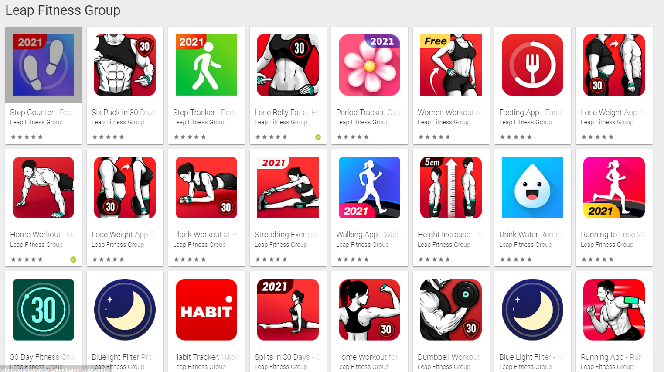

Figure Leap Fitness Group https://play.google.com/store/apps/developer?id=Leap+Fitness+Group&hl=en&gl=US

Google Fit

Google Fit is a widely used tracking app that mainly focuses on detecting what activity you may have done. The app displays to users their step count, their activity history, calorie burnt as well as data from other devices, such as smart watches. Google fit is very well integrated with Google Play Services, through Google fit’s three main APIs – Sensors API, recording API and History API. These API’s are easily accessed by developers who also want to extract and use data from a person’s device for their android app, or for certain web applications.

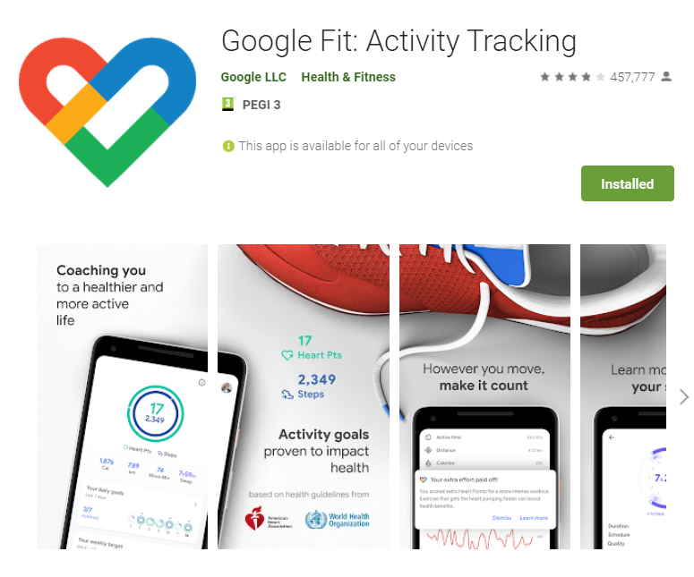

Figure Google Fit https://play.google.com/store/apps/details?id=com.google.android.apps.fitness

# REFERENCES

|  |  |
| --- | --- |
| [1] | “Association between physical exercise and mental health in 1·2 million individuals in the USA between 2011 and 2015: a cross-sectional study,” [Online]. Available: https://pubmed.ncbi.nlm.nih.gov/30099000/. |
| [2] | CDC, “NCHS Data Brief, Number 359, December 2020,” [Online]. Available: https://www.cdc.gov/nchs/data/databriefs/db395-H.pdf. |
| [3] | Office for National Statistics, “Leading causes of death, UK: 2001 to 2018,” [Online]. Available: https://www.ons.gov.uk/peoplepopulationandcommunity/healthandsocialcare/causesofdeath/articles/leadingcausesofdeathuk/2001to2018. |
| [4] | GOV.UK, “Physical Activity,” [Online]. Available: https://www.ethnicity-facts-figures.service.gov.uk/health/diet-and-exercise/physical-activity/latest. |
| [5] | “staista,” [Online]. Available: https://www.statista.com/statistics/956297/ownership-of-smartphones-uk/. |