Self-supervised learning uncovers a shared landscape for mesenchymal transitions across development and cancer
Caleb C. Reagor ^{1, 2,} * and Igor Adameyko ^{1, 3,} *
¹ Department of Physiology and Pharmacology, Karolinska Institutet, 17177 Stockholm, Sweden
² Howard Hughes Medical Institute and Laboratory of Sensory Neuroscience, The Rockefeller University, New York, NY, USA 10065
³ Department of Neuroimmunology, Center for Brain Research, Medical University of Vienna, 1090 Vienna, Austria
* Correspondence shall be addressed to: igor.adameyko@ki.se; creagor@rockefeller.edu
Abstract
Abstract text here.
Introduction
Introduction text here.
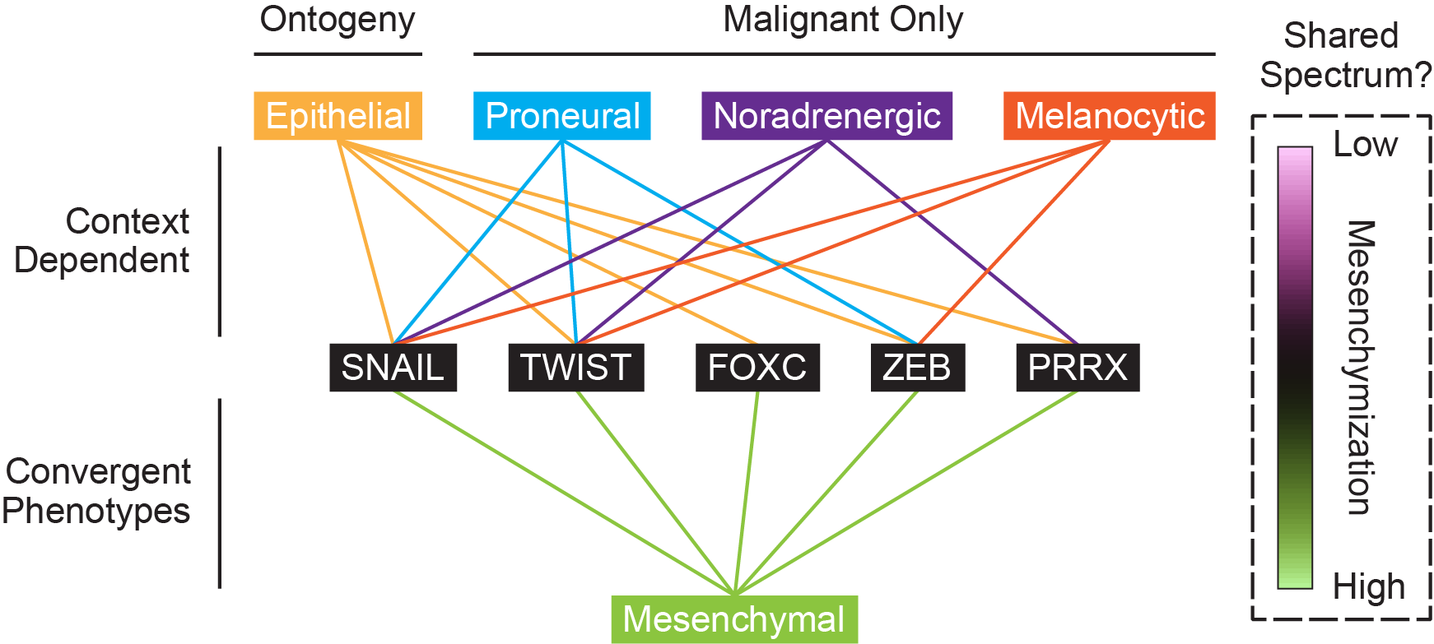
Figure 1: Mesenchymal Transitions in Development and Cancer
Despite their context dependent requirements for TFs such as Snail, Twist, and Zeb, mesenchymal transitions across development and cancer might constitute a shared spectrum with common drivers.
Results
Mesenchyme Development Meta-Atlas
We first sought to identify shared transcriptional states across mesenchymal transitions by collecting publicly available single-cell RNA-sequencing (scRNA-seq) datasets, which we then used to construct a mesenchyme development meta-atlas (Figure 2a). These datasets encompassed key events during the formation of various connective tissues throughout the face, hindlimbs, posterior axial skeleton, and foregut and were broadly categorized as either mesenchymal transitions or specification of stable mesenchymal fates. We purposely selected these datasets because they displayed both conserved hallmarks of mesenchymal development as well as orthogonal programs for mesenchymal transitions versus fate specification.
Our meta-atlas comprised six scRNA-seq datasets collected from mouse and human tissues including epiblast, splanchnopleure, limb buds, and neural crest (Supplemental Table 1). Two datasets encompassed mesenchymal transitions across highly pluripotent epiblast-derived stem cells (Figure 2a, two leftmost panels), while another two datasets comprised cell-type specification of mesenchymal lineages across splanchnic mesoderm (SM) and hindlimbs (Figure 2a, middle two panels). A final pair of datasets contained corresponding trajectories for cranial neural crest cell (CNCC) delamination and migration (Figure 2a, two rightmost panels).
During gastrulation, epiblast cells underwent a lineage bifurcation and EMT to form the lateral plate mesoderm, whereas bipotent neuromesodermal progenitors (NMPs) underwent a bifurcation and partial EMT to generate the posterior somites (Scheibner et al., 2021; Jin et al., 2025). Conversely, SM-derived progenitors generated multiple, stable fates across the visceral organs including the liver, stomach, and lungs, and mesenchymal progenitors across the hindlimbs formed stable lineages for osteoblasts, chondroblasts, and tenocytes (Han et al., 2020; Zhang et al., 2024).

Lastly, to characterize non-mesodermal mesenchymal lineages and provide positive controls for cross-dataset comparisons, we included a pair of corresponding neural crest cell (NCC) datasets in the meta-atlas (Figure 2a, two rightmost panels).

The first dataset contained Schwann cell precursors (SCPs)—including many derivatives of cranial and trunk NCCs such as cranial mesenchyme, fibroblasts, melanocytes, neuroendocrine cells, and peripheral neurons and glia—while the second dataset comprised the same cranial NCCs (CNCCs) alongside additional premigratory CNCCs collected one day earlier at E8.5 (Kastriti et al., 2022) (Poverennaya). Both datasets therefore comprised a shared lineage of NCC-derived cranial mesenchyme spanning mid-to-late EMT, while the second dataset included earlier epithelial stages as well. Notably, many non-mesenchymal derivatives of NCCs such as melanocytes and neuroendocrine cells frequently give rise to highly aggressive and metastatic cancers such as melanoma and neuroblastoma, respectively (White and Zon, 2008; Kameneva et al., 2021). Thus, CNCCs represented an essential benchmark for various mesenchymized cancers including both carcinomas and non-epithelial malignancies.
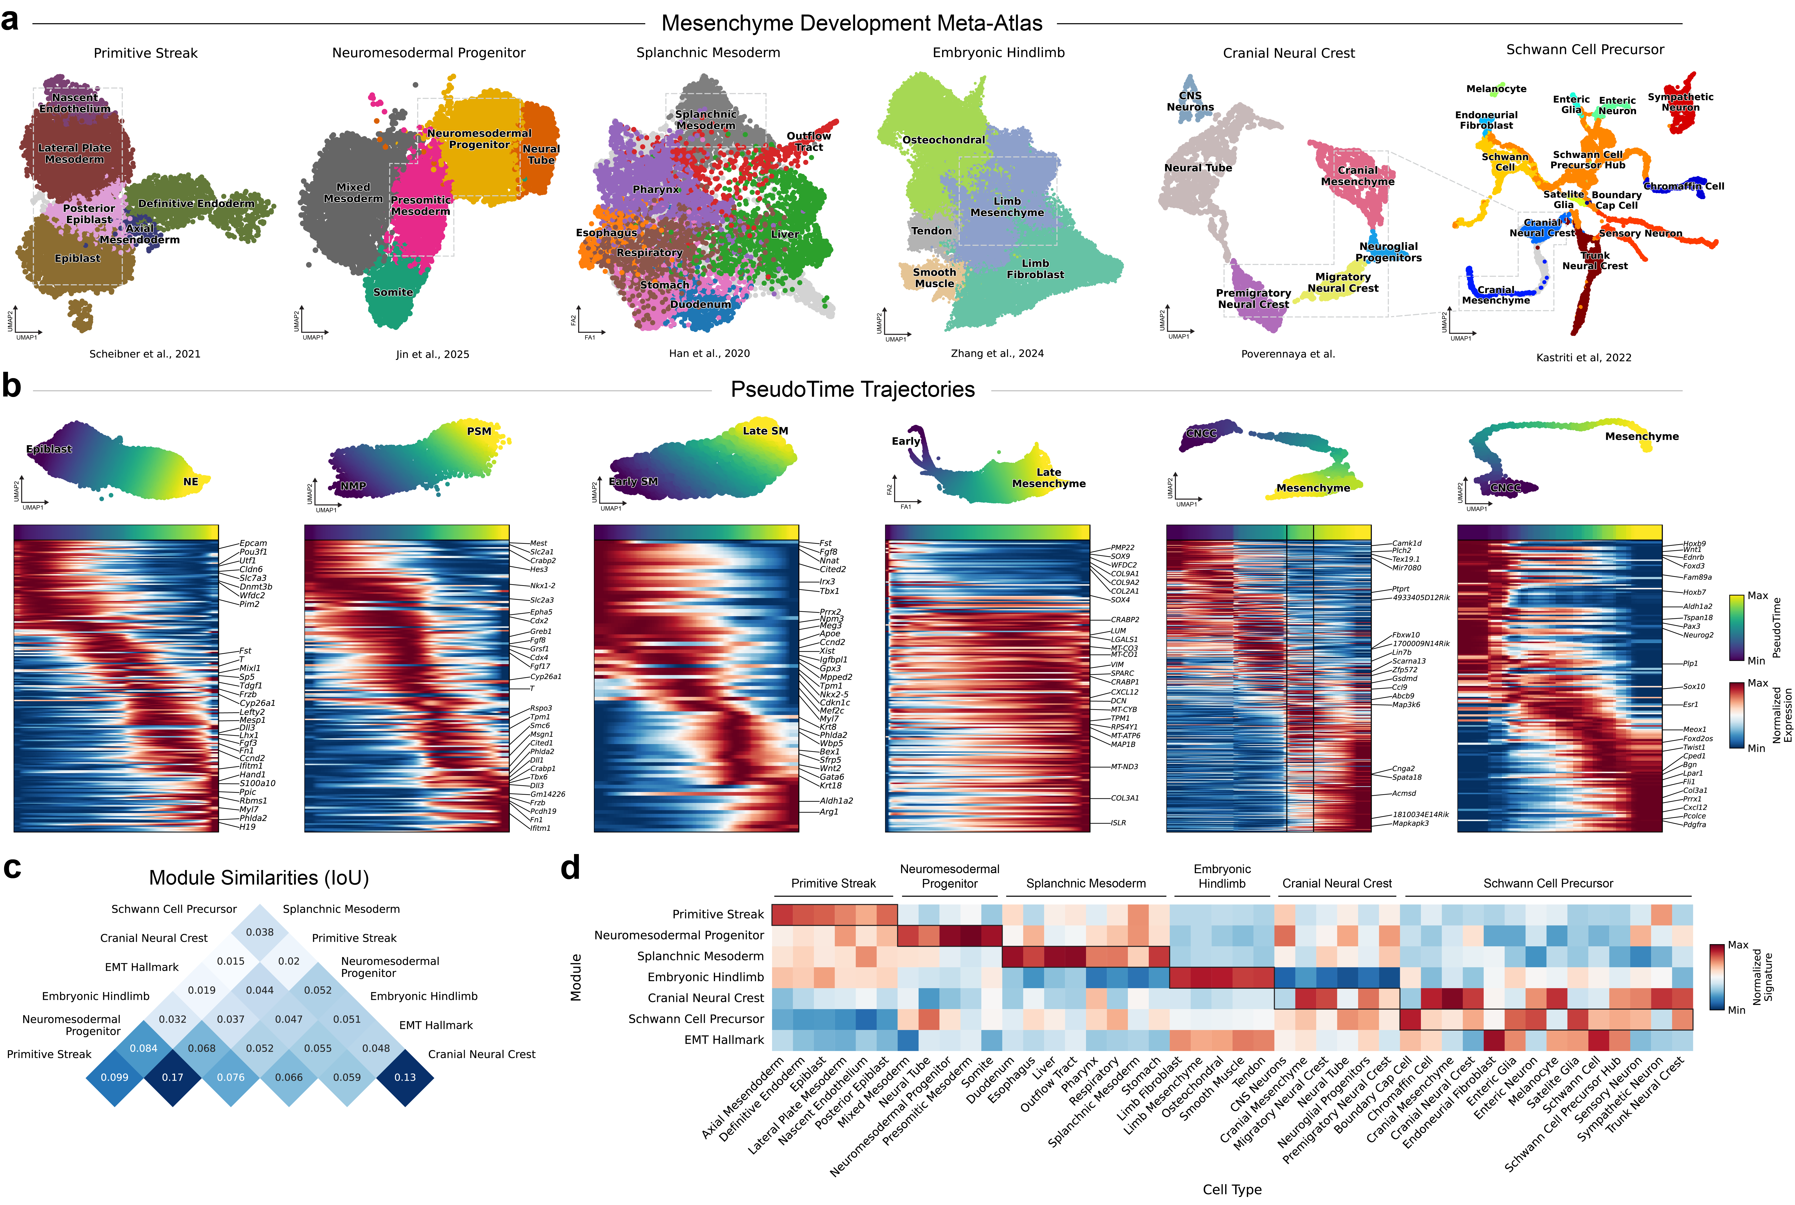
Figure 2: Mesenchyme Development Meta-Atlas
(a)

Mesenchymal PseudoTime Trajectories
Text here.

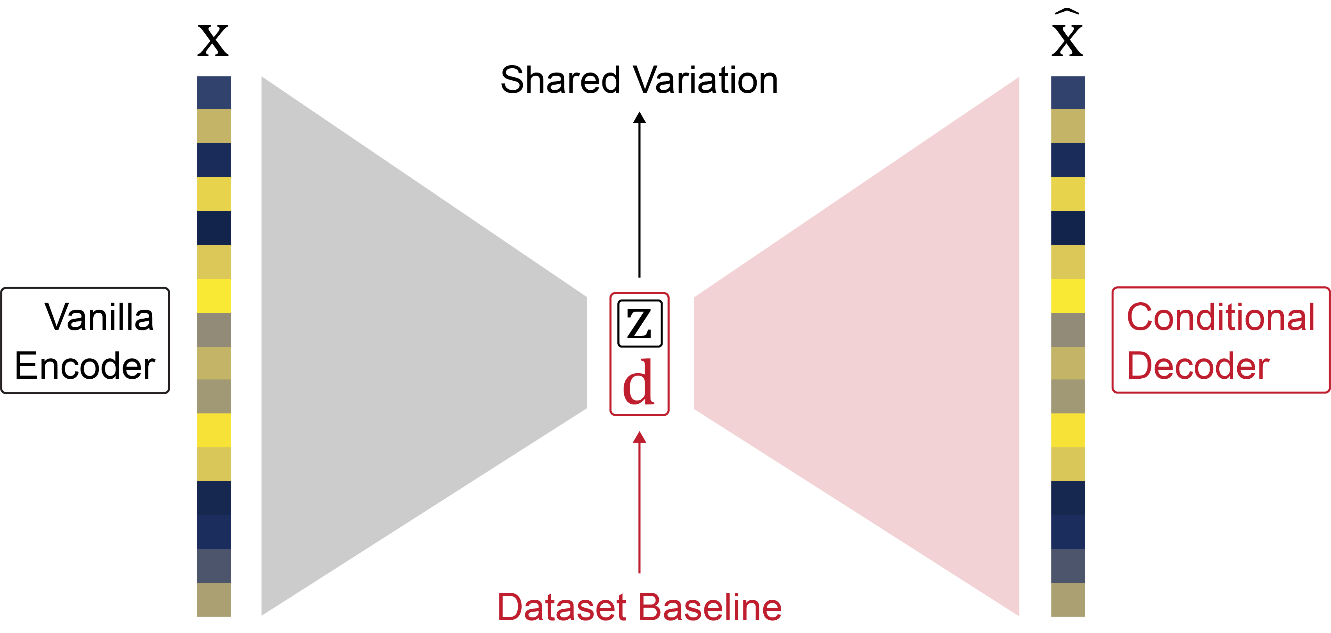
Figure 3: MesenCoder Architecture
Description here.

