Results
Mesenchyme Development Meta-Atlas
To facilitate our unbiased and comprehensive benchmarking of mesenchymal cell states across cancers, we first collected publicly available single-cell RNA-sequencing (scRNA-seq) datasets to construct a mesenchyme development meta-atlas (herein referred to as the “meta-atlas”) that contained epithelial, mesenchymal, and intermediate cell states across key transitions during embryonic development (Figure 2a, Supplemental Table 1). These datasets covered multiple stages of mesoderm and mesenchyme development including primary EMT (e.g., gastrulation and neural crest delamination), secondary EMT (e.g., visceral organogenesis), partial EMT (e.g., posterior somitogenesis), and post-EMT lineage specification (e.g., limb bud morphogenesis) (Thiery et al., 2009; Martin, 2022). These developmental milestones encompassed numerous lineage- and tissue-defining events that facilitated the formation of diverse mesodermal structures such as the connective tissues of the face, hindlimbs, posterior axial skeleton, and foregut (McLin, Henning and Jamrich, 2009; McQueen and Towers, 2020; Fabian and Crump, 2023), as well as ectodermal tissues such as the peripheral nerves and posterior spinal cord (Martin, 2022; Murtazina and Adameyko, 2023). Because these datasets displayed both conserved hallmarks of mesenchymization and EMT as well as unique features related to their specific cell types, tissues, and epigenetic states, we reasoned that our meta-atlas constituted an appropriate benchmark for assessing similar processes of mesenchymization across heterogeneous cancer cell states.
Our meta-atlas comprised six scRNA-seq datasets collected from mouse and human tissues during embryonic and post-embryonic development including epiblast, splanchnopleure, limb buds, and neural crest. Two datasets encompassed highly pluripotent cells derived from the posterior epiblast, namely the primitive streak (PS)—including lateral plate mesoderm (LPM) and definitive endoderm (DE)—and the bipotent neuromesodermal progenitors (NMPs) that generated the posterior somites and neural tube (Figure 2a, two leftmost panels). During gastrulation ($\sim$E6.5), the PS-forming posterior epiblast cells underwent a lineage bifurcation between the fully mesenchymal LPM and the hybrid epithelial/mesenchymal (E/M) DE, whereas during posterior somitogenesis ($\sim$E8.5), the bipotent NMPs underwent a lineage bifurcation
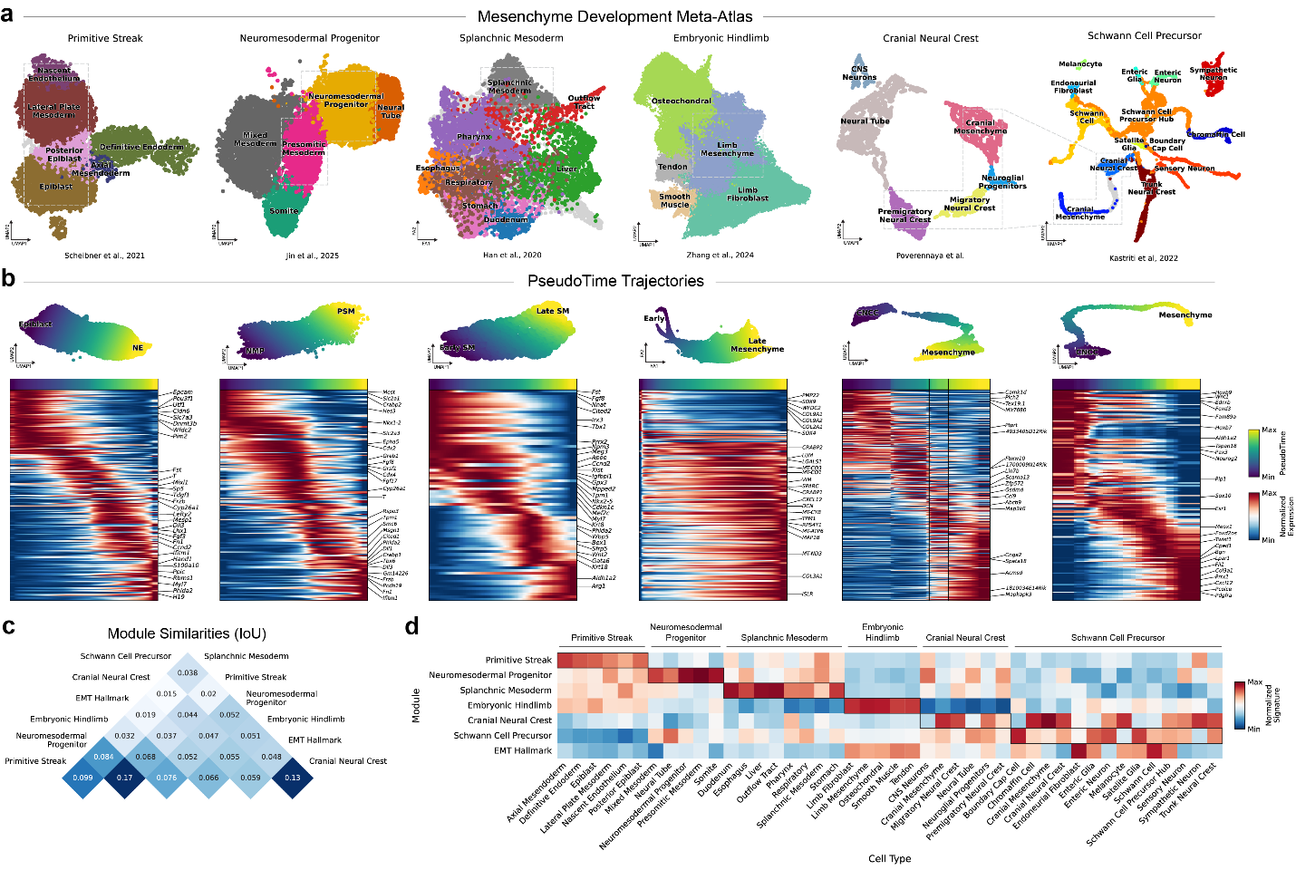
Figure 2: Mesenchyme Development Meta-Atlas
(a)

between the mesenchymal presomitic mesoderm and the epithelial neural tube (Scheibner et al., 2021; Jin et al., 2025). These datasets therefore constituted a broad spectrum of epithelial, mesenchymal, and hybrid E/M states spanning timepoints before, during, and after EMT across pluri- and multipotent stem cells, representing an important benchmark for cancer cell mesenchymization.
Two additional datasets in the meta-atlas represented further mesenchymal phenotypes and transcriptional states across LPM-derived tissues: splanchnic mesoderm (SM), which constituted the mesenchymal components of the visceral organs such as the liver, stomach, and lungs; and embryonic hindlimb-derived mesenchyme that formed the connective tissues of the limbs, including the bones, cartilage, tendons, and smooth muscle (Figure 2a, middle two panels). While both datasets encompassed multiple post-EMT cell types and lineages, the earliest SM-derived cells ($\sim$E8.5) also captured the latter stages of a secondary EMT in the transient mesodermal epithelium of the splanchnopleure (Han et al., 2020; Zhang et al., 2024). Unlike the PS and NMPs, these datasets primarily represented the later stages of mesenchymization and EMT and therefore constituted a better developmental benchmark for fully mesenchymized cancer cells either during or after metastatic migration.
Lastly, to characterize non-mesodermal mesenchymal lineages and provide positive controls for cross-dataset comparisons, we included a pair of corresponding neural crest cell (NCC) datasets in the meta-atlas (Figure 2a, two rightmost panels). The first dataset contained Schwann cell precursors (SCPs)—including many derivatives of cranial and trunk NCCs such as cranial mesenchyme, fibroblasts, melanocytes, neuroendocrine cells, and peripheral neurons and glia—while the second dataset comprised the same cranial NCCs (CNCCs) alongside additional premigratory CNCCs collected one day earlier at E8.5 (Kastriti et al., 2022) (Poverennaya). Both datasets therefore comprised a shared lineage of NCC-derived cranial mesenchyme spanning mid-to-late EMT, while the second dataset included earlier epithelial stages as well. Notably, many non-mesenchymal derivatives of NCCs such as melanocytes and neuroendocrine cells frequently give rise to highly aggressive and metastatic cancers such as melanoma and neuroblastoma, respectively (White and Zon, 2008; Kameneva et al., 2021). Thus, CNCCs represented an essential benchmark for various mesenchymized cancers including both carcinomas and non-epithelial malignancies.
Mesenchymization PseudoTime Trajectories

