call AddCharacter(1, 'Calse Trspr', 1, 'Warrior', 1, 10, 3, 5, 20, 14);

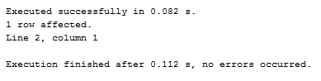

call CreateTeam('Team Awesome', 1);

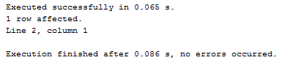

call EditCharacter(1, 'Reginald', 'Calse Trspr', 2, 'Mage', 10, 2, 3, 4, 15, 20);

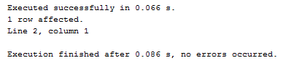

call EditTeamName('Team Awesome', 'Team Kinda Awesome');

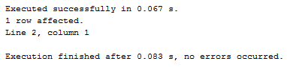

call GetCharacterGear(1, 'Reginald');

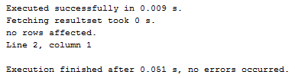

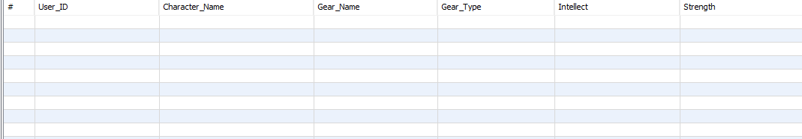

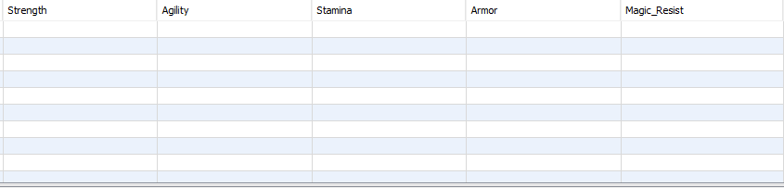

call GetCharacterNamesByID(1);

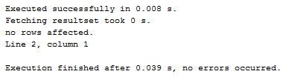

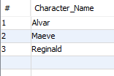

call GetCharacterStats(1, ‘Alvar’);

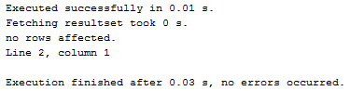





call GetEnemiesByType('Undead');

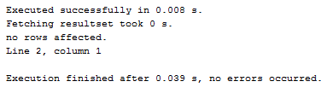

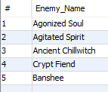

call GetEnemyNamesByType('Undead');

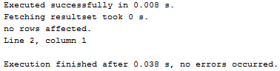

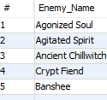

call GetGearByType('Head');

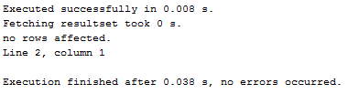

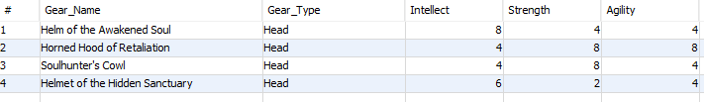

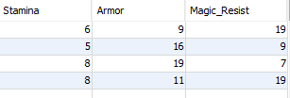

call GetGearNamesByType('Head');

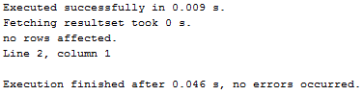

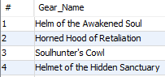

call GetTeamMembers('Team Kinda Awesome');

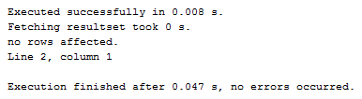



call GetTeamNames();

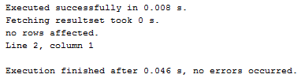

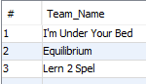

call GetTeamNamesByMember(1);

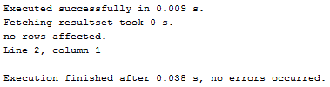



call GetTeamNamesByOwner(1);

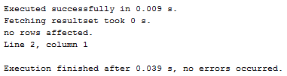



call GetTeams();

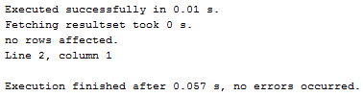

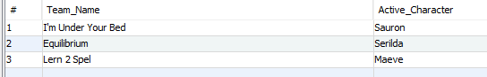

call GetTeamsByOwnerID(1);

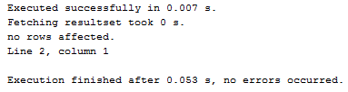



call GetTeamsByUserID(1);

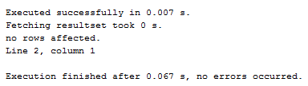



call JoinTeam(4, 1, 'Reginald');

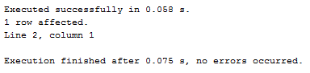

call DeleteCharacter(1, 'Reginald');

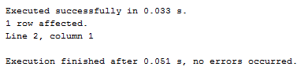

call DeleteTeam('Team Kinda Awesome');

