CUSTOMIZATION REFERENCE

Garden Decorations
  - Current catalog, acquisition methods, Garden Find rates, Garden Bonuses, and runtime artwork
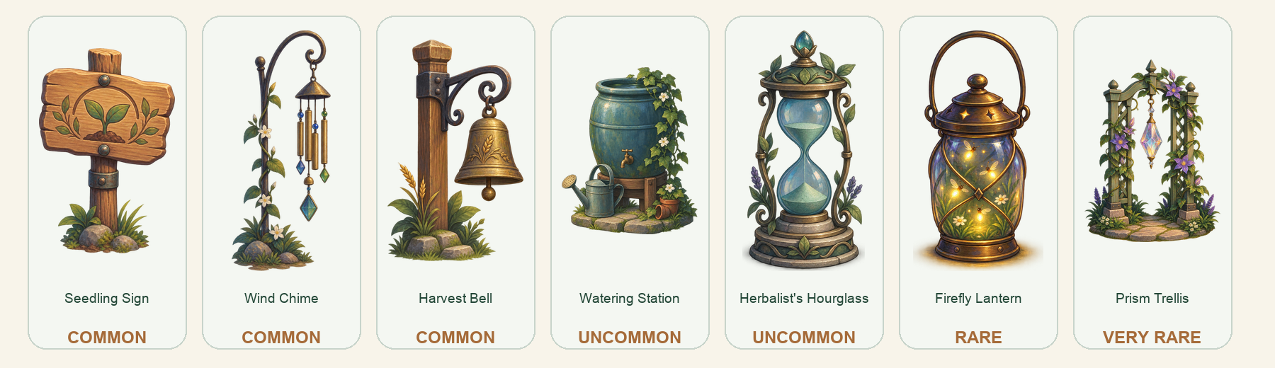
Display any owned decoration while a separate daily-locked Garden Bonus supplies the mechanics. Hiding the artwork never disables the bonus.
Current implementation | 29 August 2026

Catalog at a glance
Garden Find rates apply only to the two discovery-only decorations. Nursery items have fixed prices, while Seedling Sign is included automatically.
Decoration | Rarity | Obtain / price | Garden Find rate | Garden Bonus
Seedling Sign | Common | Included free | - | None
Wind Chime | Common | Nursery  100 Garden Coins | - | +1 Growth every 10 eligible card answers.
Harvest Bell | Common | Nursery  175 Garden Coins | - | +5 Garden Coins when today's cards are completed.
Watering Station | Uncommon | Nursery  250 Garden Coins | - | +1 Growth every 5 eligible card answers.
Herbalist's Hourglass | Uncommon | Nursery  350 Garden Coins | - | Booster Potions add 25% more Booster cards.
Firefly Lantern | Rare | Garden Find | Rare pool: 1 in 2,500; guarantee by 5,000 | +3 Growth every 4 eligible card answers.
Prism Trellis | Very Rare | Garden Find | Very Rare pool: 1 in 10,000; guarantee by 20,000 | Bank 1.5 Growth per eligible card; release it when Today's Cards are completed.
Rate note. The listed chance is the tier roll. A successful tier roll selects uniformly among that tier's unowned rewards. The hard guarantee therefore guarantees a tier discovery, not a particular decoration while multiple rewards remain.

Display and Garden Bonus
Garden Decorations have two independent selections so cosmetic preference never forces a mechanical choice.
Displayed in Garden | Controls the one prop shown on the shared stone pad. It may change at any time or be hidden without changing rewards.
Garden Bonus active today | Locks on the first eligible answer of the Anki day. A later selection is queued for the next Anki day and cannot affect today's rewards.
Persistent cadence. Wind Chime, Watering Station, and Firefly Lantern keep partial cycle progress across sessions, Anki cutoffs, hidden artwork, and days when another bonus is active.

Visual decoration profiles
The images below are the current transparent runtime artifacts, enlarged for reference. In the live Garden, every decoration uses the same fixed anchor, standardized canvas scale, and shared stone pad.
Seedling Sign seedling_sign
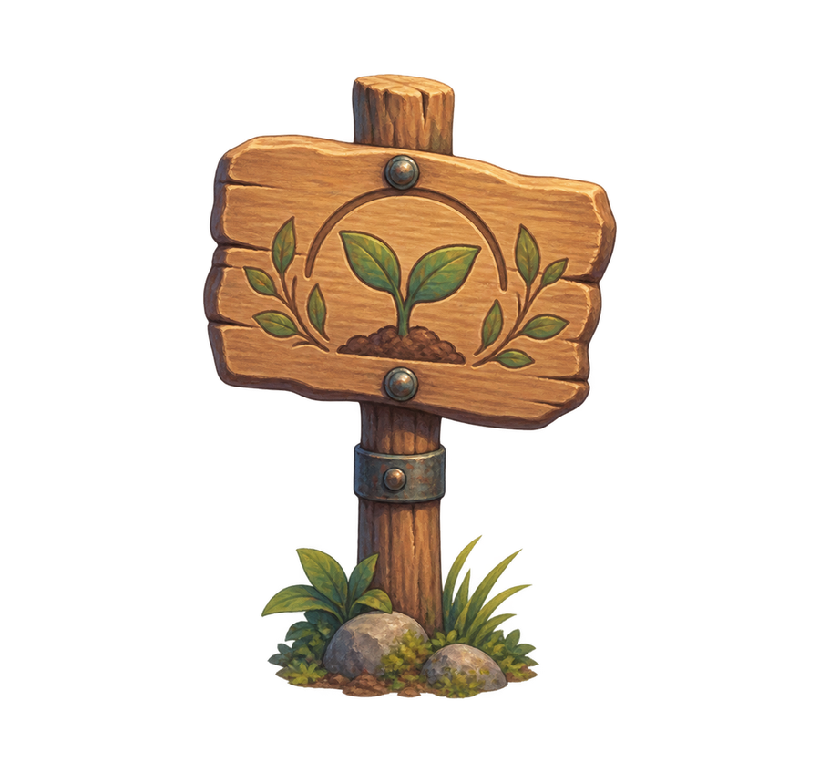  COMMON | Obtain: Included free  Price: None  Garden Find rate: Not a Garden Find  Garden Bonus: None  Runtime asset: assets/v6_storybook_gouache/garden_features/seedling_sign.webp
Acquisition detail. Included automatically; no discovery roll is required.
Wind Chime wind_chime
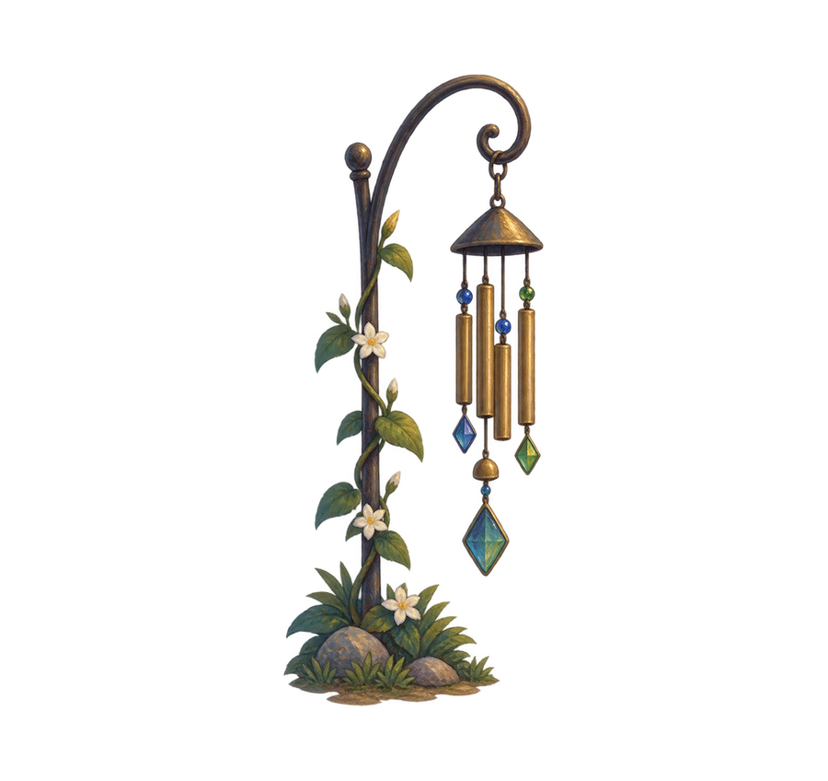  COMMON | Obtain: Nursery  Price: 100 Garden Coins  Garden Find rate: Not a Garden Find  Garden Bonus: +1 Growth every 10 eligible card answers.  Runtime asset: assets/v6_storybook_gouache/garden_features/wind_chime.webp
Acquisition detail. Purchased directly from the Nursery.

Harvest Bell harvest_bell
  COMMON | Obtain: Nursery  Price: 175 Garden Coins  Garden Find rate: Not a Garden Find  Garden Bonus: +5 Garden Coins when today's cards are completed.  Runtime asset: assets/v6_storybook_gouache/garden_features/harvest_bell.webp
Acquisition detail. Purchased directly from the Nursery.
Watering Station watering_station
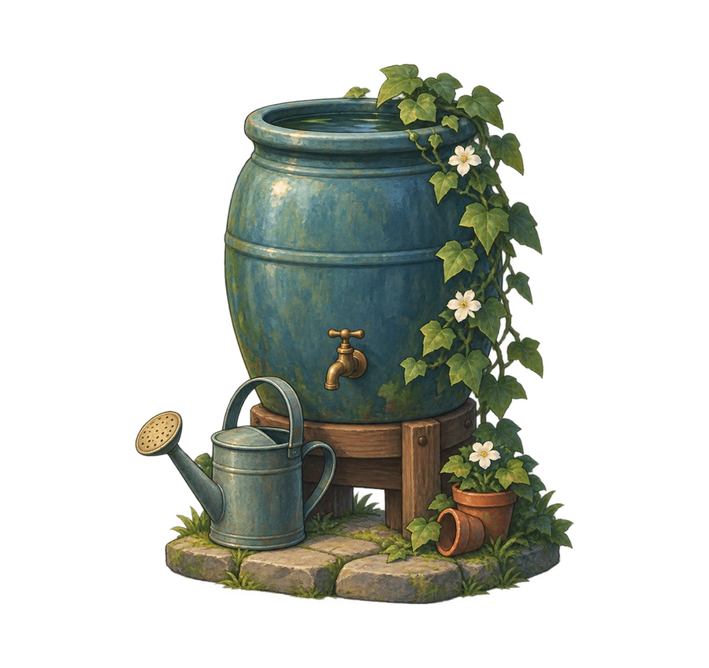  UNCOMMON | Obtain: Nursery  Price: 250 Garden Coins  Garden Find rate: Not a Garden Find  Garden Bonus: +1 Growth every 5 eligible card answers.  Runtime asset: assets/v6_storybook_gouache/garden_features/watering_station.webp
Acquisition detail. Purchased directly from the Nursery.

Herbalist's Hourglass herbalist_hourglass
  UNCOMMON | Obtain: Nursery  Price: 350 Garden Coins  Garden Find rate: Not a Garden Find  Garden Bonus: Booster Potions add 25% more Booster cards.  Runtime asset: assets/v6_storybook_gouache/garden_features/herbalist_hourglass.webp
Acquisition detail. Purchased directly from the Nursery.
Firefly Lantern firefly_lantern
  RARE | Obtain: Garden Find  Price: Not purchasable  Garden Find rate: Rare pool: 1 in 2,500; guarantee by 5,000  Garden Bonus: +3 Growth every 4 eligible card answers.  Runtime asset: assets/v6_storybook_gouache/garden_features/firefly_lantern.webp
Acquisition detail. The Rare environment pool rolls once per newly processed eligible card at a base rate of 1 in 2,500 and guarantees one Rare-tier discovery within 5,000 eligible cards. When both Firefly Lantern and Rainbow Horizon are unowned, uniform selection makes the Lantern's starting direct base chance 1 in 5,000 per eligible card.

Prism Trellis prism_trellis
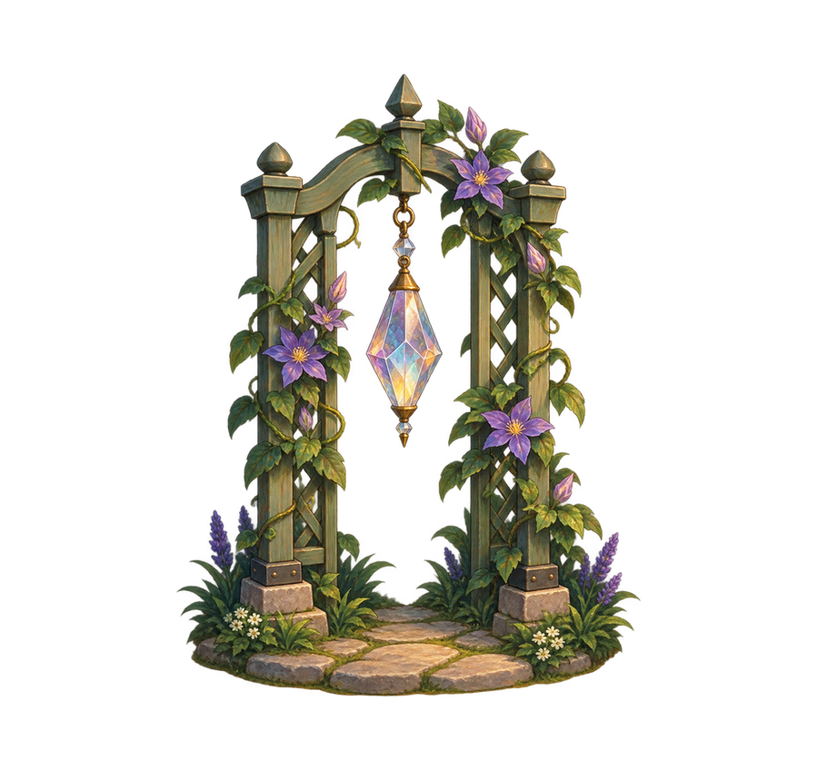  VERY RARE | Obtain: Garden Find  Price: Not purchasable  Garden Find rate: Very Rare pool: 1 in 10,000; guarantee by 20,000  Garden Bonus: Bank 1.5 Growth per eligible card; release it when Today's Cards are completed.  Runtime asset: assets/v6_storybook_gouache/garden_features/prism_trellis.webp
Acquisition detail. The Very Rare environment pool rolls once per newly processed eligible card at a base rate of 1 in 10,000 and guarantees one Very Rare-tier discovery within 20,000 eligible cards. When both Prism Trellis and Halloween Garden are unowned, uniform selection makes the Trellis's starting direct base chance 1 in 20,000 per eligible card.

How Garden Find rates work
Garden Decoration discoveries come from the environment discovery pool, which is separate from Standard Garden Finds. Each unfinished rarity tier checks independently on every newly processed eligible card.
Tier | Base tier chance | Hard guarantee | Current rewards in tier
Rare | 1 in 2,500 | 5,000 eligible cards | Firefly Lantern; Rainbow Horizon
Very Rare | 1 in 10,000 | 20,000 eligible cards | Prism Trellis; Halloween Garden
Owning the other reward in a tier removes it from selection. Once only the Garden Decoration remains unowned, the decoration receives the tier's full base chance and the next tier guarantee.
Implementation authority: ankigarden/environment.py and ankigarden/garden_finds.py; runtime artwork paths are registered in ankigarden/assets/manifest.json.

