1. Please submit a link to your GitHub repository for your class.

https://github.com/caleblj/CS450

1. Describe your overall approach to implementing the algorithm in code. How are your classes/data structures organized? How do you keep track of the necessary pieces for back-propagation.

It appends the list of weights that are in the list and changes them accordingly to the error that is found.

1. Describe the part of the assignment that gave you the most trouble, and how you overcame it.

This biggest part was getting the program to learn properly which I managed to figure out once I got the changing of the weights right.

1. Produce at least one graph to show the training progress for the Iris dataset.

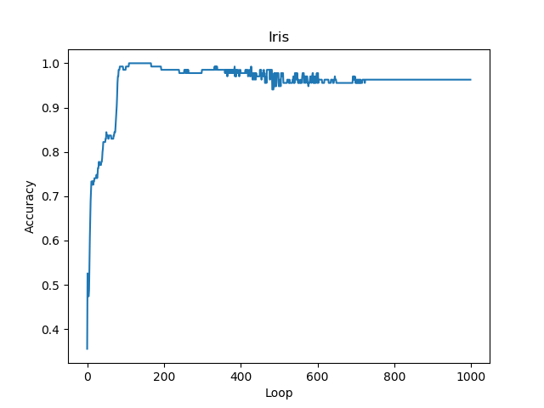

1. Compare your results on the Iris dataset to those of an existing implementation.

They were close but was a little off with my accuracy. I managed to get 72% accuracy when the classifier was supposed to get around 60%.

1. Produce at least one graph to show the training progress for the Diabetes dataset.

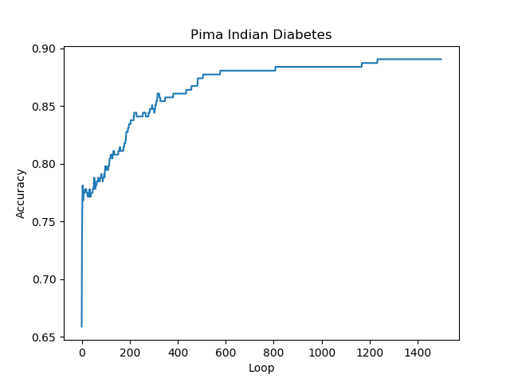

1. Compare your results on the Diabetes dataset to those of an existing implementation.

They were much closer than the Iris. I managed to get 74% accuracy when the classifier gave 77%.

1. Describe any efforts you made to go above and beyond.

N/A

1. Please state which category you feel best describes your assignment and give a 1-2 sentence justification for your choice: A) Some attempt was made, B) Developing, but significantly deficient, C) Slightly deficient, but still mostly adequate, D) Meets requirements, E) Shows creativity and excels above and beyond requirements.

D) I was able to get the classifier and model done but wasn’t really able to go too far past that.