ADVANCED RADAR RESEARCH CENTER

NORMAN, OK



EXPLANATION OF TECHNICAL SERVICE

Title: Explanation and use of a user interface for a Spatial Interference Mitigation Circuit

Author: Caleb M. Carr

Organization: Advanced Radar Research Center, Norman, OK

Date: 17 September 2019

**Table of Contents**

Request……………………………………………………………………………………………3

Summary of Technical Service…………………...………………………………………………X

Hardware Installation……………………………………………………………………………..X

Using the Interface………………………………………………………………………………..X

Troubleshooting…………………………………………………………………………………..X

Future research……………………………………………………………………………………X

Conclusion………………………………………………………………………………………..X

References…………………………………………………………………………………...……X

**(U) Request**

Caleb J. Fulton, PhD and Robin Irazoqui, PhD requested the design of a user interface in order to control the location a spatial null on a Spatial Interference Mitigation Circuit. The interface was specified to allow the client to immediately update the voltages applied to a tunable filter, and therefore the location of a spatial null.

**(U) Summary of Technical Service**

This interface runs a Matlab application through a three-stage hardware layer to control a series of voltages. In summary, the Matlab software allows the user to manually update each filter’s four varactors. The application also allows the user to hook up the output results of the SIMC to view the placement of the spatial null.

The three-stage hardware layer begins with a USB-to-SPI adapter. This link communicates the output of the Matlab application and converts it into a SPI signal which can be understood by a piece of embedded hardware, which is the next stage. This embedded link is an evaluation board with a built in Digital-to-Analog converter (DAC). The purpose of this stage is to take the binary information the SPI link sends, direct the signal to the right varactor and turn the digital value to an analog output. From here, the series of output voltages are run through an op-amp board to ensure the varactors can hold a value from 0-15V. The eval board itself can amplify up to 12V so the external amplification required is minimal.

The output of the op-amp channel contains the output voltage to each filter. The specific response of the SIMC is highly hardware-dependent so it is important to remember the voltages resulting in a spatial null at an angle (theta, phi) with one filter layout may place its null elsewhere with a different filter construction.

**(U) Hardware Installation**

As discussed above, this interface runs through a three-stage hardware layer. The following components are required:

* *Total Phase* Aardvark I2C-SPI USB Host Adapter
* *Analog Devices* EVAL AD5372EBZ
* Custom op-amp chain (construction files found in GitHub repository).

The pinouts of the adapter and eval board can be found in the Datasheet directory of the repository. When connecting the Aardvark to the Eval board, it is important to ensure the reference voltage on the AD5372 is set to 3V (Link4 = A); this determines the internal 12V amplification. As well, Link 1 must be removed to allow stand-alone operation through the Aardvark.

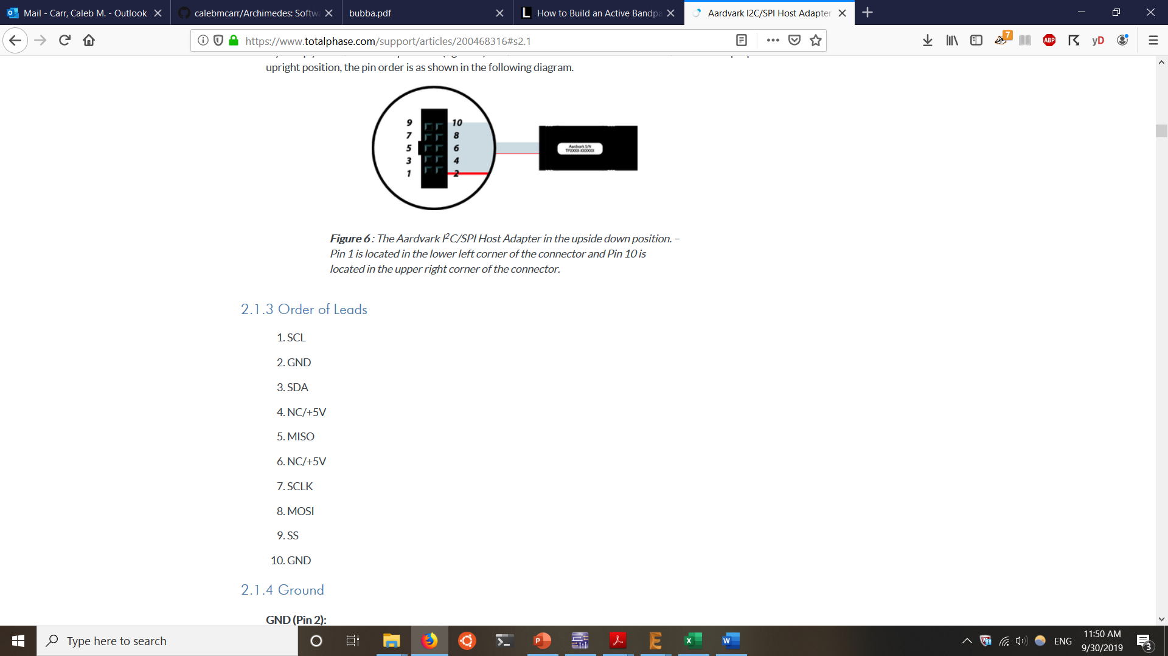 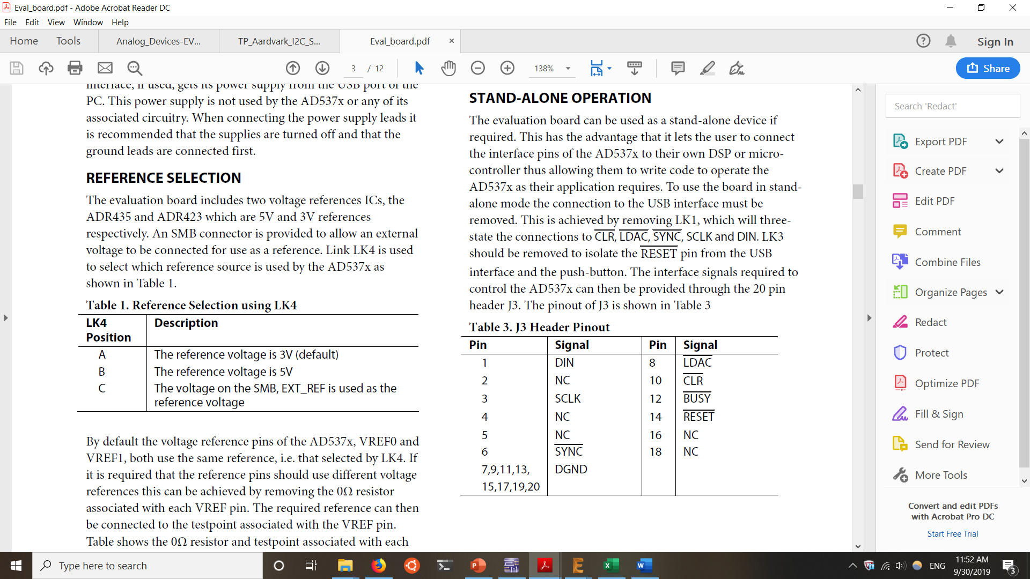

*Figure 1. pinouts of the Aardvark1 and Eval board J3 Header2*

**References**

[1]"Aardvark I2C/SPI Host Adapter User Manual", *Total Phase*, 2019. [Online]. Available: https://www.totalphase.com/support/articles/200468316#s2.1. [Accessed: 30- Sep- 2019].

[2]"Preliminary Technical Data EVAL-AD5370/2/3EBZ", Analog Devices, 2019.