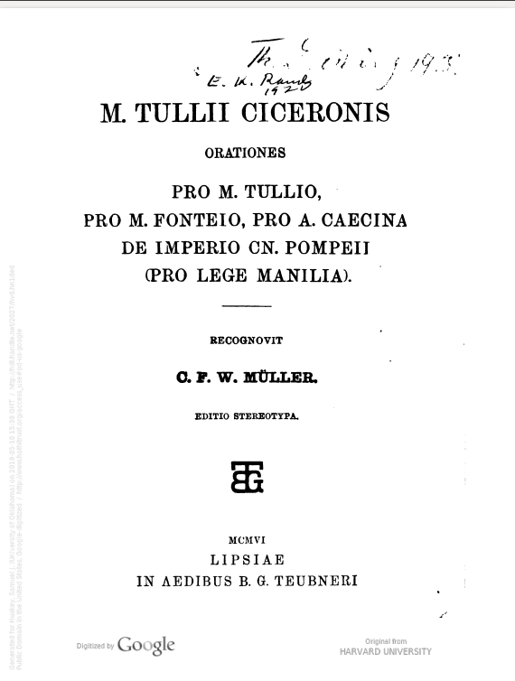
Author
Title
Editor

Publication Notes
Watermark­
Edition Notes

