Caleb Myers

ENPM661

Project 2

Read Me

Welcome to my Project_2 maze solver. The algorithm used was the Dijkstra search algorithm. In order to run this code you will need to have the (copy), (numpy as np), (cv2), and (time) library installed. After getting the necessary library installed follow the steps below to run the code.

1. Open the proj2_Caleb_Myers.py python file.
2. Run the code.
3. The code will prompt you to enter the x and y coordinate of the initial position. Enter the coordinate with respect to the map graph below.

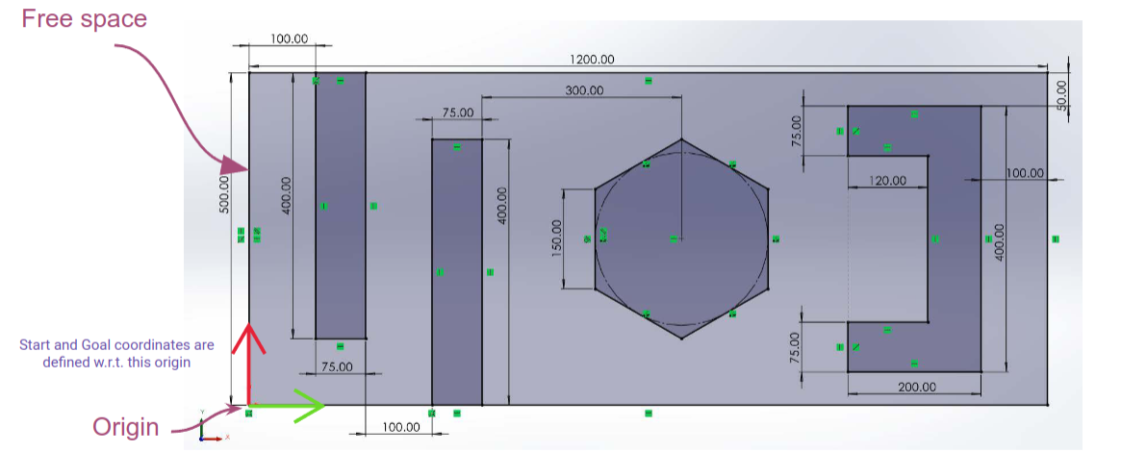

1. The origin is (0,0) and the top right corner is (1200,500). Ensure that the entered position is in the free space.
2. Next enter in the goal position. For example, if you want the initial position to be (0,0) and the goal to be (90,93) enter the following coordinates when prompted.
   1. Look at the Read Me file and type in the initial position.

Input initial x position: 0

Input initial y position: 0

Look at the Read Me file and type in the goal position.

Input goal x position: 90

Input goal y position: 93

1. After entering the goal coordinate the code will run. When finished, the time to complete the program will be printed and a mp4 file named dijsktra_caleb_myers.mp4 will be saved to your folder. This file is a video representation of the search algorithm and the path taken.
2. After this you are all done! Thank you for viewing my Dijkstra maze solver.