Algonquin College Logo

# SCHOOL OF ADVANCED TECHNOLOGY

### ICT - Applications & Programming

### Computer Engineering Technology – Computing Science



A21

Model Definitions (RE/Automaton)

Lab Professor / Lab Session:

Vardaan Sangar / 013

Team:

Name: Caleb Viciana-Arril - Id: 041075766

Language Name: Kobe

Algonquin College Logo

# MODEL TASK[1] FOR ASSIGNMENT 2.1 – Kobe

### Task 1: Language Symbols (2.0 marks)

**List examples:** Define main symbols to be used:

* Special symbols (ex: “{“, “(“, “<=”, etc.)
* Comments
* Variables
* Functions
* Literals (numbers, strings)
* Keywords
* Datatypes

1. **Symbols**

* FUNCTION PARAMETER CONTAINER: ()
* LESS THAN: <
* GREATER THAN: >
* LESS THAN OR EQUAL TO: <=
* GREATER THAN OR EQUAL TO: >=
* EQUALS: ==
* NOT: !
* AND: &&
* OR: ||

1. **Structures**

* COMMENTS: #
* VARIABLES: num, decNum, nameOfPerson
* FUNCTIONS: sum(x, y)

1. **Literals**

* INTEGERS = 1;
* FLOATS: 1.5
* STRING: ‘Caleb’

1. **Keywords**

* def
* If / else
* While / Do-while / for
* return

1. **Datatypes**

* Char
* Int
* Float
* String

### Task 2: RE – Regular Expression (3.0 mark)

**Lexeme Classes:** Define the classes to be used in your regular expression:

**Answer:**

**C = #**

**N = \n**

**L = [A-Z|a-z]**

**D = [0…9]**

**B1 = (**

**B2 = )**

**P = .**

**Q = ‘**

**U = _**

**W = ‘\b’, ‘\t’, ‘\0’**

**O = [^(CNLDB1B2PQUW)]**

Define the RE to be used for: variables, literals and keywords:

**Answer:**

**\* Comments: C(^N)*N**

**\* Variables: L(L|D|U)\***

**\* Methods: L(L|D|U)*B1**

**\* Integer: D+**

**\* Float: D*PD+**

**\* String: Q(^Q)*Q**

**\* Keywords: L+**

### Task 3: TD – Transition Diagram (3.0 marks)

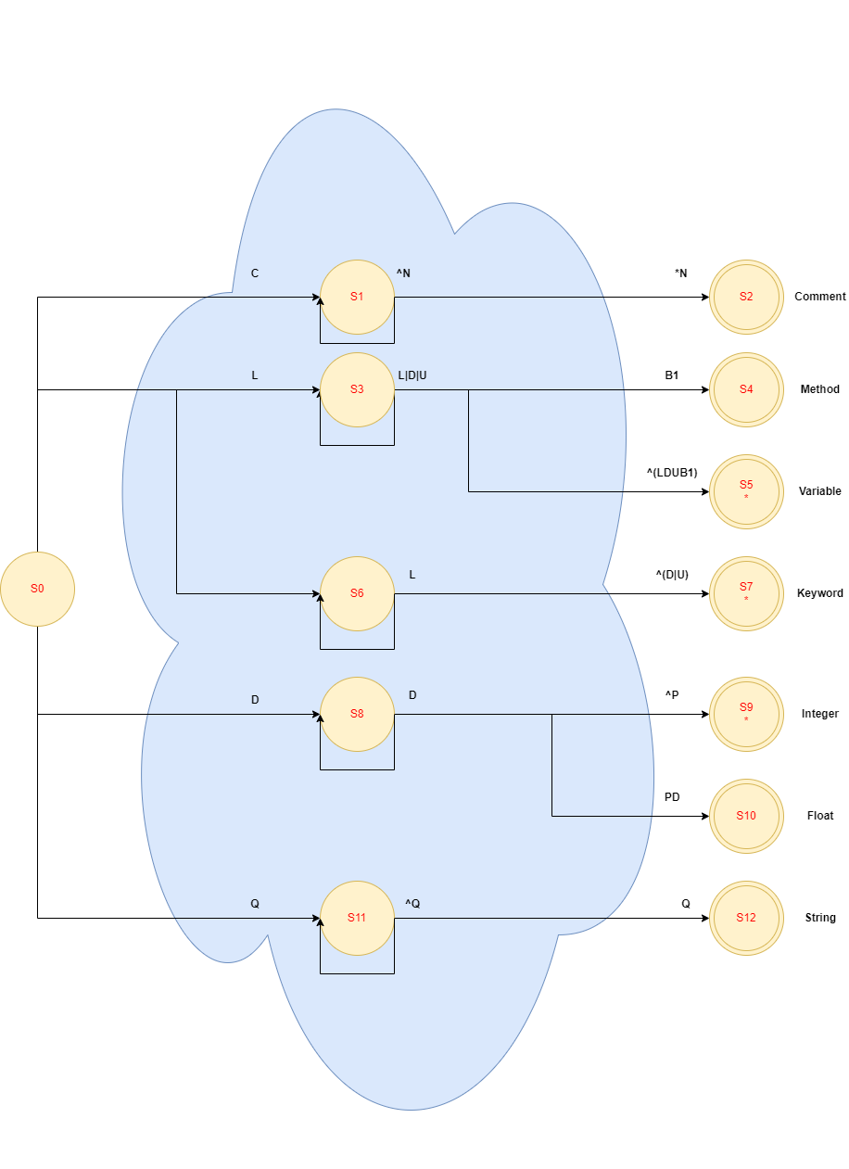

### Task 4: TT – Transition Table (2.0 marks)

|  |  |  |  |  |  |  |  |  |  |  |  |
| --- | --- | --- | --- | --- | --- | --- | --- | --- | --- | --- | --- |
| **Input** | **Input Symbol** | | | | | | | | | | |
| **State / Classes** | **0** | **1** | **2** | **3** | **4** | **5** | **6** | **7** | **8** | **9** | **10** |
|  | **C(#)** | **N(\n)** | **L(A-Z|a-z)** | **D(0-9)** | **B1(‘(‘)** | **B2(‘)’)** | **P(.)** | **Q(‘)** | **U(_)** | **W(‘\b’, ‘\t’, ‘\0’)** | **O(other)** |
| S0 | 1 | ES | 3 | 8 | ES | ES | ES | 11 | ES | ES | ES |
| S1 | 1 | 2 | 1 | 1 | 1 | 1 | 1 | 1 | 1 | 1 | 1 |
| S2 | FS | FS | FS | FS | FS | FS | FS | FS | FS | FS | FS |
| S3 | 5 | 5 | 3 | 3 | 4 | 5 | 5 | 5 | 3 | 5 | 5 |
| S4 | FS | FS | FS | FS | FS | FS | FS | FS | FS | FS | FS |
| S5 | FS | FS | FS | FS | FS | FS | FS | FS | FS | FS | FS |
| S6 | 7 | 7 | 6 | 6 | 7 | 7 | 7 | 7 | 6 | 7 | 7 |
| S7 | FS | FS | FS | FS | FS | FS | FS | FS | FS | FS | FS |
| S8 | 9 | 9 | 9 | 8 | 9 | 9 | 10 | 9 | 9 | 9 | 9 |
| S9 | FS | FS | FS | FS | FS | FS | FS | FS | FS | FS | FS |
| S10 | FS | FS | FS | FS | FS | FS | FS | FS | FS | FS | FS |
| S11 | 11 | 11 | 11 | 11 | 11 | 11 | 11 | 12 | 11 | 11 | 11 |
| S12 | FS | FS | FS | FS | FS | FS | FS | FS | FS | FS | FS |

*Update: Feb 4th 2024.*

1. Adapted from resources developed by Prof. Svillen Ranev (Algonquin College, 2019)