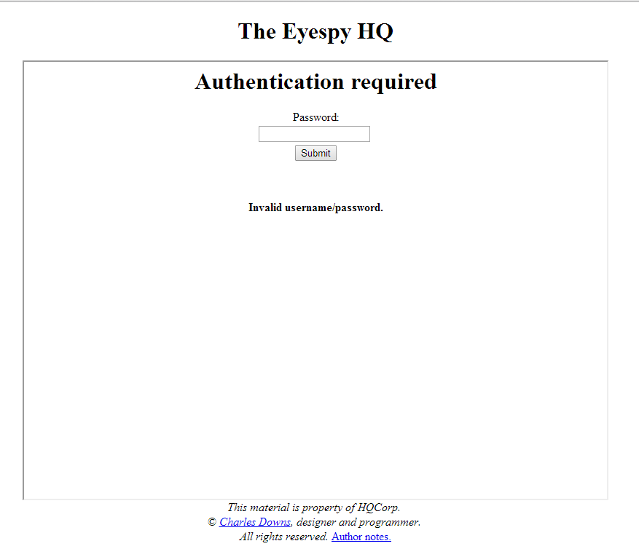Valid data testing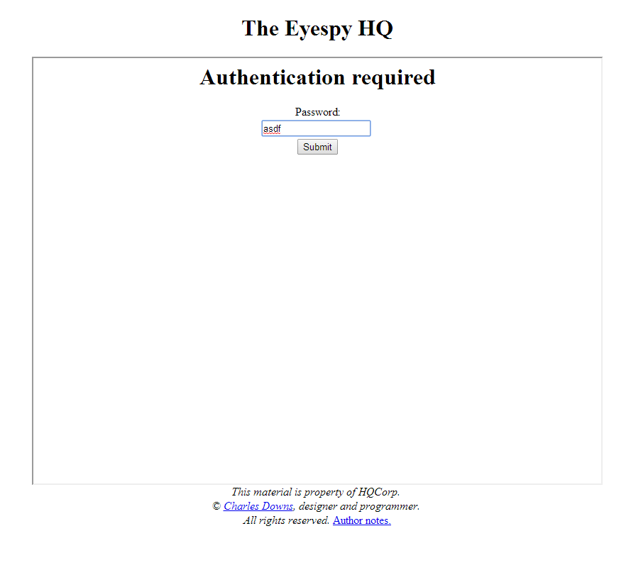 performed on Eyespy HQ.

Figure 1, T1 - Invalid password CAUSE

Figure 2 - T1, Invalid Password EFFECT

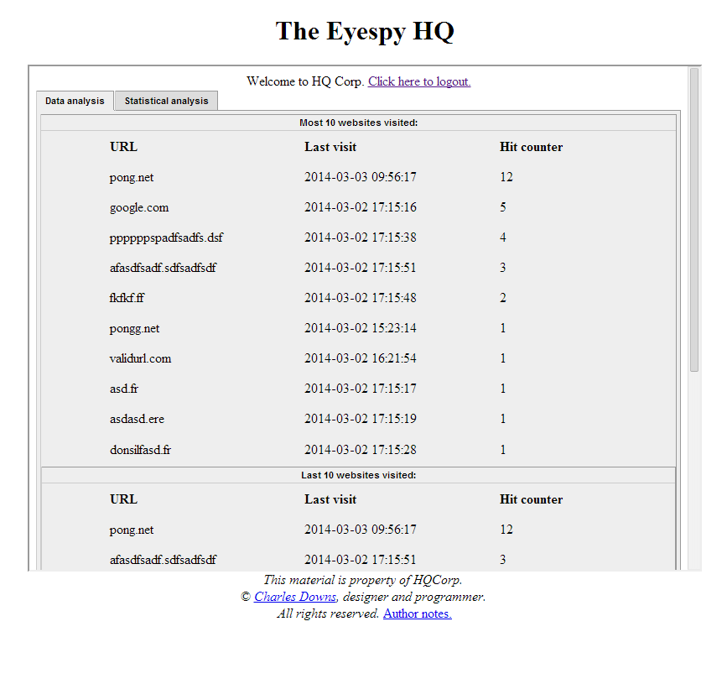

Figure - T1, valid password result logon

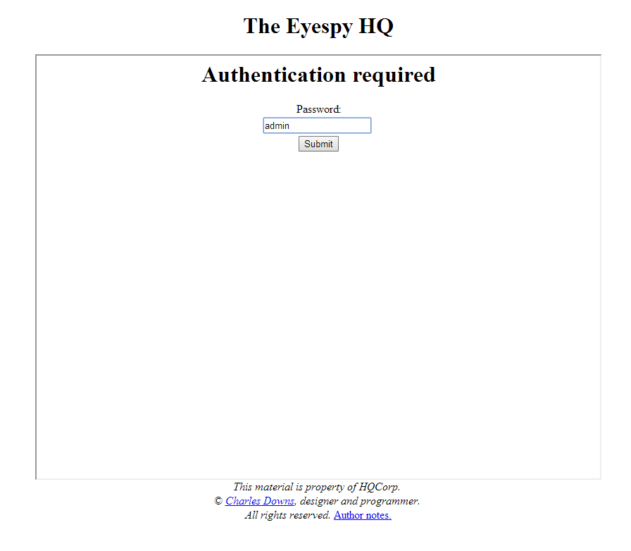

Figure - T1, Valid password entered

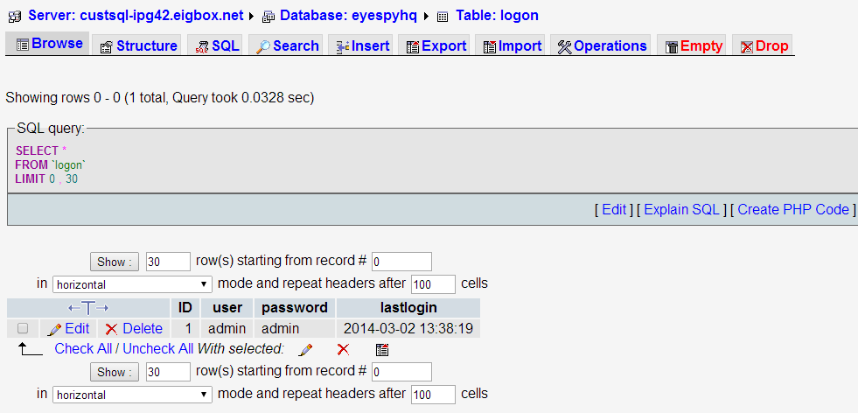

Figure - T1, proof of valid password

**The following messages are issued by Eyespy Core, valid data.**

Figure - T2.1, Invalid URL

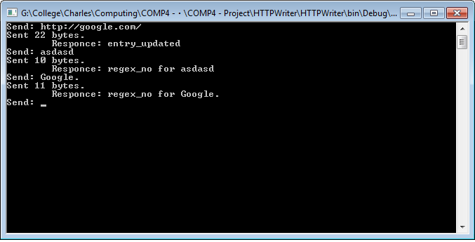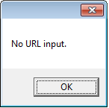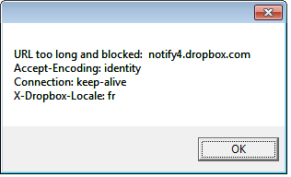

Figure - T2.2, No URL submitted

**The following messages are issued by Submit.php, the URL submission/validation PHP script.**

Result when URL submitted to the Submit.php script is VALID. **T3, valid URL.**

Result when URL does not match the Regex pattern. **T3, invalid URL.**

Result when the URL is missing a domain name. **T3, invalid URL.**

**Malicious data test, the following messages are issued by Eyespy HQ.**

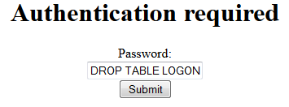

Figure - T4.1 Malicious data input (CAUSE)

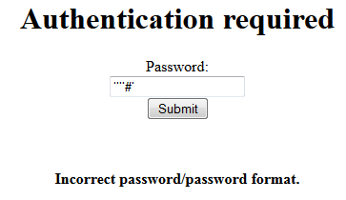

Figure - T4.2, Malicious data response (EFFECT) + invalid input attempted (CAUSE)

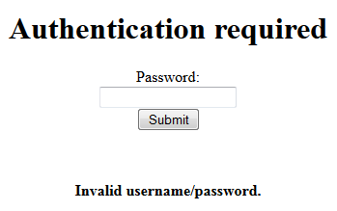

Figure . T4 - Invalid data response