NCTU-CS Digital System Lab.

Online Test (1/8)

Design: Plane

Data Preparation

Prepare following files by yourselves:  
plane.v  
plane.ucf

Design Description and Examples

In this test,there are two air plane on the screen after reset.

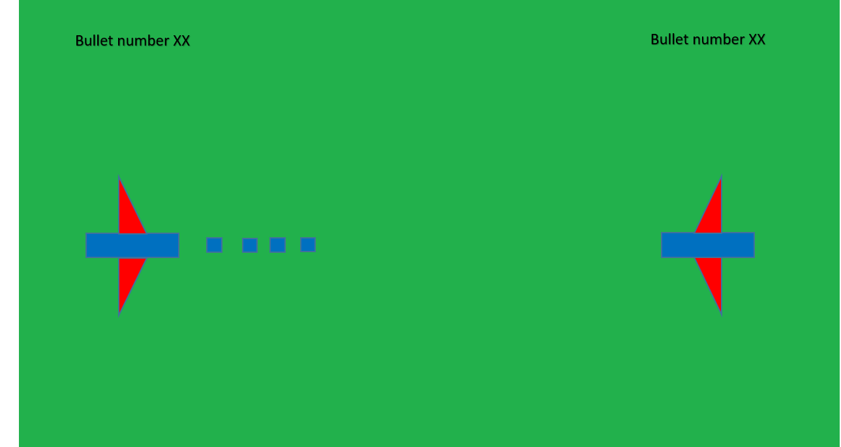

1.The air plane can move up or down，and fierd bullets.

2.If the plane was hit by bullet, the game is over.

3.When game over, you should display “XX is Game Over”on the screen.

4. When you run out of bullets，you should display “Game Over”on the screen.

4.Left is A，right is B

Specifications

1. After reset，game is start，bullet’s number is 20.
2. The air plane can move up and down only.
3. The air plane moves 20 pixel per press for up or down，and the bullet moves 4 pixel per half second.
4. The plane’s wing should be 40 pixel，and the bullet is 4*4 pixel.
5. A side’s “up=w” “down=s” “fire=d”，B side’s “up=up” “down=down” “fire=left.”
6. All outputs are synchronized at clock positive edge.
7. It is asynchronous, active-high reset architecture.

Grading Policy

Function Validity: 80%

Questions: 20%

Note

Name to the file name of .v file and .rar file before upload file on e3 platform:

plane _0556123_陳小明.v

plane _0556123_陳小明.rar