Database Homework 2
0416037 李家安
OS: Fedora 23 Server
RAM: DDR4 8G * 2
Storage 480G SSD

1.
SQL:

SELECT COUNT(*)
FROM (
SELECT DISTINCT Origin, Dest
FROM records
) T;

TIME:
27.64 sec

ANS:
6901
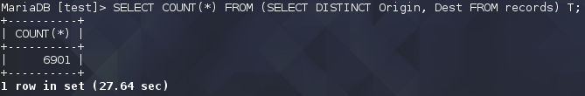
2.
SQL:

SELECT COUNT(*) AS flaitAmount
FROM records
WHERE Dest='JFK' AND ActualElapsedTime BETWEEN 60 AND 180;

TIME:
6.11 sec

ANS:
303868
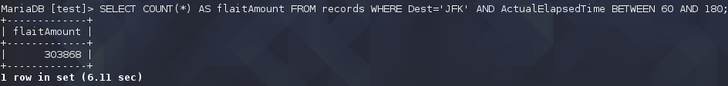
3.
SQL:

SELECT model, COUNT(*) AS modelAmount
FROM plane_data
WHERE model LIKE '737%'
GROUP BY model;

TIME:
0.01 sec

ANS:
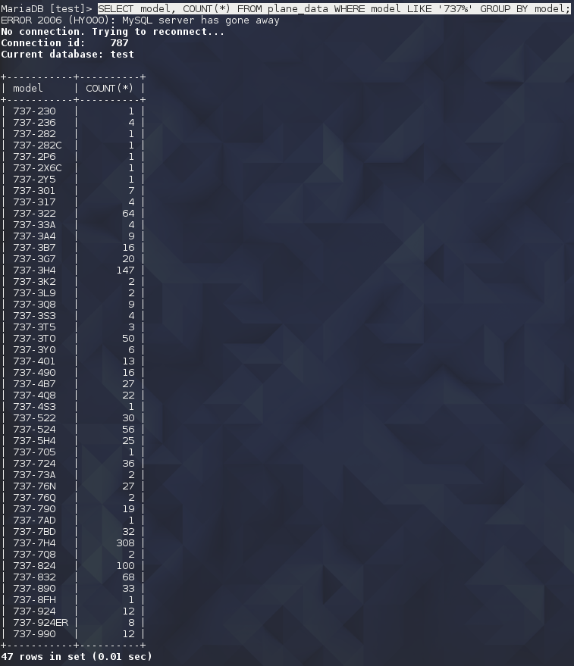
4.
SQL:

CREATE INDEX i_r4
ON records(TailNum);
CREATE INDEX i_p4
ON plane_data(tailnum);

SELECT model, AVG(Distance)/AVG(ActualElapsedTime) AS AVG_speed
FROM (
SELECT model, ActualElapsedTime, Distance
FROM records r RIGHT JOIN plane_data p ON r.TailNum=p.tailnum
) T
WHERE model IS NOT NULL AND Distance IS NOT NULL AND ActualElapsedTime IS NOT NULL AND ActualElapsedTime!=0
GROUP BY model;

DROP INDEX i_r4
ON records;
DROP INDEX i_p4
ON plane_data;

TIME:
2 min 13.18 sec + 0.05 sec + 1 min37.78 sec = 3 min 56.01 sec

ANS:
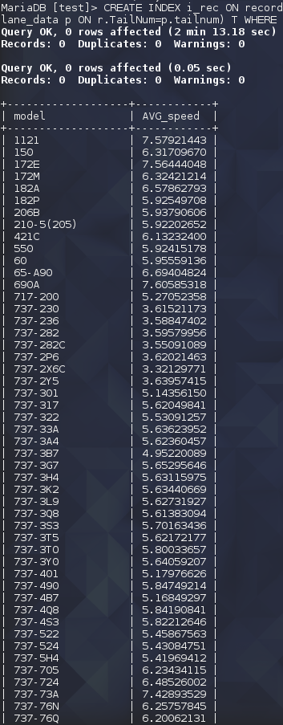
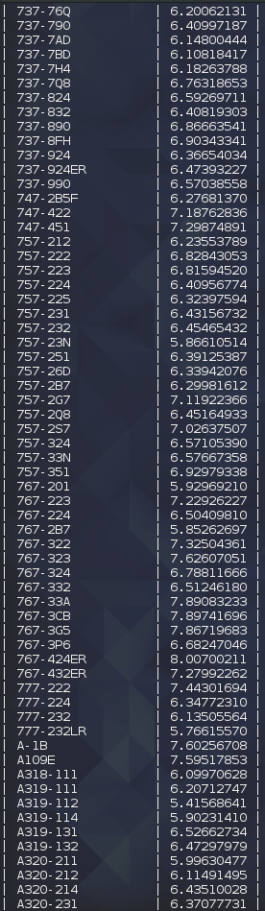
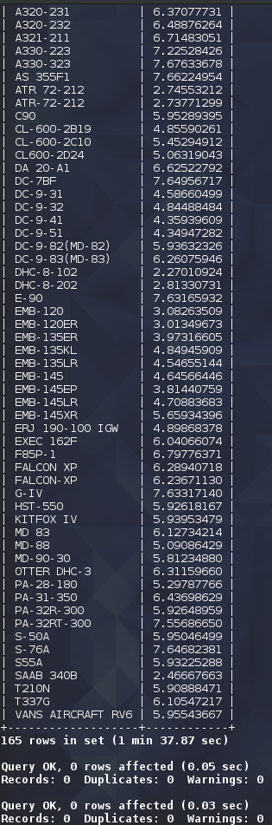

5.
SQL:
TIME:
ANS:

6.
SQL:

SELECT DISTINCT model
FROM plane_data
WHERE model IS NOT NULL AND tailnum NOT IN (
SELECT DISTINCT TailNum
FROM records
WHERE year='2008'
);

TIME:
14 min 20.93 sec

ANS:
11AC
M-5-235C
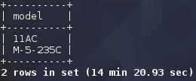

7.
SQL:

CREATE INDEX i_r7
ON records(TailNum);
CREATE INDEX i_p7
ON plane_data(tailnum);

SELECT DISTINCT manufacturer
FROM (
SELECT manufacturer, ArrDelay
FROM records r, plane_data p
WHERE r.TailNum=p.tailnum AND ArrDelay IS NOT NULL AND ArrDelay!=0
) T
GROUP BY manufacturer
HAVING AVG(ArrDelay) > 30;

DROP INDEX i_r7
ON records;
DROP INDEX i_p7
ON plane_data;

TIME:
1 min 56.13 sec + 0.05 sec + 1 min 28.50 sec = 3 min 25.07 sec

ANS:
BOEING OF CANADA LTD
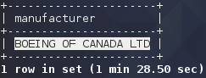

8.
(a) week

SQL:

SELECT CASE DayOfWeek
WHEN 1 THEN 'MONDAY'
WHEN 2 THEN 'TUESDAY'
WHEN 3 THEN 'WEDNESDAY'
WHEN 4 THEN 'THURSDAY'
WHEN 5 THEN 'FRIDAY'
WHEN 6 THEN 'SATURDAY'
WHEN 7 THEN 'SUNDAY'
END AS DayOfWeek , AVG(DepDelay)
FROM records
GROUP BY DayOfWeek;

TIME:
36.12 sec

ANS:
Saturday 遇到的 Delay 會最少
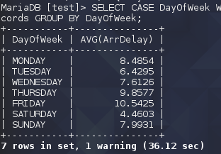

(b) time

SQL:

SELECT CONCAT(ROUND(CRSDepTime/100, 0), 'hour') AS hour, AVG(ArrDelay)
FROM records
GROUP BY ROUND(CRSDepTime/100, 0);

TIME:
52.60 sec

ANS:
5:00~6:00 遇到的 Delay 會最少
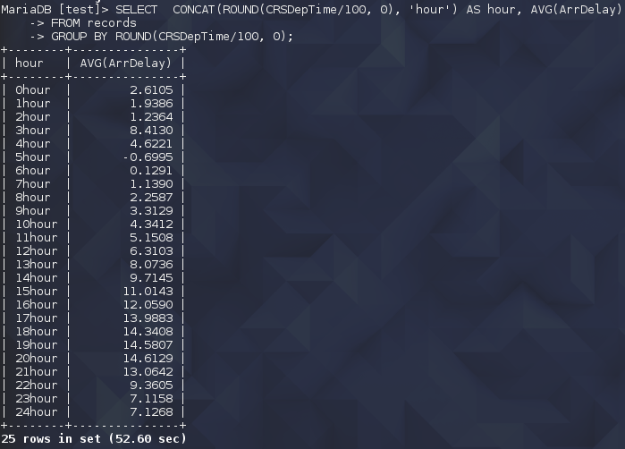

9.
SQL:

CREATE INDEX i_r9
ON records(TailNum);
CREATE INDEX i_p9
ON plane_data(tailnum);

SELECT Year-issY, AVG(ArrDelay)
FROM (
SELECT CAST(RIGHT(issue_date,4) AS int) AS issY, r.Year, ArrDelay
FROM plane_data p RIGHT JOIN records r ON p.tailnum=r.TailNum
) T
WHERE issY IS NOT NULL AND Year IS NOT NULL AND Year >= issY AND issY!=0
GROUP BY Year-issY
ORDER BY Year-issY;

DROP INDEX i_r9
ON records;
DROP INDEX i_p9
ON plane_data;

TIME:
1 min 54.19 sec + 0.05 sec + 2 min 23.07 sec = 4 min 17.31 sec

ANS:
我認為會，利用SQL找出飛行年與飛機發行年(也就是當時飛機年齡)與平均delay時間，發現越老的飛機，delay時間也會越久。
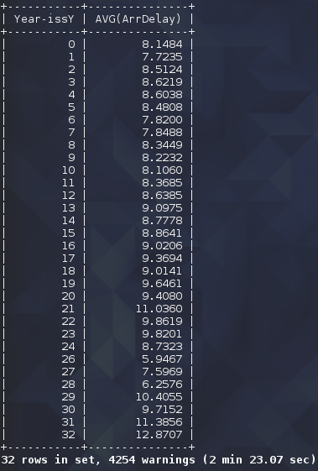

10.
(a) season

SQL:

SELECT season, SUM(ArrDelay) AS sum_delay
FROM (SELECT ArrDelay,
CASE
WHEN Month IN (3,4,5) THEN 'Spring'
WHEN Month IN (6,7,8) THEN 'Summer'
WHEN Month IN (9,10,11) THEN 'FALL'
WHEN Month IN (12,1,2) THEN 'Winter'
END AS season
FROM records
) T
GROUP BY season
ORDER BY FIELD(season, 'Spring', 'Summer', 'Fall', 'Winter');

TIME:
53.57 sec

ANS:
季節感覺會，夏天的delay就明顯高很多。
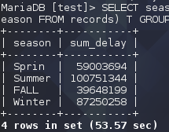

(b) weather

SQL:

SELECT AVG(WeatherDelay) AS avg_delay
FROM records
WHERE WeatherDelay IS NOT NULL;

TIME:
17.27 sec

ANS:
天氣感覺不大會影響delay，我試著找出平均WeatherDelay，發現它並不大。
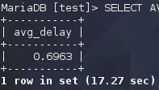

11.
SQL:
TIME:
ANS:

12.
SQL:

CREATE INDEX i_r12
ON records(TailNum);
CREATE INDEX i_p12
ON plane_data(tailnum);

SELECT `type`, AVG(Taxiln) AS avgTaxiln
FROM plane_data p, records r
WHERE p.tailnum=r.TailNum AND `type` IS NOT NULL
GROUP BY type
ORDER BY AVG(r.Taxiln);

DROP INDEX i_r12
ON records;
DROP INDEX i_p12
ON plane_data;

TIME:
2 min 0.48 sec + 0.04 sec + 4 min 22.52 sec = 6 min 23.44 sec

ANS:
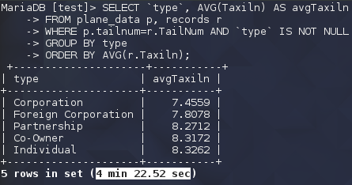
我試圖尋找飛機type與起飛時間的關係，結果發現似乎沒有太大的關係。

