使用工具：

FLEX： LEX公開原始碼版本是FLEX，代表"快速的詞法分析器"(fast lexical analyzer)，flex.exe

LEX： 詞法分析器產生工具(lexical analyzer)

LEX檔： 在TXT檔中編寫LEX結構，存檔為*.l (l為小寫的L，如lextext.l)
將LEX檔案輸入給FLEX，它會將這個檔案轉換成一個C檔案，其檔名為lex.yy.c

VC6.0： 將lex.yy.c 檔案可以被編譯成一份可執行檔 lex.yy.exe

工具流程：

Lextest.l(編輯檔) -> flex.exe(Lex產生c程式碼) -> lex.yy.c(c程式碼) -> lex.yy.exe(詞法分析器)
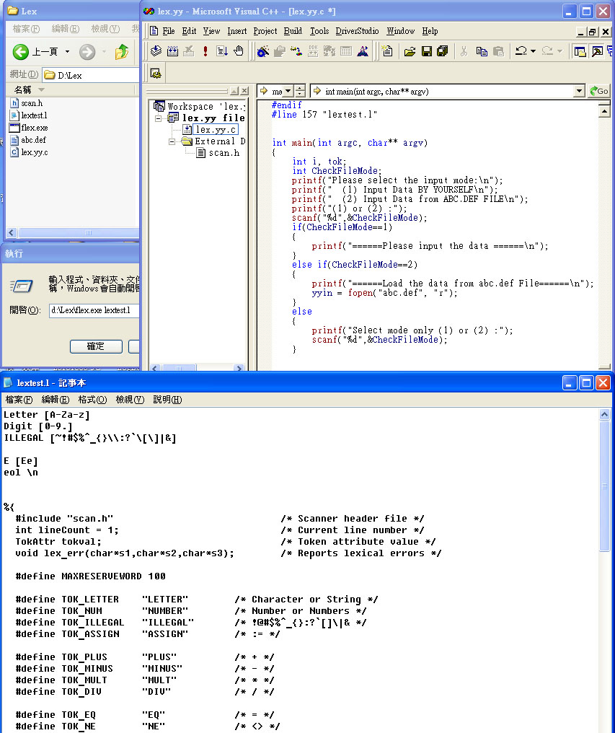
使用檔案
lextest.l 匯入flex.exe
Lex 語法編輯
C檔案
產生語法分析器： lex.yy.exe(詞法分析器)，此與法分析器，輸入方式可分2種：
(1) 使用者一行一行輸入分析
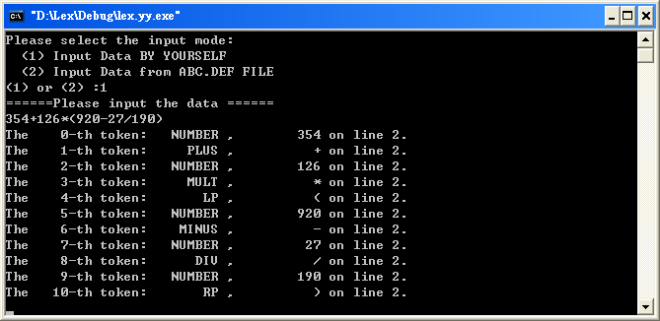
Home Work
(2) 匯入檔案，預設為abc.def
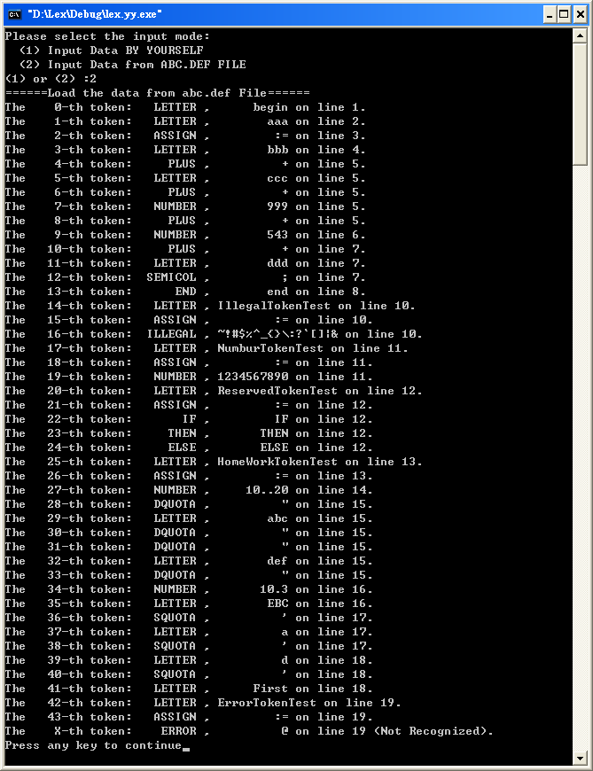
Number
範例驗證
]]
Illegal
]]
Reserved
Home Work
Error used @ ForTest
Letter [A-Za-z]
Digit [0-9.] /* . decimal poin include*/
ILLEGAL [~!#$%^_{}\\:?`\[\]|&]

eol \n

%{
#include "scan.h" /* Scanner header file */
int lineCount = 1; /* Current line number */
TokAttr tokval; /* Token attribute value */
void lex_err(char*s1,char*s2,char*s3); /* Reports lexical errors */

#define MAXRESERVEWORD 100

#define TOK_LETTER "LETTER" /* Character or String */
#define TOK_NUM "NUMBER" /* Number or Numbers */
#define TOK_ILLEGAL "ILLEGAL" /* !@#$%^_{}:?`[]\|& */
#define TOK_ASSIGN "ASSIGN" /* := */

#define TOK_PLUS "PLUS" /* + */
#define TOK_MINUS "MINUS" /* - */
#define TOK_MULT "MULT" /* * */
#define TOK_DIV "DIV" /* / */

#define TOK_EQ "EQ" /* = */
#define TOK_NE "NE" /* <> */
#define TOK_LT "LT" /* < */
#define TOK_LE "LE" /* <= */
#define TOK_GT "GT" /* > */
#define TOK_GE "GE" /* >= */

#define TOK_LP "LP" /* ( */
#define TOK_RP "RP" /* ) */

#define TOK_COMMA "COMMA" /* , */
#define TOK_SEMICOL "SEMICOL" /* ; */

#define TOK_IF "IF" /* if */
#define TOK_THEN "THEN" /* then */
#define TOK_ELSE "ELSE" /* else */
#define TOK_END "END" /* end */
#define TOK_WHILE "WHILE" /* while */
#define TOK_DO "DO" /* do */
#define TOK_READ "READ" /* read */
#define TOK_WRITE "WRITE" /* write */

#define TOK_DQUOTA "DQUOTA" /* " */
#define TOK_SQUOTA "SQUOTA" /* ' */

#define TOK_ERROR "ERROR" /* @ For Test */
%}

%%
[Ii][Ff] { return(TOK_IF); }
[Tt][Hh][Ee][Nn] { return(TOK_THEN); }
[Ee][Ll][Ss][Ee] { return(TOK_ELSE); }
[Ee][Nn][Dd] { return(TOK_END); }
[Ww][Hh][Ii][Ll][Ee] { return(TOK_WHILE); }
[Dd][Oo] { return(TOK_DO); }
[Rr][Ee][Aa][Dd] { return(TOK_READ); }
[Ww][Rr][Ii][Tt][Ee] { return(TOK_WRITE); }

{Letter}{Letter}* { return(TOK_LETTER ); }
{Digit}{Digit}* { return(TOK_NUM); }
{ILLEGAL}{ILLEGAL}* { return(TOK_ILLEGAL); }

:= { return(TOK_ASSIGN); }
\+ { return(TOK_PLUS); }

\- { return(TOK_MINUS); }
\* { return(TOK_MULT); }
\/ { return(TOK_DIV); }

\= { return(TOK_EQ); }
\<> { return(TOK_NE); }
\< { return(TOK_LT); }
\<= { return(TOK_LE); }
\> { return(TOK_GT); }
\>= { return(TOK_GE); }

\( { return(TOK_LP); }
\) { return(TOK_RP); }

\, { return(TOK_COMMA); }
\; { return(TOK_SEMICOL); }

\" { return(TOK_DQUOTA); }
\' { return(TOK_SQUOTA); }

\@ { lex_err(TOK_ERROR,yytext,"Not Recognized"); }

\n { lineCount ++; }

[ \t]+ { /* skip spaces and tabs */ }

{eol} { lineCount ++; }

%%

int main(int argc, char** argv) // main
{
int i, tok;
int CheckFileMode;
printf("Please select the input mode:\n");
printf(" (1) Input Data BY YOURSELF\n");
printf(" (2) Input Data from ABC.DEF FILE\n");
printf("(1) or (2) :");
scanf("%d",&CheckFileMode);

if(CheckFileMode==1) {
printf("======Please input the data ======\n");
}else if(CheckFileMode==2) {
printf("======Load the data from abc.def File======\n");
yyin = fopen("abc.def", "r");
}else{
printf("Select mode only (1) or (2) :");
scanf("%d",&CheckFileMode);
}

for (i = 0; 1==1; i ++) {
tok = yylex();
fprintf(stderr, "The %4d-th token: %8s , %10s on line %d.\n", i, tok, yytext, lineCount);
}
return(0);
}

void lex_err(char *s1, char *s2, char *s3) // To report an error message
{
fprintf(stderr, "The X-th token: %8s , %10s on line %d (%s).\n", s1, s2, lineCount, s3);
}

yywrap() // To finish scanning at end of file
{
fclose(yyin);
exit(1);
}

