# Office notes

Документация за проекта по курса Разработка на уеб приложения и услуги със Spring Framework v5

ФМИ

s

Изготвил:

Цветан Велизарон Алексиев, 45297

Дата: 12.02.2020

# Project summary и описания на използваните технологии и библиотечни модули

The ***Office events application*** provides ability for companies to create events, visible for the whole company or only for team, to remind their employees for important activities and to organize different rallies and trainings. In addition to that it allows users to register, and administrators and managers to manage them.

The system will be developed using ***Spring 5 Application Development Framework and Spring Boot***.It will implement web-based front-end client using ***Angular CLI*** and **TypeScript** libraries for asynchronous page data updates. The application will have pure backend (**Spring**) and frontend (**Angular** **CLI**)

The backend will be implemented as a ***REST/JSON API*** using JSON data serialization. The main user roles are:

• *Anonymous User* – can only view the homepage with short description about the web applications

• *Dev* (extends *Registered User*) – can create events visible for the whole company and for his team and also only for him, delete and edit his own events, see all company events and these for his team

• Manager (extends Registered User) – can do what a dev can , delete and edit all events in his team, add and remove team member from his team

• *Admin*(extends *Registered User*) – can change user role, create new teams, add managers to teams and remove them, create, delete, edit new rooms for events

Подробна функционалност във вече описания документ в началото на курса.

# Описание на реализацията

* Backend

Стандартно REST приложение с подходящо разделение на уеб контролери, прихващащи клиентските заявки, сървиси енкапсулирщи бизнес логиката на приложението и отделни хранилища за съхраняване в базата от данни. Използване а база от данни MYSQL 8.0.

Приложението е разделено на 4 главни модула:

* **Потребителски модул : Admin**
* **Модул за управление на отборите : Manager, Admin**
* **Модул за управление на събитията :Manager, Dev**
* **Модул за управление на стаите за събитията : Admin**

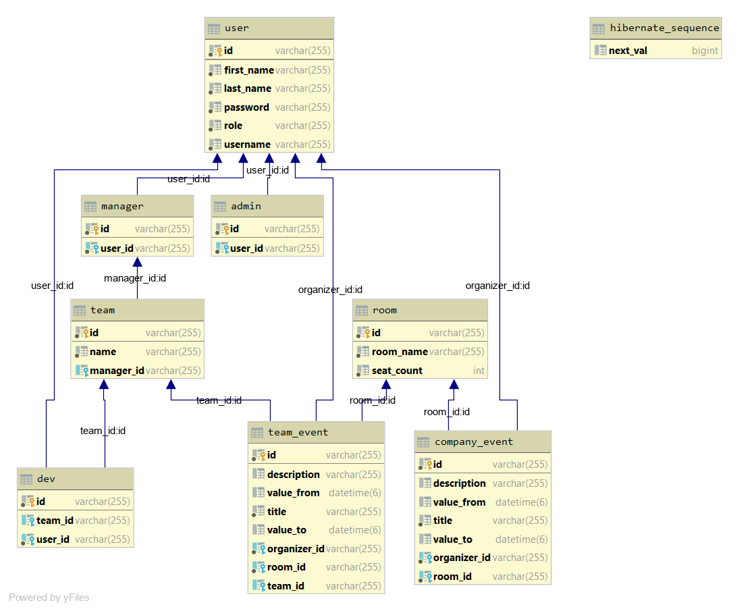

* Frontend

|  |  |  |  |
| --- | --- | --- | --- |
| 1) Authentication module | |  |  |
|  | | * login page |  |  | |
|  | | * register page |  |  | |
|  | | 2) Homepage module |  |  | |
|  | | * Teams page |  |  | |
|  | | * Create event page |  |  | |
|  | | *User page |  |  | |
|  | | * Room page |  |  | |
|  |  | | | |
|  |  | | | |