Advance Data Cleaning
MAKINI CALEB
2026-10-19

Set working directory
setwd("C:/Users/ADMIN/OneDrive/Desktop/caleb makini")

Import Libraries
library(dplyr)
library(tidyverse)
library(rio)
library(readxl)

Data importation
data = read_excel("dtcln.xlsx")
head(data)
# A tibble: 6 × 10
Age Income_KES Household_Size Farm_Size_Acres Monthly_Expenses_KES
<dbl> <dbl> <dbl> <dbl> <dbl>
1 58 71751 7 5.74 51513
2 48 67200 4 5.11 31599
3 34 67572 2 4.52 37294
4 NA 58125 1 3.95 30161
5 27 66921 4 3.66 31099
6 40 250000 4 3.21 180000
# ℹ 5 more variables: Years_Experience <dbl>, Education <chr>, Gender <chr>,
# Extension_Access <chr>, Adoption_Status <chr>

Data stracture
str(data)
tibble [100 × 10] (S3: tbl_df/tbl/data.frame)
$ Age : num [1:100] 58 48 34 NA 27 40 58 38 42 30 ...
$ Income_KES : num [1:100] 71751 67200 67572 58125 66921 ...
$ Household_Size : num [1:100] 7 4 2 1 4 4 1 2 1 6 ...
$ Farm_Size_Acres : num [1:100] 5.74 5.11 4.52 3.95 3.66 3.21 0.5 4.41 7.41 4.26 ...
$ Monthly_Expenses_KES: num [1:100] 51513 31599 37294 30161 31099 ...
$ Years_Experience : num [1:100] 13 28 16 29 13 14 3 29 6 18 ...
$ Education : chr [1:100] "Secondary" "College" "College" "College" ...
$ Gender : chr [1:100] "Female" "Female" "Male" "Male" ...
$ Extension_Access : chr [1:100] "No" "Yes" "No" "No" ...
$ Adoption_Status : chr [1:100] "Non-Adopter" "Non-Adopter" "Adopter" "Non-Adopter" ...

Check for missing values
colSums(is.na(data))
Age Income_KES Household_Size
4 5 0
Farm_Size_Acres Monthly_Expenses_KES Years_Experience
3 3 0
Education Gender Extension_Access
4 3 3
Adoption_Status
2

Separate continuous and categorical variables
continuous_vars <- c("Age", "Income_KES", "Household_Size", "Farm_Size_Acres", "Monthly_Expenses_KES",
"Years_Experience")
categorical_vars <- c("Education", "Gender", "Extension_Access", "Adoption_Status")
head(continuous_vars)
[1] "Age" "Income_KES" "Household_Size"
[4] "Farm_Size_Acres" "Monthly_Expenses_KES" "Years_Experience"

Check missing values in continuous variables
colSums(is.na(data[continuous_vars]))
Age Income_KES Household_Size
4 5 0
Farm_Size_Acres Monthly_Expenses_KES Years_Experience
3 3 0

Replace missing continuous values with the MEAN
for (var in continuous_vars) {
data[[var]][is.na(data[[var]])] <- mean(data[[var]], na.rm = TRUE)
}
colSums(is.na(data[continuous_vars]))
Age Income_KES Household_Size
0 0 0
Farm_Size_Acres Monthly_Expenses_KES Years_Experience
0 0 0

Replace missing continuous values with the MEDIAN
for (var in continuous_vars) {
data[[var]][is.na(data[[var]])] <- median(data[[var]], na.rm = TRUE)
}

Find the mode for categorical variables

R does not have a simple built-in mode() function for statistical mode, so we create one:
get_mode <- function(x) {
ux <- unique(na.omit(x))
ux[which.max(tabulate(match(x, ux)))]
}
get_mode(data$Gender)
[1] "Male"

Replace missing categorical values with the MODE
for (var in categorical_vars) {
mode_value <- get_mode(data[[var]])
data[[var]][is.na(data[[var]])] <- mode_value
}
colSums(is.na(data[categorical_vars]))
Education Gender Extension_Access Adoption_Status
0 0 0 0

investigate OUTLIERS
summary(data[continuous_vars])
Age Income_KES Household_Size Farm_Size_Acres
Min. : 20.00 Min. : 10022 Min. : 1 Min. : 0.500
1st Qu.: 30.00 1st Qu.: 44522 1st Qu.: 2 1st Qu.: 3.505
Median : 41.21 Median : 58276 Median : 4 Median : 4.725
Mean : 41.42 Mean : 60219 Mean : 4 Mean : 5.854
3rd Qu.: 48.25 3rd Qu.: 68204 3rd Qu.: 6 3rd Qu.: 6.147
Max. :110.00 Max. :300000 Max. :25 Max. :60.000
Monthly_Expenses_KES Years_Experience
Min. : 6357 Min. : 1.00
1st Qu.: 24204 1st Qu.: 6.00
Median : 31527 Median :16.00
Mean : 34468 Mean :15.61
3rd Qu.: 37284 3rd Qu.:22.25
Max. :220000 Max. :70.00

Simple case
boxplot(data$Income_KES)
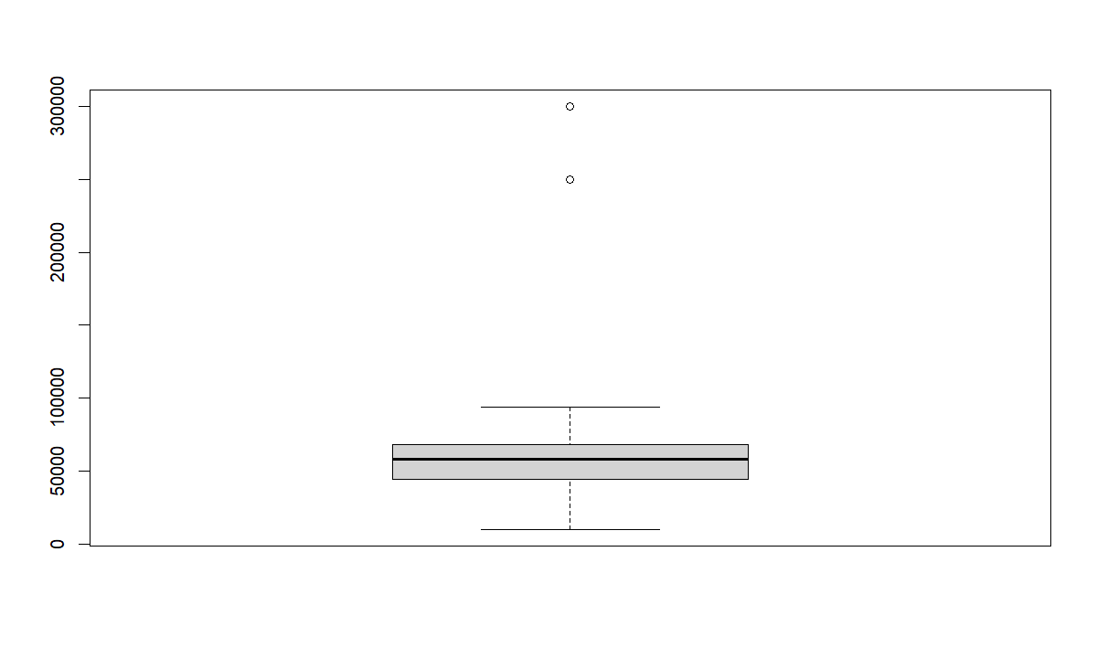

Boxplot of all continuous variables
boxplot(data[continuous_vars], main = "Boxplots of Continuous Variables", las = 2,
col = "lightblue")
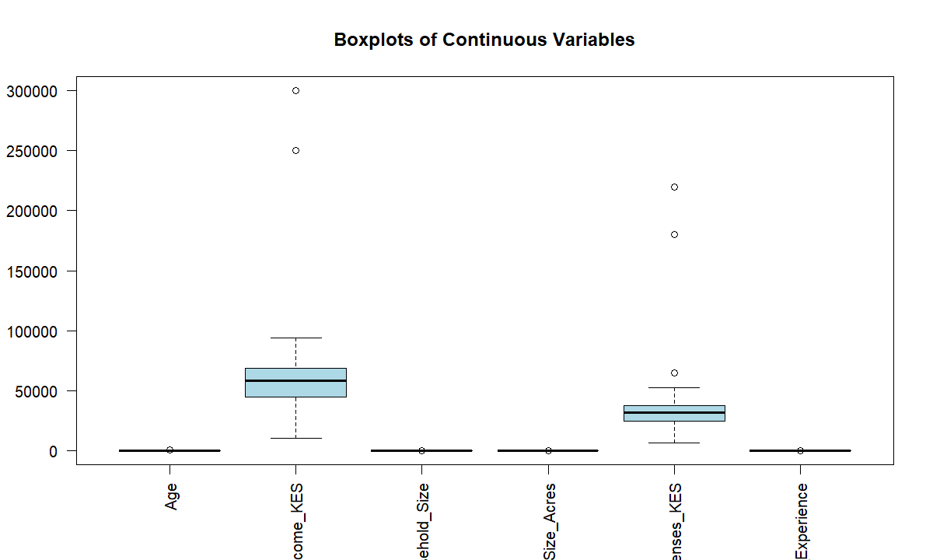

Scale the continuous variables
scaled_data <- scale(data[continuous_vars])
scaled_data <- as.data.frame(scaled_data)
head(scaled_data)
Age Income_KES Household_Size Farm_Size_Acres Monthly_Expenses_KES
1 1.14986590 0.32326793 1.0553435 -0.01611948 0.6533265
2 0.45647943 0.19569629 0.0000000 -0.10510424 -0.1099692
3 -0.51426163 0.20612403 -0.7035624 -0.18843917 0.1083179
4 0.00000000 -0.05869012 -1.0553435 -0.26894919 -0.1650872
5 -0.99963216 0.18787549 0.0000000 -0.30991043 -0.1291340
6 -0.09822975 5.31986564 0.0000000 -0.37347098 5.5781823
Years_Experience
1 -0.24740636
2 1.17446927
3 0.03696877
4 1.26926098
5 -0.24740636
6 -0.15261465

Boxplot of SCALED continuous variables
boxplot(scaled_data, main = "Boxplots of Scaled Continuous Variables", las = 2, col = "lightgreen")
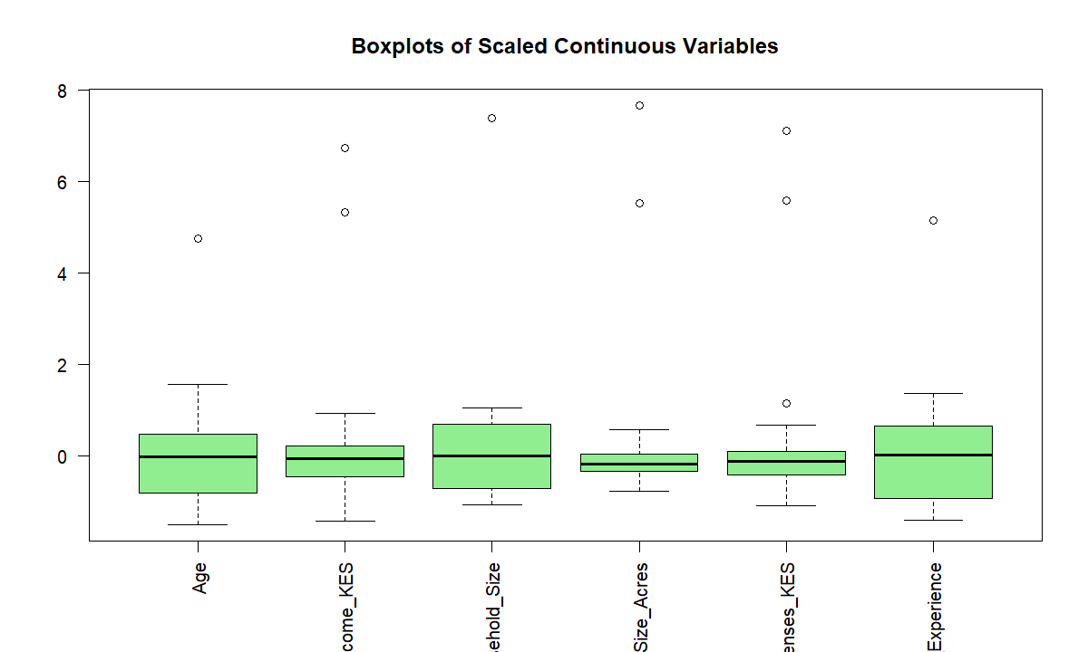

Important; Scaling does NOT remove outliers. It only puts variables on a common scale. The outlier remains an outlier after scaling.

Identify outliers using the IQR method
find_outliers <- function(x) {
Q1 <- quantile(x, 0.25, na.rm = TRUE)
Q3 <- quantile(x, 0.75, na.rm = TRUE)
IQR_value <- Q3 - Q1
lower <- Q1 - 1.5 * IQR_value
upper <- Q3 + 1.5 * IQR_value
which(x < lower | x > upper)
}

Test
find_outliers(data$Income_KES)
[1] 6 19
find_outliers(data$Farm_Size_Acres)
[1] 38 53

Count outliers in every continuous variable
outlier_count <- sapply(data[continuous_vars], function(x) length(find_outliers(x)))
outlier_count
Age Income_KES Household_Size
1 2 1
Farm_Size_Acres Monthly_Expenses_KES Years_Experience
2 3 1

Replace outliers with the MEDIAN

We use the median because it is resistant to extreme observations.
replace_outliers_median <- function(x) {
Q1 <- quantile(x, 0.25, na.rm = TRUE)
Q3 <- quantile(x, 0.75, na.rm = TRUE)
IQR_value <- Q3 - Q1
lower <- Q1 - 1.5 * IQR_value
upper <- Q3 + 1.5 * IQR_value
median_value <- median(x, na.rm = TRUE)
x[x < lower | x > upper] <- median_value
return(x)
}
for (var in continuous_vars) {
data[[var]] <- replace_outliers_median(data[[var]])
}

Check the boxplots again
boxplot(data[continuous_vars], main = "Continuous Variables After Outlier Treatment",
las = 2, col = "lightblue")
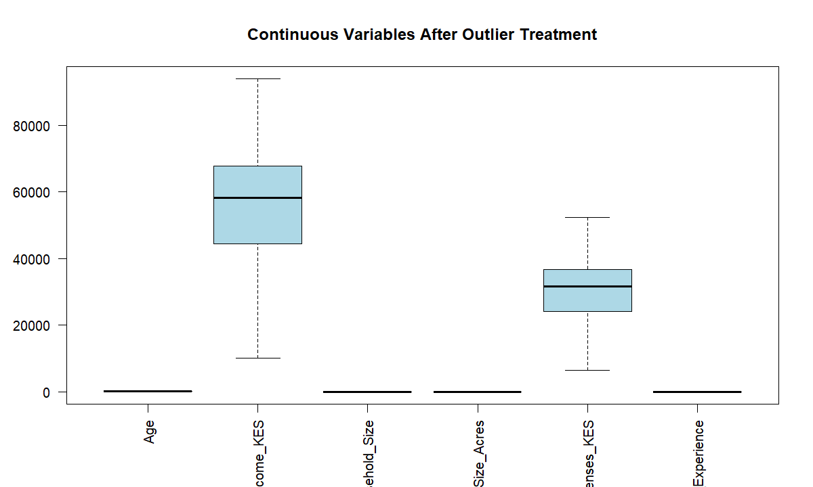

Scaled data
scaled_data <- as.data.frame(scale(data[continuous_vars]))
boxplot(scaled_data, main = "Boxplots of Scaled Continuous Variables After Outlier Treatment",
las = 2)
