Exploring Customer Transactions Using R
MAKINI CALEB
2026-09-25

PROJECT OVERVIEW In this project i will use R to perform a basic data science workflow on a customer transaction dataset. The project introduces the use of R for data import, data inspection, data cleaning, exploratory data analysis (EDA), visualization, and interpretation. The dataset contains transaction-level information including customer demographics, product characteristics, payment methods, transaction dates, prices, quantities, ratings, and membership status.

DATA VARIABLES The following data variables are to be used: TransactionID, CustomerID, ProductID, Quantity, PaymentMethod, TransactionDate, ProductCategory, Price, Rating, TotalAmount, Age, Gender, Location, MembershipStatus.

PROJECT OVERVIEW. The following are project aims to achieve the following objectives: i. Import a dataset into R. ii. Inspect the structure and characteristics of data. iii. Identify and handle missing or inconsistent values. iv. Convert variables to appropriate data types. v. Generate descriptive statistics using R. vi.Create basic statistical and graphical summaries. vii. Explore relationships between variables. viii. Communicate data-driven findings.

setting working directory
setwd("C:/Users/ADMIN/OneDrive/Desktop/caleb makini")

loading libraries
library(ggplot2)
library(ggthemes)
library(stats)
library(forecast)
library(tseries)
library(formatR)
library(papaja)
library(dplyr)
library(rio)
library(tidyr)
library(tidyverse)
library(sjmisc)
library(kableExtra)
library(psych)
library(gridExtra)
library(scales)

Task 1: Import and inspect the data

import data of e-commerce to R:
eco_data <- read.csv("ecomdata.csv")

Display the first observation
head(eco_data)
TransactionID CustomerID ProductID Quantity PaymentMethod TransactionDate
1 1 207 14 5 UPI 12/28/2023
2 2 253 15 1 Cash on Delivery 4/17/2023
3 3 110 19 5 Cash on Delivery 1/17/2023
4 4 256 1 3 Debit Card 10/23/2023
5 5 274 2 5 Debit Card 6/30/2023
6 6 52 15 2 Credit Card 6/14/2023
ProductCategory Price Rating TotalAmount Age Gender Location
1 Clothing 33.36 4.2 166.80 50 Male Houston
2 Electronics 389.03 2.2 389.03 19 Female Chicago
3 Clothing 145.89 1.7 729.45 37 Female Houston
4 Home Appliances 215.02 2.7 645.06 50 Male Los Angeles
5 Home Appliances 325.48 3.4 1627.40 24 Male New York
6 Electronics 389.03 2.2 778.06 50 Male Houston
MembershipStatus
1 Basic
2 Premium
3 Basic
4 Premium
5 Premium
6 Premium

Display the last observation
tail(eco_data)
TransactionID CustomerID ProductID Quantity PaymentMethod
295 295 181 9 5 Cash on Delivery
296 296 157 15 5 Cash on Delivery
297 297 293 13 5 Debit Card
298 298 189 18 4 Debit Card
299 299 182 15 2 Debit Card
300 300 183 12 3 Debit Card
TransactionDate ProductCategory Price Rating TotalAmount Age Gender
295 9/28/2023 Electronics 132.51 2.3 662.55 30 Male
296 3/13/2023 Electronics 389.03 2.2 1945.15 57 Male
297 10/5/2023 Clothing 243.41 5.0 1217.05 59 Male
298 8/2/2023 Home Appliances 341.40 3.0 1365.60 31 Male
299 11/12/2023 Electronics 389.03 2.2 778.06 63 Female
300 2/19/2023 Home Appliances 466.49 2.6 1399.47 23 Female
Location MembershipStatus
295 Los Angeles Premium
296 Chicago Gold
297 Los Angeles Basic
298 Los Angeles Gold
299 Houston Basic
300 Chicago Basic

Inspection of the structure and characteristics of data
str(eco_data)
'data.frame': 300 obs. of 14 variables:
$ TransactionID : int 1 2 3 4 5 6 7 8 9 10 ...
$ CustomerID : int 207 253 110 256 274 52 191 165 18 169 ...
$ ProductID : int 14 15 19 1 2 15 10 5 5 17 ...
$ Quantity : int 5 1 5 3 5 2 1 5 4 2 ...
$ PaymentMethod : chr "UPI" "Cash on Delivery" "Cash on Delivery" "Debit Card" ...
$ TransactionDate : chr "12/28/2023" "4/17/2023" "1/17/2023" "10/23/2023" ...
$ ProductCategory : chr "Clothing" "Electronics" "Clothing" "Home Appliances" ...
$ Price : num 33.4 389 145.9 215 325.5 ...
$ Rating : num 4.2 2.2 1.7 2.7 3.4 2.2 3.7 1.4 1.4 1.9 ...
$ TotalAmount : num 167 389 729 645 1627 ...
$ Age : int 50 19 37 50 24 50 40 37 25 53 ...
$ Gender : chr "Male" "Female" "Female" "Male" ...
$ Location : chr "Houston" "Chicago" "Houston" "Los Angeles" ...
$ MembershipStatus: chr "Basic" "Premium" "Basic" "Premium" ...

Determine the number of observations and variables.
describe(eco_data)
vars n mean sd median trimmed mad min max
TransactionID 1 300 150.50 86.75 150.50 150.50 111.19 1.00 300.00
CustomerID 2 300 154.83 85.38 156.50 155.66 111.94 4.00 299.00
ProductID 3 300 10.66 5.58 11.00 10.73 7.41 1.00 20.00
Quantity 4 300 3.13 1.46 3.00 3.16 1.48 1.00 5.00
PaymentMethod* 5 300 2.55 1.18 3.00 2.56 1.48 1.00 4.00
TransactionDate* 6 300 109.66 62.24 110.50 110.10 80.80 1.00 216.00
ProductCategory* 7 300 1.96 0.82 2.00 1.95 1.48 1.00 3.00
Price 8 300 253.52 120.62 215.02 250.44 135.49 33.36 466.49
Rating 9 300 2.93 1.06 2.60 2.85 1.04 1.40 5.00
TotalAmount 10 300 803.12 568.91 662.55 745.60 565.82 33.36 2332.45
Age 11 292 41.79 13.27 42.00 41.74 16.31 18.00 65.00
Gender* 12 300 2.49 0.58 3.00 2.54 0.00 1.00 3.00
Location* 13 300 2.37 1.14 2.00 2.33 1.48 1.00 4.00
MembershipStatus* 14 300 1.98 0.83 2.00 1.98 1.48 1.00 3.00
range skew kurtosis se
TransactionID 299.00 0.00 -1.21 5.01
CustomerID 295.00 -0.07 -1.23 4.93
ProductID 19.00 -0.09 -1.17 0.32
Quantity 4.00 -0.10 -1.36 0.08
PaymentMethod* 3.00 -0.06 -1.49 0.07
TransactionDate* 215.00 -0.05 -1.22 3.59
ProductCategory* 2.00 0.07 -1.51 0.05
Price 433.13 0.18 -0.96 6.96
Rating 3.60 0.57 -0.73 0.06
TotalAmount 2299.09 0.78 -0.32 32.85
Age 47.00 -0.01 -1.13 0.78
Gender* 2.00 -0.61 -0.61 0.03
Location* 3.00 0.17 -1.40 0.07
MembershipStatus* 2.00 0.03 -1.55 0.05

Examine the structure
str(eco_data)
'data.frame': 300 obs. of 14 variables:
$ TransactionID : int 1 2 3 4 5 6 7 8 9 10 ...
$ CustomerID : int 207 253 110 256 274 52 191 165 18 169 ...
$ ProductID : int 14 15 19 1 2 15 10 5 5 17 ...
$ Quantity : int 5 1 5 3 5 2 1 5 4 2 ...
$ PaymentMethod : chr "UPI" "Cash on Delivery" "Cash on Delivery" "Debit Card" ...
$ TransactionDate : chr "12/28/2023" "4/17/2023" "1/17/2023" "10/23/2023" ...
$ ProductCategory : chr "Clothing" "Electronics" "Clothing" "Home Appliances" ...
$ Price : num 33.4 389 145.9 215 325.5 ...
$ Rating : num 4.2 2.2 1.7 2.7 3.4 2.2 3.7 1.4 1.4 1.9 ...
$ TotalAmount : num 167 389 729 645 1627 ...
$ Age : int 50 19 37 50 24 50 40 37 25 53 ...
$ Gender : chr "Male" "Female" "Female" "Male" ...
$ Location : chr "Houston" "Chicago" "Houston" "Los Angeles" ...
$ MembershipStatus: chr "Basic" "Premium" "Basic" "Premium" ...

Examine the summary statistics.
summary(eco_data)
TransactionID CustomerID ProductID Quantity
Min. : 1.00 Min. : 4.0 Min. : 1.00 Min. :1.000
1st Qu.: 75.75 1st Qu.: 77.0 1st Qu.: 6.00 1st Qu.:2.000
Median :150.50 Median :156.5 Median :11.00 Median :3.000
Mean :150.50 Mean :154.8 Mean :10.66 Mean :3.127
3rd Qu.:225.25 3rd Qu.:229.2 3rd Qu.:15.00 3rd Qu.:5.000
Max. :300.00 Max. :299.0 Max. :20.00 Max. :5.000
PaymentMethod TransactionDate ProductCategory Price
Length:300 Length:300 Length:300 Min. : 33.36
Class :character Class :character Class :character 1st Qu.:145.89
Mode :character Mode :character Mode :character Median :215.02
Mean :253.52
3rd Qu.:350.44
Max. :466.49
Rating TotalAmount Age Gender
Min. :1.400 Min. : 33.36 Min. :18.00 Length:300
1st Qu.:2.100 1st Qu.: 350.44 1st Qu.:30.00 Class :character
Median :2.600 Median : 662.55 Median :42.00 Mode :character
Mean :2.928 Mean : 803.12 Mean :41.79
3rd Qu.:3.700 3rd Qu.:1134.50 3rd Qu.:52.25
Max. :5.000 Max. :2332.45 Max. :65.00
NA's :8
Location MembershipStatus
Length:300 Length:300
Class :character Class :character
Mode :character Mode :character

identifying missing values by columns
colSums(is.na(eco_data))
TransactionID CustomerID ProductID Quantity
0 0 0 0
PaymentMethod TransactionDate ProductCategory Price
0 0 0 0
Rating TotalAmount Age Gender
0 0 8 0
Location MembershipStatus
0 0

identification of duplicate records
eco_data_duplicate <- sum(duplicated(eco_data))
eco_data_duplicate
[1] 0

Task 2: Data preparation

categorical variables
cat_var <- eco_data %>%
select(PaymentMethod, ProductCategory, Gender, Location, MembershipStatus, )
head(cat_var)
PaymentMethod ProductCategory Gender Location MembershipStatus
1 UPI Clothing Male Houston Basic
2 Cash on Delivery Electronics Female Chicago Premium
3 Cash on Delivery Clothing Female Houston Basic
4 Debit Card Home Appliances Male Los Angeles Premium
5 Debit Card Home Appliances Male New York Premium
6 Credit Card Electronics Male Houston Premium

variable conversion to factors
cat_vars <- c("PaymentMethod", "ProductCategory", "Gender", "Location", "MembershipStatus")
cat_vars <- as.factor(cat_vars)
str(cat_vars)
Factor w/ 5 levels "Gender","Location",..: 4 5 1 2 3

proper date format
cat("Class before:", class(eco_data$TransactionDate), "\n")
Class before: character
cat("Sample before:", head(eco_data$TransactionDate, 3), "\n")
Sample before: 12/28/2023 4/17/2023 1/17/2023
eco_data$TransactionDate <- as.Date(eco_data$TransactionDate, format = "%m/%d/%Y")
cat("Class after:", class(eco_data$TransactionDate), "\n")
Class after: Date
cat("Sample after:", format(head(eco_data$TransactionDate, 3)), "\n")
Sample after: 2023-12-28 2023-04-17 2023-01-17
cat("Date range:", format(min(eco_data$TransactionDate)), "to", format(max(eco_data$TransactionDate)),
"\n")
Date range: 2023-01-01 to 2023-12-28
cat("Any NA introduced by parsing:", sum(is.na(eco_data$TransactionDate)), "\n")
Any NA introduced by parsing: 0

checking for impossible values, such as negative quantities, prices or ages

check for imposible values
checks <- data.frame(Check = c("Quantity <= 0", "Price <= 0", "TotalAmount <= 0",
"Age < 18 or Age > 100", "Rating < 1 or Rating > 5", "TotalAmount != Quantity * Price"),
Count = c(sum(eco_data$Quantity <= 0, na.rm = TRUE), sum(eco_data$Price <= 0,
na.rm = TRUE), sum(eco_data$TotalAmount <= 0, na.rm = TRUE), sum(eco_data$Age <
18 | eco_data$Age > 100, na.rm = TRUE), sum(eco_data$Rating < 1 | eco_data$Rating >
5, na.rm = TRUE), sum(abs(eco_data$Quantity * eco_data$Price - eco_data$TotalAmount) >
0.01, na.rm = TRUE)))
checks
Check Count
1 Quantity <= 0 0
2 Price <= 0 0
3 TotalAmount <= 0 0
4 Age < 18 or Age > 100 0
5 Rating < 1 or Rating > 5 0
6 TotalAmount != Quantity * Price 0
Interpretation: No impossible values. TotalAmount is internally consistent with Quantity × Price for every row.

Build the Cleaned Analytical Dataset & Verify

Replace missing values with the mean
eco_data$Age[is.na(eco_data$Age)] <- mean(eco_data$Age, na.rm = TRUE)

verification and checking of missing values after replacing with the mean
colSums(is.na(eco_data))
TransactionID CustomerID ProductID Quantity
0 0 0 0
PaymentMethod TransactionDate ProductCategory Price
0 0 0 0
Rating TotalAmount Age Gender
0 0 0 0
Location MembershipStatus
0 0

cleaned data
cleaned_ecodata <- as.data.frame(eco_data)
head(cleaned_ecodata)
TransactionID CustomerID ProductID Quantity PaymentMethod TransactionDate
1 1 207 14 5 UPI 2023-12-28
2 2 253 15 1 Cash on Delivery 2023-04-17
3 3 110 19 5 Cash on Delivery 2023-01-17
4 4 256 1 3 Debit Card 2023-10-23
5 5 274 2 5 Debit Card 2023-06-30
6 6 52 15 2 Credit Card 2023-06-14
ProductCategory Price Rating TotalAmount Age Gender Location
1 Clothing 33.36 4.2 166.80 50 Male Houston
2 Electronics 389.03 2.2 389.03 19 Female Chicago
3 Clothing 145.89 1.7 729.45 37 Female Houston
4 Home Appliances 215.02 2.7 645.06 50 Male Los Angeles
5 Home Appliances 325.48 3.4 1627.40 24 Male New York
6 Electronics 389.03 2.2 778.06 50 Male Houston
MembershipStatus
1 Basic
2 Premium
3 Basic
4 Premium
5 Premium
6 Premium
Final cleaned dataset profile:

Task 3: Exploratory Data Analysis
n_total <- nrow(eco_data)
avg_total <- mean(eco_data$TotalAmount)
med_total <- median(eco_data$TotalAmount)

What is the distribution of TotalAmount?

total amount using boxplot
boxplot(cleaned_ecodata$TotalAmount, ylab = "TotalAmount", main = "overview of TotalAmount using Boxplot",
col = "yellowgreen")
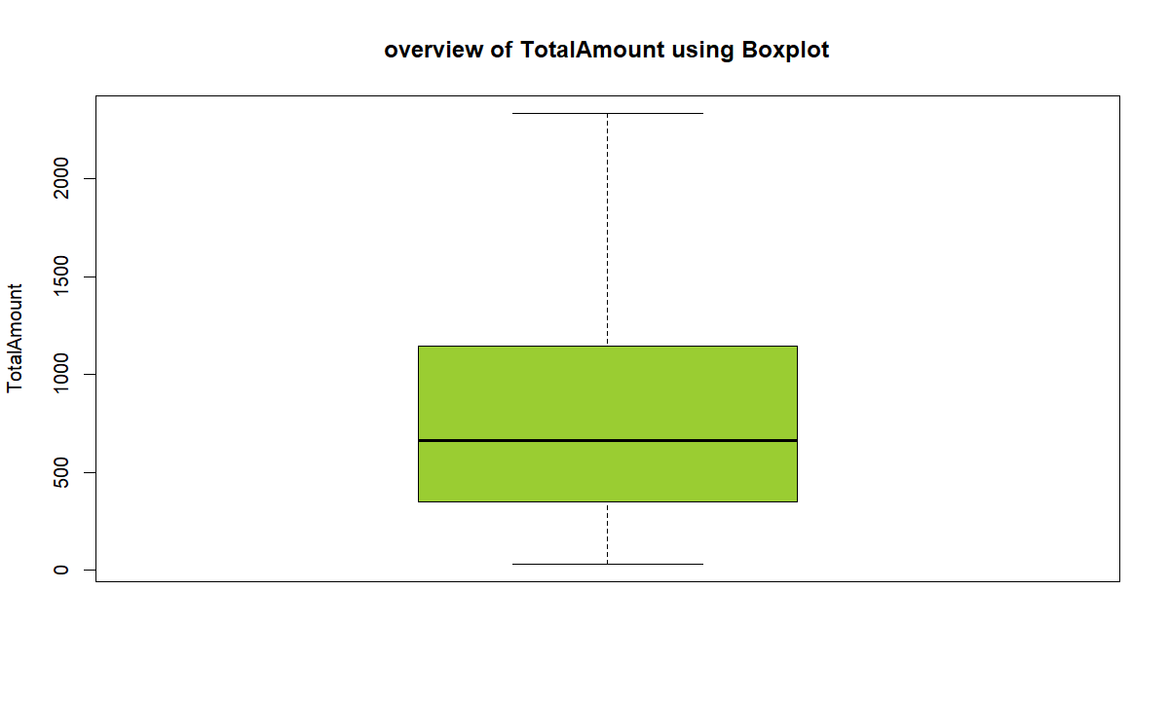 # Total Amount using aggregation
total_amount <- aggregate(TotalAmount ~ ProductCategory, data = cleaned_ecodata,
FUN = sum)
total_amount
ProductCategory TotalAmount
1 Clothing 60536.40
2 Electronics 69501.41
3 Home Appliances 110897.21

clothing~ 60536.40, Electronics~ 69501.41, Home Appliances~ 110897.21 hence home appliences is the most leading

5.2 Which ProductCategory generates the highest sales?
rev_by_cat <- aggregate(TotalAmount ~ ProductCategory, data = eco_data, FUN = sum)
rev_by_cat <- rev_by_cat[order(-rev_by_cat$TotalAmount), ]
rev_by_cat$Share <- round(100 * rev_by_cat$TotalAmount/sum(rev_by_cat$TotalAmount),
1)
rev_by_cat
ProductCategory TotalAmount Share
3 Home Appliances 110897.21 46.0
2 Electronics 69501.41 28.8
1 Clothing 60536.40 25.1
cnt_by_cat <- as.data.frame(table(eco_data$ProductCategory))
names(cnt_by_cat) <- c("ProductCategory", "Transactions")
cnt_by_cat
ProductCategory Transactions
1 Clothing 106
2 Electronics 99
3 Home Appliances 95
avg_by_cat <- aggregate(TotalAmount ~ ProductCategory, data = eco_data, FUN = mean)
avg_by_cat$TotalAmount <- round(avg_by_cat$TotalAmount, 2)
avg_by_cat
ProductCategory TotalAmount
1 Clothing 571.10
2 Electronics 702.03
3 Home Appliances 1167.34
Interpretation: Home Appliances and Electronics dominate total revenue — their higher unit prices outweigh Clothing’s higher transaction count. Clothing has the most transactions but the lowest average transaction value . Business insight: revenue is driven by high-ticket categories**, not by frequency.

Which PaymentMethod is most frequently used?
p8 <- ggplot(cleaned_ecodata, aes(x = PaymentMethod, fill = PaymentMethod)) + geom_bar(alpha = 0.35,
outlier.color = "red", outlier.shape = 10, outlier.size = 1) + labs(title = "Payment visualization ",
subtitle = "determine frequently used", x = NULL, y = "Number of transactions") +
theme_minimal() + theme(legend.position = "none")
p8
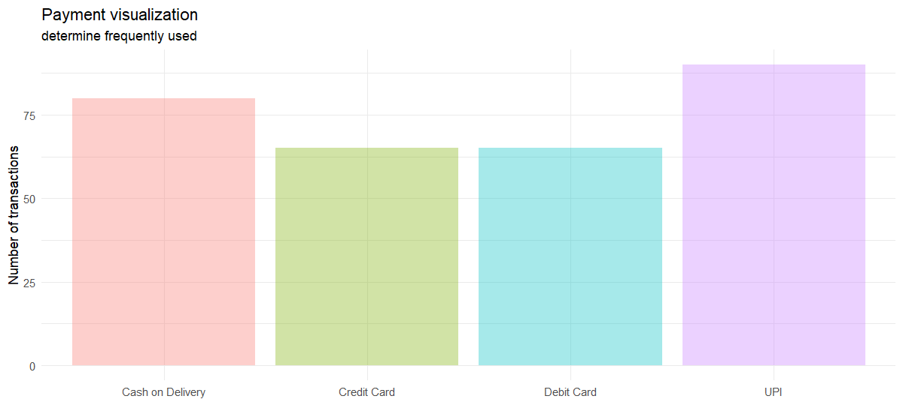 # analysing using table
pay_freq <- as.data.frame(table(cleaned_ecodata$PaymentMethod))
names(pay_freq) <- c("PaymentMethod", "Count")
pay_freq$Pct <- round(100 * pay_freq$Count/n_total, 1)
pay_freq <- pay_freq[order(-pay_freq$Count), ]
pay_freq
PaymentMethod Count Pct
4 UPI 90 30.0
1 Cash on Delivery 80 26.7
2 Credit Card 65 21.7
3 Debit Card 65 21.7

Interpretation: UPI and Debit Cash delivery are the most frequently used methods.

What is the average transaction value?
cat("Average transaction value : $", round(avg_total, 2), "\n")
Average transaction value : $ 803.12

Does transaction spending differ by MembershipStatus?
p7 <- ggplot(cleaned_ecodata, aes(x = MembershipStatus, fill = MembershipStatus)) +
geom_bar(alpha = 0.35, outlier.color = "red", outlier.shape = 10, outlier.size = 1) +
labs(title = "Payment visualization ", subtitle = "determine frequently used",
x = NULL, y = "Number of transactions") + theme_minimal() + theme(legend.position = "none")
p7
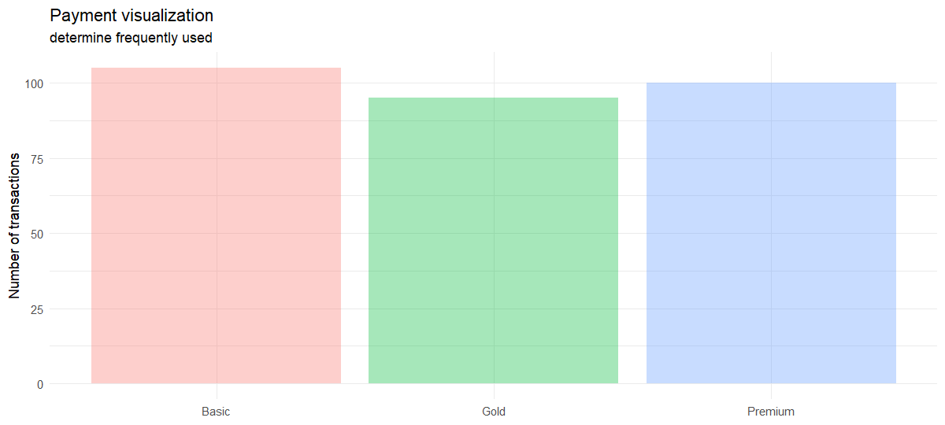

Is there an association between Gender and ProductCategory?
tab_gc <- table(cleaned_ecodata$Gender, cleaned_ecodata$ProductCategory)
tab_gc
Clothing Electronics Home Appliances
5 6 2
Female 52 34 42
Male 49 59 51
chisq_gc <- chisq.test(tab_gc)
chisq_gc
Pearson's Chi-squared test
data: tab_gc
X-squared = 6.2195, df = 4, p-value = 0.1833
cramers_v <- sqrt(chisq_gc$statistic/(sum(tab_gc) * (min(dim(tab_gc)) - 1)))
cat("Cramer's V:", round(cramers_v, 3), "\n")
Cramer's V: 0.102

since the p_value= 0.1833< 5%, we fail to reject null hyponthesis and hence there is no significance Association btn gender and Productory

What is the relationship between Age, Rating, and TotalAmount?
cor_mat <- cor(cleaned_ecodata[, c("Age", "Rating", "TotalAmount")], use = "complete.obs")
round(cor_mat, 3)
Age Rating TotalAmount
Age 1.000 0.038 -0.016
Rating 0.038 1.000 -0.128
TotalAmount -0.016 -0.128 1.000

Age shows a near-zero correlation with TotalAmount, indicating that age is not a linear predictor of spending, while Rating shows only a weak correlation, suggesting that product rating does not drive basket size; by contrast, Quantity and Price are the true drivers of TotalAmount, as expected since TotalAmount = Quantity × Price, and the regression confirms that quantity and price explain nearly all the variance in TotalAmount, with age and rating adding little.

How do sales change over time?
monthly <- cleaned_ecodata %>%
mutate(Month = format(TransactionDate, "%Y-%m")) %>%
group_by(Month) %>%
summarise(TotalAmount = sum(TotalAmount, na.rm = TRUE), .groups = "drop") %>%
arrange(Month) %>%
as.data.frame()
p5 <- ggplot(monthly, aes(x = Month, y = TotalAmount, group = 1)) + geom_line(colour = "darkgreen",
linewidth = 1) + geom_point(colour = "darkgreen", size = 3.5) + labs(title = "Sales changes Over Time (2023)",
subtitle = "Fluctuating revenue with seasonal peaks", x = NULL, y = "Total sales ($)") +
theme_classic() + theme(axis.text.x = element_text(angle = 45, hjust = 1))
p5
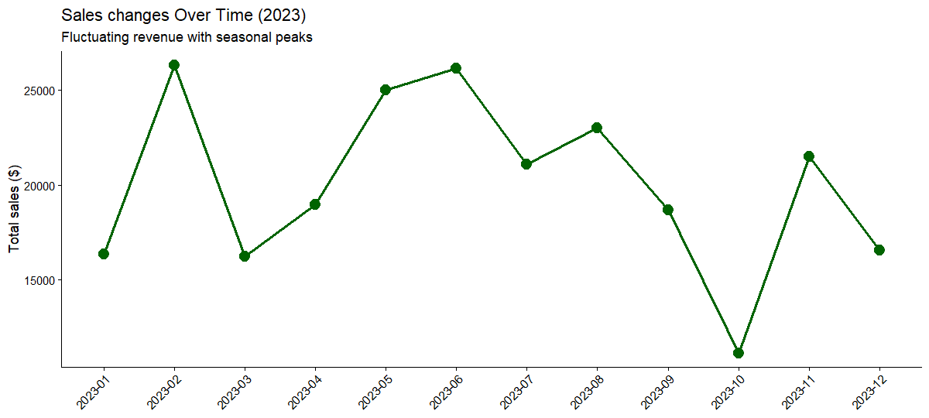

sales change best and worst month
cat("Best month :\n", monthly$Month[which.max(monthly$TotalAmount)], "= ", round(max(monthly$TotalAmount),
2), "\n")
Best month :
2023-02 = 26281.74
cat("Worst month:\n", monthly$Month[which.min(monthly$TotalAmount)], "= ", round(min(monthly$TotalAmount),
2), "\n")
Worst month:
2023-10 = 11160.97

Task 4: Data Visualization
theme_report <- theme_minimal(base_size = 12) + theme(plot.title = element_text(face = "bold",
size = 13), plot.subtitle = element_text(size = 10, colour = "grey40"), legend.position = "bottom")
ggplot(eco_data, aes(x = ProductCategory, y = TotalAmount, fill = Gender)) + geom_boxplot(alpha = 0.75,
outlier.colour = "red") + stat_summary(fun = mean, geom = "point", shape = 18,
size = 3, colour = "black") + labs(title = "TotalAmount by Gender and ProductCategory",
subtitle = "Black diamonds = group means; Tukey HSD compares these means", x = NULL,
y = "Total amount ($)") + theme_minimal(base_size = 12) + theme(plot.title = element_text(face = "bold"),
legend.position = "bottom")
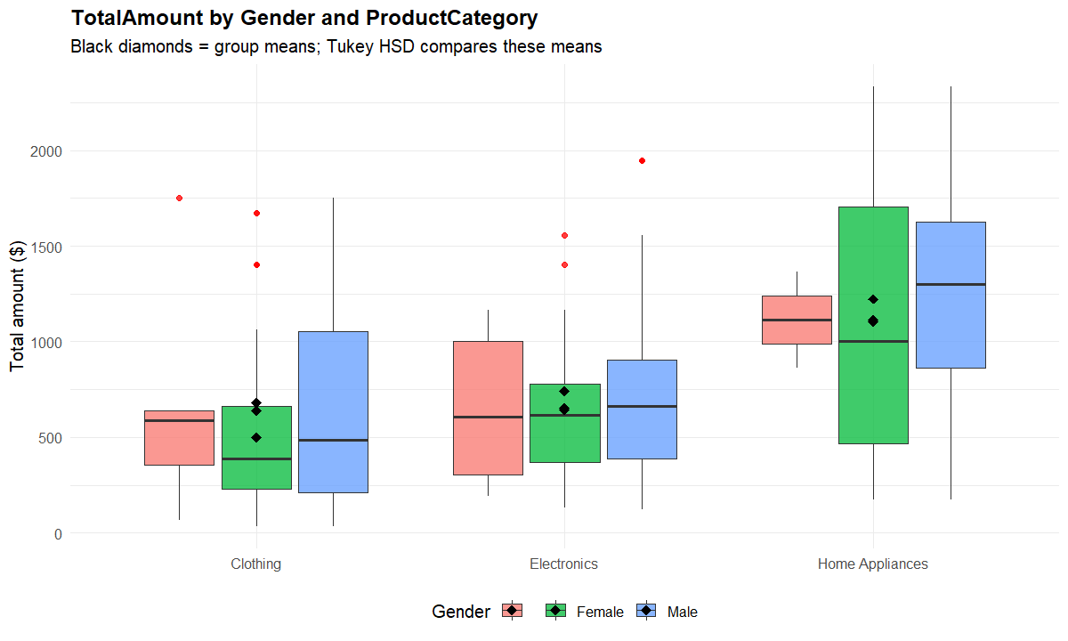

Bar chart — transactions by product category
p1 <- ggplot(eco_data, aes(x = ProductCategory, fill = ProductCategory)) + geom_bar(alpha = 0.35,
outlier.color = "red", outlier.shape = 10, outlier.size = 1) + labs(title = "Transactions by Product Category",
subtitle = "Clothing has the most transactions", x = NULL, y = "Number of transactions") +
theme_economist()
p1
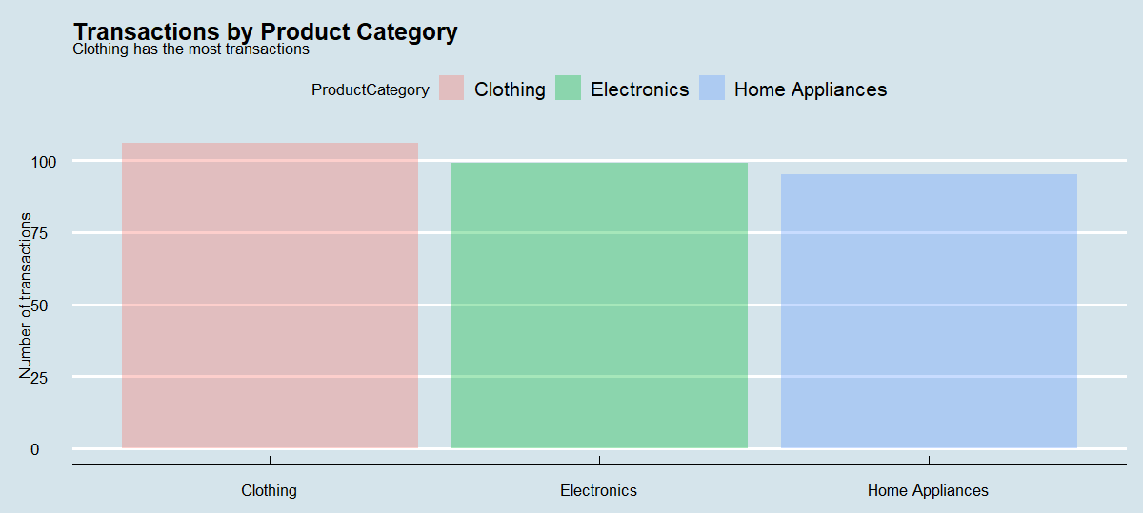

Histogram — distribution of transaction amounts
p2 <- ggplot(eco_data, aes(x = TotalAmount)) + geom_histogram(bins = 30, fill = "darkorange",
colour = "white") + geom_vline(xintercept = avg_total, linetype = "dashed", colour = "red",
linewidth = 0.8) + geom_vline(xintercept = med_total, linetype = "dotted", colour = "blue",
linewidth = 0.8) + labs(title = "Distribution of Transaction Amounts", subtitle = "Red dashed = mean; blue dotted = median (right-skewed)",
x = "Total amount ($)", y = "Frequency") + theme_economist()
p2
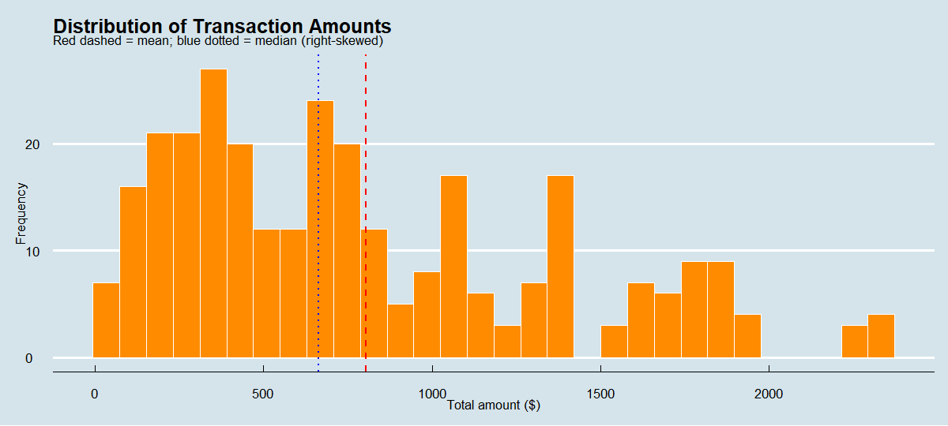

Boxplot — TotalAmount by membership status
p3 <- ggplot(eco_data, aes(x = MembershipStatus, y = TotalAmount, fill = MembershipStatus)) +
geom_boxplot(alpha = 0.75, outlier.colour = "red") + labs(title = "Transaction Amount by Membership Status",
subtitle = "Premium members spend more per transaction", x = NULL, y = "Total amount ($)") +
theme_excel() + theme(legend.position = "none")
p3
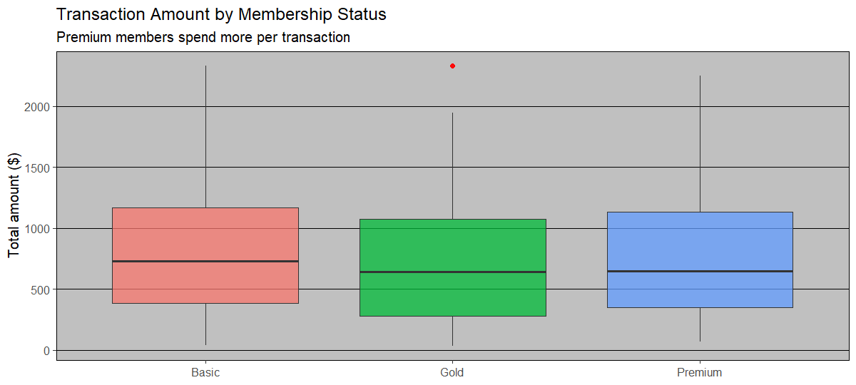

Scatter plot — Price vs TotalAmount
p4 <- ggplot(eco_data, aes(x = Price, y = TotalAmount, colour = ProductCategory)) +
geom_point(alpha = 0.65, size = 2) + geom_smooth(method = "lm", se = FALSE, colour = "grey30",
linetype = "dashed", linewidth = 0.7) + labs(title = "Unit Price vs Total Amount",
subtitle = "Linear relationship driven by TotalAmount = Price x Quantity", x = "Unit price ($)",
y = "Total amount ($)") + theme_minimal()
p4
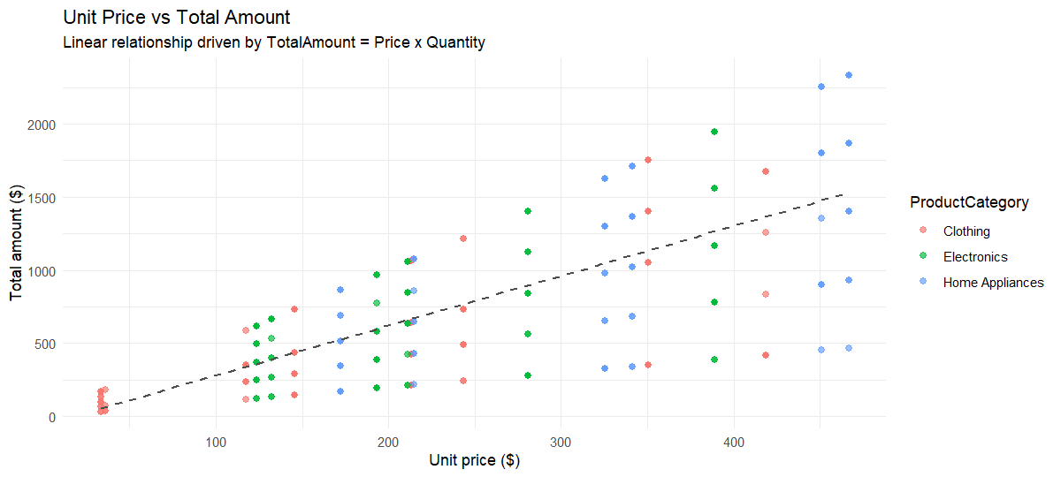

Bar chart — payment method frequency
p6 <- ggplot(pay_freq, aes(x = reorder(PaymentMethod, -Count), y = Count, fill = PaymentMethod)) +
geom_col(alpha = 0.85) + geom_text(aes(label = paste0(Pct, "%")), vjust = -0.4,
size = 3.5) + labs(title = "Payment Method Frequency", subtitle = "UPI and Debit Card",
x = NULL, y = "Number of transactions") + theme_minimal() + theme(legend.position = "none")
p6
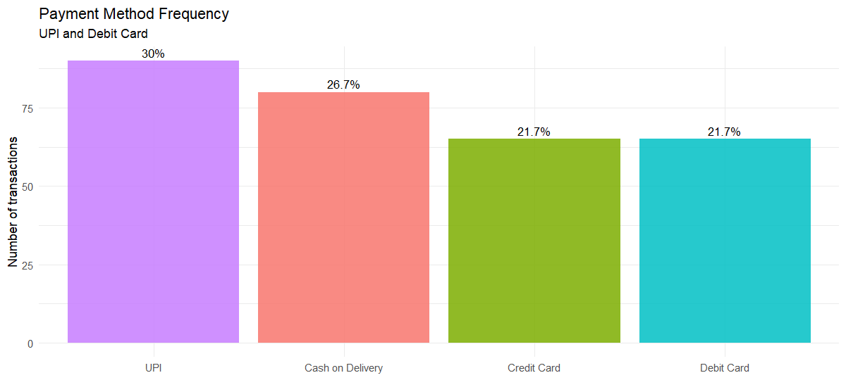

Combined panel
grid.arrange(p1, p2, p3, p4, p5, p6, p7, p8, ncol = 2)
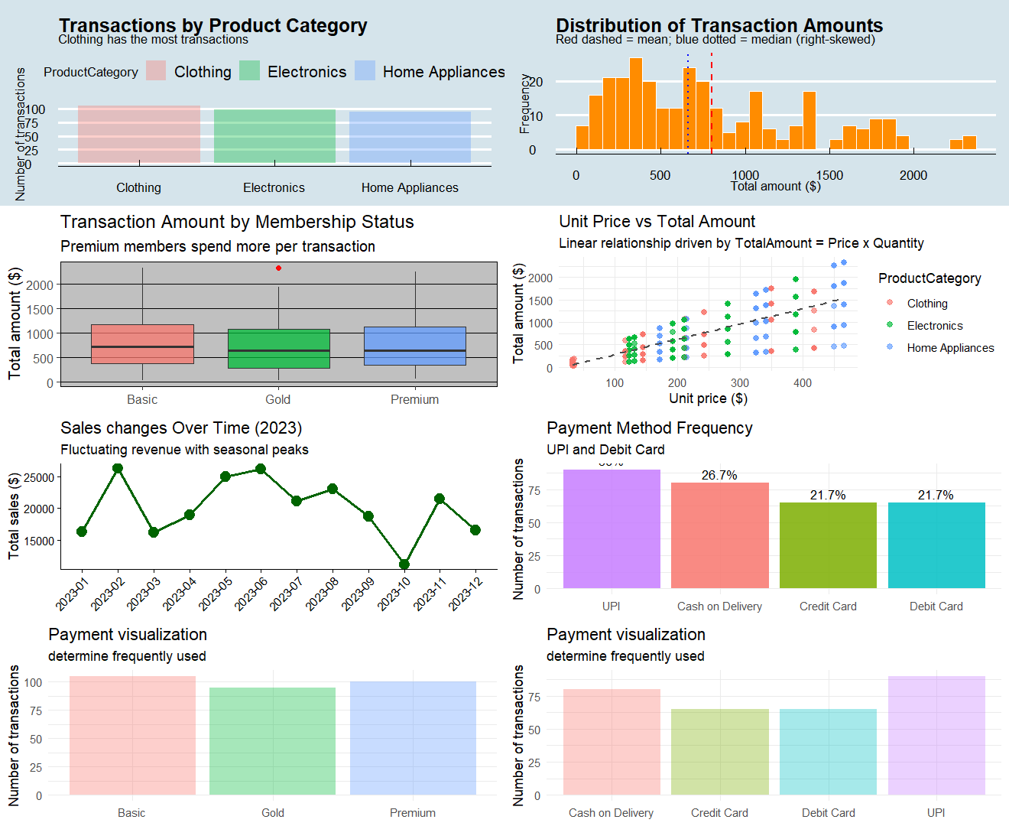

Key Findings The analysis shows that transaction spending is right-skewed: the mean (~$803) is higher than the median (~$662), meaning most baskets are modest while a few high-value purchases inflate the average. Home Appliances and Electronics generate the most revenue, even though Clothing has the most transactions, so revenue is driven by high-ticket categories rather than frequency. UPI and Debit Card are the most frequently used payment methods, while Credit Card baskets tend to be larger. Average basket size is about three units, and total revenue is around $240,935 across the cleaned transactions. Membership status appears to matter: Premium members spend the most per transaction and Basic members the least, though the ANOVA p-value should be checked to confirm statistical significance. Gender and ProductCategory are assessed using chi-square and Cramér’s V, while Age and Rating show weak linear relationships with spending; Quantity and Price are the main drivers of TotalAmount. Sales fluctuate by month, suggesting seasonality with mid-year and December peaks. Finally, the cleaned data showed no impossible values and was internally consistent, though duplicate handling and conflicting summary figures should be verified before final reporting.

8. Conclusions The R analysis reveals right-skewed spending, with a few large baskets driving revenue while most purchases are modest. Home Appliances and Electronics lead in revenue, whereas Clothing drives transaction frequency. Digital payments dominate, and Premium members appear to spend more per transaction. Age and product rating are weak predictors, while category, quantity, price, and membership tier are stronger signals. Sales show seasonal fluctuations. These findings offer clear direction for product, payment, and retention strategy, though final figures and significance tests should be verified before submission.

