**What do we want to make?**

* Flexible
* Different modes? Instrument types, notes types, synth, etc
* Bluetooth - less messy, range might not be great (but we shouldn’t be too far away anyways)
* Arduino?
  + [FLORA (Drum Glove implementation)](https://www.adafruit.com/index.php?main_page=category&cPath=92) - arduino based, wearable and small
  + Drum gloves with FLORA: <https://learn.adafruit.com/midi-drum-glove/>
  + Bluetooth compatible - [Bluefruit](https://www.adafruit.com/product/2487) LE
    - IOS/Android app available; bypass Macs entirely?
    - <https://github.com/adafruit/adafruit-bluefruit-le-desktop> desktop drivers

Sensors

[Square force sensitive resistor](https://www.adafruit.com/product/1075?gclid=CjwKCAiAy-_iBRAaEiwAYhSlAxpf_716rcnwPPeeMId8hXImt1iTrfJFz4BAhdthDDHdZ6r1Galc2RoC0aAQAvD_BwE)

[Long flex sensor](https://www.adafruit.com/product/182)

Learning

[Arduino tutorial](https://learn.adafruit.com/lesson-0-getting-started/overview)

[Flex Sensor Hookup Guide](https://learn.sparkfun.com/tutorials/flex-sensor-hookup-guide/all)

[Serial to MIDI](https://www.instructables.com/id/Arduino-Sensors-and-MIDI/)

[MIDI USB](https://www.arduino.cc/en/Tutorial/MidiDevice)

[send MIDI notes via USB (code)](https://github.com/arduino-libraries/MIDIUSB/blob/master/examples/MIDIUSB_write/MIDIUSB_write.ino)

[Getting usb midi into Ableton](https://forum.ableton.com/viewtopic.php?t=227044)

[More on Ableton inputs](https://help.ableton.com/hc/en-us/articles/209774205-Live-s-MIDI-Ports-Explained)

[Mac Virtual Bus](https://help.ableton.com/hc/en-us/articles/209774225-Using-virtual-MIDI-buses)

Resources

[Make Music with Shoes - NPR](https://www.npr.org/sections/allsongs/2010/04/tired_of_just_making_calls_mus_1.html)

[Musical Midi Shoes - Instructables](https://www.instructables.com/id/Musical-MIDI-Shoes/)

[Wireless Shoes (YT)](https://www.youtube.com/watch?v=4OmUaGdWhCY)

**What we need to decide:**

* Socks or shoes? Those flexible nikes are a good choice if we want to go for shoes, but expensive
* How many sensors? Draw a diagram of shoe/foot and place sensors and what kind of sounds we think would suit each location/sensor type best
* When to meet regularly? Where?
* Organization and planning stuff for rest of term
* Make timeline of what we want done by end of each week - VJ

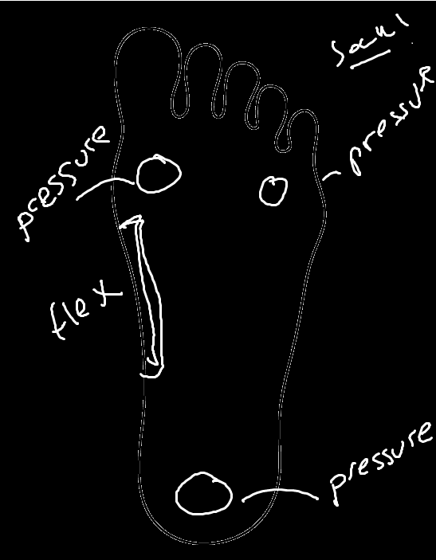

I can’t write/draw ^

We can do a combination of taps, double tap, etc

* Flex sensor: tuning, modulator wheel
* Pressure sensors: can have different combinations do different things, i.e. left + right makes drum sound, only left makes piano or something

Meeting Notes

* Bluetooth is probably better, but we need to make sure it’s reliable - testing, maybe backup wired setter
  + Test with Bluefruit Android/IOS app
* Are sensors strong enough? They need to be able to handle a dancing man
  + Place inside shoe, attach to sock; maybe look into gel inserts or something to soften blows
  + He’ll be using boots, plan for that
* 2 pressure and 1 flex for now
  + max forums for bend sensors and flex sensors → VJ recommended
    - VJ has some sensors now, maybe we can test with them at some point?
  + Make sure sensors are compatible with FLORA; should be since it’s just an arduino, but check
  + Piezoelectric sensors? Can be difficult to place, but high resolution and accuracy
* **Step 1**: get input into a computer, from sensors → arduino/FLORA → Mac
  + Attach FLORA to leg or something to avoid damage; use tube socks to hold in place, also aesthetic
    - If using wired setup, wires will go into boot
    - FLORA is sewable!
* Timeline!!
  + Testing and Setup
    - Get info into the computer
    - Test sensors using alligator clips, etc
    - Get familiar with Max, Arduino, Ableton
  + Eventually will sauter everything into place for more comfort and security