**CSCI 3230 Binary Files Lab**

**Goals** This first program will serve as a warm-up for the later projects. You will become familiar with the use of C# binary files. You must use good object oriented design for this program.

The data used for this program consists of botanical field study records – plants that have been observed, by whom, where and when.

**1. Startup** On program startup, prompt the user for the name of a text file (or better: use the OpenFileDialog widget). This file will contain plant information (see below for format). If the input file is present, open that file for read access. If the input file is missing, use the default input file name “bio.txt” and open it instead. If there is any problem opening the file, display an error message and exit the program.

**2. File Format** The input file will consist of some number of records, one per line. Records within the line are delimited by the pipe character (“|”). There are seven fields: id, common name, scientific name, latitude, longitude, date, and name. The id field is an integer; latitude and longitude are doubles, the data field is up to 20 characters, and the others are strings up to 64 characters.

**3. Processing** The program should read records from the input file and display them on the screen, one at a time. After all records have been displayed, write out a new binary file of the records. See the example code for how to deal with binary records in C#.

4. **ITEMS to Do**

1. Updated ProcessTextFile so that is prints the content of the file to a textbox.

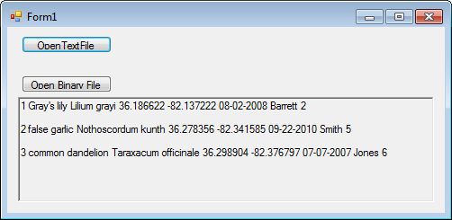

1. Update ProcessBinaryFile
   1. That it creates a text file by replaces “.dat” with “_2.txt”
   2. Write the record back to the binary file with the delimiters (as with the original txt file)

5. Testing

* Call Open Text File with Bio.txt -> creating Bio.dat
* Call Open Binary with Bio.dat creating Bio_2.txt
* Call Open Text File with Bio_2.txt -> creating Bio_2.dat
* Call Open Binary with Bio.dat -> creating Bio_2_2.txt
* Fc Bio_2_2.txt Bio.txt to verify they are the same.
* Submit a screenshot of the fc.