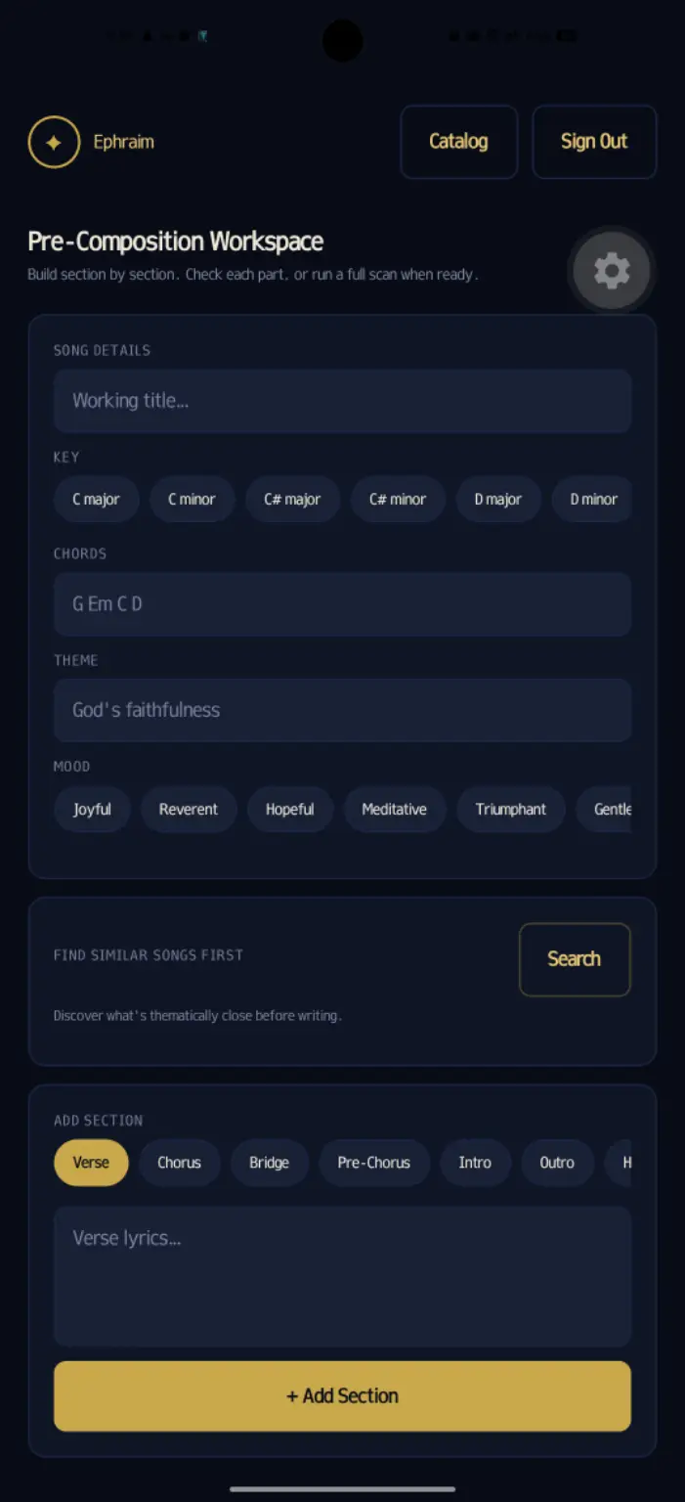
- The search button (Find similar songs first) in pre-composition workspace isn't working
- in pre-composition workspace, when I'm adding a section of my song, it doesn't

scroll up for me to see what I'm doing
- there's no audio file input option in the pre-composition workspace right now

- the song i tested in pre-composition workspace, the chorus was the exact same thing with one of the songs in the catalog, but the full scan results said it's an 18% percent match, is that because its just the chorus of the song I pasted ?

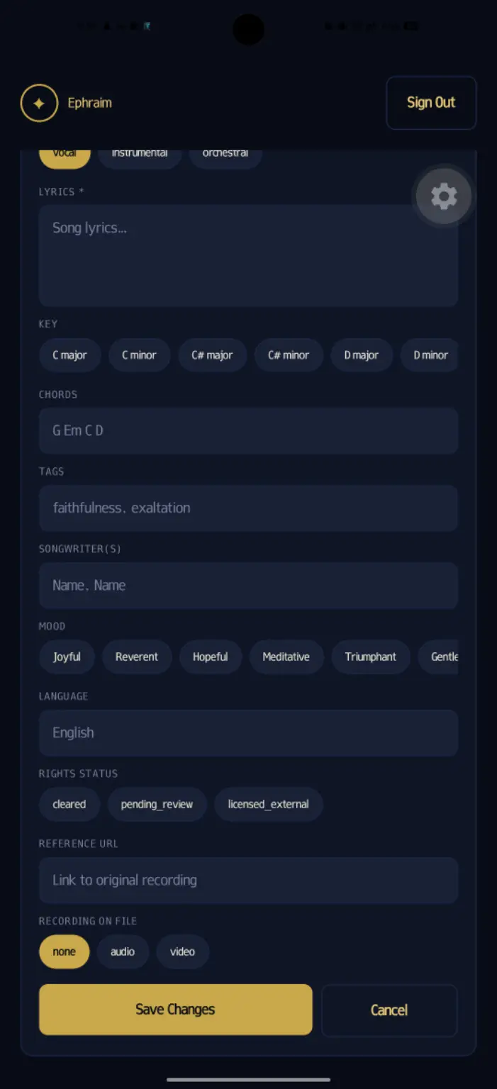

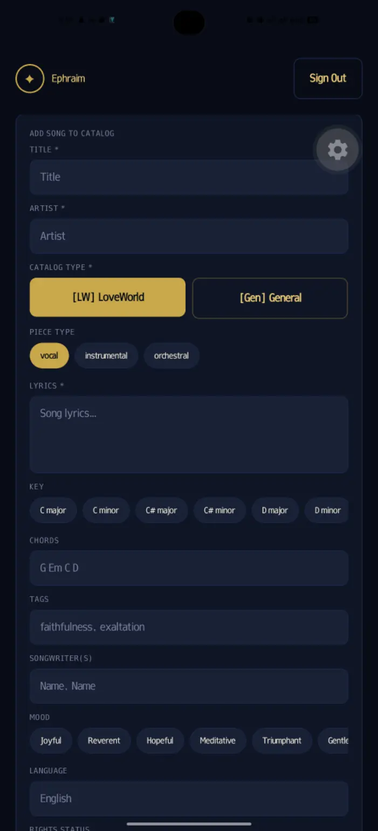

- In the catalog for loveworld songs, there should be an audio file input point for the admin to add audio to the songs in catalog
- some options aren’t needed here. Like CHORDS, LANGUAGE, MOOD, TAGS, STATUS.

-The recording on file should be a file input button, that can input audios, videos and other files, take away those option button, also take away PIECE TYPE & CATALOG TYPE.

- It's still searching for global songs from the catalog, but the search is supposed to be simultaneously, it should search from both catalog and acousticID API

