VISUAL REGRESSION REVIEW
DailyFlora Hydrangea Visual Regression Review
A screenshot-led review packet for ChatGPT Web
Date | 2026-07-15
Page | docs/realistic-flower-lab.html
Primary file | src/realisticFlowerForms.ts
Visual basis | Legacy createHydrangea from commit 0b3655c
Core outcome The incorrect continuous shell model was removed from the active path. The accepted legacy cluster of 104 readable four-sepal decorative flowers was restored, then adjusted only by narrowing random scale and softening the blue palette.

Task for ChatGPT Web
Treat the screenshots as the primary authority. First decide whether the restored version has returned to the accepted visual baseline. Do not interpret realism as a continuous shell, more holes, more random patches, or more internal parts.
- If further adjustment is needed, propose no more than three restrained changes with direct screenshot benefit.
- For each change, identify the exact parameter or generation rule and provide a minimal diff.
- Do not modify Foxtail Lily, Ammi majus, the home page, daily bouquet, Special Edition, routing, or other LAB flower forms.

1. Accepted baseline and regressed version
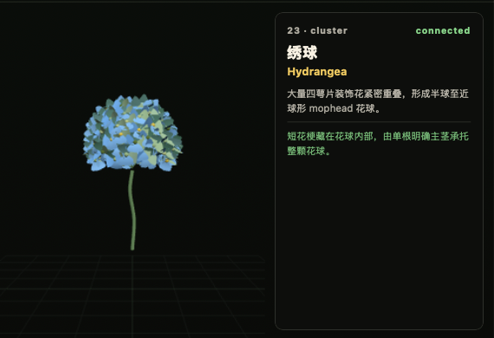
Figure 1 | Accepted legacy Hydrangea: readable flowers, unified blue, natural outline.
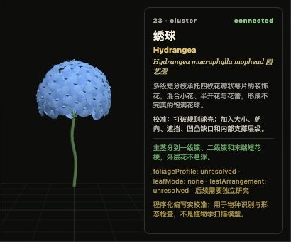  Regressed front: continuous dome shell and holes | 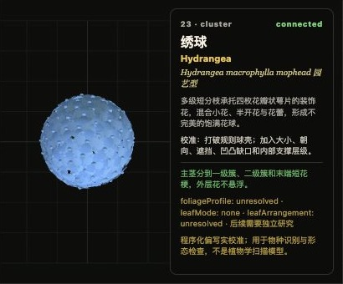  Regressed top: nearly perfect circular disk
Wrong direction Individual flowers became unreadable; surface relief became a perforated shell; the top view was too circular; internal shadows and fragments replaced the flower-cluster impression.

2. Restored version in three views
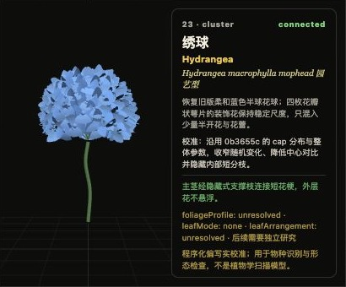
Figure 2 | Front: reads first as a blue Hydrangea cluster, then as independent four-sepal flowers.
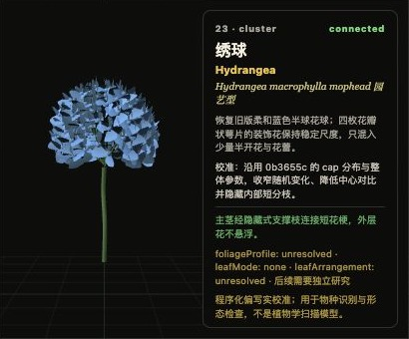  Figure 3 | Side: lightly uneven outline, not a continuous shell | 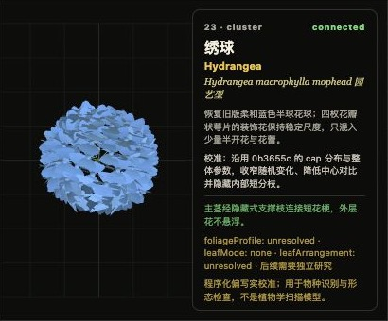  Figure 4 | Top: independent flowers, not a smooth disk
Current assessment The restored version is materially better than the regressed shell. Small dark gaps come from flower overlap and no longer become large openings or a continuous perforated surface.

3. Minimal code changes made
- Stopped routing hydrangea to createCalibratedHydrangea.
- Restored the legacy generator as the active path and named it createHydrangeaBaseline.
- Kept 104 four-sepal decorative flowers, golden-angle distribution, the natural dome outline, and internal support.
- Narrowed per-flower scale from 0.90–1.08 to 0.95–1.05.
- Changed the center to a related soft-blue blend; removed yellow, green, and dark jumps.
- Limited sepals to two neighboring blues with a white blend of 0.02–0.12.
- Did not force half-open flowers or buds back in, avoiding renewed holes and patchwork.

4. Baseline vs. regression vs. restoration
Criterion | Accepted baseline | Regressed shell | Current restoration
First read | Blue Hydrangea material | Blue shell model | Blue Hydrangea material
Flower readability | Clear | Nearly lost | Clear again
Outline and shadows | Natural and soft | Too round; heavy holes | Slight asymmetry; restrained gaps

5. Verification and retained limitations
- npm run build succeeded; Vite completed in about 11.8 seconds.
- Browser console: 0 errors and 0 warnings.
- Only src/realisticFlowerForms.ts changed: 14 lines total, 7 additions and 7 deletions.
- The legacy generator keeps individual short pedicels, so draw calls remain higher. Performance work must not merge the flowers back into a shell.

Appendix A | Active generator
This is the current render path. Use it to propose a targeted minimal diff.
function createHydrangeaBaseline(options: BuildOptions) {
const rng = createRng(`${options.seed}:hydrangea`);
const group = new THREE.Group();
const green = colorAt(options.palette, options.palette.length - 1, '#5d7f54');
const stem = stemAlong([
new THREE.Vector3(0, -1.18, 0),
new THREE.Vector3(-0.025, -0.72, 0.015),
new THREE.Vector3(0.035, -0.28, -0.02),
new THREE.Vector3(0, 0.02, 0)
], 0.028, green, 16);
group.add(stem.mesh);
const flowerCount = 104;
const cloudCenter = new THREE.Vector3(0, 0.4, 0);
const softCenter = colorAt(options.palette, 1).clone()
.lerp(colorAt(options.palette, 0), 0.55);
const petals = new THREE.InstancedMesh(
roundedSepalGeometry(0.15, 0.115, 0.014),
flowerMaterial(colorAt(options.palette, 0), 0.84),
flowerCount * 4
);
const centers = new THREE.InstancedMesh(
new THREE.SphereGeometry(0.032, 8, 6),
flowerMaterial(softCenter, 0.9),
flowerCount
);
let petalIndex = 0;
for (let i = 0; i < flowerCount; i += 1) {
const yNorm = 0.98 - (i / Math.max(1, flowerCount - 1)) * 1.38;
const angle = i * 2.39996 + rng.range(-0.08, 0.08);
const ring = Math.sqrt(Math.max(0, 1 - yNorm * yNorm));
const normal = new THREE.Vector3(
Math.cos(angle) * ring, yNorm, Math.sin(angle) * ring
).normalize();
const radius = rng.range(0.58, 0.65);
const bloom = cloudCenter.clone().addScaledVector(normal, radius);
const shortPedicel = bloom.clone().addScaledVector(normal, -0.1);
group.add(cylinderBetween(shortPedicel, bloom, 0.0045, green));
const scale = rng.range(0.95, 1.05);
setInstance(
centers, i, bloom, new THREE.Vector3(scale, scale, scale),
softCenter, 0, normal
);
const reference = Math.abs(normal.y) < 0.88
? up : new THREE.Vector3(1, 0, 0);
const tangent = new THREE.Vector3()
.crossVectors(normal, reference).normalize();
const bitangent = new THREE.Vector3()
.crossVectors(normal, tangent).normalize();
for (let p = 0; p < 4; p += 1) {
const pa = p / 4 * Math.PI * 2 + rng.range(-0.04, 0.04);
const petalDirection = tangent.clone()
.multiplyScalar(Math.cos(pa))
.addScaledVector(bitangent, Math.sin(pa))
.addScaledVector(normal, 0.08)
.normalize();
setInstance(
petals, petalIndex, bloom,
new THREE.Vector3(scale, scale, 1),
colorAt(options.palette, p % 2).clone()
.lerp(new THREE.Color('#ffffff'), rng.range(0.02, 0.12)),
0, petalDirection
);
petalIndex += 1;
}
}
const supportHub = new THREE.Vector3(0, 0.05, 0);
for (let i = 0; i < 9; i += 1) {
const angle = i / 9 * Math.PI * 2;
const inner = cloudCenter.clone().add(new THREE.Vector3(
Math.cos(angle) * 0.28,
-0.08 + (i % 3) * 0.13,
Math.sin(angle) * 0.28
));
group.add(cylinderBetween(supportHub, inner, 0.007, green));
}
group.add(petals, centers);
return group;
}

Dispatcher entry
case 'hydrangea':
return createHydrangeaBaseline(options);

Appendix B | Required ChatGPT response format
- State whether the restoration has reached the visual baseline, citing the front, side, and top screenshots.
- If changes remain necessary, provide no more than three, ranked by visual benefit.
- For each change, name the exact parameter or generation rule.
- Explicitly list the incorrect structures that must not return.
- Do not modify Foxtail Lily, Ammi majus, the home page, daily bouquet, Special Edition, routing, or any other LAB flower form.
- If code is suggested, provide a minimal diff against createHydrangeaBaseline; do not rewrite the whole flower form.
Acceptance principle Judge the result by cluster impression, individual-flower readability, natural outline, and soft blue color in screenshots—not by code complexity.

