### **Get Started - Onboard With Calimatic Coach**

Get Started with your Account setup and one-on-one training from Calimatic Coach.



Written By Ivan Karmer

Updated 2 years ago

Calimatic provides the following services to get started with the platform:

* **Free Calimatic Coach Program -** An online meeting with your personal Calimatic Coach to determine your needs.
* **Platform Configuration -** Web-session with your Coach to get step by step walkthrough of the Platform and configuration to get you started with a customized platform.
* **Billing & ePayments Configuration -** Setting up Billing & ePayments and configuring the payment system to your requirements.
* **Free Training to Franchise/Center Admin -** Free of charge 1-hour training to the Franchise/Center Admin on the management, tools, and frameworks of the platform.
* **Ongoing support -** Customer Support team to provide any type of assistance about the platform.

At Calimatic, we ensure that you will:

1. Get a customized platform for your needs
2. Use the platform effectively
3. Have innovative tools on-hand
4. Get assistance from the Support Team

Book your one-on-one session [here](https://calendly.com/calimatic/60min).

Contact us at hello@calimaticedtech.com for any questions.

### **Quick Start For Admins**

First steps after you subscribe to Calimatic EdTech (Jump Start)



Written By Ivan Karmer

Updated one year ago

This article covers the steps to quickly get started with the Platform.

The user with which you subscribe to Calimatic (Free or Paid) will be the Master Admin.

Once you login as Master Admin, you will be landed in the Dashboard/Home Page (after you activate your account and accept the End User License Agreement).

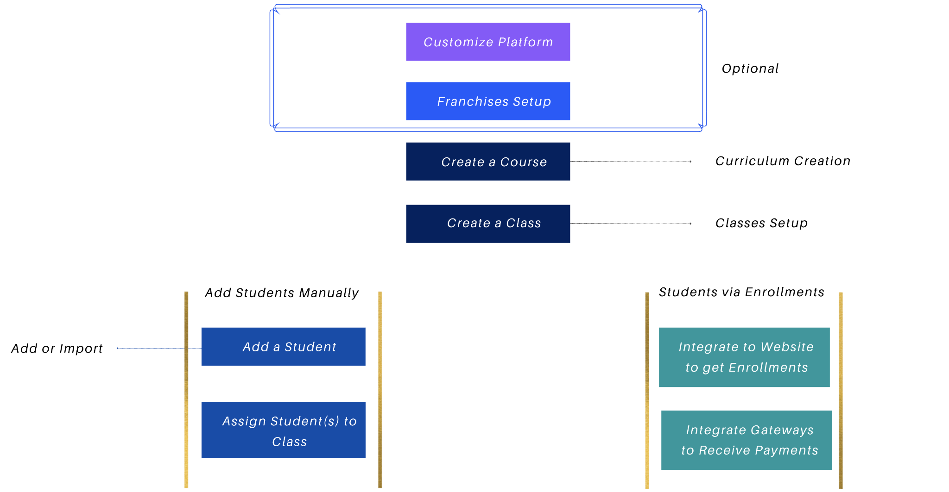

***Customization - If you want to Customize the Platform to meet your branding & institute needs*,** the high level Platform customizations are listed here - [Customizing the Platform](https://help-lcm.calimatic.com/article?categoryId=52&solutionId=149)

***Franchise or Center Management***

***If you want to use the Platform for multiple Centers or Franchises separately*,** you have the ability to create separate accounts for each Center or Franchise.

* The Platform accounts structure are explained here - [Platform Accounts Structure](https://help-lcm.calimatic.com/article?categoryId=3&solutionId=159)
* Follow these steps to create a new Center or Franchise account - [Franchise or Center Creation](https://help-lcm.calimatic.com/article?categoryId=6&solutionId=102)
* Follow below steps for each Franchise or Center as needed. If you have Franchises or Centers in multiple countries, please contact us to discuss the Payment Gateways & other details regarding the setup.

***Curriculum Creation***

**Create a Course:**

Click on the Courses menu. You have the ability to create and manage Courses and Curriculum or learning content in 2 different views -

1. Clicking on Course Player submenu will navigate to the Course Player page (OR)
2. Clicking on Central submenu will navigate to the Central page  
     
   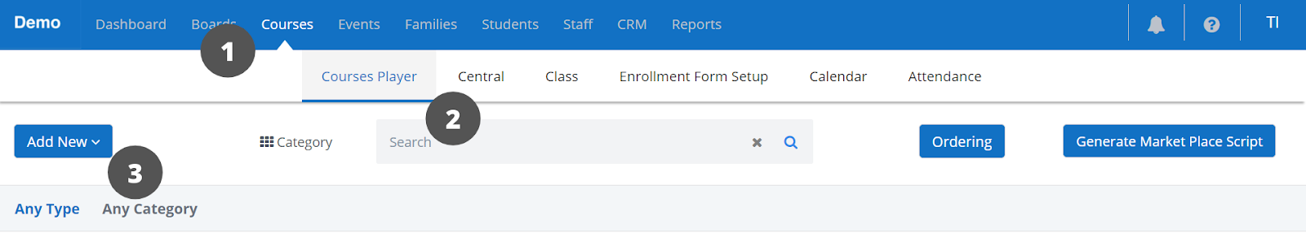

You can choose any one of these ways based on your convenience.

Clicking on the "Add New" button and selecting the "Course" option will open the Course popup.

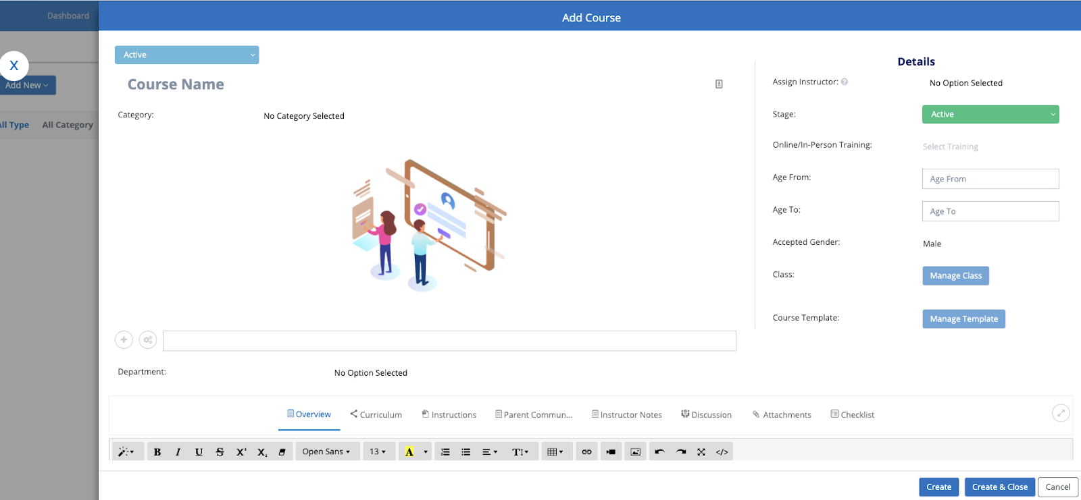

Enter the required information for the Course as needed.

Click on the Create button and this will create the Course and keep the popup open.

***Class Creation***

You have the ability to create classes for a Course or its Level in the Course popup or in "Classes Overview" page. Refer here for managing Classes in ["Classes Overview"](https://help-lcm.calimatic.com/article?categoryId=10&solutionId=177)

**Create a Class within a Course:**

Click on the "Manage Class" popup. In the popup, click on the "Add New" button to create a new Class.

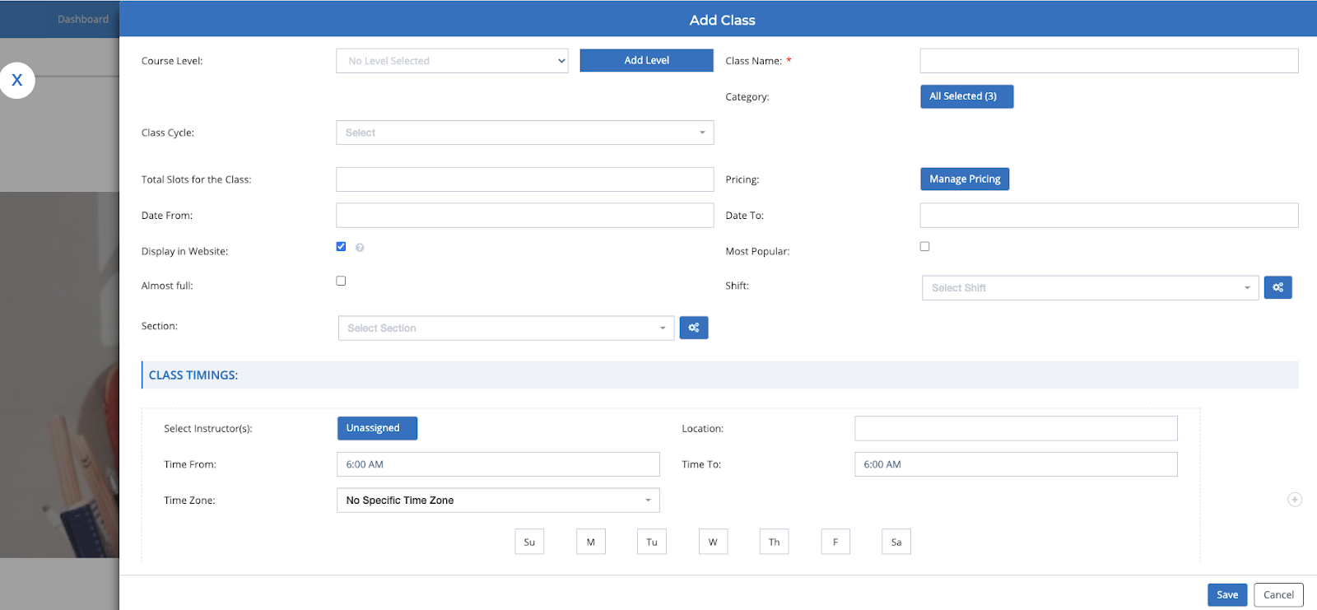

Enter required information for Class and click on Manage Pricing to enter Pricing information.

Click on the Save buttons for Pricing and Class popups to save the info.

***Setup Payment Gateway to receive Payments for the enrollments***

Refer here to setup Stripe to receive Payments for US & International Clients - [Stripe Payment Setup](https://help-lcm.calimatic.com/article?categoryId=3&solutionId=158)

Refer here to setup RazorPay to receive Payments for India Clients - [Razor Payment Setup](https://help-lcm.calimatic.com/article?categoryId=3&solutionId=163)

Refer here to setup Plaid to receive Bank Account Payments for US Clients - [Plaid Payment Setup](https://help-lcm.calimatic.com/article?categoryId=3&solutionId=162)

***Integrate the enrollment page to your website or directly use the enrollment page***

Click on the Courses menu and click on the Class submenu. Click on the "Class Setup" menu on the left side section.

Click on the "Generate Embedded Script" to integrate to your website. Copy the code from the popup and add in your website code.

Add a Student and assign him to a Class (if not Enrolled via enrollment page)?

Click on the Students menu and click on "Student Info" submenu.

Click on the “Add Student" button to add a new Student. In the Overview tab, you have the ability to add Student's Information, add one or more Contacts of a Student.

Click on Create button to create the Student. In the Student popup, click on the Class tab and click on "Add to a Class" button.

Click on "Add to Class" button for the Class you need to add the Student.

**To Add Bulk Students**, refer here - [Import Students & Parents/Contacts](https://help-lcm.calimatic.com/article?categoryId=3&solutionId=181)

***Add a Instructor or Staff***

Click on the Staff menu and click on the Staff Info submenu.

Click on Add Staff and fill the required information in the Staff Info popup. Click on the "Create & Close" button.

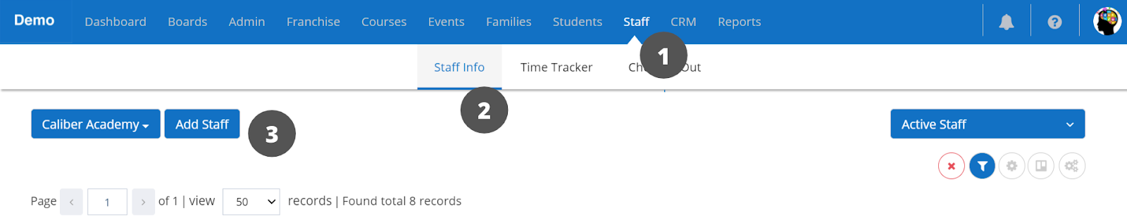

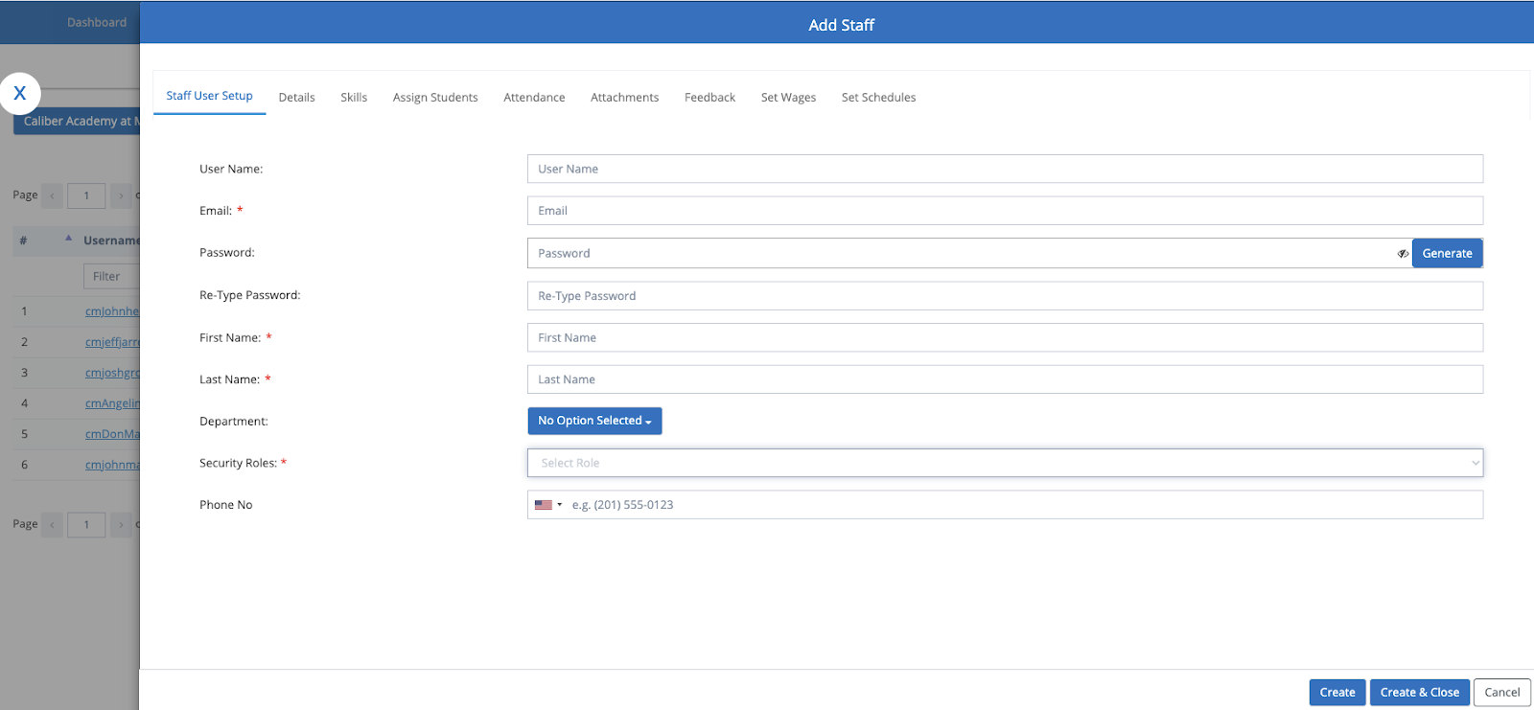

**To Add Bulk Staff**, refer here - [Import Staff](https://help-lcm.calimatic.com/article?categoryId=3&solutionId=182)

### **Get Started - Students**

Quick Overview to get started with the Platform for Students

MM

Written By Marianna Mkhchyan

Updated one year ago

Once you activate your account and accept the End User License Agreement, you will land in the home page (which is the ***Dashboard)***. The upper menu bar gives access to all the areas of the platform that you have access to.

Here is the needed information to get started to using the platform -

* Join Online Class
* View Assigned Courses and the Assignments
* View/Take Exams
* View White Board
* View your Profile Information
* View the Calendar for your assigned Classes and Events

In the Dashboard (Home) Page, under the Links section, you have the ability to navigate to the mentioned areas by clicking on the appropriate links.

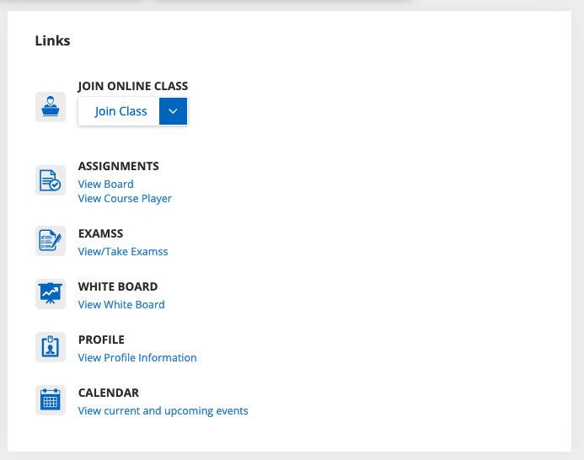

**Join Online Class**

In the Dashboard page, under the Links section, click on the "Join Class" drop down list. Look for the Class you need to attend and select the option. Click on the Continue button in the popup after you make sure your system/phone Mic and Video cam is connected and working properly. If the class has started, you will be automatically navigated to the Class. If the class hasn't started, a popup will appear. Please wait for the instructor to start the Class or contact the instructor for any questions.

View Assigned Courses and the Assignments

You have 2 places (Boards or Course Player) to go for viewing the Courses or your Assignments. Based on the information from your instructor, use the appropriate location.

1) **Boards** -

Click on the Boards menu in the upper menu bar. You will be navigated to your Board where all your assignments are listed under each Course row.

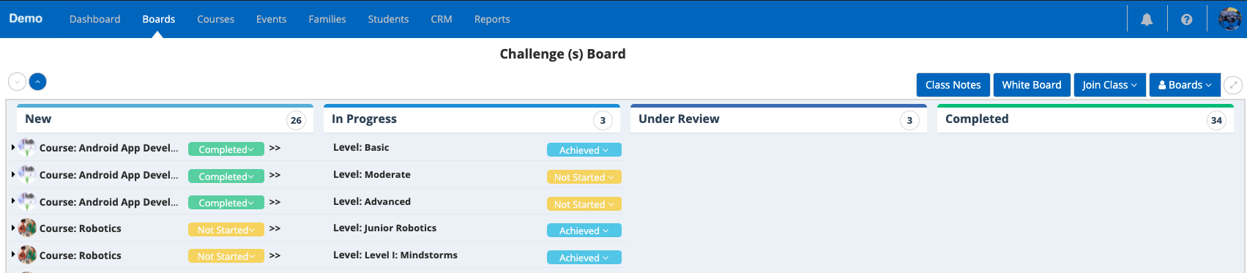

Expand the Course by clicking on the expand icon to view your assignments. Here you will see the assigned items for the corresponding Course and Level. Click on the title of the item to open it.

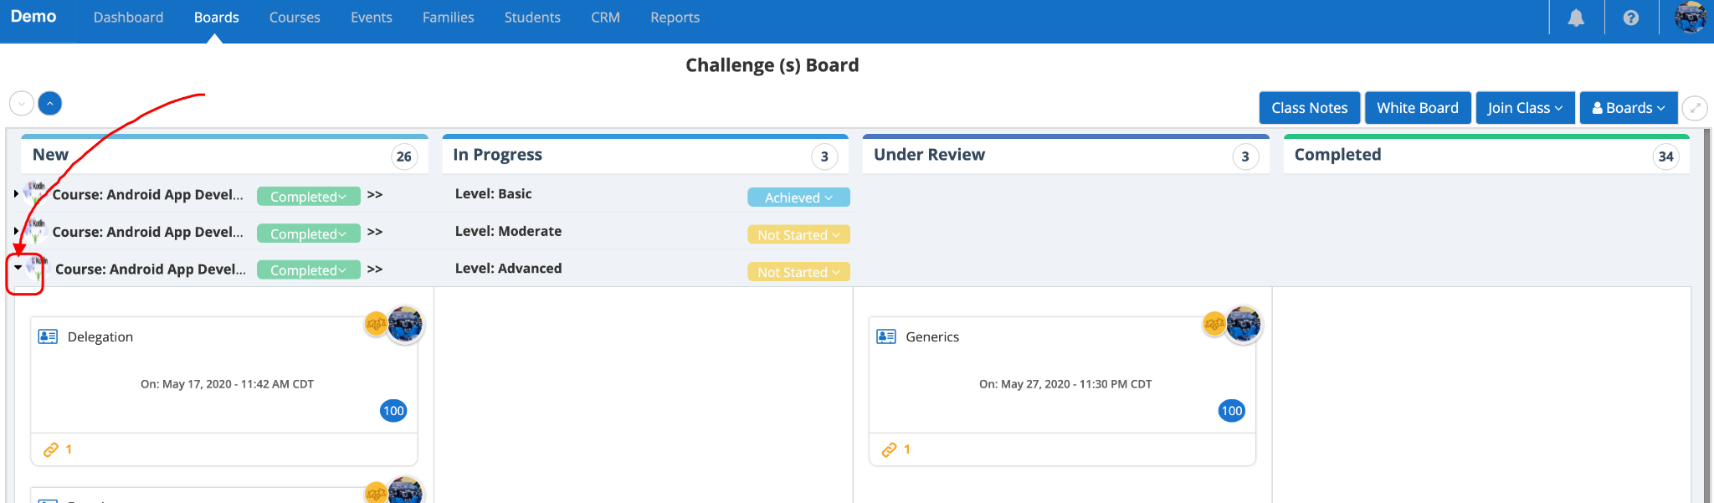

In the Student Instructions, you have all the lessons or assignments associated with the item. Talk to your instructor if you have any questions.

You also have the ability to view Class Notes (for the previously conducted Classes), ability to view your White Board, Join your Classes and switch between different boards.

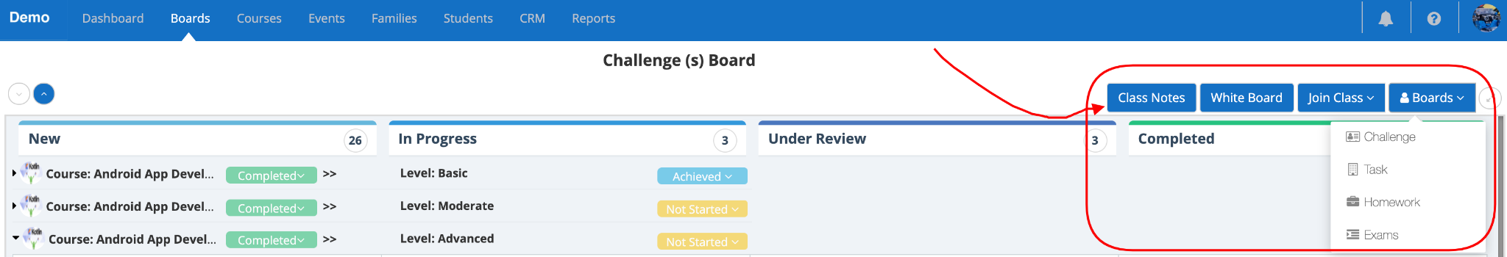

2) **Course Player** -

Click on the Courses menu in the upper menu bar. Click on the "Courses Player" submenu in the 2nd menu bar. You will be navigated to the Course Player page which will show you all your assigned Courses.

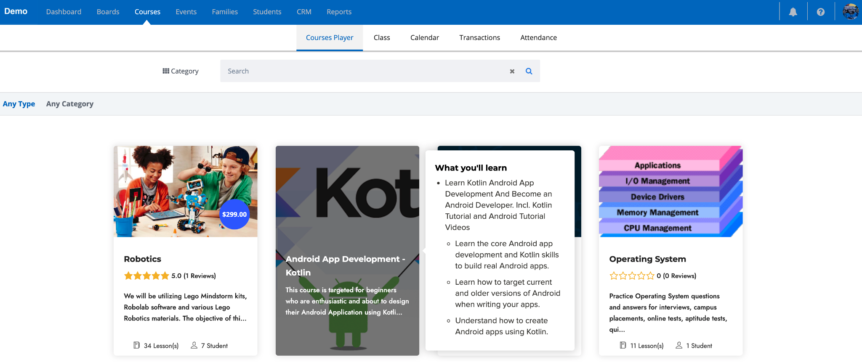

Click on the course you need to learn or view assignments. You will be navigated to the corresponding course page. Here you have the ability to Join your Classes, ability to view Class Notes (for the previously conducted Classes) and ability to view your White Board. Scrolling down will display your curriculum and the assignments assigned to you. Talk to your instructor if you have any questions.

View or Take Exams

Click on the Students menu in the upper menu bar. Click on the Assessments/Exams menu in the 2nd menu bar. Here you will see all your assigned Assessments or Exams or Tests. Hovering on the Assessment row will show you the buttons like "Take Assessment", "Re-Take Assessment", "View Result", "Continue" or "Submit Assessment" depending on the status of the Assessment.

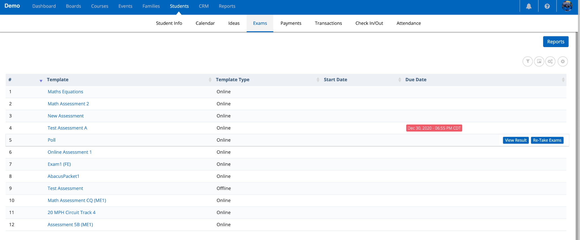

View White Board

You can access your White Board from 2 places (Boards or Course Player). Your White Board page is the same irrespective of which navigation path you go.

To access from Boards, click on Boards menu in the Upper menu bar. Click on the "White Board" button on the top right side of the page.

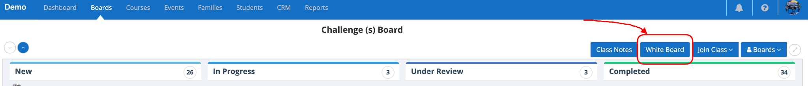

To access from Course Player, click on Courses menu in the Upper menu bar. Click on the "Courses Player" in the 2nd menu bar. Click on any Course in the page. In the Course page, click on the "White Board" button on the top right side of the page.

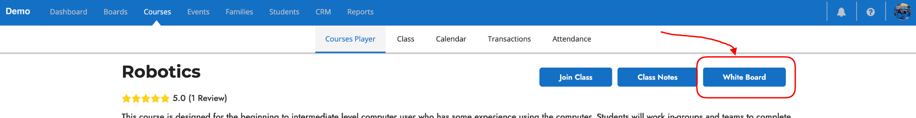

View your Profile Information

Click on the Students menu in the Upper menu bar. Click on the "Students Info" menu in the 2nd menu bar. Click on the Student Name in the grid which will open a popup.

All your profile information is shown here. Overview tab is selected by default. Clicking each tab will show your corresponding information.

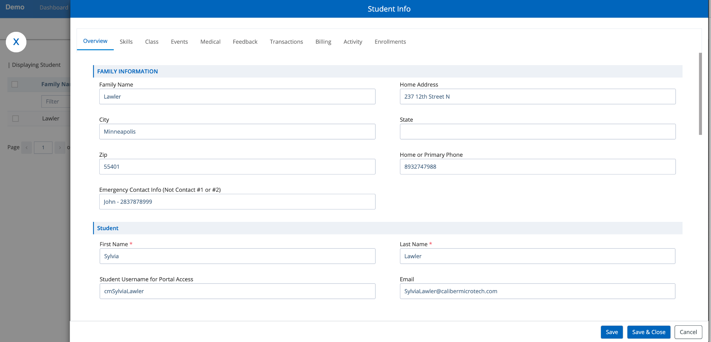

View the Calendar for your assigned Classes and Events

Click on the Courses menu in the Upper menu bar. Click on the Calendar menu in the 2nd menu bar. Here you can see all your assigned Classes and Events schedules by day, week, or month with Month selected by default. Clicking on the Class or Event will show you the details (Time, Instructors, etc.).

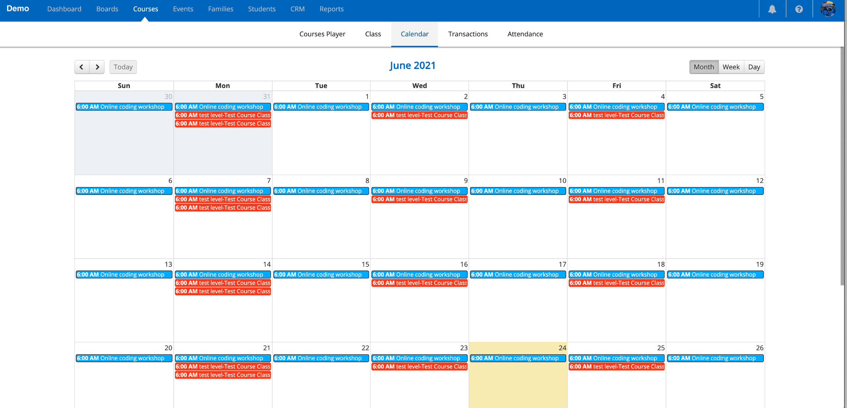

### **Get Started - Parents**

Quick Overview to get started with the Platform for Parents

MM

Written By Marianna Mkhchyan

Updated one year ago

Once you activate your account and accept the End User License Agreement, you will land in the home page (which is the ***Dashboard)***. The upper menu bar gives access to all the areas of the platform that you have access to.

Here is the needed information to get started to using the platform -

* Add Student or Enroll Student to new Classes or Events
* Add Billing Info, View Payments and View Transactions
* View Students Reports
* View Students Profiles
* View your Profile Information
* View the Calendar for the assigned Classes and Events

In the Dashboard (Home) Page, under the Links section, you have the ability to navigate to the mentioned areas by clicking on the appropriate links.

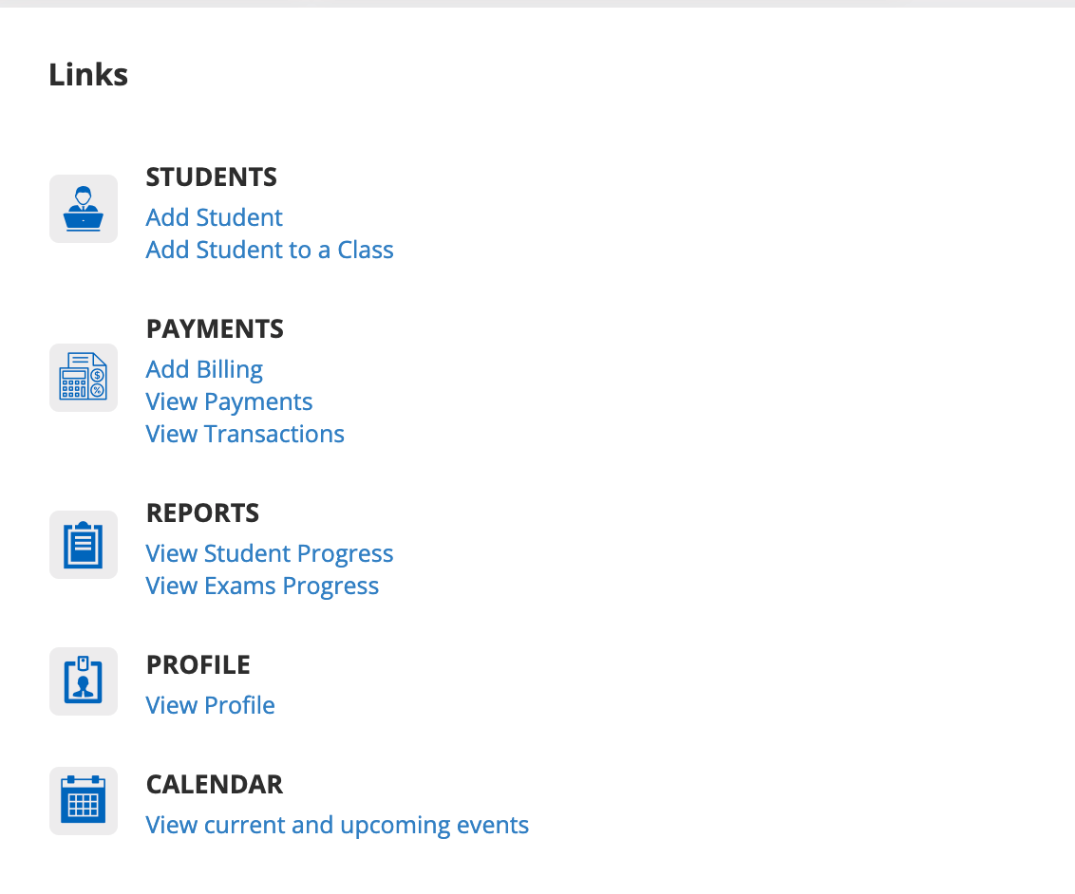

**Add new Student (add your additional Kid/Student) OR Enroll the Student (your kid) to a new Class or Event**

Click on the Students menu in the Upper menu bar. Click on the Students Info menu in the 2nd menu bar.

If you wish to add a new Student (additional kid), click on the "Add Student" button above the grid.

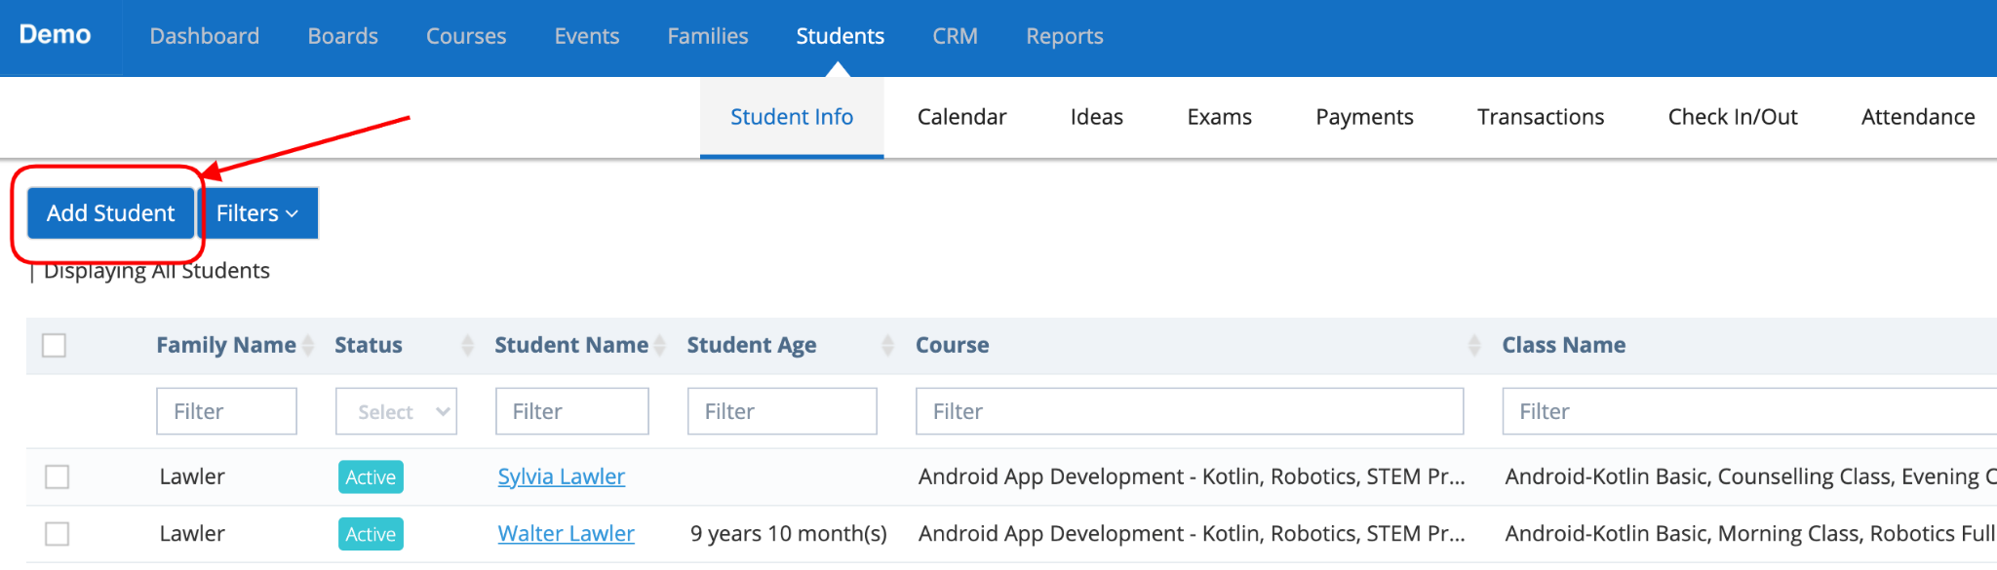

Enter the Student information and Save to create the new Students.

All your Students (or Kids) are listed in the grid. You have the ability to edit the information by clicking on the Student Name link in the grid and updating the info in the Student Info popup Overview tab.

In order to enroll the Student to a new Class or Event, click on the Student Name link in the grid. Student Info Popup will open with the Overview tab selected by default.

Click on the Class tab. Click on the "Add to a Class" button.

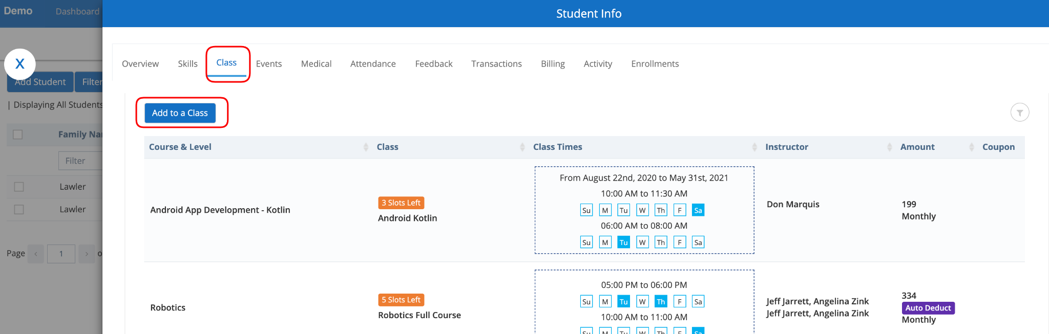

A popup will appear with the list of Classes. You have the ability to filter by Course or level, by clicking on the filter icon on the top right side of the popup above the grid and filtering the corresponding column.

Click on "Add to the Class" for which you want to enroll the Student. If you already have your billing info on file and if the Class has been configured to auto-detect any Class Fee, then you will be charged during this enrollment process.

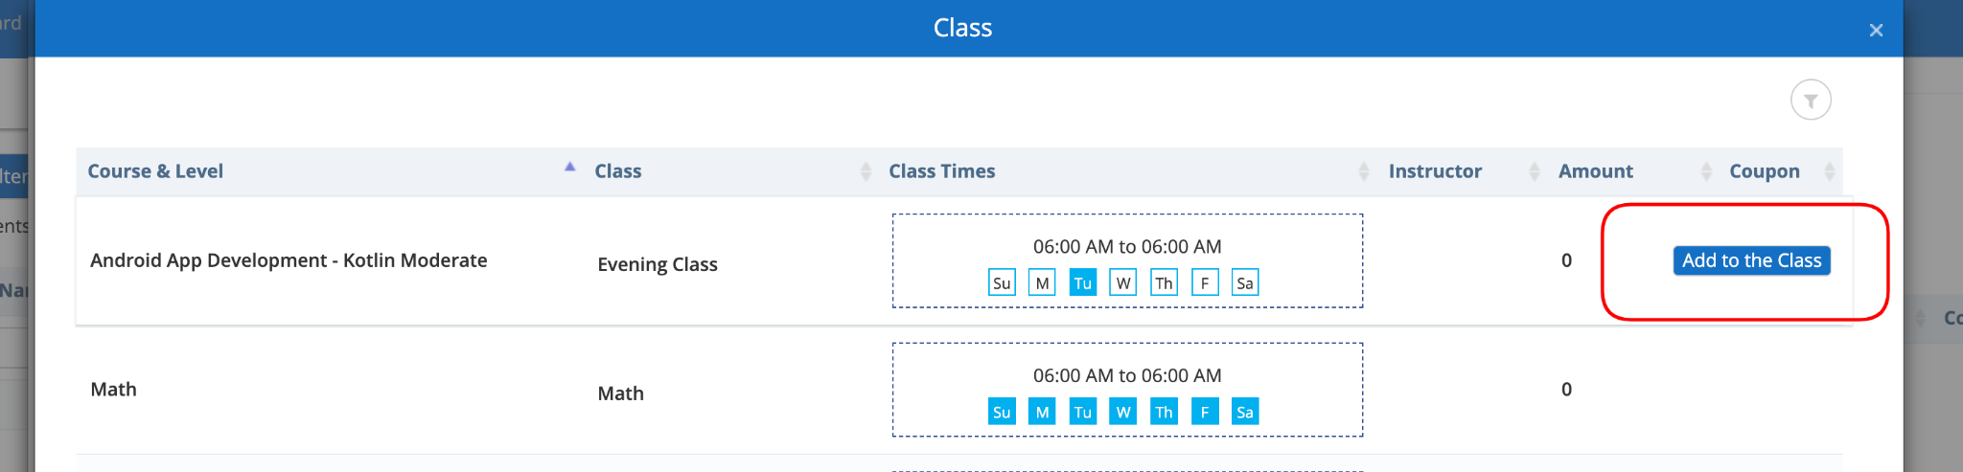

The enrolled Class will be listed in the grid.

Add Billing Info, View Payments and View Transactions

In order to add or update the Billing Info, click on the Student menu in the Upper menu bar and click on the "Students Info" menu in the 2nd menu bar. Click on the Student Name link in the grid.

Student Info Popup will open with the Overview tab selected by default. Click on the Billing tab. You have the ability to add a new payment by clicking on the "Add New Payment" button. You have the ability to change the Primary Method of Payment by selecting the switch of the corresponding payment method. You also have the ability to remove any Payment method.

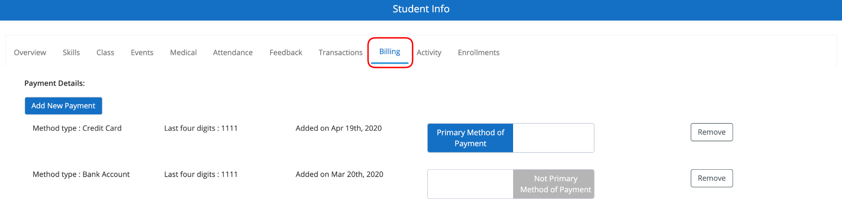

Click on the Students menu in the Upper menu bar and click on the "Payments" menu in the 2nd menu bar. You will be able to see all the Enrollment related Payment details in the first section grid.

Expand the Fees section to view any Fees assigned.

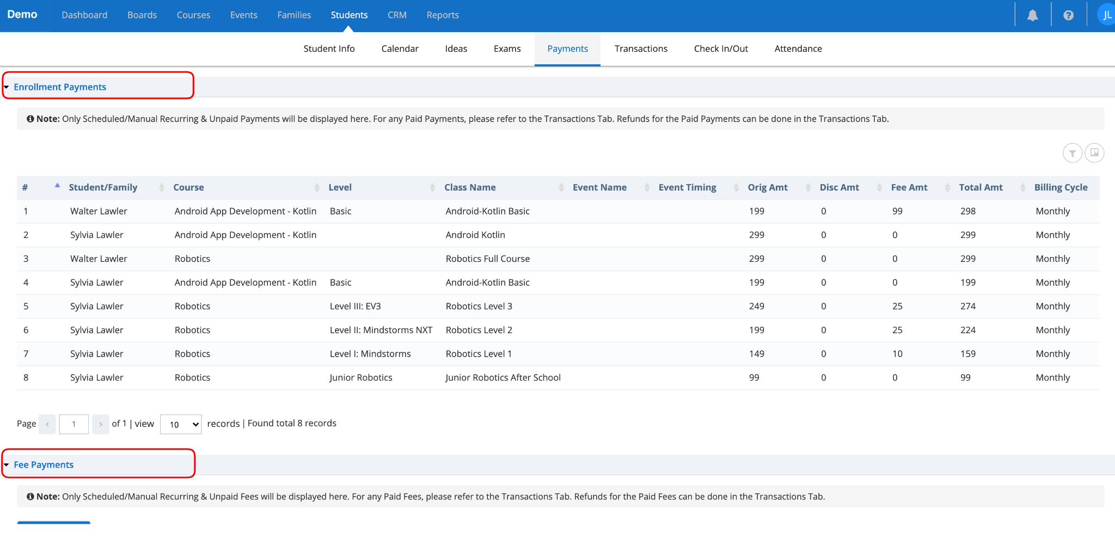

Click on the Students menu in the Upper menu bar and click on the "Transactions" menu in the 2nd menu bar. You will be able to see all the Transactions of the Payments or Fees made or deducted.

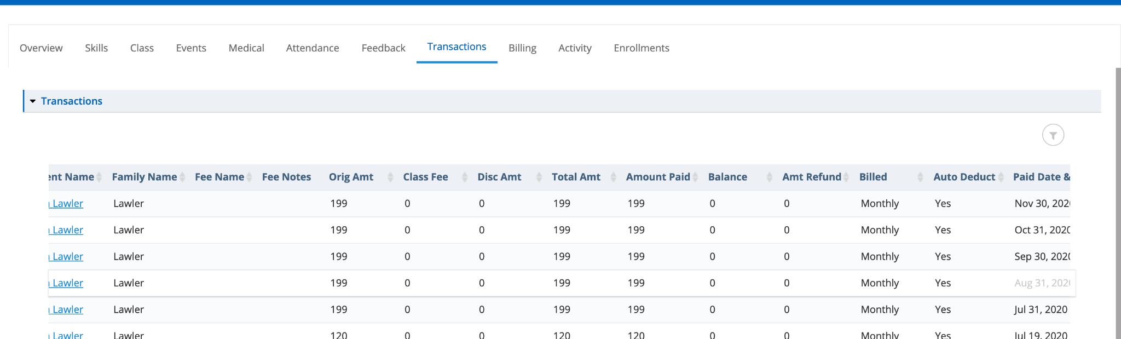

View Students Progress

1. Click on the Reports menu in the Upper menu bar and click on the "Students Progress" menu in the 2nd menu bar. Here you will be able to see all the reports related to the Students Progress.
2. Click on the Boards menu and select the Student you wish to see the specifics of the Student Progress.
3. Click on the Courses menu in the Upper menu bar and click on the "Courses Player" menu in the 2nd menu bar. All the courses assigned to the Students are listed here. Click the Course you wish to see the specifics like the Assignments/Homework, curriculum progress, etc.
4. Click on the Reports menu in the Upper menu bar and click on the "Students Progress" menu in the 2nd menu bar. Click on the Assessments/Exams menu in the left side section. Click on the Online Assessments/Exams. Here you will be able to see the progress of the Assessments or Exams or Tests completed. Opening them will show the in-depth details.

View your Profile Information

Click on the Students menu in the Upper menu bar. Click on the "Students Info" menu in the 2nd menu bar. Click on the Student Name in the grid which will open a popup.

All your profile information is shown here for the corresponding student. Overview tab is selected by default. Clicking each tab will show your corresponding information.



View the Calendar for your assigned Classes and Events

Click on the Courses menu in the Upper menu bar. Click on the Calendar menu in the 2nd menu bar. Here you can see all your assigned Classes and Events schedules by day, week, or month with Month selected by default. Clicking on the Class or Event will show you the details (Time, Instructors, etc.).



### **Get Started - Staff**

Quick Overview to get started with the Platform for Staff

MM

Written By Marianna Mkhchyan

Updated one year ago

Once you activate your account and accept the End User License Agreement, you will land in the home page (which is the ***Dashboard)***. The upper menu bar gives access to all the areas of the platform that you have access to.

The Platform supports Admin, Executives, Coordinators, Instructors, Parents, and Students roles.

Staff consists of

Executives (who have access to all the segments of the platform),

Coordinators (who are managing the instructors and organize the processes) and

Instructors (who manage the courses, classes, and students).

More information about the structure of accounts in the platform is [here](https://help-lcm.calimatic.com/article?categoryId=3&solutionId=159).

Here is the needed information to get started to using the platform -

* Add & Manage Staff (Executives and Coordinators Only)
* Create and Manage Course, Class & Curriculum
* Conduct Classes (Online or Offline)
* Contact Students
* Manage Student Courses & Assignments
* Manage Students Assessments/Exams
* Manage Attendance
* Manage Classes
* Access/Manage Student Information
* Access Student White Board
* Giving Student Points & Bonus Points
* Accessing Training Videos/Articles
* Checking Students Homework
* Checking Students Progress
* Checking Pending Payments Report
* Managing Payments & Fees
* Check Reports
* View your Profile Information
* View the Calendar for all the Active Classes and Events

In the Dashboard (Home) Page, under the Links section, you have the ability to navigate to the mentioned areas by clicking on the appropriate links.

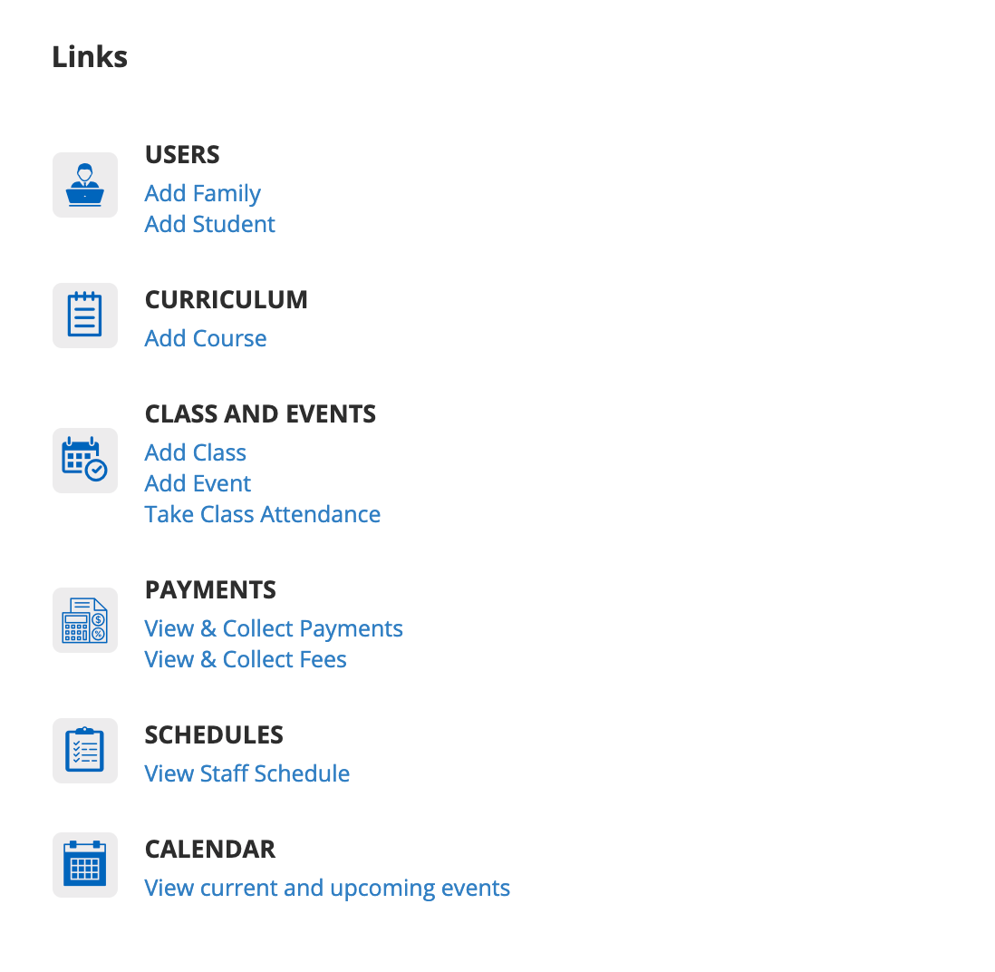

**Add & Manage Staff (Executives and Coordinators Only)**

Click on the Staff menu in the Upper menu bar. Click on the "Staff Info" menu in the 2nd menu bar. In the page, you can add staff members by clicking on "Add Staff" buttonand filling in the required information, saving and editing skills, certificates, classes, assigned students, wage, and more.

For more details about adding & managing Staff, refer here - [Staff Information](https://help-lcm.calimatic.com/article?categoryId=9&solutionId=105)

**Create and Manage Course, Class & Curriculum**

Click on the Courses menu. You have the ability to create and manage Courses and Curriculum or learning content in 2 different views -

1. Clicking on Course Player submenu will navigate to the Course Player page
2. Clicking on Central submenu will navigate to the Central page  
   

You can choose any one of these ways based on your convenience.

Clicking on the "Add New" button and selecting the "Course" option will open the Course popup.



Enter the required information for the Course as needed.

Click on the Create button and this will create the Course and keep the popup open.

Click on the "Manage Class" popup. In the popup, click on the "Add New" button to create a new Class.

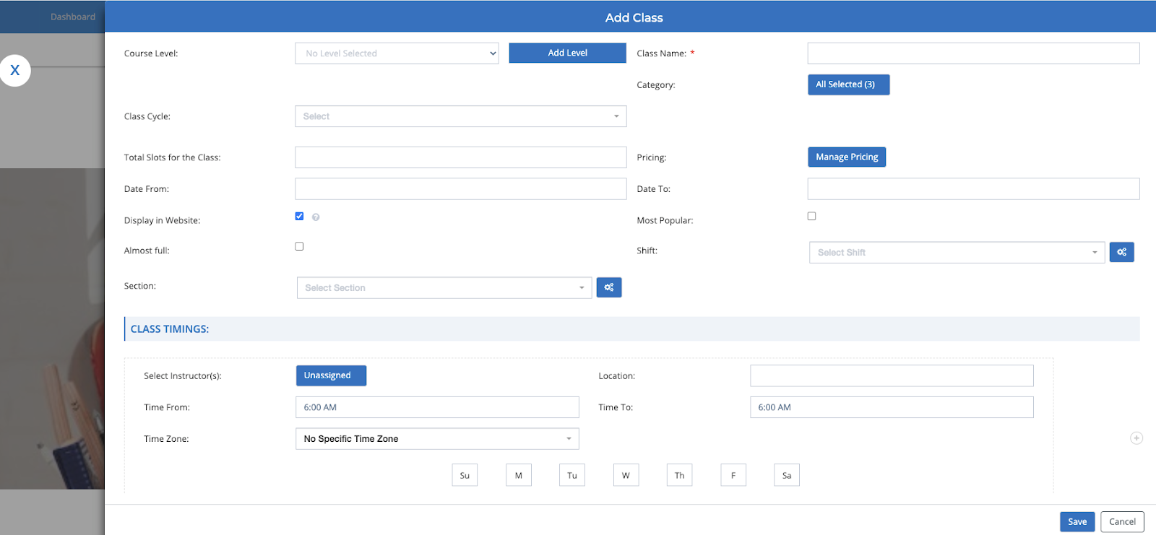

Enter required information for Class and click on Manage Pricing to enter Pricing information.

Click on the Save buttons for Pricing and Class popups to save the info.

For more information on creating the Curriculum from Central Repository - [Curriculum Management](https://help-lcm.calimatic.com/article?categoryId=4&solutionId=192)

For more information about Classes Management - [Class Management Articles](https://help-lcm.calimatic.com/article?categoryId=10)

**Conduct Classes (Online or Offline)**

You have the ability to conduct the Classes in an intuitive way from Class Boards.

You can access each Class Board where

1. You can see the list of Students associated to the Class
2. You can access the White Board of each Student of the Class
3. You can see the Assignments of each Student of the Class
4. You can add Assignments to each Student of the Class
5. You can access the Class White Board
6. You can access the Code Board of the Class
7. You can Conduct Online Class for the Class
   1. Setup Online Class Method (Calimatic, Zoom or Google Meet)
   2. Start the Class
   3. Join the running Class
   4. Send invitation to the Class
   5. Add, View & Manage Class Notes for the Class

Refer here for more information the above activities - [Class Boards](https://help-lcm.calimatic.com/article?categoryId=5&solutionId=140)

**Contact Students or Parents**

You have the ability to contact the Students or Parents in multiple ways -

1. Send Email to Individual Student or Parent
2. Send Email to all the Parents or Students of a Class
3. Send Messages from the Mobile App

In order to send an email to an Individual Student, click on the Students menu in the Upper menu bar. Click on the “Students Info” menu in the 2nd menu bar.

Click on the Student name in the Student info grid for whom you wish to send an email. In the popup, click on the Email icon on the top right side corner on the popup bar. You have the ability to make adjustments and send the email.

In order to send an email to all the Parents or Students of a class, click on the Courses menu in the Upper menu bar. Click on the Class menu in the 2nd menu bar. In the “Classes Overview” page, hover on the class for which you want to send email and click on the Actions button. Hover on “Class Students” option and Click on the “Send Email” option. In the email popup, you have the ability to make adjustments and send the email.

In order to send messages via the mobile app, install the Calimatic LMS app or your Institute branded mobile app (if it is configured). You have the ability to send messages to the Parents and Students from it.

**Manage Student Courses and Assignment**

You can manage the Student Courses and Assignments in 2 places -

1. Click Boards menu on the upper menu bar
   1. Select the Student you wish to manage under the Student Boards sections.
   2. Select the Class under the Class Boards, for which you want to manage all the Students of the Class.

For more information on the Boards, refer here - https://help-lcm.calimatic.com/article?categoryId=5

1. Click on the Courses menu on the upper menu bar. Click on the Courses Player menu in the 2nd menu bar. Click on the Course for which you want to manage the Students assignments. You will see the Student dropdown list. Select the Student you wish to manage.

If you want to see all the students submitted Assignments/Homework, scroll down to the Assignment in the curriculum and click on the “Submitted Homework(s)” button.

**Manage Student Assessments/Exams**

Click on the Students menu in the Upper menu bar. Click on the Assessments menu in the 2nd menu bar. You can manage all the Assessments for the Students.

**Manage Attendance**

Click on the Students menu in the Upper menu bar. Click on the Attendance menu in the 2nd menu bar. You can manage the Attendance for all the Students.

For more information on managing the Attendance, refer here - [Student Attendance](https://help-lcm.calimatic.com/article?categoryId=8&solutionId=68)

**Manage Classes**

Click on the Courses menu in the Upper menu bar. Click on the Class menu in the 2nd menu bar. You can create and manage all the Classes here.

For more information on managing the Classes, refer here -

[Class Management](https://help-lcm.calimatic.com/article?categoryId=10)

**Access/Manage Student Information**

Click on the Students menu in the Upper menu bar. Click on the “Students Info” menu in the 2nd menu bar. All the Students and their information can be managed here.

For more information on managing the Students, refer here - [Student Management](https://help-lcm.calimatic.com/article?categoryId=8)

In order to Add or manage a Student, refer here - [Add & Manage Student](https://help-lcm.calimatic.com/article?categoryId=8&solutionId=64)

**Access Student White Board**

Click on the Boards menu in the Upper menu bar. Search for the Student for whom you want to check the White Board and click on the Student. Click on the White Board button. You can manage all the Student related White boards here.

**Giving Student Points and Bonus Points**

Click on the Boards menu in the Upper menu bar. Search for the Student for whom you want to give Points and click on the Student. The staff has the ability to Add Bonus Points by clicking on the “Add Bonus Points” button at the top right side of the Board.

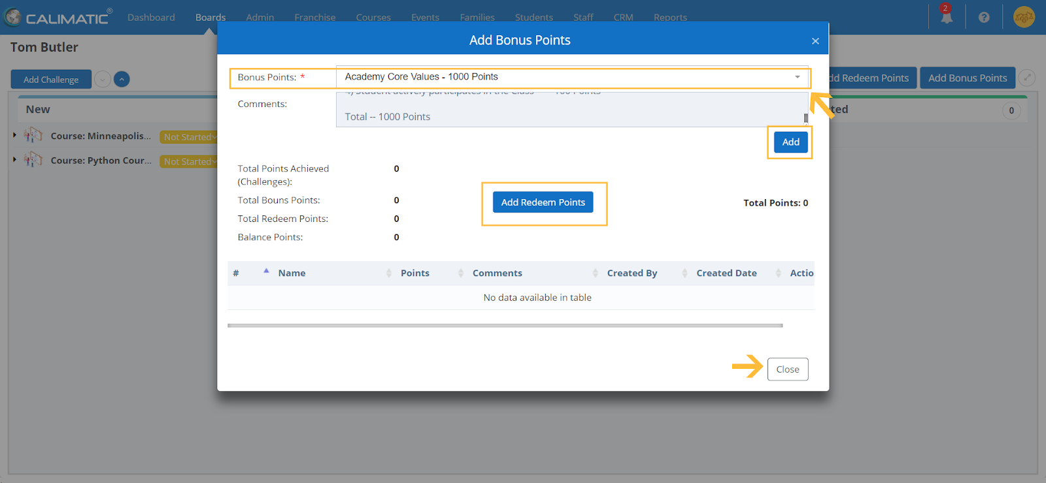

Clicking on the button will open the popup where you have the ability to select an option in the Bonus Points dropdown list field.

You can configure the Bonus Points to appear in this list in Admin > System Config > Manage Bonus Points.

Clicking on the Add button will assign them to the student. You also have the ability to Redeem Points. Usually the institutes encourage Students to Redeem Points with any rewards or gifts.

**Redeem Points --**

The staff has the ability to add redeem points by clicking on the “Add Redeem Points” button at the top right side of the Board.

Clicking on the button will open the popup to enter the Redeem Points.

**Access Training Videos/Articles**

Click on the CRM menu in the Upper menu bar. Click on the “Internal Articles” menu in the 2nd menu bar. You have the ability to view all the Training Videos/Articles here.

**Checking Students Homework**

There are 2 places where you can check the Students Homework depending on how you want to manage -

1. Courses Player -
   1. Click on the Courses menu on the upper menu bar and click on the “Courses Player” menu in the 2nd menu bar.
   2. Click on a Course for which you want to view the Students Homework.
   3. In the Course page, scroll down to the curriculum section and look for the items which have Homework/Assignments submitted.
   4. Click on the Homework button for the item. All the Students who submitted the homework will be listed on the left side section.
   5. Click on the Student name for whom you need to see the homework and you will be able to see all the details on the right side section.
2. Boards -
   1. Click on the Boards menu in the Upper menu bar. Search for the Student for whom you want to check the Homework and click on the Student.
   2. Click on the Boards button and click on the Homework option. You can manage all the Student related Homework here.

**Checking Students Progress**

You have the ability to check the Students Progress in the following areas depending on the assignments -

1. Track the progress of Challenges/Topics -
   1. For all the Students of a Class - Click on the Boards menu on the upper menu bar. In the Class Board section, click on the Class for which you want to access the information. You will see the list of Students that are associated with the class. Click on the expand icon on the left side of the Student Name in the board for whom you want to check the progress. All the Challenges or Topics assigned to the Student are listed. You have the ability to drag & drop them to their appropriate status based on the progress. If the Challenge or Topic has points then the Student will receive points once the item is completed.
   2. For each Student - Click on the Boards menu on the upper menu bar. In the Student Board section, click on the Student for whom you want to track the progress. In the Board, click on the expand icon for the Course you want to track the progress. All the Challenges or Topics assigned to the Student are listed. You have the ability to drag & drop them to their appropriate status based on the progress. If the Challenge or Topic has points then the Student will receive points once the item is completed.
   3. Reports -
      1. Students Progress: Click on the Reports menu on the upper menu bar and click on the Student Progress menu in the 2nd menu bar. You will be landed in the Students Progress page. All the Students are listed and clicking on the reports icon for the corresponding Student in the grid will display a popup with progress charts for the selected Course.
2. Track the Progress of Homework or Assignments -
   1. For all the Students of a Course - Click on the Courses menu on the upper menu bar and click on the Courses Player menu in the 2nd menu bar. Click on the Course for which you want to track the progress. Curriculum tab will be opened by default below the course image. If not, click on the Curriculum tab. For the Homework or Assignment Lesson or Step, you will see a button for any submitted Homework. Click on the button and it will display a popup where all the Students homework are listed.
   2. For each Student - Click on the Boards menu on the upper menu bar. In the Student Board section, click on the Student for whom you want to track the progress. Above the Board, on the right side, click on the Boards button and select the Homework option. All the Homework or Assignment assigned to the Student are listed. You have the ability to drag & drop them to their appropriate status based on the progress.
   3. Reports -
      1. Students Progress: Click on the Reports menu on the upper menu bar and click on the Student Progress menu in the 2nd menu bar. You will be landed in the Students Progress page. All the Students are listed and clicking on the reports icon for the corresponding Student in the grid will display a popup with progress charts for the selected Course.
3. Students > Assessments
   1. Assessment Page - Click on the Students menu in the Upper menu bar. Click on the Assessments menu in the 2nd menu bar. You can manage all the Assessments for the Students.
      1. View Students Result for an Assessment - For each Assessment, if there are any submitted Assessments, you will see the “View Result” button in the “Assigned To” column. Clicking on it will display the list of Students who attempted the Assessment and their results.
      2. View all Assessments Results for a Student - Click on the “Assignments” button on the top right side. All the students are listed here with their Assessments information. Clicking the status link will show the Assessments and their results for the corresponding student.
   2. Reports - Click on the Reports menu in the Upper menu bar. Click on the Student Progress menu in the 2nd menu bar.
      1. Assessments - Click on the Assessments menu in the left side section. To check the Online Assessments, click on the Online Assessments link. In this page, you have the ability to view the reports of the Online assessments that are attempted by the Students. To check the Offline Assessments, click on the Offline Assessments link. In this page, you have the ability to view the reports of the Online assessments that are attempted by the Students.
      2. Assessments Wise Report - Click on the “Assessments Wise Report” menu in the left side section. Select the Assessment for which you want to track the information for all the students who attempted it. High level information for all the Students is listed here.

**Checking Pending Payments Report**

Click on the Reports menu in the Upper menu bar. Click on the Billing menu in the 2nd menu bar.

By default, the Class option is selected in the drop down list with the current month selected. All the pending Classes enrollment payments are displayed here.

You have the ability to run the report for all the pending Events enrollment payments and all the pending Fees for any specified duration.

**Managing Payments & Fees**

Click on the Students menu in the Upper menu bar. Click on the Payments menu in the 2nd menu bar. There are 2 sections -

1. Enrollment Payments - All the Course/Class and Events enrollments related payments are managed here.
2. Fee Payments - All the custom fees payments are managed here.

**View your Profile Information**

Click on the Staff menu in the Upper menu bar. Click on the "Staff Info" menu in the 2nd menu bar. Click on your Name in the grid which will open a popup.

All your profile information is shown here. Overview tab is selected by default. Clicking each tab will show your corresponding information.

**View the Calendar for your assigned Active Classes and Events**

Click on the Dashboard menu in the Upper menu bar. Click on the Calendar “View current and upcoming events” link in the Links section at the bottom. This will navigate to the Calendar page where all the classes and events are displayed. Clicking on any Class or Event will display the details of it.

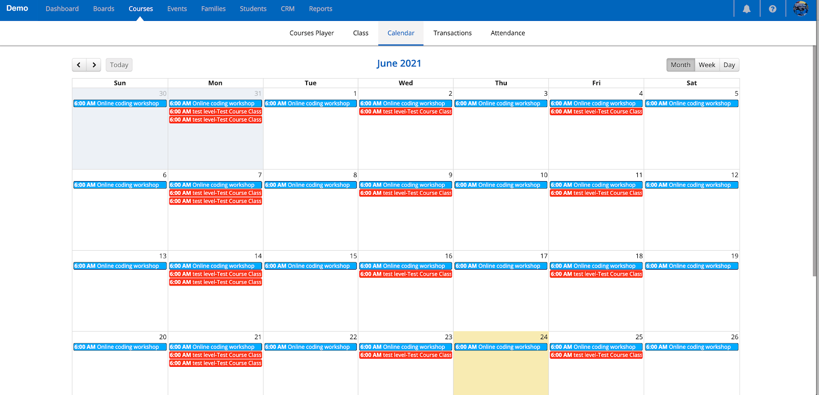

### **July 4th, 2022 - Web Portal**

July 4th, 2022 Release Notes for Calimatic EdTech Web Portal



Written By Ivan Karmer

Created one year ago

A) **New Reports are released -**

1. Reports > Billing > Transaction Summary (Provides the Transaction Summary for a specified range)
2. Reports > Class. We added few reports here -
   1. Class List Report (Provides the list of classes for the selected criteria)
   2. Class Students List (Provides the list of Students for the selected classes list criteria)
   3. Makeups Report (Provides the information for any makeups)
   4. Class Retention Report (Provides the retention information for the classes)
   5. Drop List Report (Provides the Drops or Transfers for the selected criteria)
   6. Unexcused/Excused Report (Provides the absence information if that absence is excused or unexcused)
3. Reports > Families/Students Report. We added couple of reports here -
   1. Student Retention Report (Provides the retention information of the Students
   2. Roll Sheet Report (Provides the attendance information and also provides the ability to take manual attendance on paper)

B) New Options are provided for Attendance marking - Casual, Trial, Makeup, Cancelled Class, Tady/Left Early, Expected Absent, First Day Ever, First Day at Location, First Day in Class, First Day in Course, First Day in Level, Excuse Absent, Unexcuse Absent. Along with the new options, Notes column is also added to enter any Attendance notes.

C) Changes in Enrollment Pages for existing customers -

When an existing parent login in the Enrollment page (in the website), the students of the corresponding family are displayed. The system provides the ability to enroll to the classes within the enrollment pages without the need to login to the portal.

D) Few bug fixes have been made