### **Boards Introduction**

Introduction to the Boards



Written By Ivan Karmer

Updated 2 years ago

The system provides the ability to manage the assignments & tasks for the Students and Staff in an intuitive way.

There are 3 types of Boards available - Students Boards, Class Boards, and Staff Boards.

Students Boards - Each Student assignment is listed in their corresponding Student Board and there are additional capabilities (like Joining Online Class, Accessing their White Board, etc) that can be leveraged in the Boards.

Class Boards - All the Students that are part of the Class are listed in the corresponding Class Board. The staff has the capability of starting their online class, accessing the Class White Board, tracking the Students progress of the Class, etc from the Class Board.

Staff Boards - Each Staff has a separate Board and all their Tasks can be managed here.

**Navigation:**

In the header menu bar, click on the Boards menu. Students Boards, Class Boards, and Staff Boards are shown in 3 sections in a mega dropdown list.

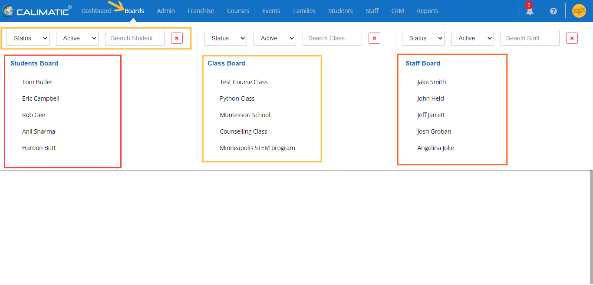

### **Students Board**

View & Track Assigned work for the Students in the Student Board



Written By Ivan Karmer

Created 2 years ago

Student Boards are a way to view & track Assigned work to the Students in a more intuitive way. There are a lot of ways you can use the Students Boards with multiple capabilities in it.

**Navigation:**

In the header menu bar, click on the Boards menu.

For any Staff Role or Admins - Students Boards, Class Boards, and Staff Boards are shown in 3 sections in a mega dropdown list based on the access. Clicking on any Student name in the Students Boards section will navigate to the corresponding Board.



For Parents - Students Boards will display in the mega dropdown list with a list of their Students. Clicking on the Student name under the Students Board will navigate to the corresponding Board.

For Students - The system will navigate the Student to their Board when they click on the Boards menu.

The system provides the ability to filter each of the Boards with different filters fields like Status, Course, etc.

Student board

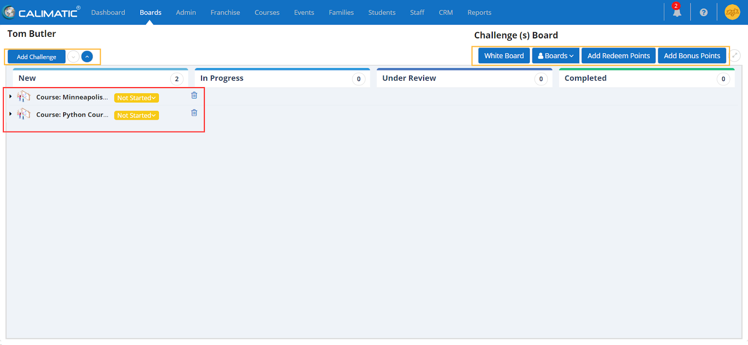

In the Student Board Page, following modules are available -

1. List of Assigned Items (Based on the Terminology set by your institute, instead of Challenge, it can be Topic or Subject, etc)
2. White Board
3. Boards (Homework, Tasks, Assessment)
4. Redeem Points
5. Add Bonus Points

**Student Board Page**

All the assigned items are displayed in one or more sections (or Courses).

4 status vertical lanes are displayed to represent the status of the assigned item.

Master/Business Admins have the ability to add/update these statuses in Admin > System Config > Form Templates. By default, following statuses are displayed - New, In Progress, Under Review and Completed.

The horizontal lanes represent the Courses & Levels. The assigned items are displayed within those lanes. Clicking on the Expand icons of the horizontal lanes will show the assigned items.

**Note:** You will not be able to Create Items here. You can only assign already created items. All the Items creation can happen in Courses menu > Course Player submenu (or) Courses menu > Central submenu.

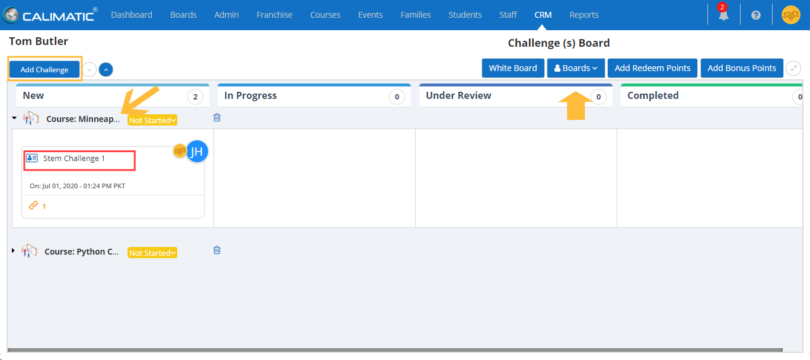

For each assigned item, it shows the item name, assigned to, assigned by, date modified/completed information along with any links and discussions.

You can view the item/challenge by left-clicking on it which will open a new window. All the details of the item are displayed in a popup.

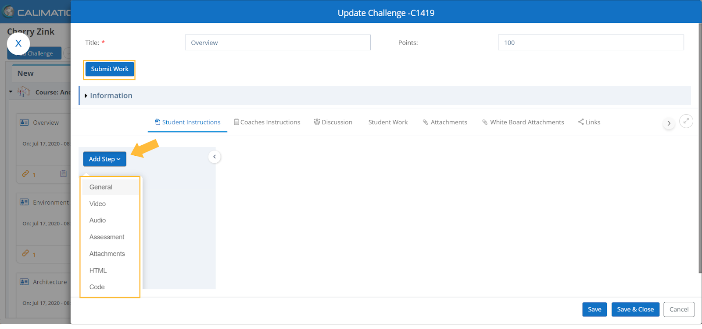

**Submit Assignment or Homework --**

The students have the ability to submit work form here by clicking on the **“**Submit Work**”** button on this popup.

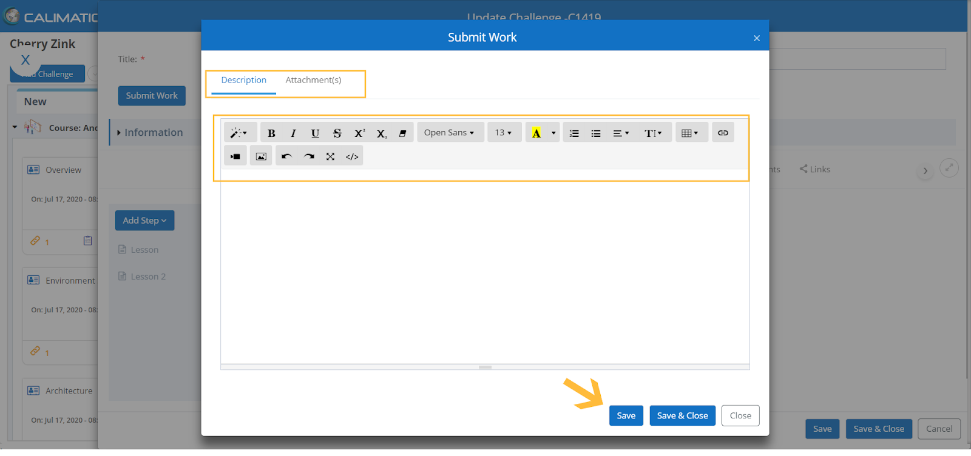

Here the students are provided the necessary writing and editing tools for their context. They also have the ability to add attachments (Files, Photos, Videos, etc) to their work.

Once done, Clicking on the Save or Save & Close button will upload their work to the system.

**Note:** The staff can also submit work for the student and have access to the challenges.

**Automatic Assignment to the Students --**

When a Student is enrolled in a Course or in a Class for a course or level then all the items associated with the course or level are automatically assigned to the student.

**Delete Items --**

Based on the permissions, the staff has the ability to remove the items by right clicking on the item and selecting the delete option or clicking on the delete icon in the vertical lane of the Course.

**Adding Items to the Students --**

The staff has the ability to add items by clicking on the Add button at top left side of the board. The system opens a popup in which you can select the Course and/or Level to see the items that are assigned but not added to the Board. Selecting the items and clicking on the “Assign” button will add the items.

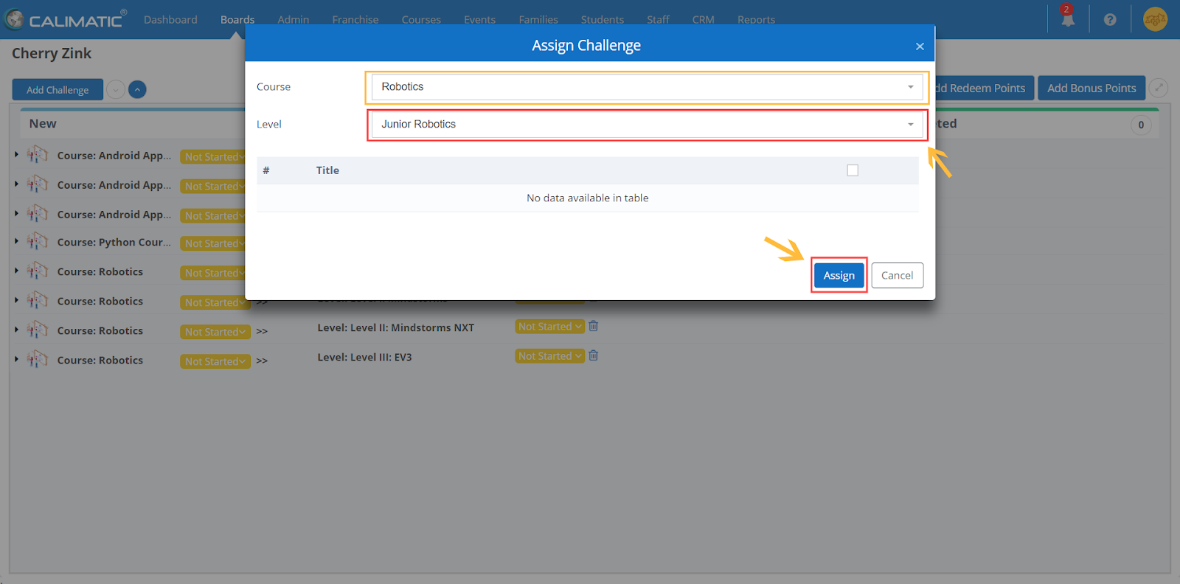

**Adding items to multiple Students --**

If you want to add items to all the Students of a Class, you can perform this action in the Class board.

**Move items across Vertical lanes --**

As the Student makes progress, the instructors have the ability to move the items to the appropriate statuses.

**Email Communication about Item Completion --**

An email is sent out to the Parents and Students if an item is moved Completed if the setting is ON. The communication email setting can be modified in Admin > System Config > Emails > Challenge Completion.

Copy emails can also be set in the Admin > System Config > Emails page.

**Points Assignment --**

If the Item has Points then the points will be assigned to the Student when the item is completed.

**Bonus Points --**

The staff has the ability to Add Bonus Points by clicking on the “Add Bonus Points” button at the top right side of the Board.

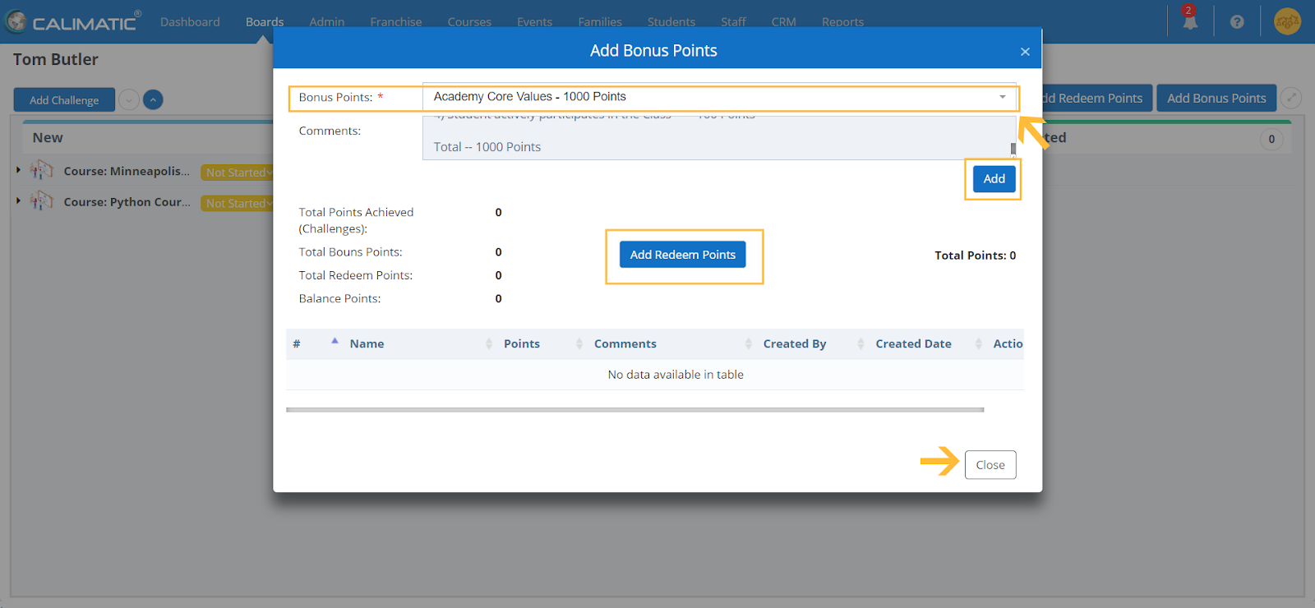

Clicking on the button will open the popup where you have the ability to select an option in the Bonus Points dropdown list field.

You can configure the Bonus Points to appear in this list in Admin > System Config > Manage Bonus Points.

Clicking on the Add button will assign them to the student. You also have the ability to Redeem Points. Usually the institutes encourage Students to Redeem Points with any rewards or gifts.

**Redeem Points --**

The staff has the ability to add redeem points by clicking on the “Add Redeem Points” button at the top right side of the Board.

Clicking on the button will open the popup to enter the Redeem Points.

**Student White Board --**

Clicking on the “White Board” button above the Board will navigate the user to the corresponding Student White Board.

Each Student will have his/her own White Board space where an unlimited number of White Boards can be created.

Here are some of the ways on how White Boards can be used -

1. For quick illustrations to expressing their Knowledge or information
2. For loading PDF on to the white board and filling information in it.
3. For submitting the white boards to the Items or Assignment/Homework
4. “View the instructions from the files (Documents or Videos or Fields of the item)” and “Draw/Write information on White Board” side by side.

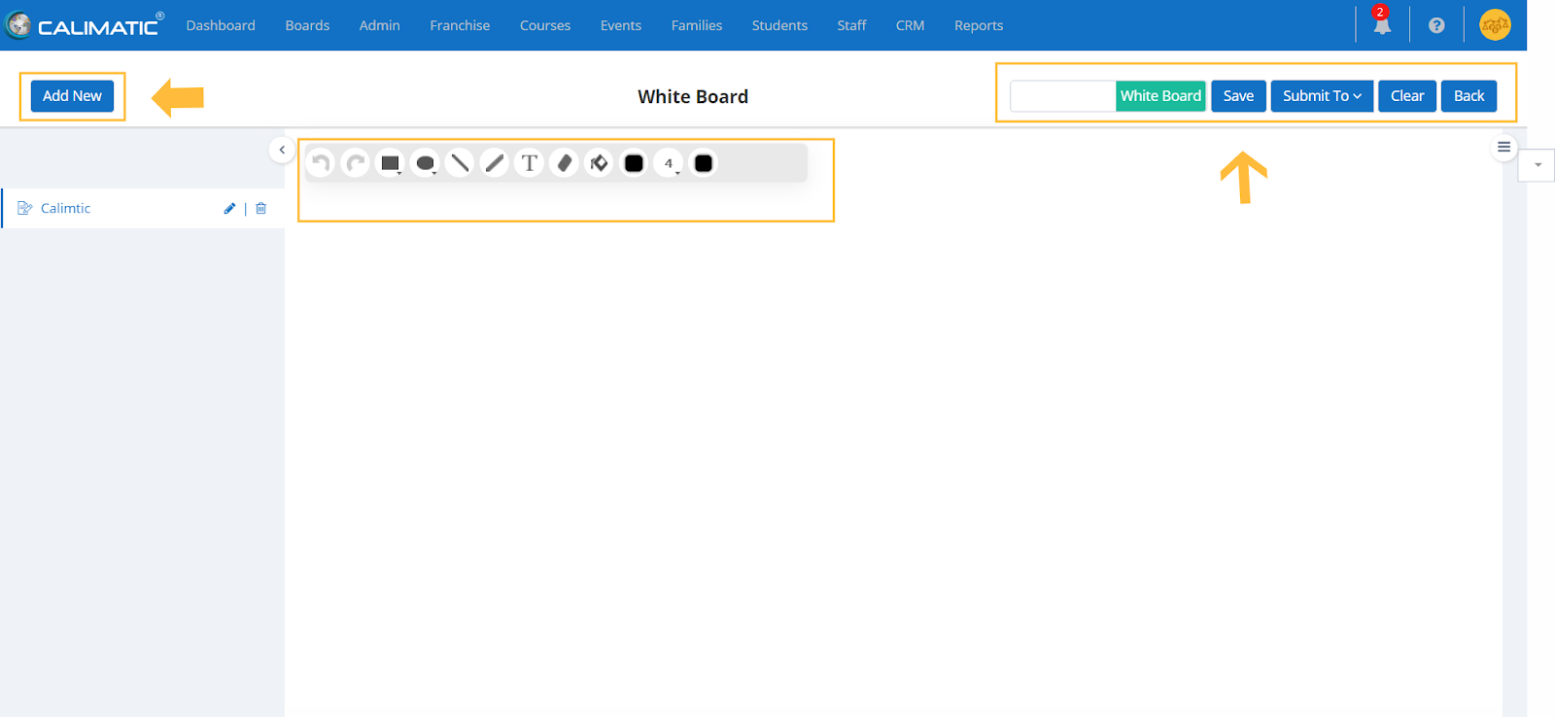

Here the system provides the ability to draw on the whiteboard and also type in text from the keyboard.

You can add a new board from the “Add New” button. You also have the ability to save the work on the whiteboard by clicking on the Savebutton.

**View Items/Challenges or Files by the Side of White board --**

Click on the side menu icon to open the right side panel.

Select an item in the dropdown list for which you want to view the details or attachments of the item.

Select the Attachment or the field which has the details in the dropdown list.

This will load the information in the right side panel.

The Student can view the details on the right side panel and draw/write on the White board.

**Load PDF on to the White Board --**

When selecting an item in the right side panel and selecting the PDF attachment file, you will have the “Add to Canvas” button. Clicking on the button will load the PDF file (all pages) into the White Board Canvas.

Students have the ability to write on the PDF and save each page separately.

**Add Files to view or add to White Board --**

In the right side panel, when you select an item, the “Add File'' button appears where you can add a file to view or add a PDF file to the White Board. The permissions to see “Add File '' button is available in Admin > System Admin > Attachments Config > Attachment Type: White Board Files.

**Code Board (For write & execute programming code) --**

There is a switch toggle on the White Board page which switches the Whiteboard into Code Board.

Code board is specifically for learning and teaching Programming languages.

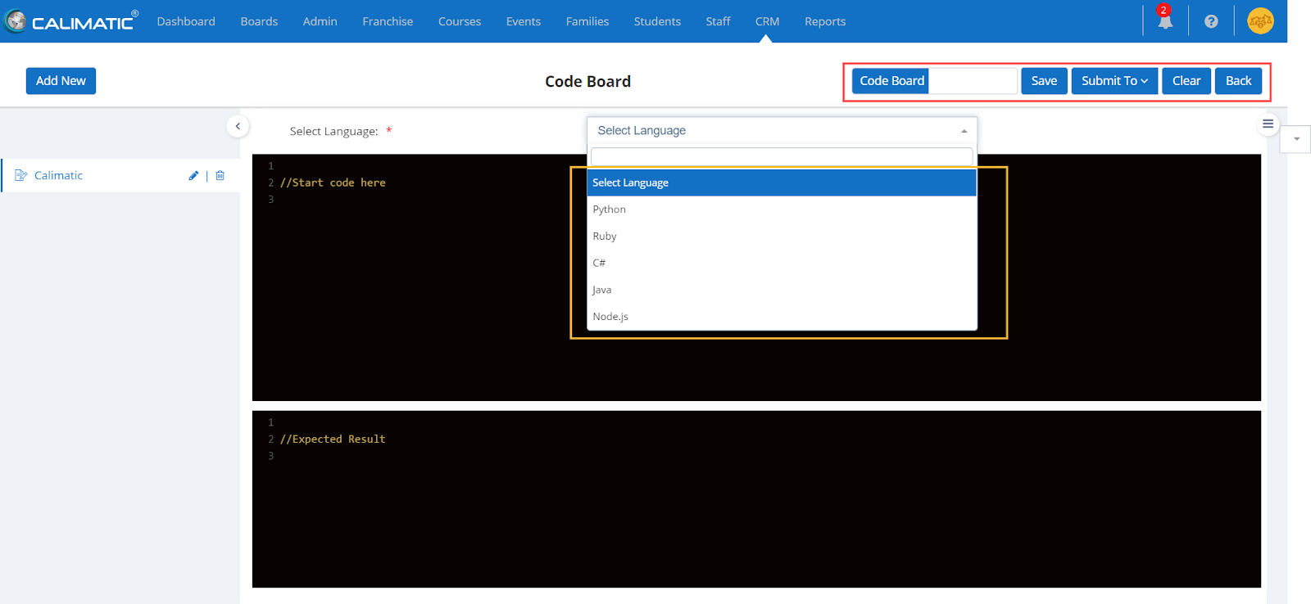

Here the system provides the ability to select different languages which are shown in the drop-down menu and gives the user the ability to save or submit the work on the aboard. You have the ability to create multiple code Board items.

**Class Notes**

Clicking on the Class Notes button will open a popup with a list of Classes that are assigned to the Student. Any notes of the Class that are recorded or entered will be displayed. In the Action column, you have the ability to view the corresponding Class notes or recording by clicking on the view icon or links.

**Boards (Switch between different Boards) -**

Clicking on the Boards button that is on the top of the board will open a drop down list with different Board options (Challenges/Items, Homework, Tasks and Assessments).

**Task Board** iswhere the tasks within the Items/Challenges are displayed.

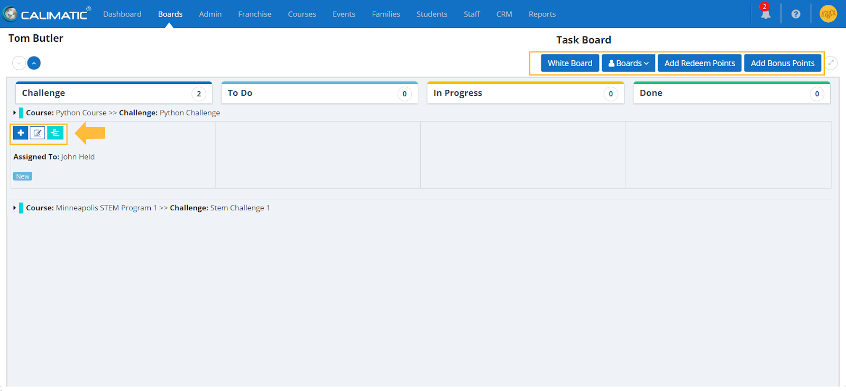

Here the system gives you the ability to add a new Task in the existing item/challenge.

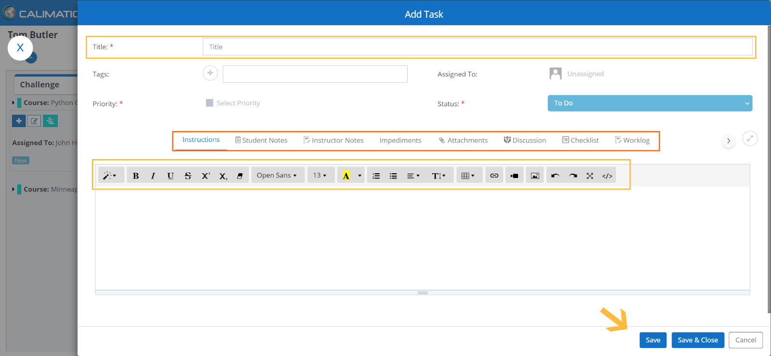

Here you are provided with the ability to add a title to the task, select the priority of the task for the student. You can also select the student it has to be assigned to from here.

You have the ability to add instructions, attachments and other details of the task.

**The Homework Board** iswhere the homework assigned to the student is accessible.

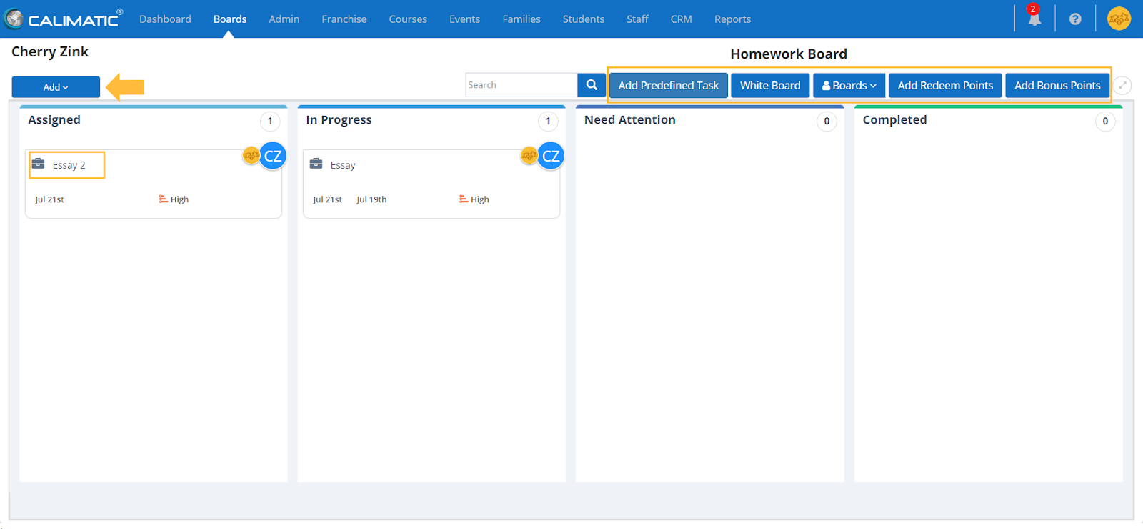

Here the assigned homework and the completed homework is viewable in the Vertical lanes based on the status. Each vertical lane represent the status of the Assignment/homework. You have the ability to add New Assignment/Homework to the board by clicking on “Add” button and selecting an option.

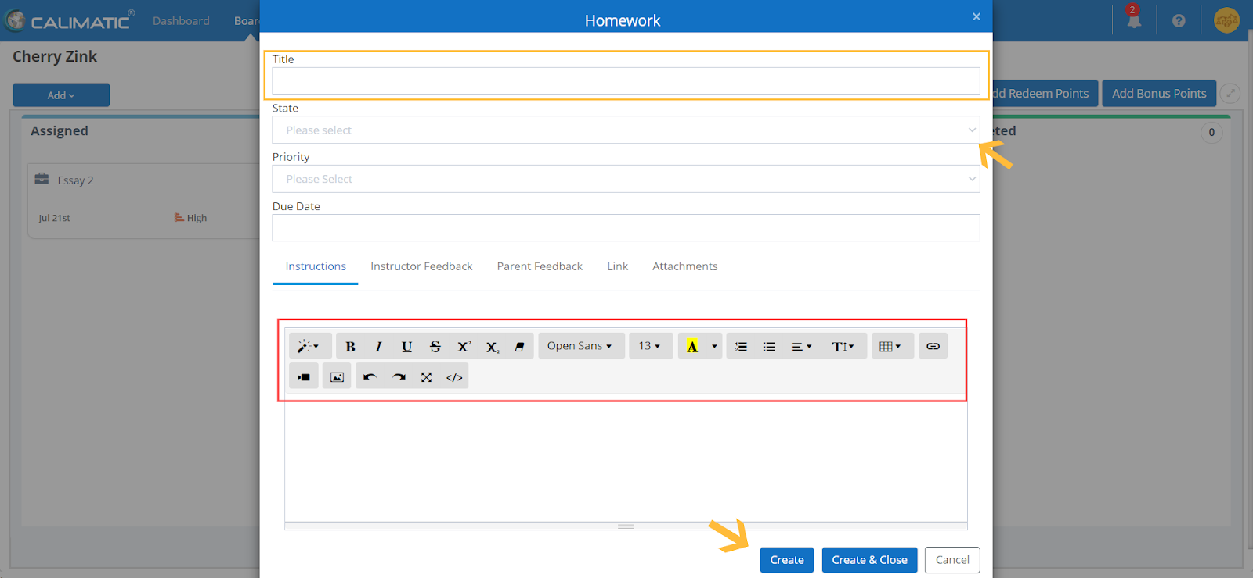

Here you are provided with the ability to add all the information regarding the assignment/homework and ability to Create the Assignment/homework.

Students can view the assigned assignments/homework and submit their work.

**Assessments Board** iswhere the assessments within the course are viewable with their assigned data.

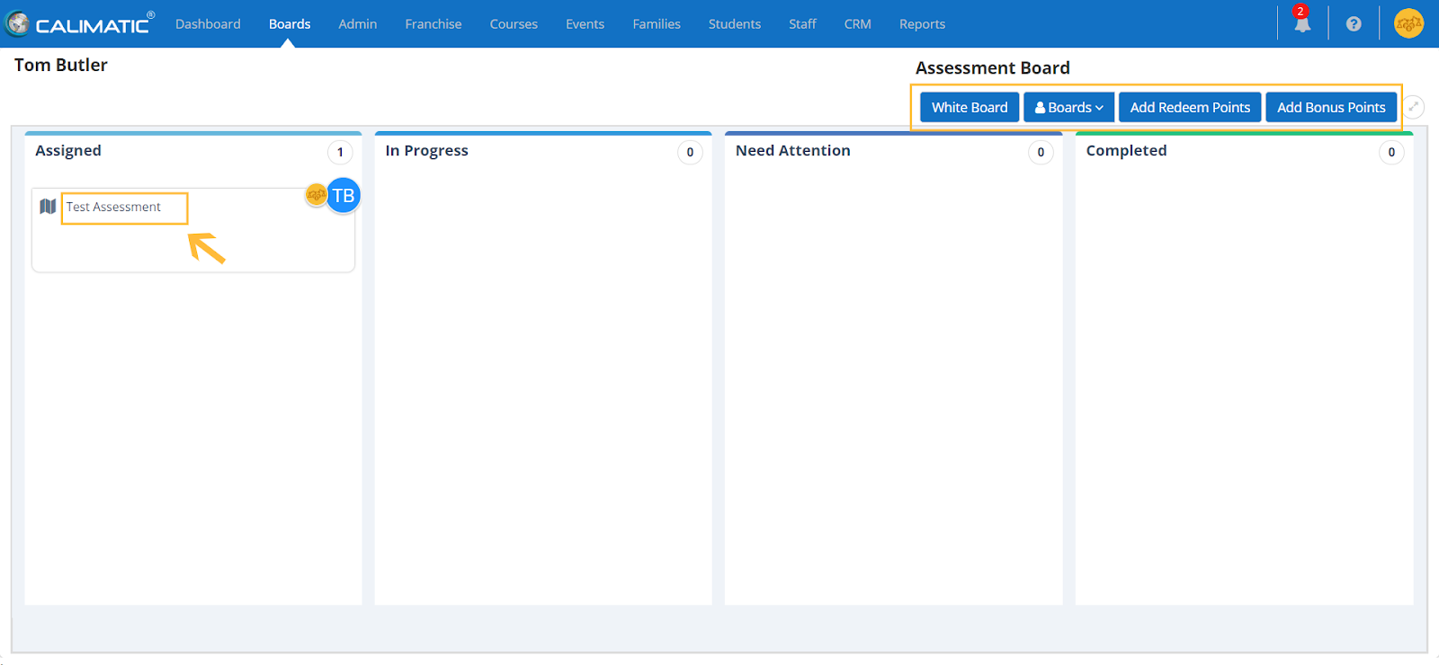

Here the assigned and the completed assessments of the students are viewable. Each vertical lane represent the status of the Assessment.

Clicking on an assessment will open the popup to view the details of the assessment (Offline or Online).

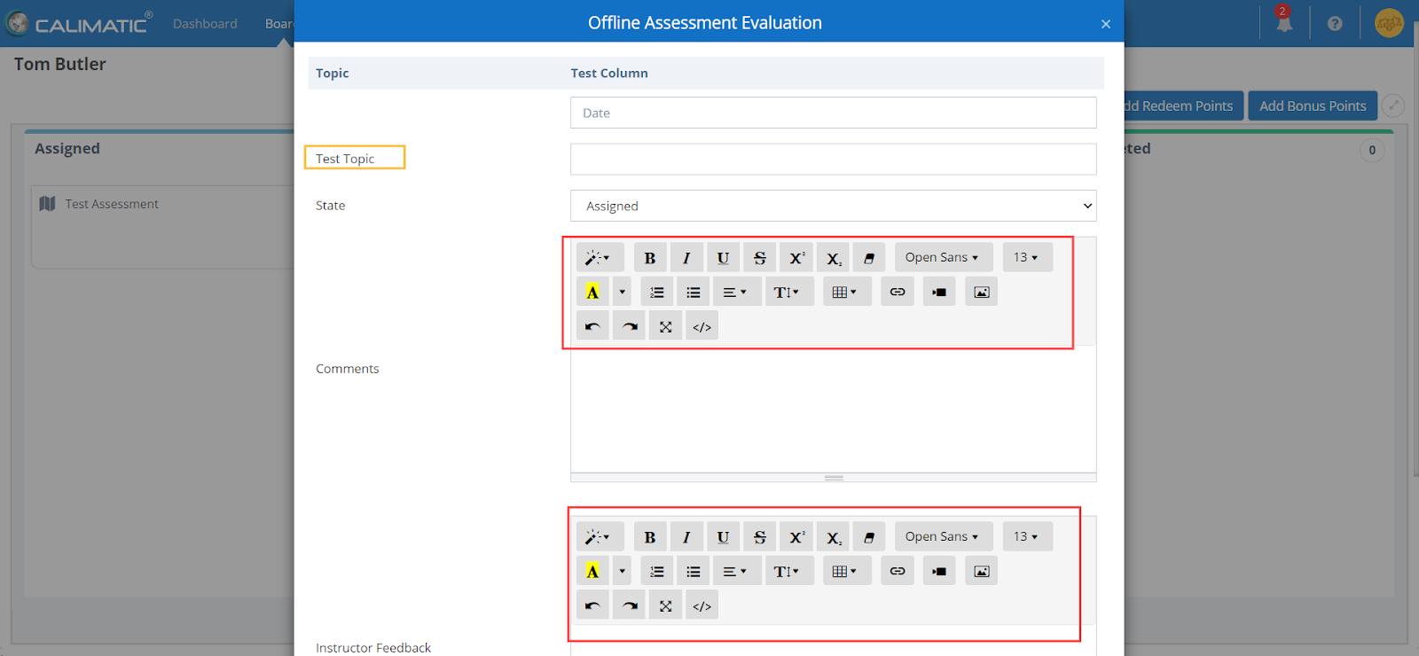

The system provides the ability for the instructor to evaluate the assessment and can add comments.

### **Class Boards**

Assign & Track Students work of a Class. Start the Online Classes.



Written By Ivan Karmer

Created 2 years ago

Class Boards provide a way to assign and track Items to the Students of a Class. There are a lot of ways you can use the Class Boards with multiple capabilities in it.

**Navigation:**

In the header menu bar, click on the Boards menu.

For any Staff Role or Admins - Students Boards, Class Boards, and Staff Boards are shown in 3 sections in a mega dropdown list based on the access. All existing classes that the Staff has access to are viewable under the class board.

Clicking on any Class name under the Class Boards section will navigate to the corresponding Class Board.



Parents and Students will not have access to the Class Boards.

All the Students enrolled to the Class are displayed in the corresponding Class Board. The Students are listed in the Horizontal Lanes.

Clicking on the Expand icon for any Student will open the Student lane and show all the assigned items to the Student.

The Vertical Lanes represents the status of the items.

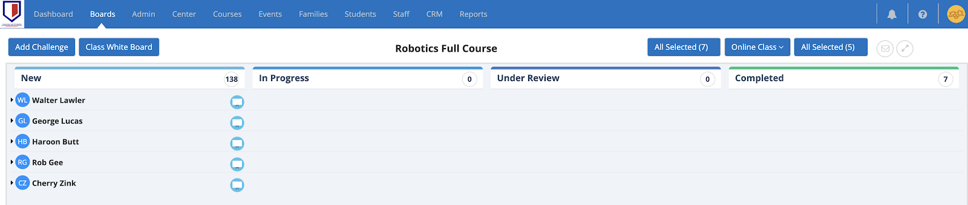

**Student White Board --**

Clicking on the White Board icon in the Horizontal Student Lane will open the corresponding Student’s White Board.

**Add Items to Students --**

You have the ability to Add items to all the Students of the Class by clicking on the “Add Challenge” button on the top left side above the board.

**Note:** You will not be able to Create Items here. You can only assign already created items. All the Items creation can happen in Courses menu > Course Player submenu (or) Courses menu > Central submenu.

**Class White Board --**

Each Class has a separate White Board. This white board can be used while conducting your classes.

You can create multiple White Board instances for each Class (you can create one per each Class instance).

Here are some of the ways on how White Boards can be used -

1. For quick illustrations to expressing the Knowledge or information
2. For loading PDF on to the white board and filling information in it.
3. “View the instructions from the files (Documents or Videos or Fields of the item)” and “Draw/Write information on White Board” side by side.

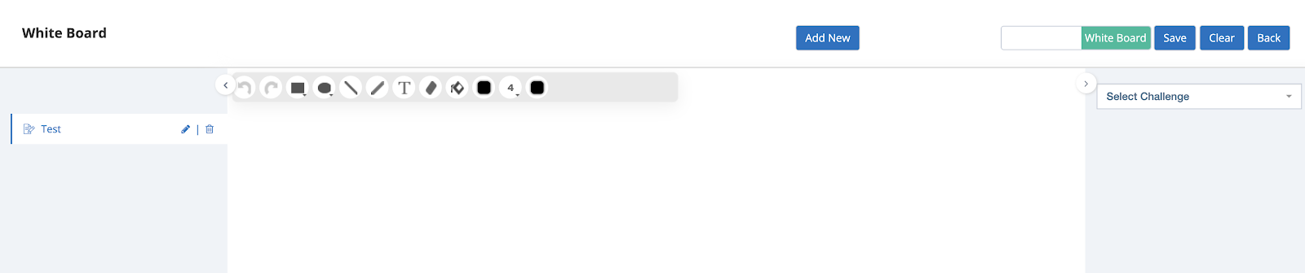

Here the system provides the ability to draw on the whiteboard and also type in text from the keyboard.

You can add a new board from the “Add New” button. You also have the ability to save the work on the whiteboard by clicking on the Savebutton.

**View Items/Challenges or Files by the Side of White board --**

Click on the side menu icon to open the right side panel.

Select an item in the dropdown list for which you want to view the details or attachments of the item.

Select the Attachment or the field which has the details in the dropdown list.

This will load the information in the right side panel.

The Student can view the details on the right side panel and draw/write on the White board.

**Load PDF on to the White Board --**

When selecting an item in the right side panel and selecting the PDF attachment file, you will have the “Add to Canvas” button. Clicking on the button will load the PDF file (all pages) into the White Board Canvas.

Students have the ability to write on the PDF and save each page separately.

**Add Files to view or add to White Board --**

In the right side panel, when you select an item, the “Add File'' button appears where you can add a file to view or add a PDF file to the White Board. The permissions to see “Add File '' button is available in Admin > System Admin > Attachments Config > Attachment Type: White Board Files.

**Code Board (For write & execute programming code) --**

There is a switch toggle on the White Board page which switches the Whiteboard into Code Board.

Code board is specifically for learning and teaching Programming languages.



Here the system provides the ability to select different languages which are shown in the drop-down menu and gives the user the ability to save or submit the work on the aboard. You have the ability to create multiple code Board items.

**Filter button (by Course Level) --**

On the top right side of the board, you will see the “All Selected” button towards the left side of the “Online Class” button. This button will appear if the Course has Levels. You can filter based on the level or for the entire course. Based on the selection, the enrolled Students will appear.

**Filter button (by Student) --**

On the top right side of the board, you will see the “All Selected” button towards the right side of the “Online Class” button. All the Students will be listed under it and you can filter one or more students in this list and the Board will reflect that selection.

**Online Class**

Clicking on ‘online class’ on the top right side above the board will let you perform different actions for the online Class.

**Setup Online Class --**

If you wish to conduct an Online Class, click on this option and click on the Setup option.

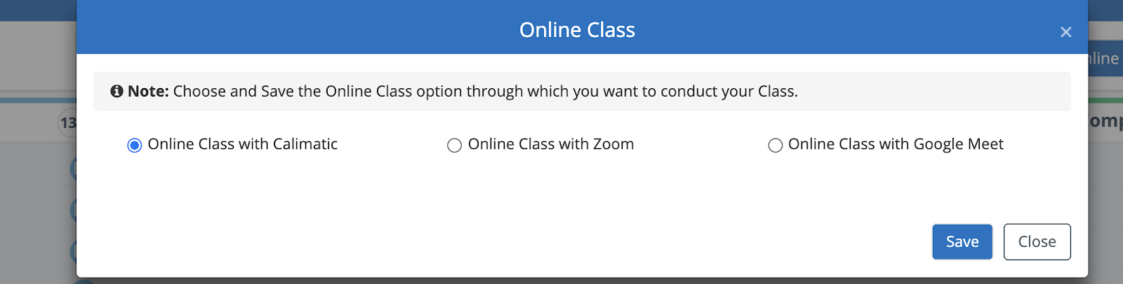

By default, the “Online Class with Calimatic” option is selected. This option is available for the institutes who are subscribed to the Calimatic hosted Online video conferencing capabilities.

You also have the ability to choose Zoom or Google Meet if you wish to conduct online class using those platforms.

For Zoom integration, you will need to set up the integration in Admin > System Config > Zoom Integration.

For Google Meet, you will need to create a google meet link and paste the link after you select the Google Meet option.

Based on this configuration, anyone who is assigned the corresponding class will be navigated to corresponding Platform automatically when they join the online Class.

**Students Joining Online Class -**

Students can Join the Online Class in 3 different places based on the access -

1. Home/Dashboard Page > My Links section - Selecting the Class in the Join Class dropdown list will navigate them to the online class.
2. Boards - Join Class - Selecting the Class in the Join Class dropdown list will navigate them to the online class.
3. Courses > Course Player > Select the Course > Join Class - Selecting the Class in the Join Class dropdown list will navigate them to the online class.

**Start the Class --**

Staff who are assigned to the Class or have access to the Class will be able to Start the Class by clicking on the Online Class > Start the Class option.

Based on the selected Platform in the Class Setup popup, the user will be navigated to the appropriate platform to conduct the Online Class.

**Join the running Class --**

Staff who are assigned to the Class or have access to the Class will be able to Join the running Class by clicking on the Online Class > Join the running Class option.

Based on the selected Platform in the Class Setup popup, the user will be navigated to the appropriate platform to Join the running Online Class if the Class has already been started by some other staff.

**Invite to the Class --**

Staff who are assigned to the Class or have access to the Class will be able to Invite to the Class by clicking on the Online Class > Invite to the Class option.

In the popup, you have the ability to select the list of users and

1. See the Preview email that is going to be sent with the details of the online class - Click on the Preview button.
2. Send Invitation - Click on the “Send Invitation” button to send an email to the selected users.

**Class Notes -**

Staff who are assigned to the Class or have access to the Class will be able to Add/View Class Notes by clicking on the Online Class > Class Notes option.

Clicking on the Class Notes will open a popup with a list of Classes Notes that have been taken. Any notes of the Class that are recorded or entered will be displayed. In the Action column, you have the ability to view/update the corresponding Class notes or recording by clicking on the view icon or links.

Note: Any Calimatic Hosted Online Classes Recordings and any Zoom recordings will be available here. Please note that Google Meet recordings will not be available here.

In order to add new Class Notes, Click on “Add Class Notes” button.

You have the ability to enter Class notes in the editor and add any Attachments (files or videos).

Class Notes are widely used to write the information about what have been covered in the Class. This is used for multiple purposes -

1. If a substitute instructor needs to take a class then they have the required info.
2. Students & Parents can refer to the Class notes.
3. Instructors can even refer to their old Class notes about their Class coverage.

### **Staff Boards**

Assign & Track Tasks to the Staff



Written By Ivan Karmer

Created 2 years ago

Staff Boards provide a way to assign and track Tasks to the Staff. While the system is not only about tracking students progress but also provides the ability to track Staff work progress.

**Navigation:**

In the header menu bar, click on the Boards menu.

For any Staff Role or Admins - Students Boards, Class Boards, and Staff Boards are shown in 3 sections in a mega dropdown list based on the access. Clicking on any Staff name under the Staff Board section will navigate to the corresponding Staff Board.



Parents and Students will not have access to the Staff Boards.

The system provides the ability to filter each of the Boards with different Staff Status.

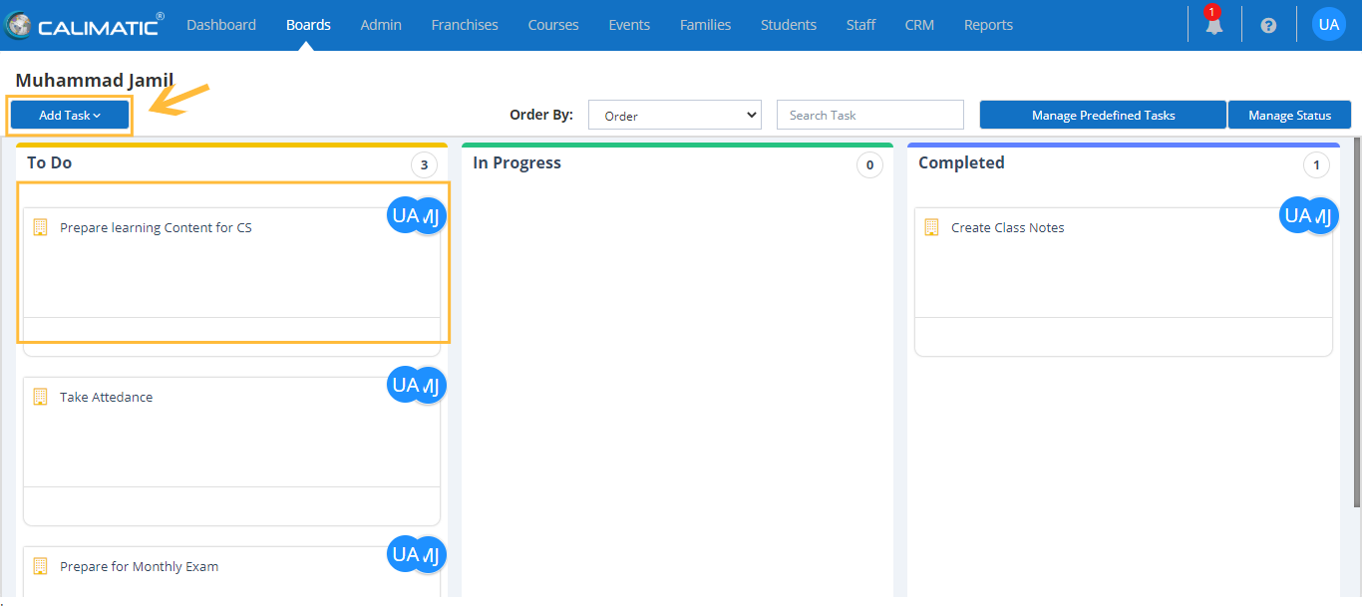

All the Tasks assigned to the Staff are listed in the Board.

Vertical Lanes represent the status of the Task.

You can manage the Task status (based on the permission) by clicking on “Manage Status” button.

Clicking on “Add Task '' button will open a dropdown list to Add a new Task or Add from a Predefined Tasks list.

Adding a task will open a popup to enter the details of the task and assign to a Staff.

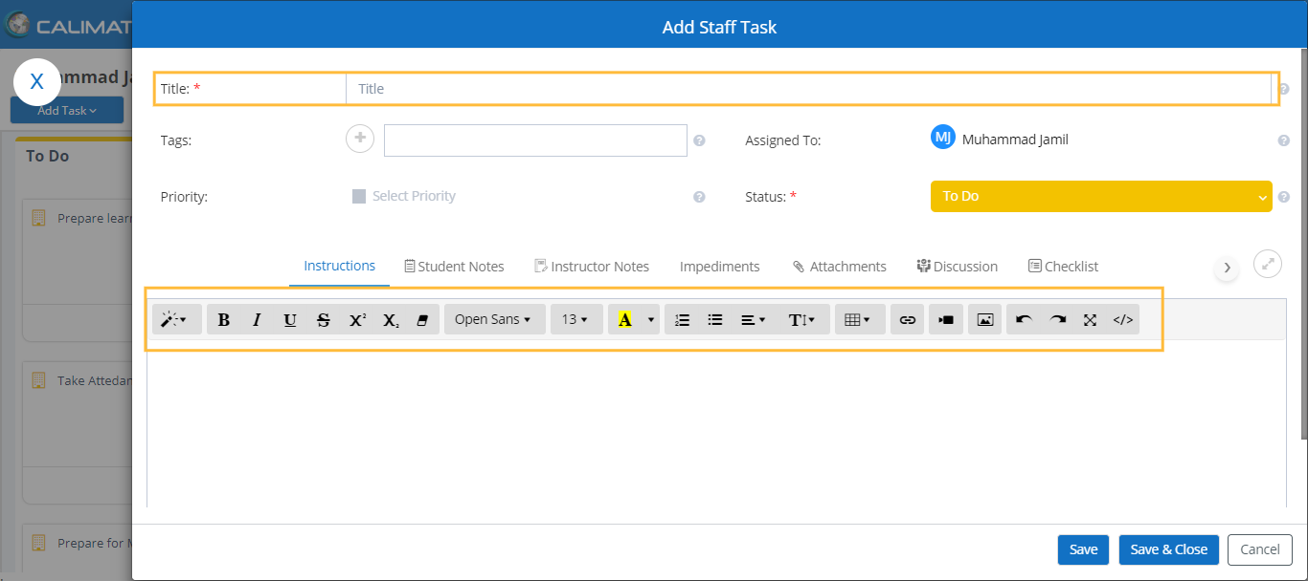

Staff has the ability to move the Tasks across the vertical lanes.