E-commerce Design System

Introduction:

Ecommerce system which provide functionality as follows

1. Seller can add product to system with product name, category and subcategory.
2. User can search product by name, category, subcategory and description.
3. User can add product in cart and remove card
4. User can make order make payment.

**Architecture**

Here I am going with microservices architecture. As we can have more pods for search service as more utilization. Used 3 databases for 3 reason.

**Elasticsearch**: We need fast searching, sorting and filters which is more easily possible with elastic search free text search. Used fuzzy search as well so user can type matching words.

**MongoDB**: Product may have multiple fields and unstructured. So better to use mongo DB here, Now I used some of the properties only we can add more dynamically.

**MySQL**: To store orders and carts details used relational database as it has some relation data. like User will have cart and carts will have items in it. Same for orders as well.

Flow chart of System:

**Search Product:** 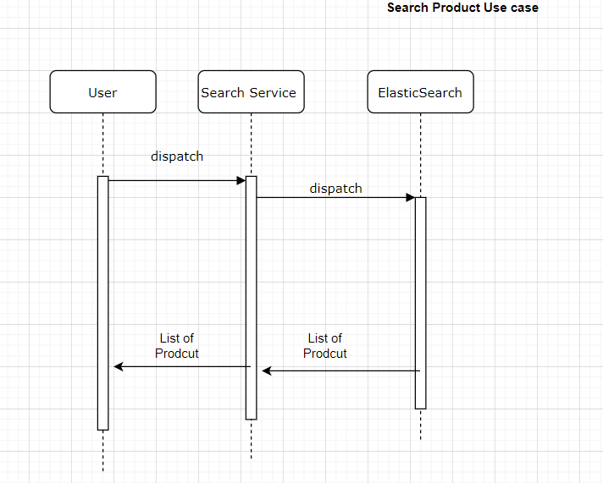

Add Product to System:

Checkout:

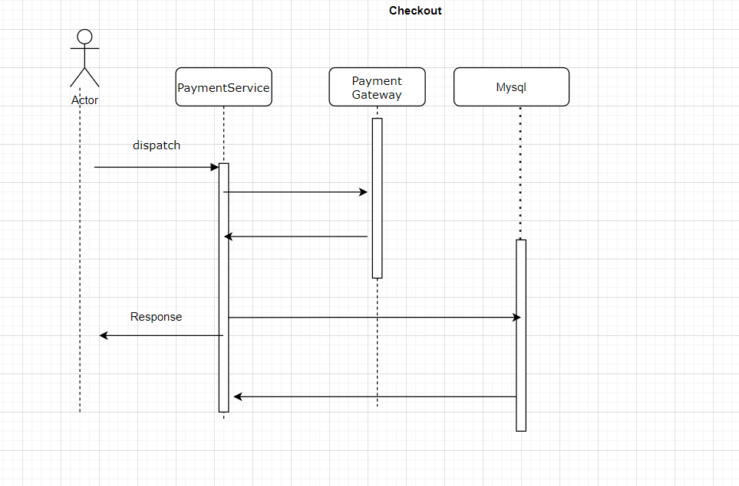

Services Description:

**Product Service:**

* This is only responsible for Add product by seller in system or add inventory.
* To get product Id need to create productid by adding product in mongo DB.
* Snapshot of the product details need to add in Elasticsearch for quick search.
* It has following rest end points
  + Add Product
  + Get Product

**Search Services:**

* This service is important service as most consume service.
* Elasticsearch free text search used for quick search as well as fuzzy search.
* Elasticsearch provide fastest search technique.
* It has following end points
  + Search with any text

**Cart Service:**

* This service will only handle add and remove product from cart
* Uses MySQL as Database as we have relational data.
* It has following endpoints
  + Delete product from cart
  + Add product from cart

**Payment service:**

* This service will handle payment and create order for given item
* I mocked payment gateway for now and return required payment info
* It has only one endpoint i.e. checkout