**One cell:** The geometry is shown in the figure. Cell goes to the right with speed V, radius of the dorsal surface is R. I will be doing the limiting case, in which the conditions at the front and rear are very similar. What it means is that the adhesion/protrusion/retraction forcesandare very similar.

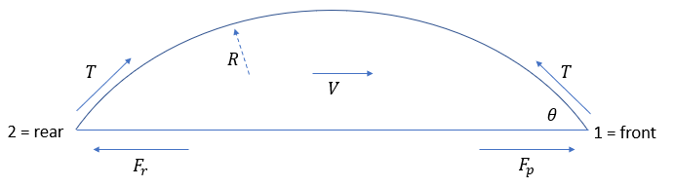

Specifically, let. Hereis the maximal adhesion/protrusion force; exponential term reflects the effect of tension breaking off the adhesions, andis the characteristic large tension that breaks the adhesions. The force decreases as V increases;is the respective proportionality coefficient. We will use the linear approximation:. Thus, the force balance eq at the front is:  (Eq 1)

Similarly, at the rear:  (Eq 2)

So, the adhesion force at the rear is a little weaker than at the front, and also is more sensitive to detaching effect of the tension (notein the denominator). For simplicity, we assumed the sameat the front and rear, but note: at the rear, the force becomes greater when adhesions have to be broken at greater speed when cell moves to the right. “The conditions at the front and rear are very similar” means: .

Scaling: F is force scale, F/is velocity scale,where A is the conserved area is the length scale. Then:

Front:  (Eq 1)

Rear:  (Eq 2)

whereare non-dim model parameters.

Subtracting eq 1 from eq 2, we get: 

Getting rid of the second-order small terms, we have:



This is a very interesting conclusion: if protrusion/retraction asymmetry is greater, then tension t slows cell down – sign ofis negative if f is big enough, but if the adhesion detachment asymmetry is greater, then tension t accelerates protrusion – sign ofis positive if tau is big enough.

Next, adding Eqs 1 and 2, we can find the angle (neglecting terms much smaller than 1):



For consistency, t_0 has to be greater than t (in fact, significantly greater if we want linear approx to esp), so:



It is clear now that t>1, otherwise the tension cannot contain the adh/protr forces and cell is becoming flat (other mechanisms will kick in to contain its elongation). Also, if t becomes significantly greater than 1, theta 🡪 pi/2 as expected and the cell becomes a semi-circle. It is also easy to check that the model gives stable cell shape – if cell is more elongated, velocity at the rear becomes faster than that at the front, and visa versa is cell is more round.

How to find radius: area of the cell is, and so the non-dim radius is:

.

The non-dim pressure differential in the cell is:



Note that as tension grows, theta approaches const, and so does radius, and then pressure is simply proportional to tension. The pressure does not affect things directly, but if blebbing protrusion of the front is limited by pressure, one can assume that the protrusion velocity is limited by v = kp, where k is a parameter. Then, things could become interesting depending on whether this v or v from force balance above are greater. If the former, we have to write for the rear: , from which we will find theta and r and p. For the front, the angle will be sharper than for the rear – like a ‘bird’s beak’ – as actually observed – a tiny lamellipodium sticking forward (see fig). We’ll return to this topic later.

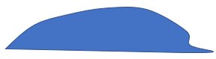

%%%%%%%%%%%%%%%%%%%%%%%%%%%%%%%%%%%%

**Two cells**: let us start with *completely symmetric case of exactly the same cells*; obviously, they will not be moving then:

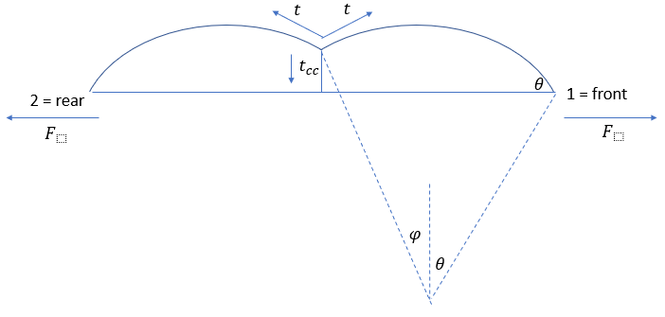

We can approximate the shape by throwing away this tiny triangle at the left of the right cell, its area is small enough, I think for any reasonable case. But if you feel ambitious, or it’s simple enough, then of course add the triangle. Eqs at the left and right are the same:

, so.

The area of one cell is approximately: , and so:

.

Finally, we find angle fi from the force balance at the top of the cell-cell boundary:



Note, that for the c-c boundary to be finite (not to collapse to the ground), the following inequality has to hold:. As, for large t, theta is close to pi/2, and t_cc < 2t. But for t ~ 1, t_cc < 2txsqrt(2(t-1)).

**Two moving cells**: let us finally consider the case of two moving cells (see the figure below):

Let the trailer at the left has tension, while tension of the leader is. Then, at the front of the leader:



whereis a small angle change. At the rear of the trailer:



Expanding in terms of the order 1 and linear in small parameters, ignoring higher order terms, and cancelling the terms of order 1, we get from the 1st equation:



From the 2nd equation:



Comparing these 2 equations gives us two things: 1) , and 2) here is the speed of two cells:

.

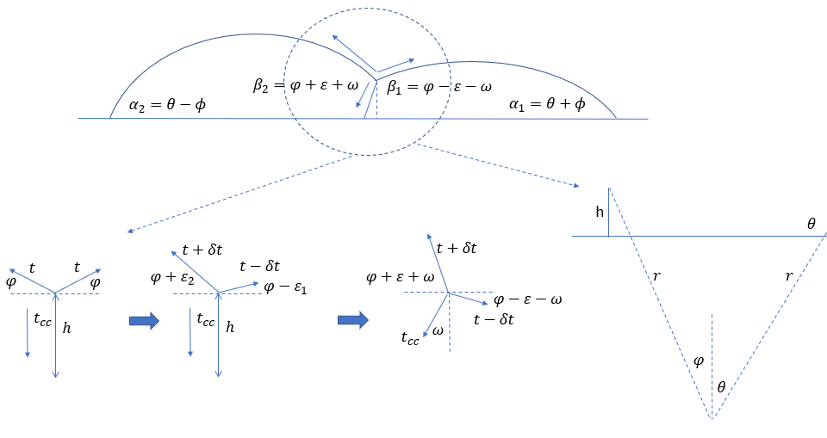

What we have in the square bracket is the speed of one cell, let’s call it. Also, recall that, so in the round bracket we have. Thus:



It already tells us that we can increase the speed of 2 cells compared to 1. Now we have to find angle; here is how we do that (you have to look closely at the figure, as geometry is quite atrocious).

Let us start with two symmetric non-moving cells and analyze three force vectors at the top of the cell-cell boundary (blow-up of this point is shown in the bottom left of the figure). The eq for the force balance is:. Now, let tensions change toand. And let the angles of the trailer and leader tensions turn as follows:. For now, we will keep the t_cc vertically down. For the horizontal force balance, we have:; considering that all changes are small, we have in the linear approximation:, or.

The vertical force balance is:, or, in the linear approximation:

, or

. Thus,.

Now, let there be a certain balance of adhesive-protrusive-retractive forces at the bottom of the cell-cell boundary, such that the cell-cell-boundary net tension has to pull the ventral cell-cell junction not vertically up, but at angle(which is found from the eqwhereis the net adhesive-protrusive-retractive force at the ventral cell-cell junction). Here are the angles we have now (see the figure again):

.

Recall the formula for the cell radius:. Substituting the perturbed angles and using the linear approximation, we can find how the radii of the leader (1) and trailer (2), respectively, change:

.

.

Now, let us calculate the height of the wall between the cell, h. From simple trigonometry, in the case of the symmetric non-moving cells (see bottom right of the figure:. For the perturbed angles:. We can calculate now the change of this wall for the leader:



and for the trailer:

.

But, of course:

, or:



We can find anglefrom this equation!:

.

Now let us go back to the velocity of two cells:

,

Where:.

There is a great wealth of physical and biological implications from these formula, and cool limiting cases, which I am exploring. Four things:

First: I could make a mistake somewhere; let me know if you notice any.

Second: Note that I used the implicit assumption that the cell-cell boundary is straight. But how could that be? The pressures in the leader and trailer will change:. Note though that the pressure changes are small, while t_cc is of the order 1, and so the cell-cell boundary curvature will be small, and can be neglected in the first order (or not, not sure yet). Of course, this perturbation approach breaks down if t_cc is small as well – then the boundary curvature can be significant. But note also, that t_cc cannot be too small anyway – then we’ll have problem with eq- it may not have a solution, or angles epsilon will not be small. The point is we have to be careful with limitations of the approximation.

Third: the force balance at the ventral cell-cell junction can depend on v, for example a very likely model would be:. This leads to a linear system for v and fi, which can be easily solved and it leads to another cool set of predictions. Note also that angle w is not necessarily positive.

Fourth: I think it is clear, in principle, how to do the whole problem numerically without any perturbation. Look at this figure:

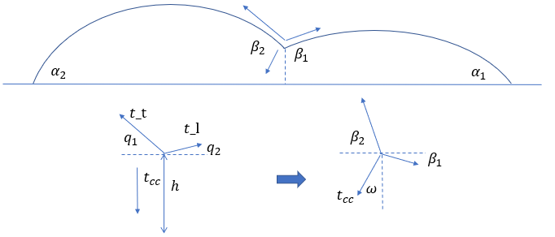

A) choose some v, then you can find alpha1 and alpha2. B) From knowing three force parameters – t_t, t_l, t_cc, we can find angles q1 and q2. C) choose some angle w, then we can find angles beta1 and beta2. D) Knowing angles alpha and beta, we can find radii of both cells, r1 and r2. E) Knowing angles alpha and beta and radii r1 and r2, we can find the heights of the cell-cell boundary h1 and h2. F) Constrain h1 = h2. G) Knowing t_t, t_l, r1 and r2, we find pressures p1 and p2. H) Knowing (p2-p1) and t_cc, we find the radius of the cell-cell boundary, r_cc. I) Knowing h, w, r_cc, we find what is the angle gamma at the ventral end of the cell-cell boundary. J) Gamma is a function of v, or a constant; in any case, the force balance condition at the ventral end of the cell-cell boundary closes the system.

This can probably be done as a iterative numerical algorithm, or minimization of error, or something.

%%%%%%%%%%%%%%%%%%%%%%%%%%%%%%%%%%%%



**2D:** Cell’s dorsal surface is; the boundary of this surface is(see figure). This flat surface is in the x-y-plane; x-axis is the direction of the tactic directional cue, and the cell is polarized in that direction. The ventral surface,, is given by the equation: , where[pN/um] is the cortex tension and is a given parameter, and[pN/um^2] is variable in time (see below). The boundary condition for eq.is. In addition, the volume of the cell is conserved:whereis the constant model parameter – cell volume.

The boundary of the dorsal surface (we’ll call it cell edge) is deforming in a locally normal direction (see fig) with local velocity, which is a function of 1) anglebetween the x-axis and polar angular coordinate of the point at the edge, and 2) of the contact anglewhereare Cartesian coordinates of the point at the cell edge with polar coordinate. To measure, we need to define the cell center (cross in the fig). One convenient way to define it is find the dashed line parallel to the x-axis which divides the dorsal surface in two equal halves (so that areas to the left and right from this line are the same:), and then take the center of the dashed line (see fig).

Let us try the following velocity of the boundary, which can be derived from a force balance combined with Young-Dupre eq.: .

Hereare model parameters.

First, scale and non-dimensionalize the model. I would take volume^1/3 as length scale, T*(length scale) as force scale; (length scale)/kappa_2 as time scale.

Then, think about the numerics. The algorithm probably should be similar to that in Hunter’s paper:

At any time step,

1. On a given, solvewith. Find P from the condition: . (In Hunter’s paper it seems they have some neat trick for doing that)
2. Find the cell center, compute, deform the cell edge.



X-axis (directional cue, direction of cell polarization)

