Memo

June 6, 2023

## **Performance Analysis of Baseball Pitcher Nestor**

**Introduction** In this analysis, we examine the performance of baseball pitcher Nestor, focusing on various key metrics and pitch characteristics. The goal is to provide insights into Nestor’s pitching style, effectiveness, and areas for improvement for the Seattle University Baseball team. Through visually appealing graphs and charts, we will explore the relationship between spin rate, release speed, pitch type, pitch calls, exit velocities, and swing and miss rates.

**Overview and Performance Metrics**

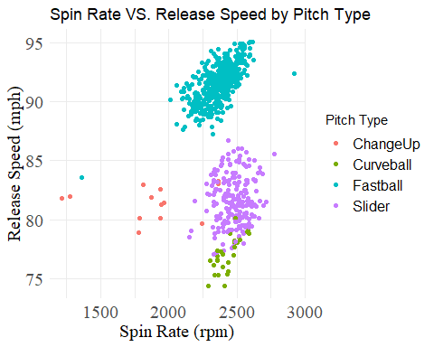

The first graph, “Spin Rate VS. Release Speed by Pitch Type,” displays the relationship between the spin rate and release speed of Nestor’s pitches categorized by pitch type. It allows us to understand the variations and tendencies in Nestor’s pitching style. The scatter plot reveals the distribution of spin rates and release speeds for each pitch type, providing a comprehensive overview of Nestor’s performance.

**Pitch Repertoire Analysis**

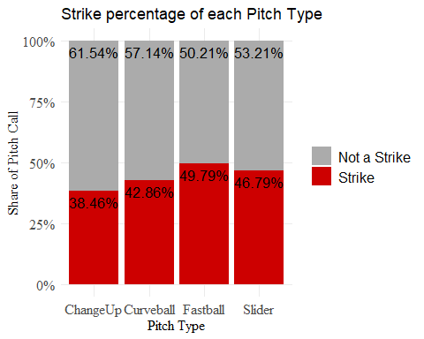

Next, we delve into the pitch repertoire analysis through the graph “Share of Pitch Call VS. Pitch Type.” This stacked column chart presents the share of pitch calls for each pitch type, distinguishing between strikes and non-strikes. By assessing the effectiveness of different pitch types in generating strikes, we gain valuable insights into Nestor’s ability to control the strike zone. To ensure a strike, we would advise Nestor to throw fastballs.

**Pitch Speed and Exit Velocities**

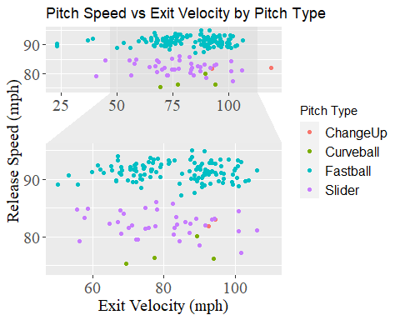

To understand the impact of pitch velocity on the batters, we explore the graph “Exit Velocities VS. Pitch Speed, Sorted by Pitch Type.” This scatter plot analyzes the relationship between exit velocities and pitch velocities for Nestor’s pitches, categorized by pitch type. By examining the interaction between these variables, we gain insights into how Nestor’s pitch velocity influences the batters’ ability to generate high exit velocities. To minimize the likelihood of the batter hitting a home run and producing weaker contact on the ball, Nestor should consider utilizing a curveball, ChangeUp, or slider pitch. These pitches offer variations in speed that can increase the chances of generating less powerful contact.

**Swing and Miss Analysis**

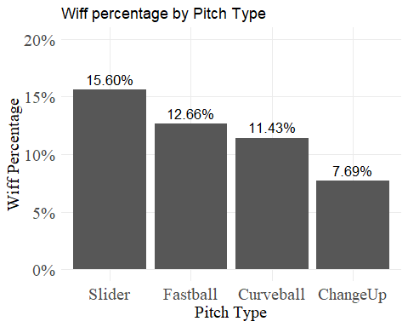

Lastly, we investigate Nestor’s effectiveness in inducing swings and misses using the graph “Swing and Miss by Pitch Type.” The bar chart displays the swing and miss percentages for each pitch type. By comparing these percentages, we can assess the effectiveness of Nestor’s pitches in generating swings and misses, providing crucial insights into his ability to deceive batters. The slider is Nestor’s most effective pitch for inducing swings and misses from batters.

**Key Takeaways**

By analyzing these visualizations together, we can gain insights into Nestor’s pitching performance. The following are some specific key takeaways of Nestor’s performance:

* Using a scatterplot, we can observe Nestor’s patterns in spin rates and release speeds for different pitch types. The visualization shows the consistency of Nestor’s release speed and spin rate for the same type of pitch through clusters of points in the graph. The pitch with the overall fastest spin rate and release speed is a fastball. The ChangeUp pitch tends to see lower spin rates and release speeds.
* The pitch that is most likely to be called a strike is a fastball. We see this in a breakdown of pitch types through a bar graph. A slider is the second most likely pitch to be called a strike.
* The ChangeUp pitch was done less frequently than any other pitch, so it’s difficult to make any meaningful conclusions. It also had the most outliers.
* The pitch that Nestor throws to generate the most swings and misses is a slider. We can see the other pitches that Nestor throws and their percentage breakdown of wiffs through a bar chart.

These insights can help Nestor and his team make informed decisions, such as refining pitch selection, adjusting velocities, and identifying areas for improvement to enhance overall performance on the field.

**Recommendations**

Considering the findings, we offer the following recommendations for Nestor’s improvement:

Overall, Nestor should continue to keep a wide variety of pitches in his arsenal to remain unpredictable to hitters that he is pitching against.

1. In scenarios where there are runners on the bases that are a threat to score, Nestor should rely slightly more heavily on the fastball or the slider, as his fastball has the highest strike percentage out of all his pitches and his slider has the highest percentage to induce a swing and a miss, which also creates strikes.
2. Curveballs, change ups, and sliders create slower exit velocities, which are how hard hitters hit the ball. Therefore, they should be utilized earlier in the innings when there are no/few runners on bases in order to create pop flies and easier balls to catch for the defenders.
3. The fastball is Nestor’s most effective pitch overall, as it has a significantly higher strike rate than his other pitches, and a strike is the best-case scenario for pitchers in any situation.

**Causation Vs Correlation**

Baseball, like any other sport, is still performance based and includes many more factors than just statistics. It’s impossible to guarantee that our recommendations will work because of the wide variety of factors. Pitching includes elements like psychology, human error, fatigue, and level of competition that will affect how effective pitchers are. There is not a “one size fits all” answer for what type of pitch Nestor should use when he is pitching, because at the end of the day, he is trying to deceive the hitter, and every hitter and pitcher is different. Each time Nestor faces the same hitter, they gather more information and make the pitches he threw the last time he faced them less effective. Nestor also becomes much more tired as he continues to pitch throughout the game, hitters continue to rotate throughout the game, he plays a different team every game, and human error could cause him to not throw as effectively at random, which will all affect how effective his pitches are.

In conclusion, our dashboard explores what makes an ideal pitch based on a variety of pitch velocities, pitch types, and other factors. We started off by exploring which pitches had the highest whiff percentages. Our data set had a disproportionate number of Slider and Fastball entries compared to Changeup and Curveballs, which posed a problem in the reliability of our analysis. Our data showed that Fastballs and Sliders had a significantly higher strike percentage than Curveballs and changeups, possibly accounting for their higher popularity in university games. Fastballs also have significantly higher average velocity than other pitches, perhaps partially explaining their higher strike rate. However, sliders are not significantly faster than Changeups or Curveballs, and still enjoy a similar strike rate to Fastballs. Understanding the relationships between key metrics empowers Nestor and his team to make informed decisions, optimize their strategies, and strive for enhanced performance on the baseball field.